RISC-V CNN Digit Recognition SoC
Architecture Document
RISC-V Based SoC with Hardware CNN Accelerator for Handwritten Digit Recognition
Preliminary architecture based on the project abstract and current system block diagram

1. Purpose and Scope
This document defines the high-level architecture of the proposed RISC-V CNN Digit Recognition SoC. It describes the major hardware blocks, their responsibilities, the system interconnect, data movement, control flow, CNN computation, external interfaces, and the intended FPGA demonstration.
The system targets handwritten-digit recognition using a 28 × 28 grayscale image. It integrates a RISC-V processor with instruction and data memory, standard peripherals, a DMA controller, a hardware CNN convolution accelerator, a ReLU unit, and a 7-segment display controller.

2. Problem Statement and Design Objective
Handwritten digit recognition is used as a compact image-classification application. CNN convolution requires repeated multiplication and accumulation operations. Performing these operations entirely in software increases the computational load on a general-purpose processor.
The design therefore uses dedicated hardware for the computationally intensive convolution while retaining RISC-V for system control and remaining lightweight software processing. DMA is used to reduce processor involvement in block data movement.

3. Top-Level SoC Architecture
The RISC-V processor is the central control unit. The AHB-Lite interconnect provides the common system bus for memory-mapped communication among the processor, memories, accelerator and peripherals. The PC communicates with the FPGA through UART. The final recognized digit is displayed on the Basys3 seven-segment display.
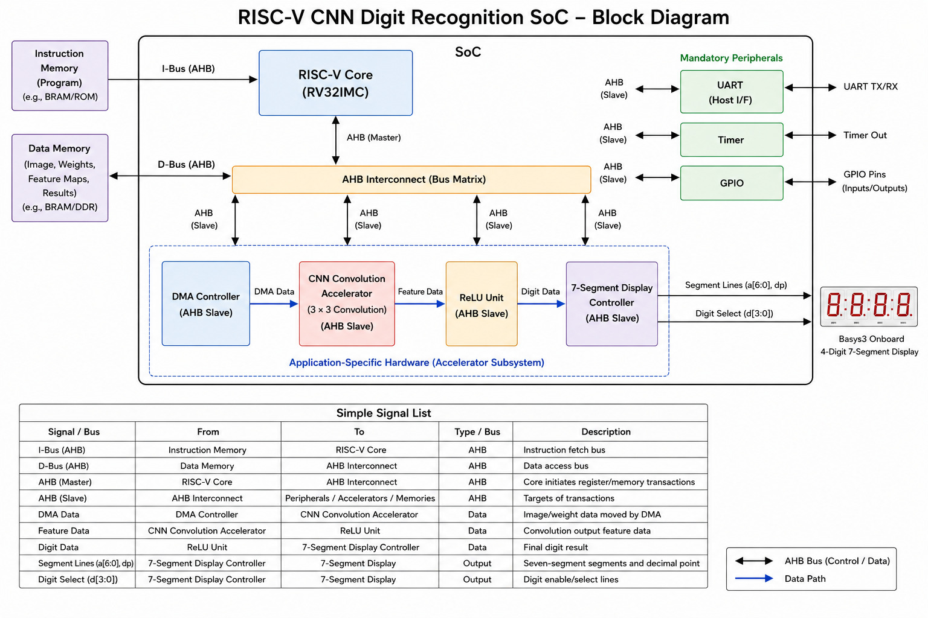
Figure 1. Current system block diagram with data and control paths.

4. Major Architecture Blocks
Block | Architectural Role
RISC-V Processor / RV32I Core | Central control and program execution. Configures IPs through memory-mapped registers, sequences recognition, and performs remaining lightweight classification.
Instruction Memory (IMEM) | Stores the RISC-V application program and supplies instructions.
Data Memory (DMEM) | Stores image pixels, CNN weights, biases, feature maps and results.
AHB-Lite Interconnect | Common system interconnect for memory-mapped CPU/DMA transactions and peripheral/accelerator access.
DMA Controller | Moves blocks of image and CNN data between memory and accelerator with reduced CPU involvement.
CNN Convolution Accelerator | Performs the 3 × 3 convolution using dedicated multipliers, accumulation/adder logic and bias addition.
ReLU Unit | Applies ReLU(x)=max(0,x) to convolution results.
Feature Map Buffer | Holds processed feature data for the remaining classification path.
RISC-V Software Classifier | Runs on RISC-V and performs the remaining classification to determine digit 0–9. Exact software/RTL division must match the final implementation.
UART | Provides PC/FPGA communication for image input in the intended demonstration and status/result output.
Timer | Measures processing/execution time and provides timer status/interrupt behavior.
GPIO | Provides general-purpose status and control I/O.
7-Segment Display Controller | Maps the recognized digit to the Basys3 seven-segment pattern and controls multiplexing.
Clock & Reset Generator | Provides common clock and reset infrastructure.

5. System Interconnect
AHB-Lite is represented at the top level as one shared system bus. Individual AHB-Lite signals belong to the corresponding master/slave interface and should not be duplicated as separate top-level point-to-point connections in the architecture drawing.
• RISC-V is the main software/control-side bus master.
• DMA requires master access when it performs programmed memory transfers.
• IMEM, DMEM, UART, Timer, GPIO and memory-mapped accelerator registers are addressable targets.
• The final DMA arbitration/topology and exact bus implementation are RTL-level decisions to be frozen before coding.

6. Memory Architecture
Memory | Contents | Primary Consumer
IMEM | RISC-V application instructions | RISC-V
DMEM | 28 × 28 image = 784 pixel values | RISC-V / DMA
DMEM | CNN weights and biases | DMA / CNN
DMEM / feature storage | Processed feature maps and results | RISC-V classifier / system

7. External Input: PC and UART
The intended live demonstration starts on a PC. The user draws a handwritten digit, the PC converts it to a 28 × 28 grayscale representation, and the resulting pixel stream is transferred to the FPGA through UART.
PC drawing → 28 × 28 conversion → UART → FPGA/SoC → DMEM
The project abstract explicitly assigns UART to debugging, status and result communication. The current demonstration concept additionally uses the same UART link for PC-to-FPGA image input. The final documentation should state this input role explicitly.

8. DMA Architecture
RISC-V configures the DMA using source address, destination address, transfer length and control information. After the transfer is started, DMA performs the programmed block movement with minimal processor involvement.
Operation | Source | Destination
Image transfer | DMEM | CNN accelerator / input buffer
Weight transfer | DMEM | CNN accelerator / weight buffer
Processed result storage | Accelerator path | DMEM / feature storage, as finalized

9. CNN Convolution Accelerator
The current baseline uses a 3 × 3 convolution. Each output position uses nine input-weight products followed by accumulation and bias addition.
Y = Σ(Input[i,j] × Weight[i,j]) + Bias, i,j = 0..2
A fully parallel baseline uses nine multipliers so that the nine products of a 3 × 3 window can be formed concurrently. The resulting products are combined by an adder/accumulation structure.
The 3 × 3 kernel is the current project baseline, not a claim that larger kernels are inherently inferior. Efficiency should be evaluated using throughput, hardware utilization, memory traffic, execution time and processor overhead.

10. CNN Weights and Numerical Representation
CNN weights are trained offline and then used during FPGA inference. The final weights must come from the exact trained model; arbitrary illustrative values must not be used as the implementation weights.
Train → Validate → Freeze weights → Quantize → Export memory data → Load/store in DMEM → CNN inference
The exact pixel width, weight width, signedness, fixed-point scaling, bias width and memory layout are implementation parameters and must be finalized before RTL freeze.

11. ReLU and Feature-Map Processing
The convolution output is passed through a ReLU stage:
ReLU(x) = max(0,x)
Negative values are mapped to zero and positive values are retained. The processed feature data is then stored or made available for the remaining classification path.

12. RISC-V Classification
After convolution and ReLU, the processed feature map is made available to software running on the RISC-V processor. The software performs the remaining lightweight classification and determines one of the ten classes, 0–9.
The current block diagram shows fully connected classification logic within the RISC-V classification stage. The exact FC computation, data layout and software implementation must be defined consistently with the final firmware.

13. Output Interfaces
Interface | Connection | Purpose
7-Segment | RISC-V result → Display Controller → Basys3 | Physical recognized digit
UART | FPGA UART → PC | Status, debugging and recognition result
Timer | Timer → RISC-V/status | Execution-time measurement
GPIO | SoC ↔ external pins | General-purpose control/status

14. End-to-End Functional Flow
1. PC draws a handwritten digit.
2. PC converts the drawing into a 28 × 28 grayscale image.
3. PC transmits the image pixel stream through UART.
4. FPGA/SoC receives the image and places it into the memory flow.
5. RISC-V initializes the system and configures required peripherals/IPs.
6. RISC-V programs the DMA source, destination, length and control.
7. DMA transfers required image/weight blocks to the CNN accelerator.
8. CNN performs the 3 × 3 hardware convolution.
9. Convolution output is passed to the ReLU unit.
10. Processed feature-map data is stored/made available for classification.
11. RISC-V software performs the remaining classification and determines digit 0–9.
12. RISC-V writes the digit to the display path.
13. 7-Segment Controller drives the Basys3 display.
14. UART reports status/result and the Timer measures execution time.

15. Data Paths
ID | From | To | Data / Purpose
D1 | PC | UART | Serialized image data
D2 | UART | DMEM | 784 input pixel values
D3 | DMEM | DMA | Image/weight blocks
D4 | DMA | CNN | Image/weight data
D5 | CNN | ReLU | Convolution feature data
D6 | ReLU | Feature storage | Processed feature map
D7 | Feature storage | RISC-V software | Classification input
D8 | RISC-V | 7-Segment Controller | Predicted digit
D9 | 7-Segment Controller | Basys3 | Segment and digit-select signals
D10 | UART | PC | Status/result output

16. Control Paths
ID | From | To | Control / Status
C1 | RISC-V | AHB Interconnect | Bus address/control transaction
C2 | RISC-V | DMA | DMA configuration and start
C3 | RISC-V | CNN | CNN configuration and start
C4 | CNN | RISC-V/status | Busy/done/status
C5 | RISC-V | ReLU | Enable/configuration, if memory-mapped
C6 | RISC-V | 7-Segment Controller | Display control
C7 | RISC-V | UART | UART configuration/control
C8 | RISC-V | Timer | Timer configuration/start/stop
C9 | RISC-V | GPIO | GPIO configuration
C10 | DMA/CNN/Timer/UART/GPIO | RISC-V/PIC | Interrupt/event signals, if implemented
C11 | Clock/Reset | SoC | Clock and reset

17. Performance and Efficiency
The accelerator should be evaluated as a complete hardware architecture. The objective is to reduce the effective execution cost of the CNN workload while maintaining acceptable FPGA resource usage and recognition accuracy.
• Execution cycles / processing time
• MAC throughput and utilization
• FPGA LUT, FF, DSP and BRAM usage
• Memory traffic and effective bandwidth
• DMA overhead and CPU involvement
• Clock frequency
• Power, if estimation is available
• Recognition accuracy after quantization

18. RTL Architecture Boundaries
This document defines responsibilities and high-level connections. The separate Markdown signal specification defines the preliminary signal-level interfaces. The following items must be frozen before RTL implementation:
• Exact RISC-V core variant and instruction extensions
• AHB-Lite topology, bus mastering and arbitration
• Complete memory map and peripheral base addresses
• Register map for DMA, CNN, ReLU, UART, Timer, GPIO and display
• UART image-transfer framing and pixel encoding
• CNN pixel/weight/bias widths, signedness and fixed-point format
• Number of CNN filters, feature-map dimensions, stride and padding
• DMA-to-CNN handshake and buffering
• CNN-to-ReLU handshake
• Feature-map storage format
• Exact RISC-V classification algorithm
• Interrupt architecture
• Clock frequency, clock-domain crossings and reset synchronization
• Final trained/quantized weight files

19. Architecture Summary
The SoC combines general-purpose processing with application-specific acceleration. RISC-V provides system control and software execution; AHB-Lite provides the memory-mapped interconnect; DMEM stores image, weight and feature data; DMA handles bulk movement; the CNN accelerator performs 3 × 3 convolution; ReLU performs activation; RISC-V performs remaining classification; the seven-segment controller drives the Basys3 output; UART provides PC communication/monitoring; and the Timer provides performance measurement.
PC → UART → DMEM → DMA → CNN → ReLU → Feature Data → RISC-V Classification → Display/UART

