Fortune IT,
#201, 2nd Floor, Manjeera Square,
Mythrivanam , Ameerpet,
Hyderabad, Telangana – 500016

Date: 21/02/2026

Subject: Task Assignment for Project Documentation –
College Management System (CMS)
1. Task Objective
The objective of this project is to design and develop a fully functional College Management System using Python full-stack technologies. The system aims to automate and streamline various academic and administrative operations within a college environment.
This project focuses on building an integrated web-based application that manages core functionalities such as student registration, faculty management, course allocation, attendance tracking, examination records, and result processing. The system is designed to reduce manual paperwork and improve data accuracy.
The task requires independent development of the complete system, including:
- Requirement analysis
- System design (frontend, backend, and database architecture)
- Implementation using Python-based technologies
- Testing and validation
- Deployment and documentation
The final outcome will be a scalable, user-friendly, and secure web application that demonstrates full-stack development skills while serving as both an academic reference and a practical management solution for educational institutions.

2. Scope of Work
The scope of this project includes the complete analysis, design, development, testing, and documentation of a web-based College Management System developed using Python full-stack technologies. The system is intended to automate academic and administrative processes within a college environment.
The documentation covers the following major areas:

A. Project Understanding
1. Project Overview
The College Management System is a centralized web-based application designed to manage and streamline the daily operations of a college. The system integrates various academic and administrative functions into a single platform, enabling efficient data management, communication, and reporting.
The application ensures organized handling of student records, faculty details, course management, attendance tracking, examination processes, and result generation.
2. System Purpose and Scope
Purpose:
- To automate manual administrative tasks.
- To reduce paperwork and human errors.
- To provide real-time access to academic data.
- To ensure secure and structured data storage.
Scope:
- Student information management
- Faculty and staff management
- Course and subject allocation
- Attendance management
3. User Roles and Responsibilities
The system supports multiple user roles with defined permissions:
1. Administrator
- Manage student and faculty records
- Create and assign courses
- Approve registrations
- Generate reports
- Manage user accounts and permissions
2. Faculty
- View assigned courses
- Mark student attendance
- Upload marks and results
- View student details
3. Student
- View personal profile
- Check attendance records and examination results
- Access course information
B. Module-Wise Documentation
Below is the detailed documentation of each module included in the system:

1. Authentication Module
Description:
Handles secure login, registration, and user authentication.
Features:
- Role-based login (Admin, Faculty, Student)
- Password encryption
- Session management
- Logout functionality
Users:
Administrator, Faculty, Student
2. Student Management Module
Description:
Manages complete student-related information.
Features:
- Add, update, delete student records
- View student profiles
- Search and filter students
- Assign courses
Users:
Administrator
Functional Logic:
Admin performs CRUD operations on student records stored in the database.

3. Faculty Management Module
Description:
Manages faculty information and subject assignments.
Features:
- Add, update, delete faculty details
- Assign subjects
- View faculty list
Users:
Administrator
Functional Logic:
Faculty data is stored in the database and linked with assigned subjects and departments.

4. Course Management Module
Description:
Handles course creation and subject allocation.
Features:
- Create courses
- Assign subjects to courses
- Map faculty to subjects
Users:
Administrator
Functional Logic:
Courses and subjects are linked through relational database tables for structured data handling.

5. Attendance Management Module
Description:
Tracks and maintains student attendance records.
Features:
- Mark attendance
- View attendance history
- Generate attendance reports
Users:
Faculty, Student
Functional Logic:
Faculty marks attendance daily; records are stored and percentage is automatically calculated.

6. Examination & Result Module
Description:
Manages examination details and result processing.
Features:
- Enter internal and external marks
- Calculate total and grade
- Publish results
- View results
Users:
Faculty, Student, Administrator
Functional Logic:
Marks are entered by faculty, the system calculates totals and grades based on predefined grading rules.

7. Reporting Module
Description:
Generates academic and administrative reports.
Features:
- Student performance reports
- Attendance reports
- Course-wise reports
- Downloadable reports (PDF/Excel)
Users:
Administrator

C. SYSTEM DESIGN DOCUMENTATION

1️⃣ ER Diagram (Entity Relationship Diagram)
Entities:
- Student
- Faculty
- Admin
- Course
- Department
- Subject
- Attendance
- Marks

📊 ER Diagram
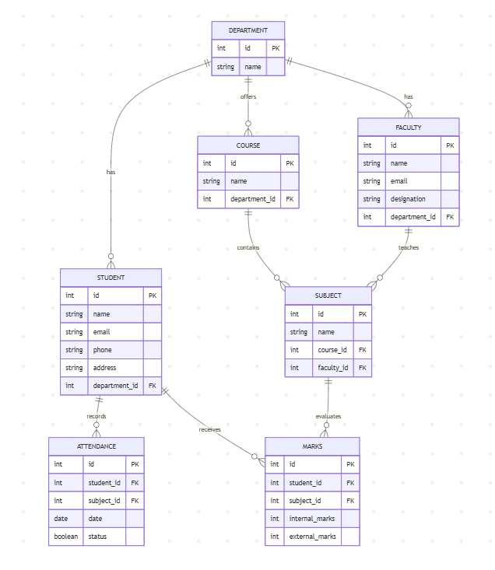

2️⃣ Use Case Diagram
Actors:
- Admin
- Faculty
- Student

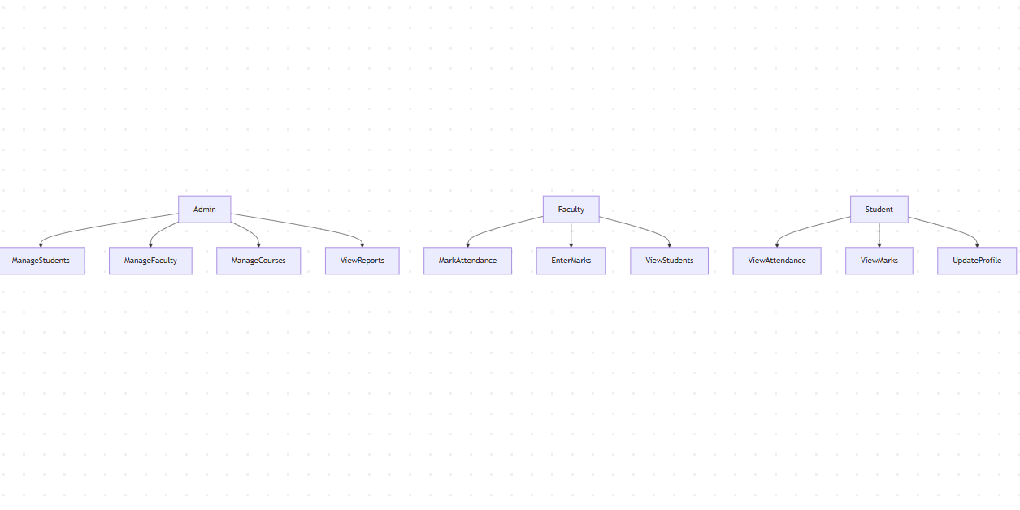
3️⃣ Data Flow Diagram (DFD)

🔹 Level 0 (Context Diagram)
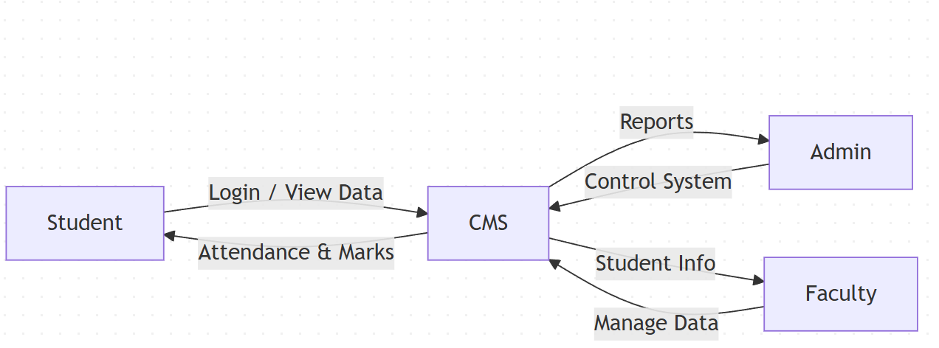

🔹 Level 1 DFD
Processes:
- Authentication
- Student Management
- Faculty Management
- Attendance Management
- Marks Management
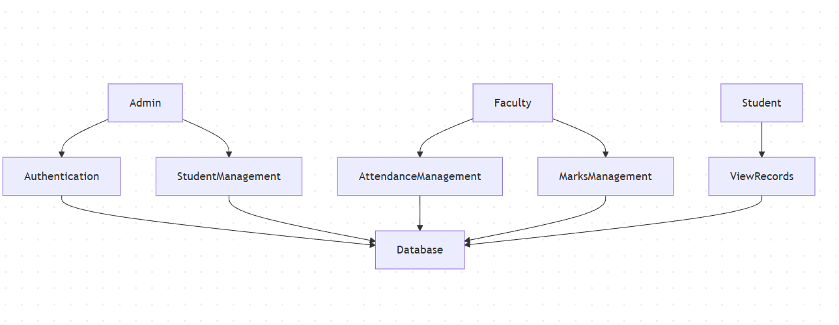

🔹 Level 2 DFD (Attendance Example)
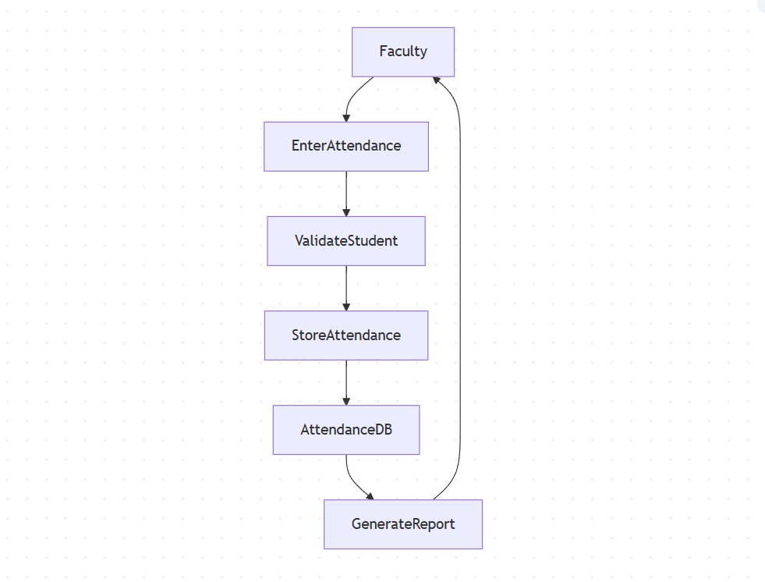

4️⃣ Class Diagram (Django Model Representation)
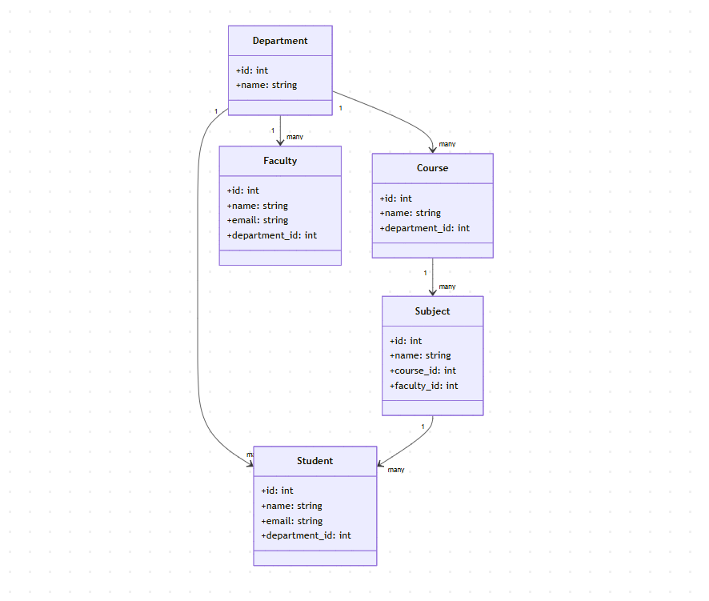

5️⃣ System Architecture
🏗 Django MVT Architecture
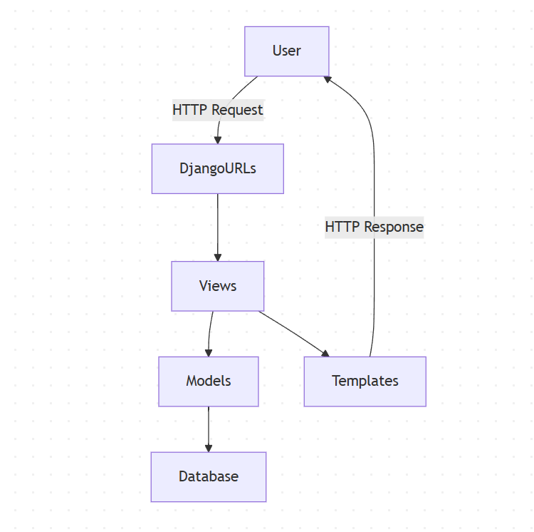

Explanation:
- Model → Database structure
- View → Business logic
- Template → Frontend UI
- URL → Routing layer

D. DATABASE DOCUMENTATION

1️⃣ Student Table
Field | Type | Key
id | AutoField | PK
name | CharField(100)
email | EmailField | Unique
phone | CharField(15)
address | TextField
department_id | ForeignKey | FK
Relationship:
- Many Students → One Department
- One Student → Many Attendance Records
- One Student → Many Marks

2️⃣ Faculty Table
Field | Type | Key
id | AutoField | PK
name | CharField(100)
email | EmailField | Unique
designation | CharField(50)
department_id | ForeignKey | FK

3️⃣ Department Table
Field | Type | Key
id | AutoField | PK
name | CharField(100)

4️⃣ Course Table
Field | Type | Key
id | AutoField | PK
name | CharField(100)
department_id | ForeignKey | FK

5️⃣ Subject Table
Field | Type | Key
id | AutoField | PK
name | CharField(100)
course_id | ForeignKey | FK
faculty_id | ForeignKey | FK

6️⃣ Attendance Table
Field | Type | Key
id | AutoField | PK
student_id | ForeignKey | FK
subject_id | ForeignKey | FK
date | DateField
status | BooleanField

7️⃣ Marks Table
Field | Type | Key
id | AutoField | PK
student_id | ForeignKey | FK
subject_id | ForeignKey | FK
internal_marks | IntegerField
external_marks | IntegerField

E. TECHNOLOGY STACK OVERVIEW
Layer | Technology
Frontend | HTML5, CSS3, Bootstrap, JavaScript
Backend | Python, Django
Database | PostgreSQL / MySQL
Authentication | Django Authentication System
ORM | Django ORM
Server | Django Development Server / Gunicorn
Version Control | Git

F. UI / SCREEN DOCUMENTATION

1️⃣ Login Page
Components:
- Email field
- Password field
- Login button
- Forgot password link
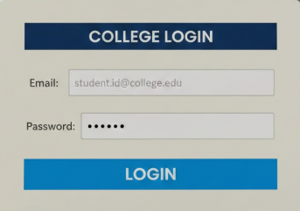
2️⃣ Home Page
- Navigation bar
- About section
- Contact section
- Login/Register button

3️⃣ Admin Dashboard
Features:
- Manage Students
- Manage Faculty
- Manage Courses
- Generate Reports
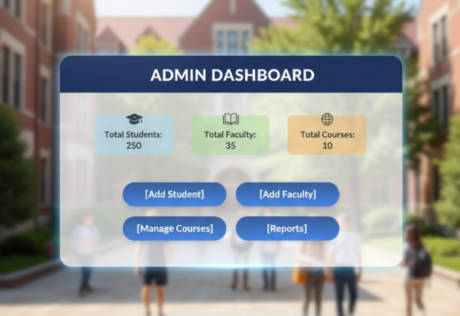
4️⃣ Faculty Dashboard
Features:
- Mark Attendance
- Enter Marks
- View Student List

5️⃣ Student Dashboard
Features:
- View Attendance
- View Marks
- Update Profile
- Download Report
3. Submission Deadline
We are allotted 7 days to complete this task.
Start Date: [21/02/2026]
End Date: [DD/MM/YYYY]

IMPLEMENTATION OVERVIEW
3.1 Development Methodology
The College Management System was developed using a modular and iterative development approach. Each module (Student, Faculty, Course, Attendance, Marks, Authentication) was developed and tested independently before integration.
The project follows the Django MVT (Model-View-Template) architecture, which ensures separation of concerns:
- Model → Handles database structure using Django ORM
- View → Contains business logic
- Template → Handles frontend presentation
- URLs → Routing mechanism

3.2 Module Implementation
1. Authentication Module
- Implemented using Django’s built-in authentication system.
- Role-based login (Admin, Faculty, Student).
- Session-based authentication.
- Password hashing using Django security framework.
2. Admin Module
- Manage students (Add, Update, Delete, View)
- Manage faculty
- Manage courses and subjects
- Generate reports
3. Faculty Module
- Mark student attendance
- Enter internal and external marks
- View assigned subjects and student lists
4. Student Module
- View attendance records
- View marks
- Update profile details

3.3 Database Implementation
- Database designed in 3NF (Third Normal Form).
- Foreign keys maintain referential integrity.
- Django ORM used for database operations.
- Migrations used to create and update database schema.
4.TESTING
4.1 Testing Approach
The system was tested using:
- Unit Testing
- Integration Testing
- System Testing
- User Acceptance Testing

4.2 Unit Testing
Each module was tested individually:
- Login validation
- Student CRUD operations
- Attendance marking
- Marks entry validation
Django’s built-in testing framework was used for writing test cases.
Example Test Case:
Test Case ID | TC01
Module | Login
Input | Valid username & password
Expected Output | Successful login
Result | Pass

4.3 Integration Testing
- Verified interaction between modules.
- Checked if attendance reflects correctly in student dashboard.
- Verified marks entry updates student records properly.

4.4 System Testing
- Full system workflow tested.
- Role-based redirection tested.
- Navigation and UI tested.
- Data consistency verified.
4. CONCLUSION
The College Management System successfully digitizes and automates the administrative and academic activities of a college.
The system:
- Reduces manual paperwork
- Improves data accuracy
- Enhances transparency
- Provides real-time access to academic records
- Ensures secure and role-based access
The Django framework helped in rapid development, scalability, and maintainability of the system. The project demonstrates strong understanding of:
- Backend development
- Database design
- Role-based authentication
- Full-stack integration
- Software engineering principles
This system can be efficiently used in educational institutions to manage student and faculty data digitally.

5. FUTURE SCOPE
The system can be enhanced further by implementing the following features:
1. Online Fee Management
- Payment gateway integration
- Automatic receipt generation
2. Result Analytics
- Graph-based performance analysis
- Semester-wise comparison charts
3. Mobile Application
- Android/iOS app integration
- API-based backend using Django REST Framework
4. Notification System
- Email notifications
- SMS alerts
- Push notifications
5. Attendance Analytics
- Percentage calculation
- Attendance shortage alerts
6. Online Assignment Submission
- File upload system
- Faculty grading module
7. AI-Based Performance Prediction
- Predict student performance trends
- Early warning system for low-performing students
8. Cloud Deployment
- Multi-college support
- SaaS-based model

