BANK LOAN & CREDIT RISK ANALYSIS

Project Report

Tools Used: SQL Server and Power BI

Submitted by: [GUNTA RAHULVIJAY]

Program: M.Tech Data Science

Department: Computer Science and Engineering – Data Science

Institution: GITAM

Academic Year: 2026

Introduction

The banking sector provides loans to customers for different financial needs such as purchasing vehicles, household items, education, business activities, and renovations. However, some borrowers may fail to repay their loans, creating credit risk for banks.

Bank Loan & Credit Risk Analysis is a data analytics project that examines loan-related information to understand patterns associated with loan default. The project uses SQL Server for data cleaning, querying, and analysis, and Power BI for interactive visualization and dashboard development.

The analysis focuses on loan distribution and default patterns based on credit history, employment duration, and loan purpose. The results are presented through interactive dashboards and key insights to make the data easier to understand and support credit-risk analysis.

Problem Statement

Banks need to assess the risk associated with lending money to customers because some loans may result in default. A large amount of loan information can make it difficult to identify patterns in loan defaults manually. Therefore, there is a need to analyze loan data systematically to understand how factors such as credit history, employment duration, and loan purpose are related to loan patterns and defaults.
This project addresses this problem by using SQL Server to clean and analyze the loan dataset and Power BI to present the results through interactive visualizations and dashboards. The analysis helps identify important patterns in the available loan data and presents them in an easy-to-understand format.

Objectives

The main objectives of this project are:
- To analyze the overall distribution of loans and loan defaults.
- To examine loan patterns based on credit history.
- To analyze loan patterns based on employment duration.
- To analyze the distribution of loans across different loan purposes.
- To use SQL Server for data cleaning, querying, and analysis.
- To develop an interactive Power BI dashboard for visualizing the results.
- To identify useful patterns and insights from the loan data to support credit-risk analysis.

Dataset Description

The dataset used in this project contains 1,000 loan records. Each record represents a loan applicant and contains information related to the applicant’s financial and personal characteristics, loan details, and default status.
The main fields used for this analysis include age, loan amount, checking balance, credit history, default status, employment duration, existing loans, housing, job, loan duration, purpose, savings balance, and other relevant attributes.
The target variable is default, where 0 represents a non-defaulted loan and 1 represents a defaulted loan. In the dataset, 700 loans are non-defaulted and 300 loans are defaulted, resulting in an overall default rate of 30%.
The dataset was cleaned and analyzed using SQL Server before being used to create the interactive Power BI dashboard.

Tools and Technologies

The project was developed using the following tools and technologies:
SQL Server: Used for data storage, data cleaning, SQL queries, and analysis of loan records.
Power BI: Used to create interactive dashboards, charts, KPI cards, slicers, and key insight visualizations.
SQL: Used to retrieve, filter, group, and summarize the loan data for analysis.
Microsoft Word: Used to prepare and document the project report.

Data Cleaning and SQL Analysis

Before performing the analysis, the loan dataset was checked for incorrect and inconsistent values. During data cleaning, an incorrect value “car0” in the loan purpose field was identified and corrected to “car”.
SQL Server was then used to analyze the cleaned dataset. SQL queries were written to calculate the total number of loans, defaulted and non-defaulted loans, overall default rate, and loan distributions across different categories.
The analysis was performed based on credit history, employment duration, and loan purpose. Grouping and aggregate functions such as COUNT, SUM, and percentage calculations were used to understand the loan and default patterns.

Power BI Dashboard

Power BI was used to convert the analyzed loan data into an interactive dashboard. The dashboard provides a visual overview of loan distribution and default-related patterns.
The dashboard contains three KPI cards showing Total Loans, Defaulted Loans, and Non-Default Loans. It also includes three slicers for Credit History, Employment Duration, and Loan Purpose, which allow users to filter the dashboard interactively.
Five visualizations were created to analyze the dataset:
- Default vs Non-Default by Credit History
- Loans by Credit History
- Loans by Purpose
- Loan Default Status
- Loans by Employment
A separate Key Insights page was also created to summarize the important findings from the analysis. Navigation buttons were added to move between the main dashboard and the Key Insights page.

Key Findings

The analysis of the 1,000 loan records produced the following key findings:
- Overall Loan Default: 300 loans were defaulted and 700 loans were non-defaulted, giving an overall default rate of 30%.
- Credit History: The default rate varies across credit-history categories. The perfect credit-history category has a default rate of 62.50%, while the critical category has a default rate of 17.06%.
- Employment Duration: The less than 1 year employment category has the highest default rate among the employment-duration categories at 40.70%, followed by unemployed customers at 37.10%.
- Loan Purpose: Furniture/Appliances is the most common loan purpose with 473 loans, followed by car loans with 349 loans.
- Interactive Analysis: The Power BI dashboard allows users to filter and explore loan information using Credit History, Employment Duration, and Loan Purpose slicers.

Conclusion

This project presented an analysis of bank loan data using SQL Server and Power BI. The dataset containing 1,000 loan records was cleaned and analyzed to understand loan distribution and default patterns.
SQL Server was used for data cleaning, querying, and aggregation, while Power BI was used to create an interactive dashboard with KPI cards, slicers, charts, and a Key Insights page.
The analysis showed that 300 loans were defaulted and 700 were non-defaulted, resulting in an overall default rate of 30%. The dashboard also highlighted differences in loan patterns across credit history, employment duration, and loan purpose.
Overall, the project demonstrates how SQL and Power BI can be used together to transform raw loan data into meaningful visual insights for credit-risk analysis.

Recommendations

Based on the analysis, banks can further investigate the factors associated with loan defaults before making lending decisions. Credit history, employment duration, and loan purpose can be considered along with other financial characteristics when assessing credit risk.
The interactive Power BI dashboard can also be used by analysts to explore different customer segments and identify patterns that require further investigation.

Future Scope

This project can be extended in several ways to improve the analysis of loan and credit risk. Future work could include adding more customer and financial attributes, applying predictive machine learning models to estimate the probability of loan default, and comparing the performance of different models.
The Power BI dashboard can also be enhanced with additional KPIs, drill-through analysis, and more detailed customer segmentation. Using larger and more recent datasets could further improve the analysis and help identify changing loan default patterns.

References

• Microsoft Learn, Power BI Documentation, Microsoft.
• Microsoft Learn, SQL Server Documentation, Microsoft.
• SQL Server documentation and reference material for SQL queries, data manipulation, and aggregation.
• Dataset source: Kaggle, “German Credit Risk Dataset,” containing 1,000 loan records.

Appendix – Dashboard Screenshots

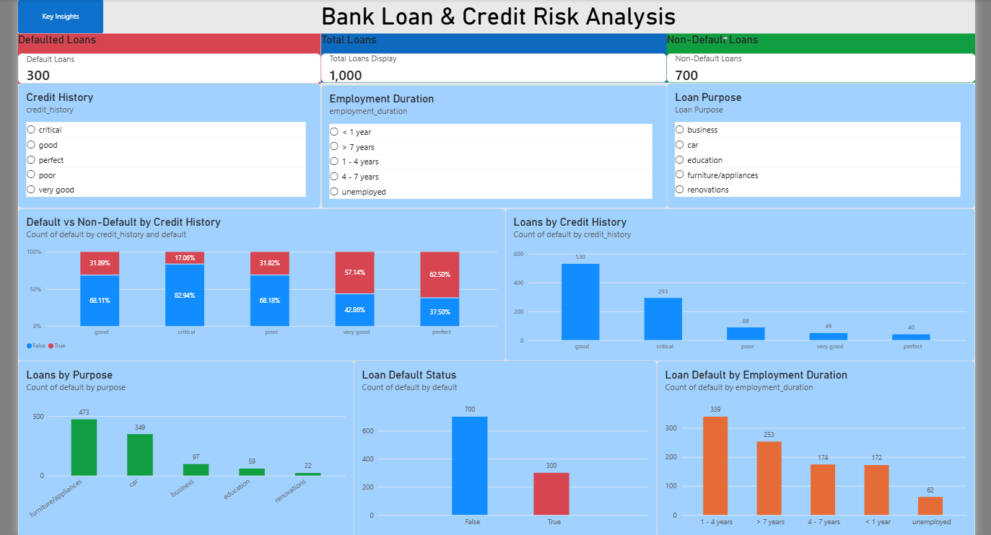
Figure 1: Bank Loan & Credit Risk Analysis Dashboard

Figure 2: Key Insights Dashboard
