5 Nov 2023

Assignment

Database design & development

**Vijay Kumar**

**Bachelor of Computing System**

**Shiu, Ram**

Sponsor/Owner

Aotearoa Motokā Rihi

33 Carrington Road, Mt. Albert

Auckland, 0612

123-456-7890

sram@unitec.co.nz

Prepared By

Vijay, Kumar

Chris Escandor

Jatinder Singh

Table of Contents

Introduction: 1

Data Volume Map: Looking Glass Recruitment 2

Data Usage Map: All Vacancies Filled 3

Data Usage Map: All Unfilled Vacancies with Candidates Interested. 4

Business processes to physical design techniques matrix table using the business processes. 5

# Introduction:

The aim of this project is to provide a robust database management system for the Looking Glass Recruitment. The company operates as a human resources agency. The current informal paper-based system frequently encounters issues when it comes to aligning a candidate's skills and qualifications with those needed for a specific job opening, as well as maintaining precise records of an employer's vacancies.

With a growing number of job seekers (referred to as candidates within the agency) availing the services of Looking Glass Recruitment, there is a need for a database application to streamline the processes of monitoring employers' vacancies and candidates' particulars. The primary objective of this new application is to establish a sturdy system that ensures employers receive accurate candidate information and candidates are directed towards suitable vacancies. It is imperative that this new application enhances the efficiency of Looking Glass Recruitment's services, leading to heightened satisfaction levels for both employers and candidates, and a substantial increase in its employer clientele.

The database must be designed and optimized according to the business requirements listed in table below:

|  |  |
| --- | --- |
| Application Requirements | |
| Form Requirements | Reports Required |
| * Enter, modify, or delete candidates. * Enter, modify, or delete vacancies. * Add or remove skills or qualifications to or from a candidate. * Add or remove skills or qualifications to or from a vacancy. * Apply a candidate to a vacancy. * Mark a vacancy as filled. | * All filled vacancies. * All unfilled vacancies. * All unfilled vacancies with candidates interested. * Vacancies by category * Vacancies by employer * All candidates |

The two most important processes are:

* All filled vacancies

On average 5 times a day

* All unfilled vacancies with candidates interested.

On average 4 times a day

# Data Volume Map: Looking Glass Recruitment

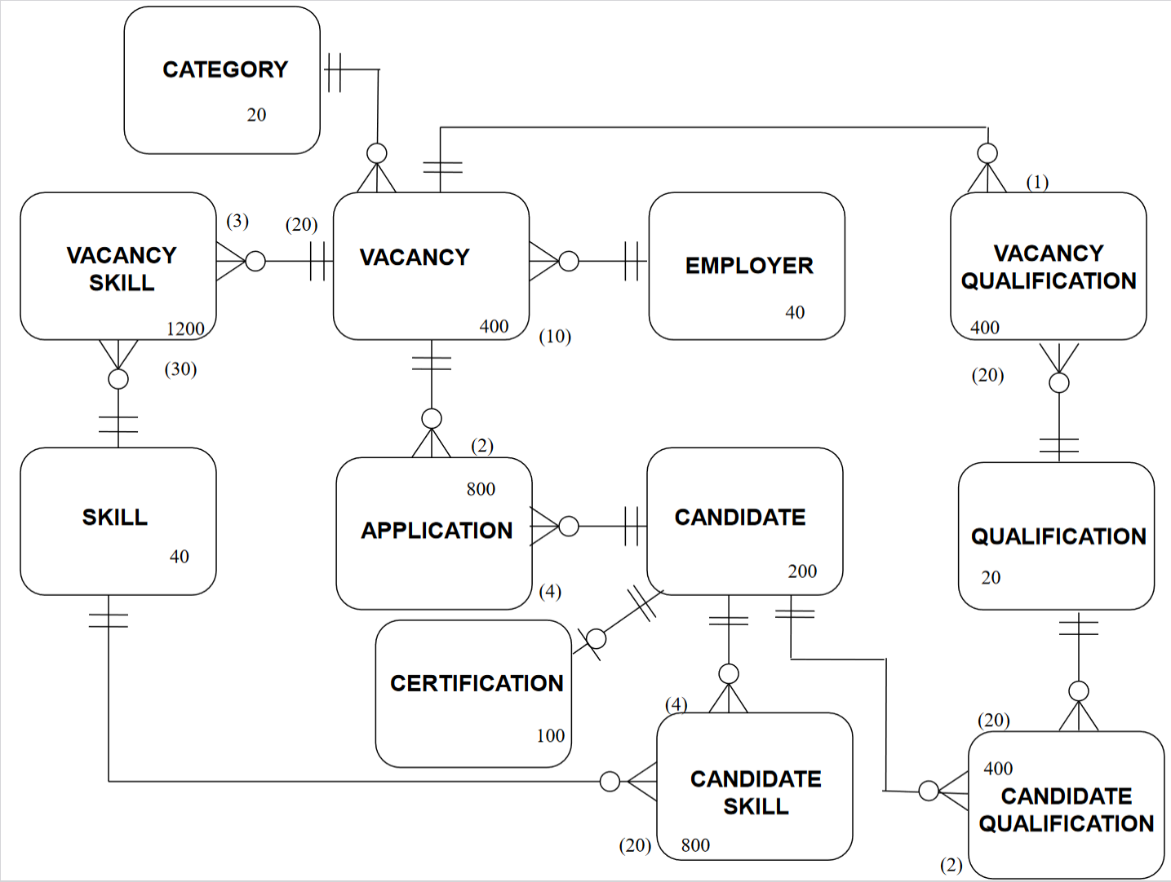

# Data Usage Map: All Vacancies Filled

# Data Usage Map: All Unfilled Vacancies with Candidates Interested.

# Business processes to physical design techniques matrix table using the business processes.

|  |  |  |  |  |  |  |  |
| --- | --- | --- | --- | --- | --- | --- | --- |
| Data Entity types  Business functions | One-one Relationship | One-many Relationship | Associative Entity | Duplication | Horizontal Partitioning | Vertical Partitioning | Indexing |
| 1.Enter, modify, or delete candidates. | Yes | Yes | Yes |  |  |  |  |
| 2.Enter, modify, or delete vacancies. | No | Yes | Yes |  |  |  |  |
| 3.Add or remove skills or qualifications to or from a candidate. | No | No | No |  |  |  |  |
| 4.Add or remove skills or qualifications to or from a candidate. | No | No | No |  |  |  |  |
| 5.Apply a candidate to a vacancy. | No | No | No |  |  |  |  |
| 6.Mark a vacancy as filled. | No | Yes | Yes |  |  |  |  |
| 7.All filled vacancies. | No | Yes | Yes |  |  |  |  |
| 8.All unfilled vacancies. | No | Yes | Yes |  |  |  |  |
| 9.All unfilled vacancies with candidates interested. | No | No | No |  |  |  |  |
| 10.Vacancies by Category. | No | Yes | No |  |  |  |  |
| 11.Vacancies by Employer. | No | Yes | No |  |  |  |  |
| 12.All Candidates. | Yes | Yes | Yes |  |  |  |  |