**Hackathon Challenge: In-Depth Hospital Data Analysis**

**Cleaning:-**

**We clean data column wise.**

**Name- In this column, firstly correct all patient name using Proper function.**

**Date Of Admission-format all the column in date format. Then I insert new column and that column name Month. By using text function we extract month from data of admission column.**

**Present In Hospital-difference between Date Of Discharge-Date of admission.**

**1. Optimal Month for Admissions and Revenue Calculation**

**Objective**: Determine which month had the highest number of patient admissions. Compute the total billing amount generated in that month. Consider all nuances such as the number of patients admitted and the billing amounts.

Solution- From Eda, August month has highest number of patient admission.in the august month , 122.7M is billing amount.

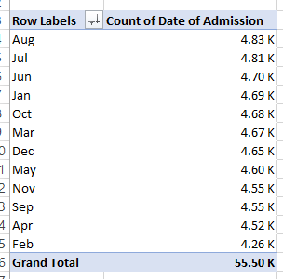 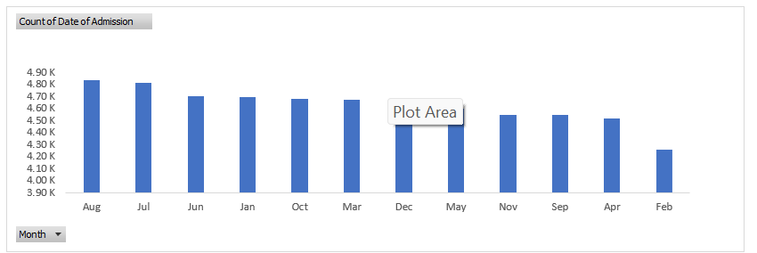

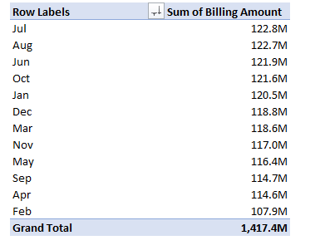 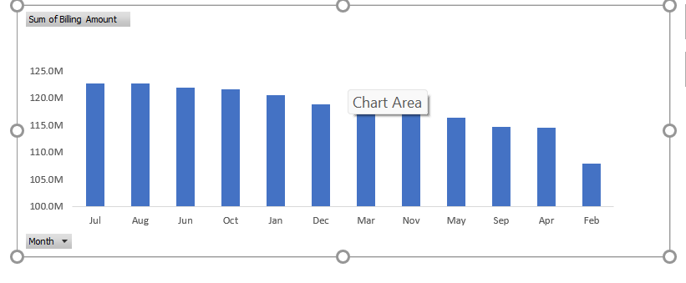

**2. Top Performing Hospital in Patient Volume**

**Objective**: Identify the hospital that recorded the highest number of admissions. Aggregate admission data based on the hospital information derived from the dataset. Ensure you handle potential issues such as hospitals with similar names or formatting inconsistencies.

Solution-From Data analysis, LLC Smith(44) is best performance hospital in terams of patient volume.

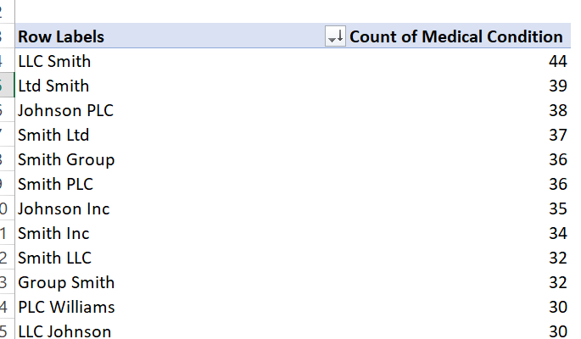

**3. Optimal Time for Medical Staff Availability**

**Objective**: Analyze the data to suggest the best time for medical staff to be most available to handle new patient admissions. Consider patterns in admission times and calculate the optimal time window for staff availability. Justify your recommendation with relevant data insights.

Solution-From analysis, firstly we calucaute no of discharge and no of admission in every hospital. We substract from no of discharge to no of admission in every hospital.then we analysis best optimal time that is the minimun which is the bet.

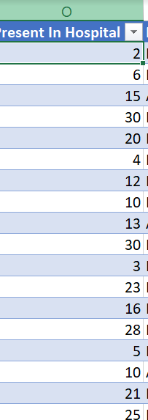

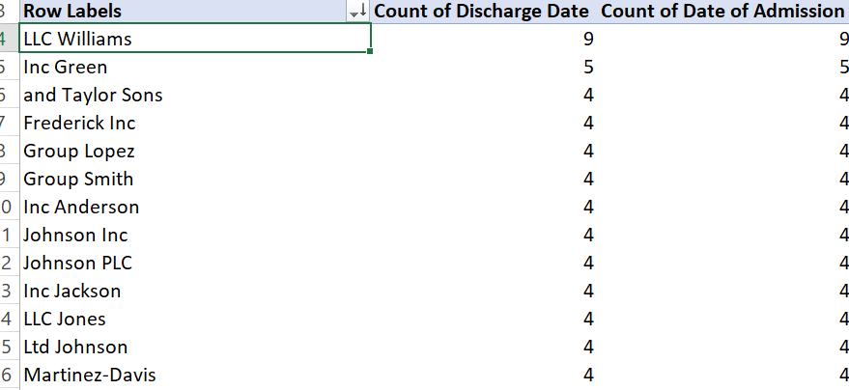

**4. Common Medical Condition and Medication Pairings**

**Objective**: Investigate which medical conditions and medications are most frequently paired together. This involves analyzing admissions to find common pairings of medical conditions and medications. Focus on identifying patterns and the significance of these pairings in patient treatment.

Solution-from data analysis, Lipitor ke cancer is the pair of medical conditions and medications.

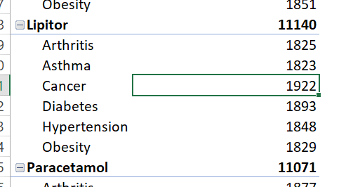

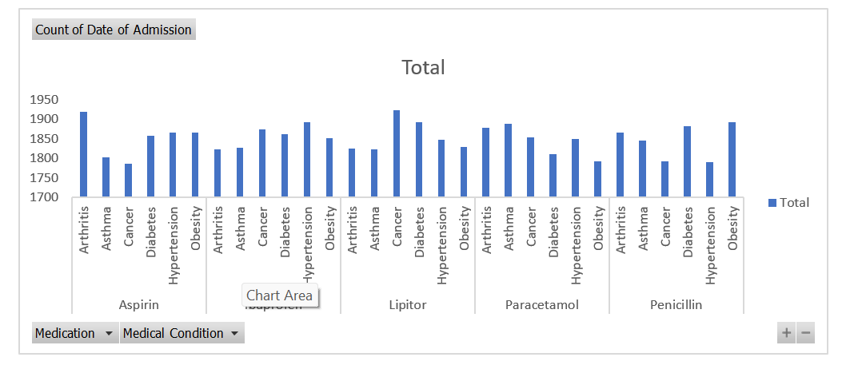

**5. Most Expensive Medical Condition and Hypothesis on Costs**

**Objective**: Determine which medical condition had the highest average billing amount. Provide a reasoned hypothesis for why this medical condition might incur the highest costs, taking into account factors such as the severity of the condition, the required treatment complexity, or length of hospital stay.

Solution-from data analysis, we conculuded as Diabietic has the highest billing amount.

