

MERN-IV

Problem Statement-4: How It Works

Table of Content

1

**PREREQUISIITE**

1.1

Client Framework

1.2

API

1.3

Database

2

**PROJECT STRUCTURE**

2.1

UI

2.2

API

3

**SCREENS**

3.1

UI

3.2

DATABASE

4

**Thank You**

**Prerequisite**

1. Node latest and stable version should be installed.
2. VScode should be installed.

**Folder Structure**

**UI**

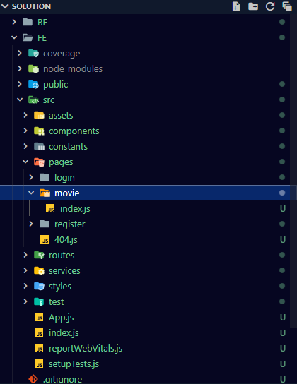

**API**

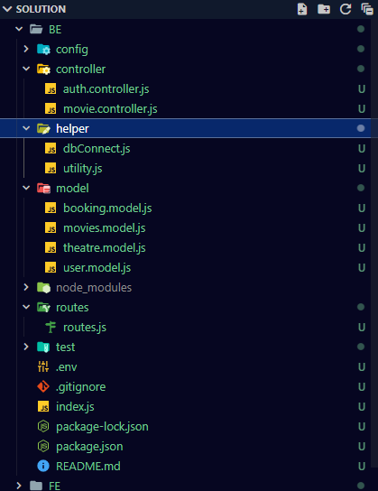

**Database**

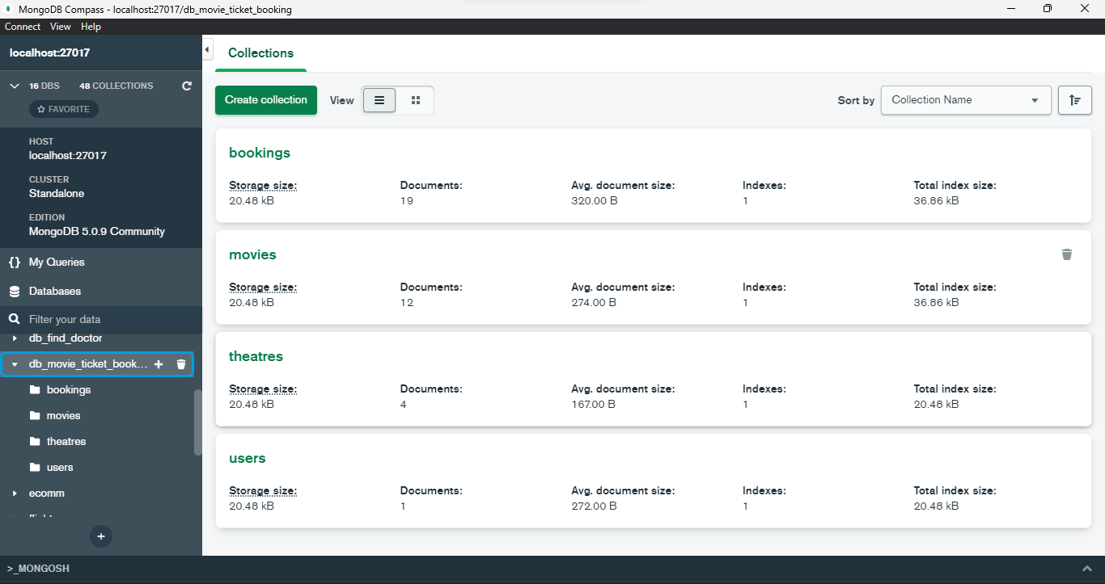

**Project Execution**

**Database**

1. Download mongodb data tools for restoring data in local.

Follow the steps in the documentation given below for installing mongodb data tools.

<https://www.mongodb.com/docs/database-tools/installation/installation-windows/#installation>

1. Unzip mongo-backup.zip folder present in the project folder.
   1. Open command prompt in the extracted folder and execute the command below

mongorestore –d db_movie_ticket_booking ./db_movie_ticket_booking

**API**

1. Open project in VScode
2. Change directory to BE, execute the command below
   1. cd BE
3. Execute below command
   1. npm i - install this package (one time)
   2. npm start - to execute API project

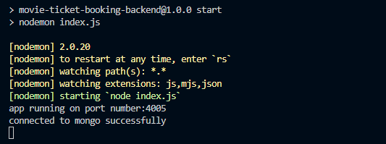

**UI**

1. Change directory to FE, execute the command below
   1. cd FE
2. npm start - to run UI project

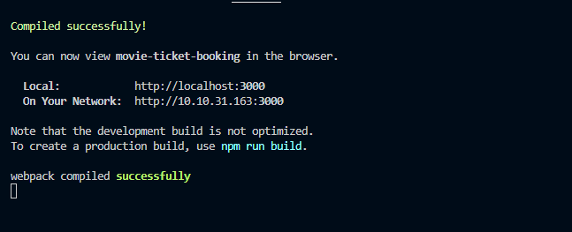

1. Open browser with Project URL: **http://localhost:3000**

**Project Execution Screens**

**UI**

1. Login Screen.

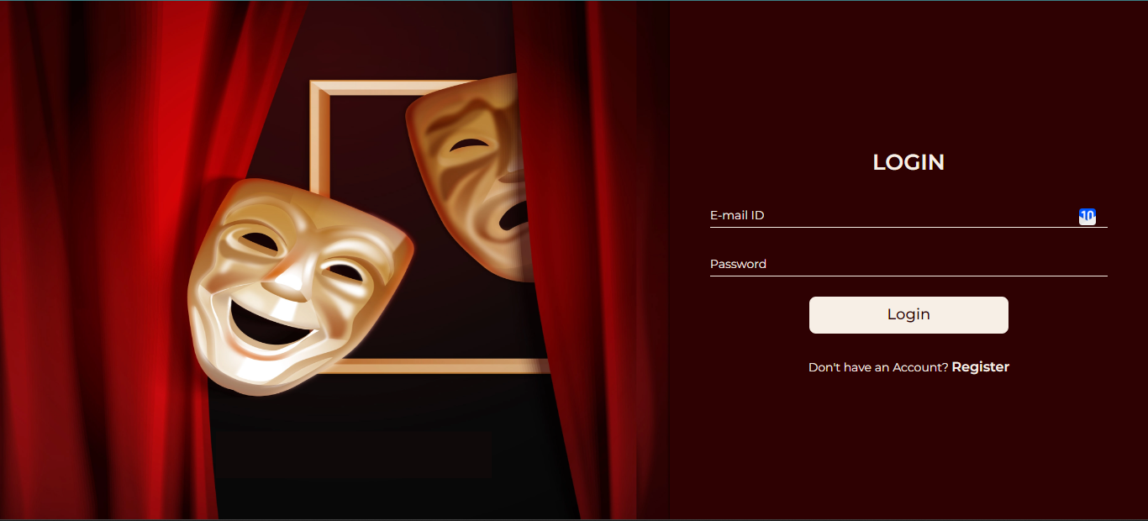

2. Register screen.

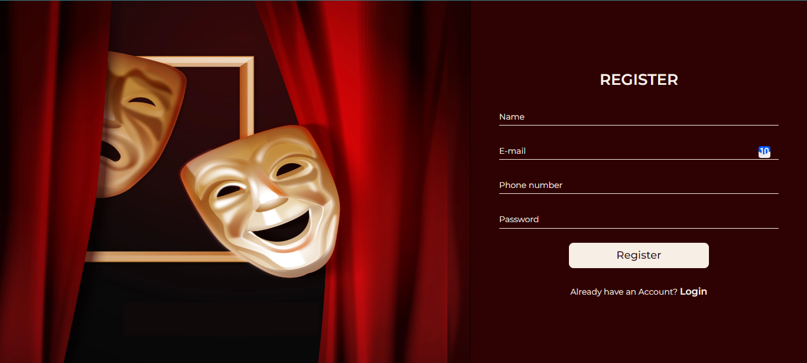

3. After login, movie screen.

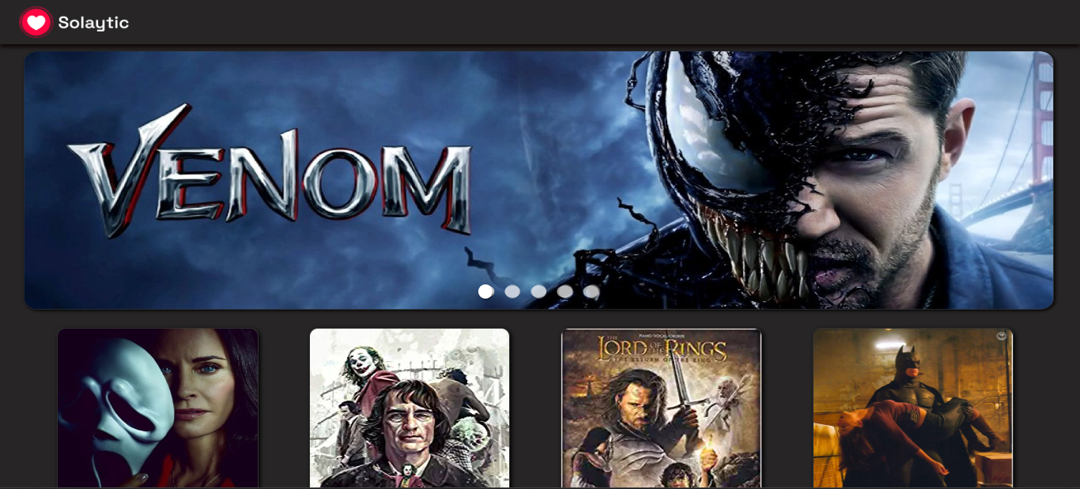

4. Click on Book Now to open select date, time, seat, and theatre.

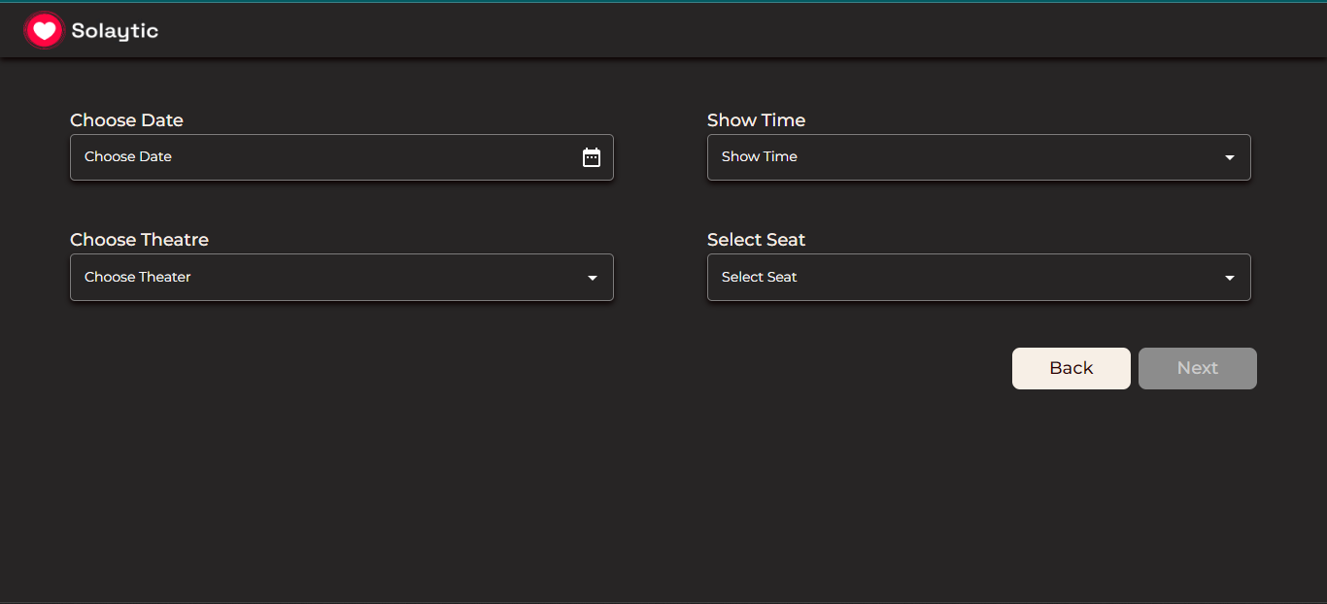

5. Click on next button for payment screen.

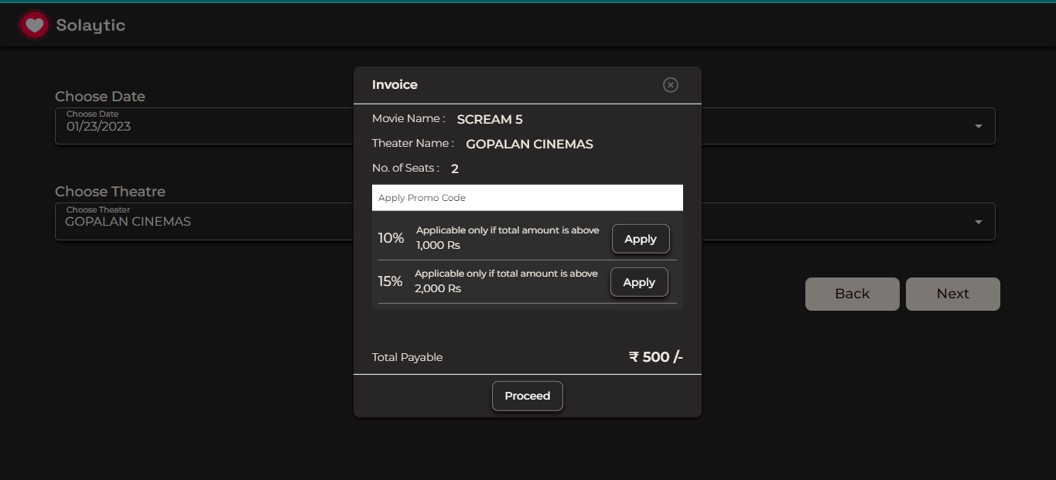

5. Click on proceed button for book movie.

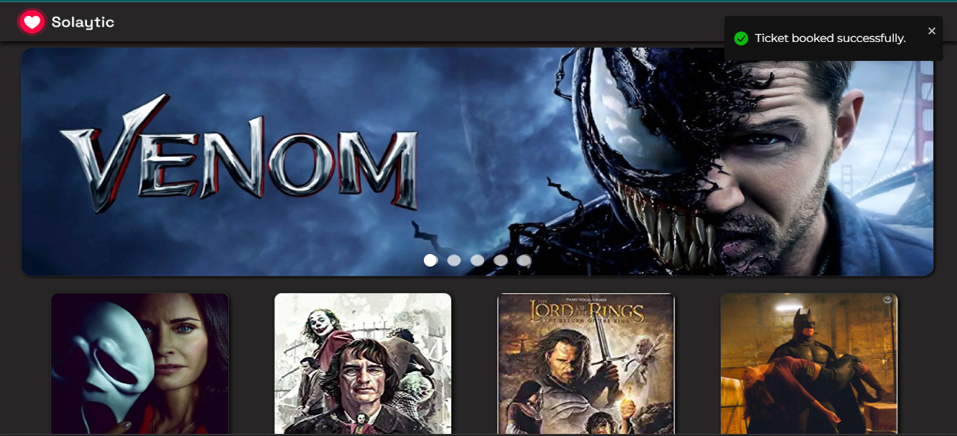

**Database**

1. Users Collection

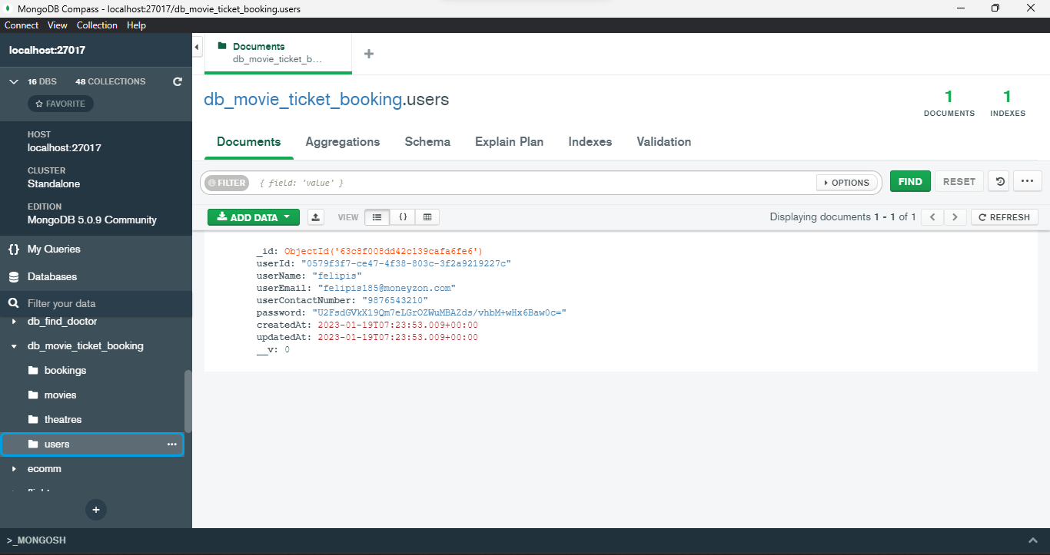

2. Movies Collection

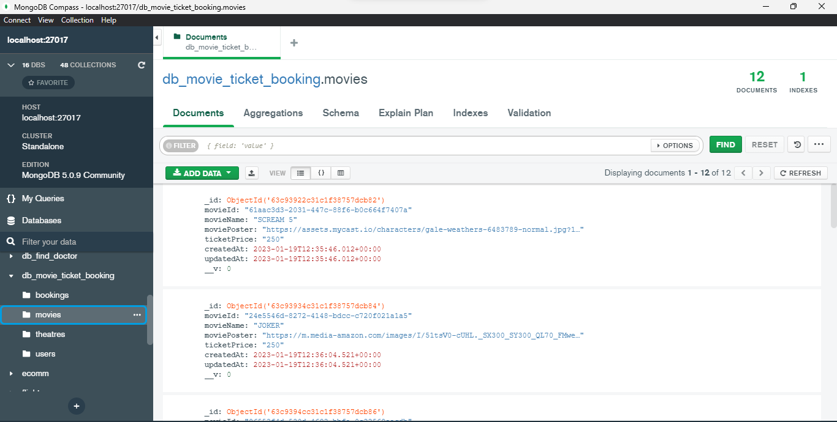

3. Theatres Collection

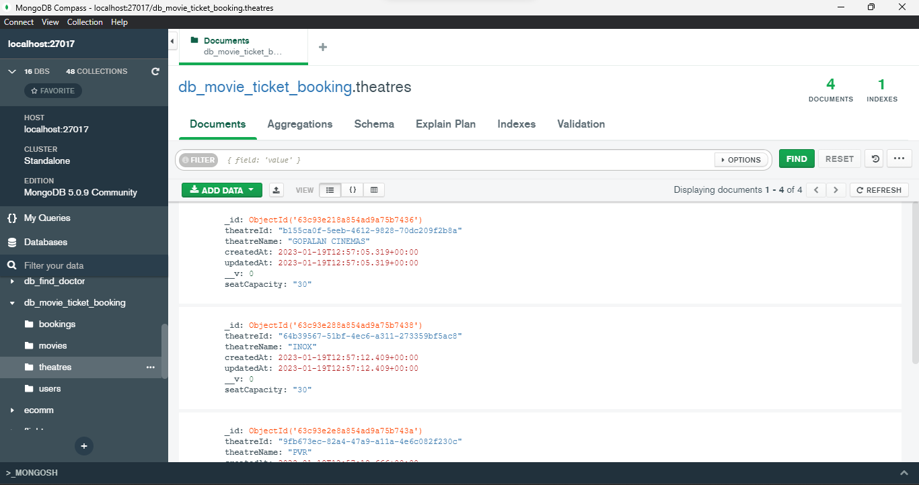

4. Bookings Collection

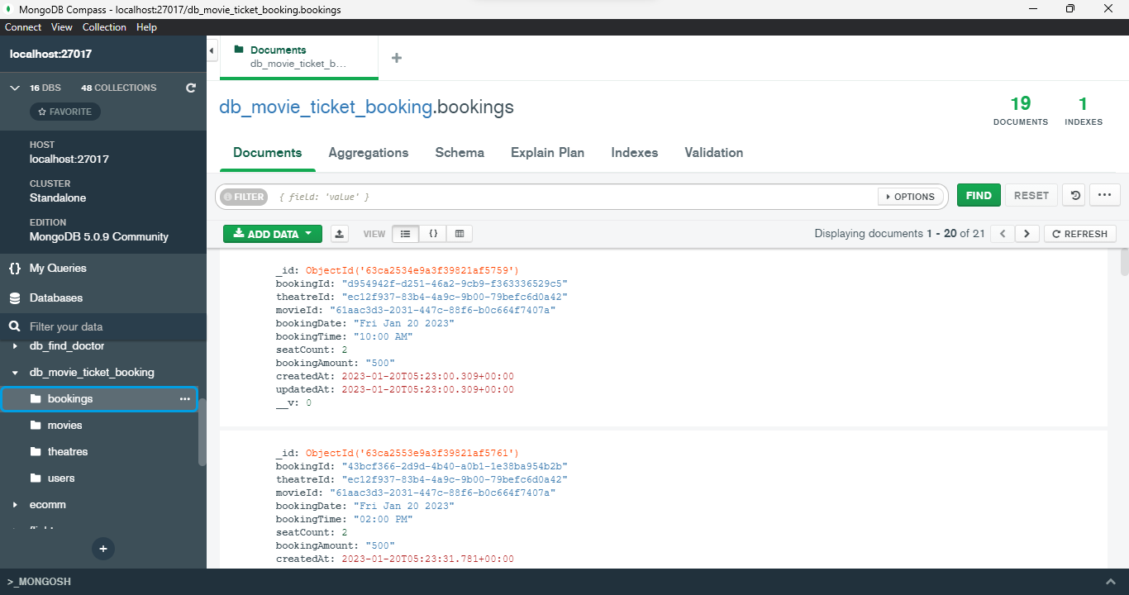

**Thank You**