# 1. Overview

This system supports the following functionalities:

* Survey Creation & Design
* Assign Survey to Users
* Conduct Survey

## Survey Creation & Design:

Creating and designing templates for surveys (e.g. AoR, Mowp, & Confirmation) with structured questions. Only admin shall able to do this.

The survey creation process leverages the following tables:

**TemplateParent:**

This table stores the metadata of the survey templates, including its Title, Code, and TemplateTypeId.

Example Use:

A survey titled “Interim – ST MOWP Test New 0910 – MoWP – US (PCAOB)” is stored here with an alias name and a reference to its type (TemplateType).

**TemplateVersion:**

Each survey can have multiple versions. This table manages these versions and their statuses (e.g., Draft, Published).

Example Use:

A survey version “V1.0” is associated with the parent template and has a Caption and Description explaining the changes.

**TemplatePanel, TemplateSection, and TemplateField:**

These tables define the hierarchy of the survey template:

Panels: Logical grouping of sections.

Sections: Grouping of fields within a panel.

Fields: Individual survey questions or inputs.

Example Use:

A section labeled “Demographics” might contain fields like "Age" (text field) or "Gender" (dropdown).

**TemplateType:**

Stores the type of survey, such as “AoR,” “Mowp,” or “Confirmation.”

Example Use:

A survey of type “Mowp” will reference a type ID here.

## Assign Survey to Users:

TBD

## Conducting Survey:

Allowing users to view the questions, provide responses, & save their survey progress for pausing and resuming later.

Submission: Finalizing and submitting the completed survey for processing.

# 2. System Components

#### a) Frontend Interface

User-friendly forms for survey interaction.

Buttons and messages for actions like saving, loading, and submitting.

Review and confirmation dialogs.

#### b) Backend Infrastructure

Database for storing surveys, user data, responses, and metadata.

APIs for data retrieval and submission.

Authentication and session handling mechanisms.

#### c) Workflow Logic

Step-by-step process handling user interactions (e.g., creating, saving, loading, and submitting surveys).

# 3. Detailed Workflow

## Step 1: Survey Creation & Design

Objective: Create a structured template for the survey to define the question types and flow.

Key Components:

Header Section: Title, introduction, purpose, and instructions.

Body: Questions grouped into sections with logical flow.

Types:

Closed-ended: Multiple choice, Yes/No.

Open-ended: Free text for qualitative data.

Footer: Save and submission button.

Storage:

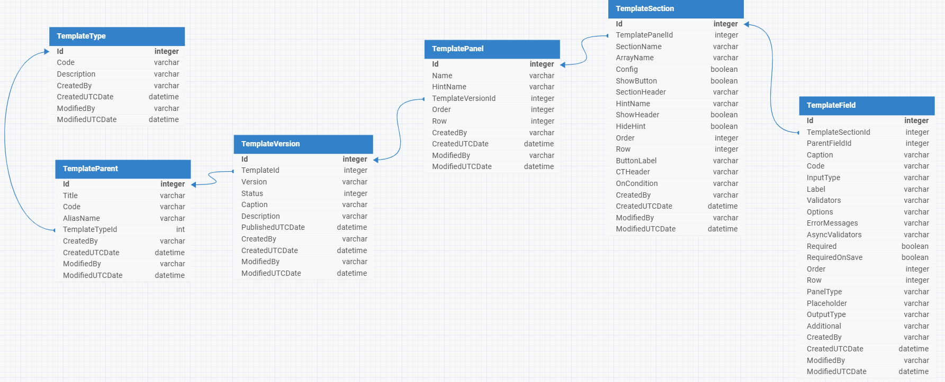

## Step 2: Assign Survey to Users

TBD

## Step 3: View & Save Survey

Objective: Allow users to view and save their progress, enabling them to pause and resume.

Process:

* As users fill out the survey, responses are saved in a database.
* When the user clicks "Save":
* Save current responses along with metadata (e.g., timestamp, user/session ID, and current question).
* Provide a confirmation: “Your progress has been saved.”

Storage:

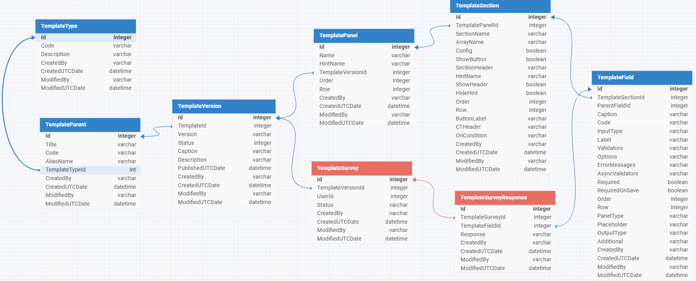

## Step 4: Loading Previously Saved Progress

Objective: Load saved survey responses so users can continue or review progress.

Process:

* When user reopens the survey.
* Retrieve saved responses and metadata from the database.
* Pre-fill the survey form with retrieved data.
* Navigate to the last saved question or section.
* Provide a confirmation message: “Your progress has been loaded.”

## Step 5: Submitting the Completed Survey

Objective: Finalize and record survey responses for processing.

Process:

* When the user clicks “Submit”:
* Validate that all required fields are completed.
* Highlight incomplete fields, if any, and prevent submission.
* Display a summary of responses for review.
* Upon confirmation:
* Save responses in the TemplateSurveyResponse table.
* Mark the survey as “Completed” in the TemplateSurvey table.

# 4. End-to-End User Journey

**Start the Survey:**

User accesses the survey and begins filling out responses.

**Save Progress:**

User pauses the survey and clicks “Save”

System saves responses and metadata in the database.

**Resume Survey:**

User reopens the survey from the dashboard or link.

The system retrieves and pre-fills saved responses, allowing continuation.

**Submit Survey:**

User completes the survey and clicks “Submit.”

The system validates, saves finalized responses, and confirms submission.

# 5. Technical Details

Survey Creation & Design:

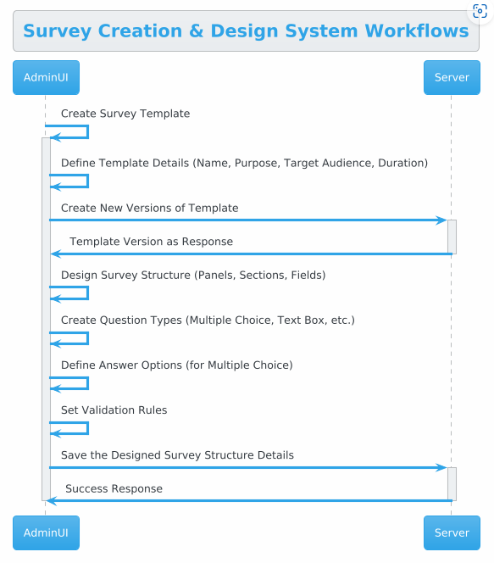

Conduct Survey:

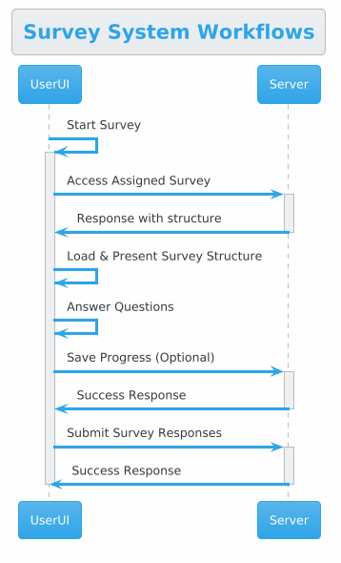

## Server side:

### DB Script:



### Data Model:



### Controller:



## Angular Client:

A Generic component for AoR, MoWP & Confirmation, which will pull the survey records and display corresponding template version’s panels, sections, and fields.

### Component:



### Models:



### Service:



