**Bloomberg Trading Challenge**

MBA-2018/19

Student Id: U1824083,U1831176,U1829443

**Executive summary:**

Bloomberg trading report throws light on the trading for a particular client by elite traders. The initial investment with £150Mn with an investment objective to maximise the capital, gain decent return on investment in short duration to maximise the income on the investment. Report highlights investment strategy that was adopted by the Elite traders with a diversified portfolio trading in major securities of different sectors with their equities. The portfolio has been developed to aim. Return of 3% to 6% return on the investment. The client and Trader have aggreged on the trading agreement of standard deviation of 3% +/- form the principle amount. The portfolio is created by applying diversified techniques on different securities which includes fundamental analysis like PESTLE analysis, Proters5 force competitive analysis and SWOT analysis with technical analysis such as analysing different factors such as Return on capital, return on investments, Earning per shares, Capital turnover, Profit/Earnings ratios. Etc. the trading has resulted with a negative 3.08% return. The main reason behind the negative return was different external factors mostly political uncertainty in London due to Brexit and in USA due to US-china trade war has affected the share prices and its declined. Another reason was high leveraged securities has ended up in loss which occupies the high weightage of the investment has led to the negative portfolio return. however, the portfolio returns in under agreed terms and most of the investment decision

|  |  |  |
| --- | --- | --- |
| **Sr. No** | **Table of Content** | **Pg. No** |
| 1 | Executive Summary | 1 |
| 2 | Introduction | 3 |
| 3 | Investment Objectives | 3 |
| 4 | Investment Strategy | 4 |
| 5 | Portfolio management, Valuation, Trade strategy | 4 |
| 6 | Portfolio Analysis | 5 |
| 7 | Portfolio Information | 6 |
| 8 | Trade Idea Analysis | 9 |
| 9 | Conclusion | 16 |
| 10 | Bibliography and References | 17 |

**Introduction:**

# The current portfolio management report outlines different trade ideas chosen for one of the clients of elite traders with 150Mn £ short term trade. Key understanding of the investment decisions, objectives, selection of different investment strategy is highlighted in the report. Portfolio analysis and evaluation is carried out highlighting different strategy is done on different securities. Securities are evaluated against different fundamental analysis using models like PEST analysis, porters5 force analysis, combines SWOT analysis, supplier network analysis. Also, technical analysis of each security is done in the report.

# **Investment objective**

| Objective | Description |
| --- | --- |
| Capital maximization | The main objective behind this investment is maximise the capital that is available to invest in different securities and investment. Low risk securities are preferred for investment. |
| Income growth | Get the share market investment to gain income growth in terms of share difference. Getting the available fund for investment and getting return on it. |
| Growth | Growth associated with the principle value that is invested to grow up to some percentage in value. |
| Trading Profits | Developing different trading strategies that actually work with the growth of the investment from shorter time span. |
| Speculation | Assumptions of higher risk higher return and investing the capital in order to gain a decent return on their investment. |

# Investment objective includes client’s satisfaction with the service that is provided by Elite traders by managing their portfolio with expectation of portfolio return from 2% to 15% depending on the time for trade and risk endurance. For the current client their portfolio deal is with the return of 3% to 6% on the portfolio with the variance of risk with 3% deviation to the principle amount which is +/- with respect to the portfolio returned agreed on. This means that by any chance if the portfolio ends up in negative figure, the worst figure of total return will be negative 3% to 6%.

# **Investment strategy:**

# An investment strategy is what gives path to the investors for different trade actions they are going to carry out during the trading period. it includes consideration of different types of factors such as tolerance to what level of risk for the portfolio, the capital management. investment strategy can be for long term and short term. (Portfolio selection H Markowitz - The journal of finance, 1952 - Wiley Online Library)

# For long term investment most of the time bonds market are selected, investment is done in mutual funds and other business. while mostly for short term strategy the investment is done sin stock markets and equity where the risk is higher but so does the return. The current client analysis of Elite trader has got 150Mn £ investment to be done for a short-term period which expect good return at moderate risk. Elite traders have decided to create a portfolio for short term investment which includes investment in stocks and equity for different securities using Bloomberg trading platform.

**Portfolio management:** portfolio management means management of the portfolio that has been created for the investors by the portfolio or fund manager. Successful portfolio management implies with good return on investment or aggreged return on investment.

(Optimal investment strategies and risk measures in defined contribution pension schemes

S Haberman, E Vigna - Insurance: Mathematics and Economics, 2002 - Elsevier)

**Valuation:** Portfolio valuation Is done against the different parameters that are currently going on in the market. different factors like bank ARP, ROI of different business in the market that has investment options are evaluated. current rate and terms like Net present value of the investment against the return is carried out and hence the portfolio return is justified for the chosen timeline.

**Short and long trading:** Long trade strategy means buying shares with the prediction that the share price will increase and eventually the shares will be shared on the increased share price in the future for gaining profit.

Short trade strategy is firstly selling the shares before buying them. Sell the shares at low price and predict that the price of the share will go down. The rebuying of the share at lower price to make profit.

**Portfolio Analysis:**

Portfolio that was proposed to the client was well diversified using different securities across different index such as S&P500, LSE, FTSE100, NYSE, NASDAQ. the more the portfolio is diversified the more the distribution of the risk is attended. Currently in due to external political factors such as Brexit and US-china trade war investment in stock market of both London and Ney York has become volatile. Also, the GBP to USD rate has also become more stubble. Investment in USD will reduce risk for the client irrespective of the conversion rate as Sterling pound is at highest declined due to Brexit. This resulted in future bad quarter for all major companies under LSE at risk and the investment more risker therefore it is better to transfer the risk within different stock market investment. The portfolio over the time did well however it ended up in low return. The clients expected portfolio return was 3% to 6% expected return with moderate risk trading strategy under the portfolio.

**The portfolio information:**

**Portfolio: Fn7230T3Elite Traders**

**Start Date: 7/31/2019**

**End Date: 8/28/2019**

**Currency: GBP**

There were different trades positions which were opened in total of 12 long position and 2 short position in different industries.

The portfolio is diversified into different industries and sectors. Above 50% of the portfolio weightage is with consumers discretionary and communication service. While the rest is distributed between the IT, industrials, consumer staples, energy and health care sector.

However, the total return of the portfolio unexpectedly turned out to be negative 3.08% of the total investment.

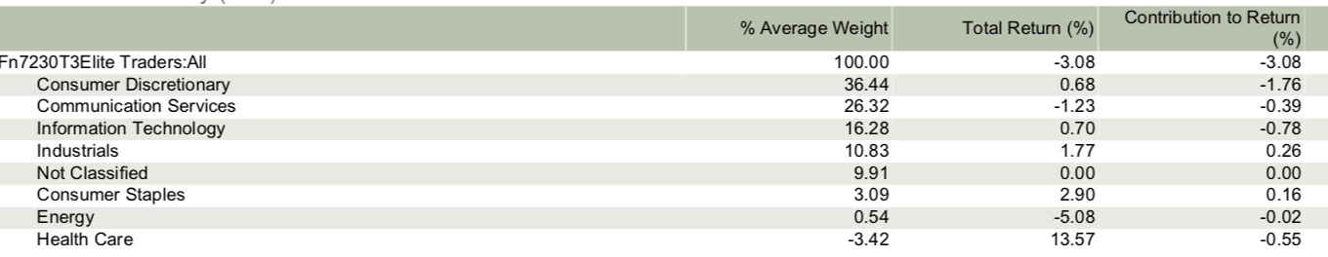

**Portfolio diversification:**

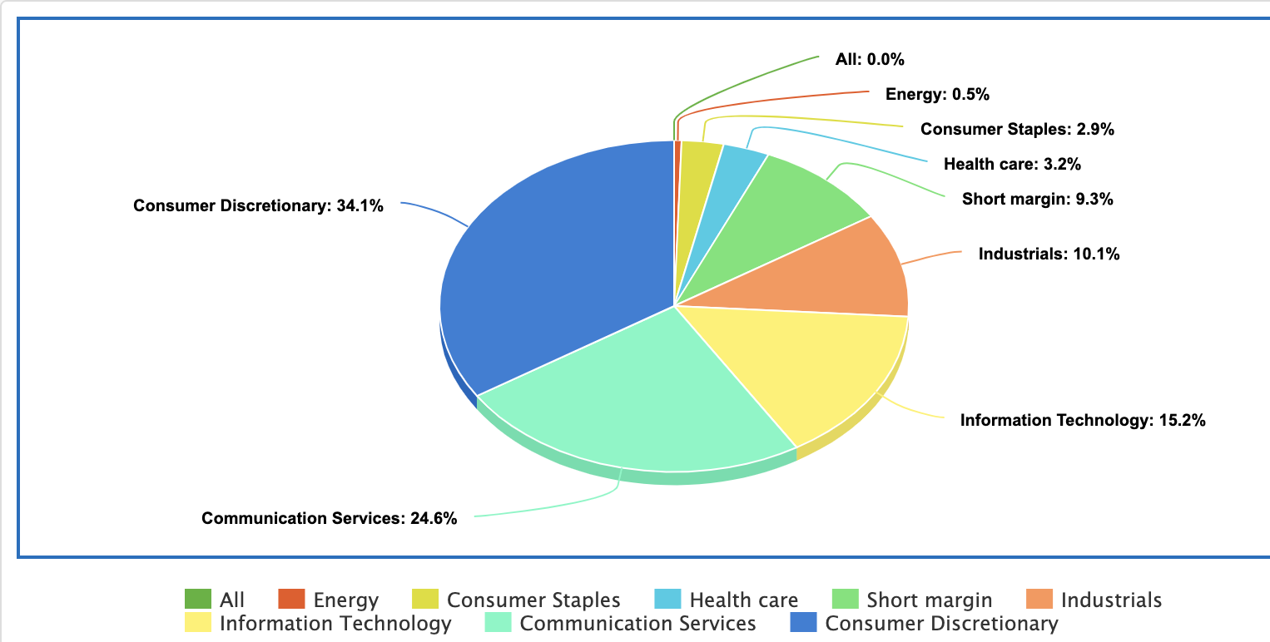

**Detailed portfolio performance:**

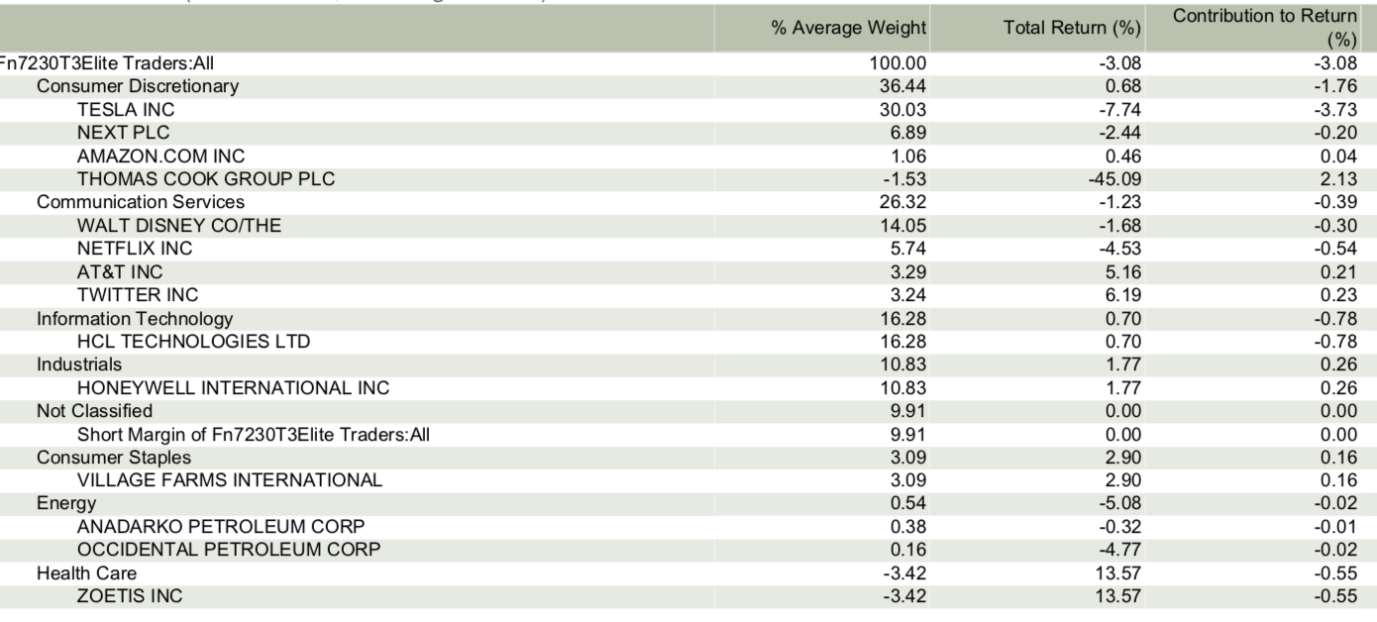

Diversified portfolio suggest that majority of the higher weighted firms led to loss which was the main reason behind the negative portfolio return. Individually some sectors have done excellently well as per the predictions but due to lower portfolio weightage the impact on the overall return is less which eventually turn down the portfolio. The diversification Is however strong and sufficient enough to justify the trade and investment. To study the performance analysis in detail let’s have a look at detailed reason for some of the major trade decisions. Fundamental analysis and technical analysis is done of major trade section which resulted in the trading decisions.

**Trade Idea Analysis:**

**Top 20 trade return firm and its impact are as shown in the table below:**

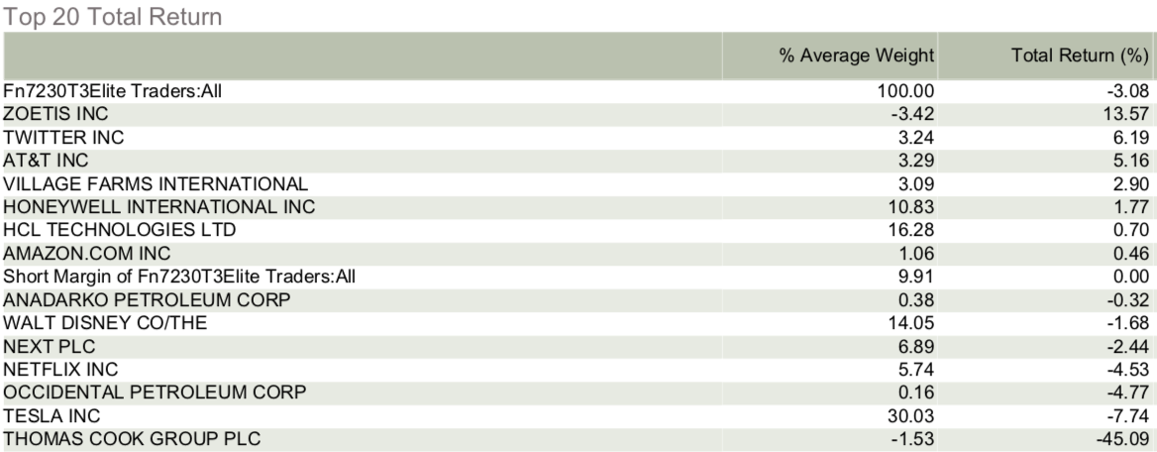

**Twitter INC:**

Twitter is one of the widely used platforms for social media tweets. over the time the industrial analysis showcases that internet industry has boom over last decade which and twitter has been one of the proven leaders in social media and information industries. strong customer base which includes major political interest in politicians tweeting about their future strategies has accelerated its importance over the time. Technological enhancement has made it more user friendly and they have monetised their business model pretty well.

Technical analysis shows that their they have strong P/E ratio which is 47.82 which makes the investment better. also, their capital growth is 39.3% PY and their current revenue growth is 24.5% which is quite competitive as per the porters % force analysis have suggested that there is a fierce competition in the internet and information industry specially in social media. Retention ration is 100% which shows good believe in the stakeholders in the firm which suggests growth. their ROE is 33.8% and with high capital growth their ROC is 24.6% which makes the technical analysis strong.

**Twitter trade details**

# 

The different purchase price was 40.66 and the closing price was 42.83 which makes the increment of 5.33% in the share price over 134,600 shares. This justify the contribution towards the expected portfolio return of 6.19% with weightage of 3.24 as long trade strategy.

**AT&T INC:**

Telecommunication industry is one of the largest growing industry as it is supported with the technological enhancement. PEST analysis shows that Technological innovation in the industry will lead the firms within the industry to grow. also, with the growth of US economy there is a huge growth in telecommunication infrastructure. porters 5 force analysis suggest that there is limited direct competition in the market as the new entrance and competition is very much difficult while buying and supplier bargaining power is low in the industry. SWOT analysis suggest that AT&T has very much grounds in the current global market which makes the firm stronger.

Technical analysis shows that its estimated P/E ratio is 12.81 which is high in the industry. ROE and ROC are also positive figures for such large firms in the telecommunication sector. at the same time the new launch of 5G technology has attracted most of the users more to buy and hence there is future forecasted revenue growth for the company. As AT&T is highly competitive, they also have strong political and US governments contracts which supports them. at the same time over the year in this disruptive technological changes AT&T has manged to constantly keep on increase in their share prices. which makes its suitable for investment.

# 

The different purchase price was 33.57 and the closing price was 35.15 which makes the increment of 4.70% in the share price over 163,162 shares despite cost of FX 0.82%. This justify the contribution towards the expected portfolio return of 5.16% with weightage of 3.29 as long trade strategy. The portfolio outperforms the index.

**Honeywell International INC:**

Companies whose fate is closely tied with the health of the economy generally underperform when risks to growth accelerate. But Honeywell International may be one of the few exceptions to that rule. Evidence of subsiding industrial activity is becoming more apparent across the board. New U.S. factory orders stagnated in June, while the JPMorgan Global Manufacturing Purchasing Managers Index posted its second straight contraction, the first time that’s happened since 2012, according to Bloomberg data. The U.S.-China trade war is nowhere near resolution. In the most recent quarter, its earnings per share grew 9%, while organic sales in its largest division, aerospace, rose 11%. With these strong numbers, Honeywell also raised its full year forecast and reported increased demand in most divisions. One of the largest industrial companies that makes Post-it’s to air filters and touch screens, reported both sales and profit fell, citing challenges ranging from high raw-materials prices to unfavourable foreign-exchange rates to headwinds in China. Honeywell’s shares, which closed yesterday at $169.59, are up nearly 30% this year and have doubled in the past five years. Some investors would see buying this name as a risky bet, especially with the economy in this late boom cycle. But we still see value in this trade and advise investors to take a long-term position. It’s hard to find an industrial stock which is as well-prepared as HON is to perform in the fast-changing economy.

# 

The different purchase price was 161.56 and the closing price was 165 which makes the increment of 2.20% in the share price over 112.767.70 shares despite cost of FX 0.82%. This justify the contribution towards the expected portfolio return of 1.77% however the weightage was 10.83 which Is major in terms of long trade strategy.

**Tesla INC:**

One of the most allocated weightage trade idea was Tesla which eventually occupies higher leverage. Short-change in the share price impact heavily on the portfolio return. the main reason behind selecting it was because it is predicted that Tesla will become a leading player in the more than $2 trillion global automotive industry and the recent negative concerns around the company create a great buying opportunity at the current share price. This 11-year-old American auto maker will likely become the largest auto maker globally by 2035 as Tesla has 1) an outstanding disruptive product portfolio that will drive consumer demand in the near-term, 2) a strong brand as an electric car manufacturer that will drive long-term revenue growth, 3) minimal competitive risk thanks to other disrupted legacy competitors’ inability to adapt from internal combustion engine (ICE) vehicles to electric vehicles, and 4) a competitive cost structure through vertical integration and little need for marketing, which will help Tesla reach above-industry-average margins.

However, the recent political factor which directly affected the import duties of different parts involving the semiconductors in the US, due to US- china trade war has affected the cost price and sales of the Tesla motors which directly affected the downfall of the company return on share. Tesla is one of the major reasons behind the negative portfolio return as it has high weightage.

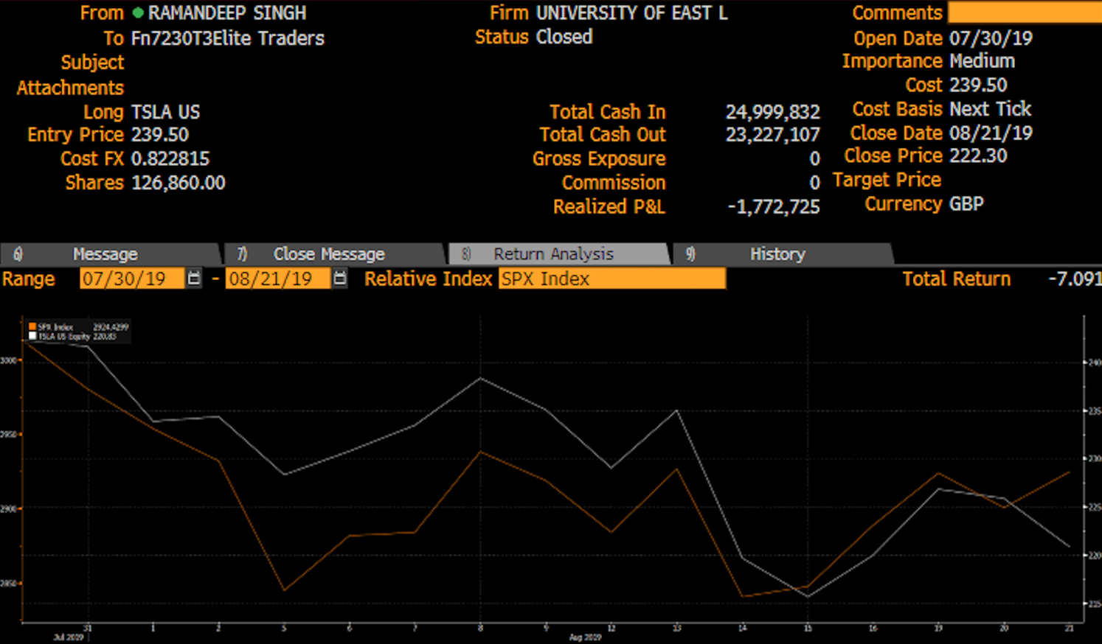

The different purchase price was 239.50 and the closing price was 222.30 which makes the decrement of 7.20% in the share price over 126,860 shares with cost of FX 0.82%. This justify downfall towards the contribution with negative return of 7.74% with high weightage of 30.03 which Is major in terms of long trade strategy.

**Zoetis INC:**

Portfolio also consists of short trade strategy which actually proved to be high as per the prediction. Zoetis INC is one of the largest growing companies’ developments, manufacturing and commercializing in animal health care. Over the time PEST analysis shows that there is hardly any external force affected the business over the years stock prices. but recent US has put lots of regulation on health care sectors which has affected the business badly. There has been a incremental in their stock price the last year. however, they got affected with several environmental international law changes which is directly going to affect their future share price.

Technical analysis suggest that they have a fair EPS which is 3.49 and Est P/E (12/19) is 32.86, this is very much decent figure in the respective industry. their current capital growth is 28.3 5 and ROC is 19.8% which makes a supportive prediction on companies forecast for growth. Due to heavy regulation of international laws and US health care taxes will definitely results in declination of stock prices for Zoetis which justifies the short strategy for this trade and gain higher real return. the average weightage over the time was -3.42 which resulted in 13.57% of contribution to the total return.

**Village Farm international:**

One of the most diversified trade was investing in this one of the growing Canadian firm to diversify the investment and mitigate the risk. One of the most emerging sectors is the sustainability sector. Environmental solutions and sustainability development is the current trend. village farms international has shown exceptional growth in the community growing and benefiting over the last year with a significance in their share price increasing and belief of their stakeholder’s support in the company has shown growth in the US. PEST and porters 5 analysis shows that environmental laws have favoured the company to reduce their competitors in the market as they support sustainable growth. at the same time there has been a content increase in the share prices over the year time. innovation and the dynamic culture that is constantly supporting the growth of the firm. also, technical analysis suggests decent figures such as estimated PE ratio which is 38% and ROE 3.9% and ROC 3.7%.

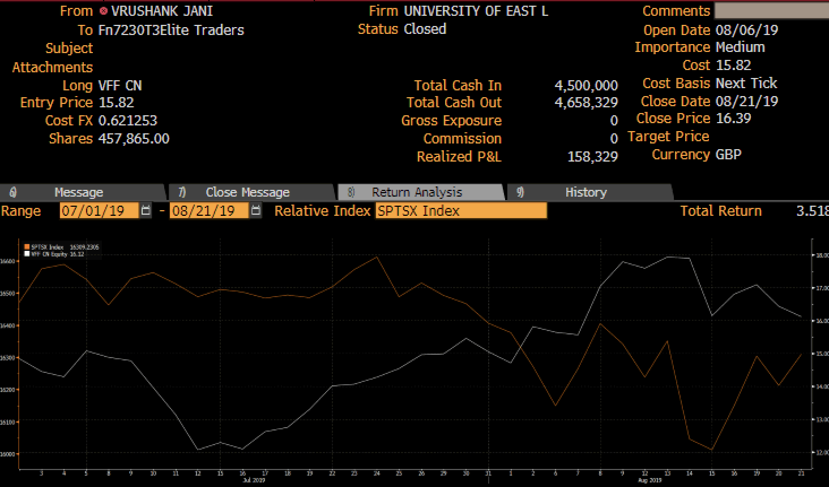

The different purchase price was 15.82 and the closing price was 16.39 which makes the increment of 3.60% in the share price over 457,865 shares despite cost of FX 0.62%. This justify the contribution towards the expected portfolio return of 2.90% however the weightage was 3.065 in terms of long trade strategy.

**Conclusion:**

From the overall perspective it can be concluded that the negative return of 3.08% on the portfolio was due to investment in stokes with high volatility and high leverage. Tesla Inc was one of the highest average weighted trade with 30.30% which resulted in negative return of 7.74%. External political factors and uncertainty is one of the major reasons behind the price downfall. The main reason behind the portfolio loss was trades with higher leverage and higher weightage went down which includes Tesla INC, Walt Disney and Next plc which was balanced against positive trade ideas such as Twitter INC, AT&T, HCL, Honeywell Technologies and Zoetis with combination of long and short trade ideas.

The overall performance and contribution weightage of the portfolio is as mentioned in the graph below. Which depicts that the major contributors resulted in major negative contribution. However, the risk of the portfolio is justified against the return as per the agreed term with 3% +/- deviation on principle amount which as the portfolio with the result of negative 3.08%.

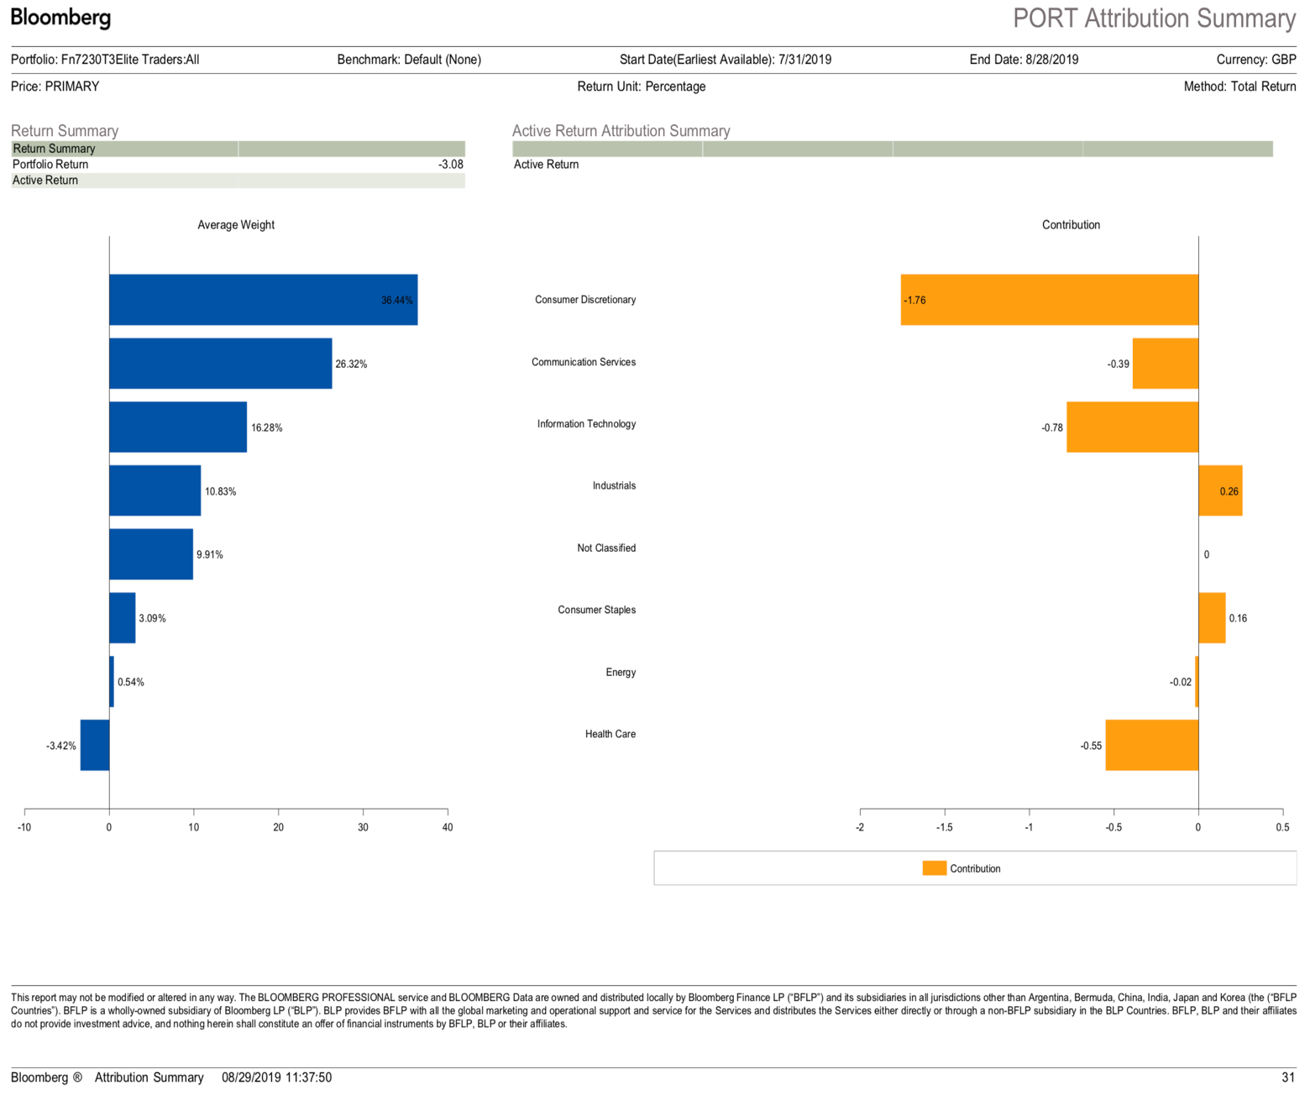

**Bibliography / Reference list:**

Portfolio selection H Markowitz - The journal of finance, 1952 - Wiley Online Library

Optimal investment strategies and risk measures in defined contribution pension schemes

S Haberman, E Vigna - Insurance: Mathematics and Economics, 2002 – Elsevier

Investment analysis and portfolio management

FK Reilly, KC Brown - 2002 - books.google.com

Pioneering portfolio management: An unconventional approach to institutional investment, fully revised and updated

DF Swensen - 2009 - books.google.com

Property investment: principles and practice of portfolio management

M Hoesli, BD MacGregor - 2014 - taylorfrancis.com

Integrated investment portfolio management system and method

W Baughman, R Hernandez, H Shethia… - US Patent App. 09 …, 2002 - Google Patents

The theory and practice of investment management: Asset Allocation, Valuation, Portfolio Construction, and Strategies

FJ Fabozzi, HM Markowitz - 2011 - books.google.com

**Portfolio Details and trading done on Bloomberg** [**www.bloomberg.co.uk**](http://www.bloomberg.co.uk)