**ReadMe - TAL Interview**

There are two folders

1. TAL [ Contains server application developed in dotnet core 5.0 and React JS]
2. MSTest [ Contains unit tests]

To run solution, open TAL.sln in TALTest folder and hit F5 or click debug [IIS Express]

This will launch browser with below screen

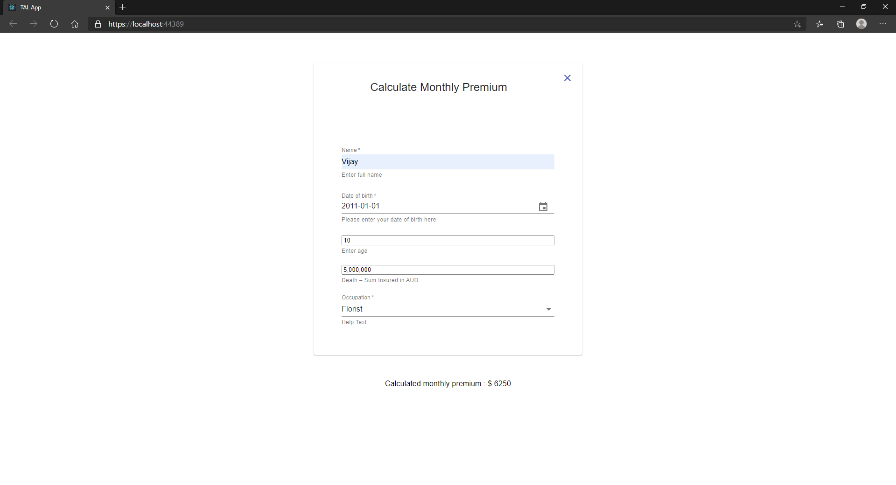

When all required fields i.e. Name, Age, BirthDate, Insured Sum are entered, Occupation control will get enabled. On selecting occupation, server will calculate monthly premium and will return result which will be displayed on screen,

In case of server error, message will be displayed on screen.

React JS application uses Formik and Yup for form validation.

Server side unit tests checks calculation and validation aspects.