OOLIX

Audience Builder & Data Partner Matching
MVP Change Specification v6
Buyer-defined audience rules -> Partner capability matching -> local reach estimation -> campaign approval -> local activation

Purpose of this document
This v6 change specification is designed to be handed directly to the development team already building from the v5 master specification. It changes the Buyer-side audience model. The old primary flow - browse Partner-published segments first - is replaced by a Buyer-led Audience Builder. This document supersedes the v5 Audience Discovery / segment-first workflow wherever the two conflict.

Version date: August 2026

Contents
1. Executive Product Change
2. New Canonical Buyer Journey
3. Canonical Product Objects
4. Standardized Audience Attribute Taxonomy
5. Data Partner Capability Publication and Mapping
6. Audience Builder - Buyer UX
7. Partner Compatibility Matching
8. Safe Reach Estimation
9. Campaign Linkage and Campaign Builder Changes
10. Data Partner Campaign Review
11. Local Audience Compilation and Materialization
12. Partner-Owned Web/App Runtime
13. Meta/Google External Activation Impact
14. API Contract Changes
15. Database / Migration Changes
16. States and Versioning
17. Privacy, Anti-Differencing and Policy Controls
18. Buyer and Partner UI Changes
19. Migration From Current Implementation
20. MVP Acceptance Criteria
21. Recommended Developer Sprint Change Plan
22. Developer Handoff Summary

1. Executive Product Change
Figure 1. New primary product flow.
The Buyer should not start by browsing a catalogue of Partner-created audience segments. The Buyer starts by describing the audience they want. Oolix then identifies which Data Partners can evaluate those requested fields, requests safe reach estimates from selected Partners, and links the final Audience Group to the campaign.
New core statement
Oolix knows the audience rule. The Data Partner knows which of its users match the rule. Oolix never needs the Partner's customer list to find compatible Partners or run Partner-owned media.

Old v5 primary model | New v6 primary model
Partner publishes 'Recent Travellers'; Buyer browses and selects it. | Buyer creates 'Shoe Shoppers' with age, shopping, payment and category rules; Oolix finds compatible Partners.
Segment catalogue is the starting point. | Audience Builder is the starting point.
Partner segment definition drives targeting. | Oolix standardized rule schema drives the request; Partner maps it locally.
Precomputed Partner segments required. | Partner standardized attributes are primary; prebuilt segments remain optional.

2. New Canonical Buyer Journey
- Buyer opens Audiences and clicks Create Audience.
- Buyer names the Audience Group and defines standardized conditions.
- Each condition is marked REQUIRED or OPTIONAL and may have a weight.
- Oolix compares requested attributes/operators with Data Partner capability metadata.
- Oolix shows compatible Partners and which fields each Partner supports or lacks.
- Buyer selects one or more Partners for safe reach estimation.
- Oolix sends the versioned rule snapshot to each selected Partner Agent; evaluation happens locally.
- Partner Agent returns only a reach bucket or BELOW_THRESHOLD / UNAVAILABLE.
- Buyer links the Audience Group to a campaign, or creates a campaign from the Audience Group.
- Buyer selects Partner/channel/placement/budget/creative.
- Each Data Partner receives its own campaign request including the requested audience rule and local reach estimate.
- Partner approves, requests changes or rejects.
- On approval, Partner Agent compiles and materializes the matching local audience.
- Partner-owned app/web ad decisions use local membership plus consent, frequency and pacing.
- Meta/Google, when enabled and eligible, use the same locally materialized approved audience.

3. Canonical Product Objects
Object | Purpose | Where stored
AudienceGroup | Reusable Buyer-defined audience intent, e.g. Urban Shoe Shoppers. | Oolix Cloud
AudienceRule | Standardized condition with operator/value and REQUIRED/OPTIONAL semantics. | Oolix Cloud
AttributeDefinition | Canonical taxonomy entry such as age or payment_method. | Oolix Cloud
PartnerCapability | What standardized attributes/operators a Partner can evaluate. | Oolix Cloud metadata only
PartnerAttributeMapping | Partner-local mapping from Oolix attribute to local view/API field. | Partner local
PartnerMatchSnapshot | Versioned compatibility result between Audience Group and Partner. | Oolix Cloud
ReachEstimate | Safe bucket returned by a Partner for one Audience Group version. | Oolix Cloud metadata
AudienceMaterialization | Local compiled membership set for an approved activation. | Partner only
CampaignAudienceLink | Links campaign to one Audience Group version. | Oolix Cloud
PartnerRequest | Partner-specific campaign approval request. | Oolix Cloud
Activation | One Partner + one channel execution path. | Cloud + Agent state

MVP simplification
Use one Audience Group per campaign in the first MVP. A join table can still be used so multiple audience groups can be supported later without a destructive migration.

4. Standardized Audience Attribute Taxonomy
Buyers must never write SQL or arbitrary database expressions. They build audiences using an Oolix-controlled taxonomy. Every AttributeDefinition declares a data type, supported operators, validation rules, policy class and display metadata.
Category | Example attributes | MVP operators
Demographic | age, gender | BETWEEN, EQ, IN
Geography | country, state, city, region | EQ, IN
Commerce | online_shopper, purchase_category, purchase_recency_days, purchase_frequency | EQ, IN, LTE/GTE, BETWEEN
Payment behaviour | payment_method | IN
Travel | recent_booking, domestic_international, booking_recency_days | EQ, IN, LTE/GTE
Engagement | active_user_days, app_active, loyalty_tier | LTE/GTE, EQ, IN

{
"attribute_key": "payment_method",
"display_name": "Payment method",
"category": "PAYMENT_BEHAVIOUR",
"data_type": "ENUM",
"operators": ["IN"],
"allowed_values": ["UPI", "CREDIT_CARD", "DEBIT_CARD", "COD"],
"policy_class": "GENERAL",
"version": 1
}
- Do not enable highly sensitive classes in the MVP without explicit legal/policy design.
- Attribute taxonomy is versioned. A campaign request binds to the exact taxonomy/rule version approved by the Partner.
- Partner can support an attribute without exposing its internal field name or raw values.

5. Data Partner Capability Publication and Mapping
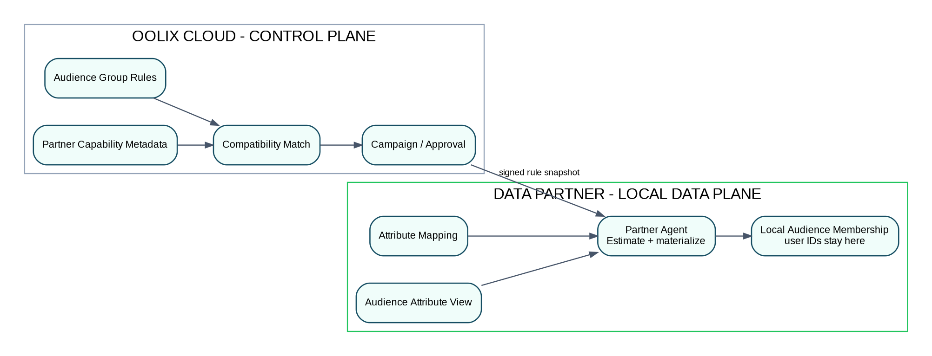
Figure 2. Capability metadata is central; customer fields and membership remain local.

5.1 Partner publishes safe capability metadata
{
"partner_org_id": "org_partner_a",
"capability_version": 4,
"attributes": [
{"attribute_key":"age","operators":["BETWEEN"],"status":"AVAILABLE"},
{"attribute_key":"gender","operators":["IN"],"status":"AVAILABLE"},
{"attribute_key":"online_shopper","operators":["EQ"],"status":"AVAILABLE"},
{"attribute_key":"payment_method","operators":["IN"],"status":"AVAILABLE"},
{"attribute_key":"purchase_category","operators":["IN"],"status":"AVAILABLE"},
{"attribute_key":"purchase_recency_days","operators":["LTE"],"status":"AVAILABLE"}
],
"geographies":["IN"],
"channels":["PARTNER_WEB","PARTNER_APP","META"],
"updated_at":"..."
}

5.2 Local-only mapping
Oolix attribute | Partner local source example | Central?.
age | derived from dob | No
gender | sex_code | No
payment_method | pay_mode | No
purchase_category | product_class/category_code | No
purchase_recency_days | derived from last_order_at | No
online_shopper | derived/materialized boolean | No

Recommended Partner integration
Do not dynamically join a large transactional production schema for every estimate or ad request. The Partner should expose a restricted Audience Attribute View or internal audience API/materialized table that the Agent is allowed to query.

6. Audience Builder - Buyer UX

6.1 Navigation
Dashboard
Campaigns
AUDIENCES
Audience Groups
Create Audience
ASSETS
Creatives
PERFORMANCE
Leads
Reports
Billing
Connections
Team

6.2 Create Audience fields
Field | Example | Rule
Audience name | Urban Shoe Shoppers | Required
Description | Likely footwear buyers | Optional
Geography | Delhi NCR | Standardized geography
Age | 18-35 | REQUIRED
Online shopper | Yes | REQUIRED
Purchase category | Footwear | REQUIRED
Purchase recency | <= 90 days | REQUIRED
Gender | Male/Female/Any | OPTIONAL
Payment method | UPI or Credit Card | OPTIONAL
Match mode | Exact required / flexible optional | Required

6.3 Canonical rule JSON
{
"audience_group_id":"aud_100",
"name":"Urban Shoe Shoppers",
"version":3,
"rules":[
{"attribute":"age","operator":"BETWEEN","value":[18,35],"required":true,"weight":5},
{"attribute":"online_shopper","operator":"EQ","value":true,"required":true,"weight":5},
{"attribute":"purchase_category","operator":"IN","value":["FOOTWEAR"],"required":true,"weight":5},
{"attribute":"purchase_recency_days","operator":"LTE","value":90,"required":true,"weight":4},
{"attribute":"gender","operator":"IN","value":["MALE","FEMALE"],"required":false,"weight":1},
{"attribute":"payment_method","operator":"IN","value":["UPI","CREDIT_CARD"],"required":false,"weight":2}
]
}
Rule semantics
REQUIRED means a Partner must support the attribute and operator to be compatible. OPTIONAL means the Partner can still match, but the missing rule lowers its compatibility score. The Buyer must see which optional conditions are unavailable at each Partner.

7. Partner Compatibility Matching
- Load Audience Group version and rules.
- Load PartnerCapability for eligible Partners in the Buyer's Network/Marketplace scope.
- For each rule, check attribute + operator + geography/policy compatibility.
- If any REQUIRED rule is unsupported, mark Partner INCOMPATIBLE.
- If all REQUIRED rules are supported, calculate weighted coverage across all rules.
- Return match_score, supported_fields, missing_optional_fields, capability_version and channel availability.
supported_weight = sum(weight for supported rules)
total_weight = sum(weight for all rules)
match_score = round(100 * supported_weight / total_weight)
if any(required rule unsupported):
status = "INCOMPATIBLE"
else:
status = "COMPATIBLE"
Partner | Required | Optional | Score | Reach | Channels
Commerce A | 4/4 | 2/2 | 100% | Not requested | Web, App, Meta*
Rewards B | 4/4 | 1/2 | 93% | Not requested | App, Web
Retail C | 3/4 | 2/2 | INCOMPATIBLE | - | Web

- INCOMPATIBLE Partners cannot be selected unless Buyer edits required rules.
- External channel badges remain CONDITIONAL until later account/policy checks.
- match_score is schema/rule compatibility, not audience quality.

8. Safe Reach Estimation
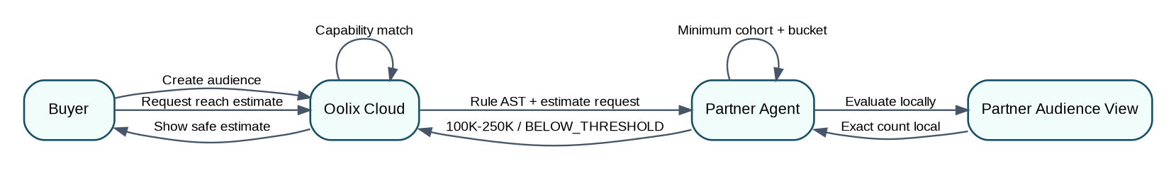
Figure 3. Reach estimation happens inside the selected Partner.

8.1 Cloud request
POST /v1/audiences/aud_100/reach-estimates
{
"audience_version":3,
"partner_org_ids":["org_partner_a","org_partner_b"]
}
202
{
"requests":[
{"reach_estimate_id":"re_1","partner_org_id":"org_partner_a","status":"REQUESTED"},
{"reach_estimate_id":"re_2","partner_org_id":"org_partner_b","status":"REQUESTED"}
]
}

8.2 Agent evaluation
- Validate signed rule snapshot and local mapping version.
- Evaluate only against the approved Audience Attribute View/API.
- Calculate exact matching count locally.
- Apply minimum cohort threshold and convert to standard reach bucket.
- Return bucket/freshness/rule hash/mapping version - never exact count.
{
"reach_estimate_id":"re_1",
"status":"READY",
"reach_bucket":"100K_250K",
"freshness_at":"2026-08-23T15:00:00Z",
"audience_rule_hash":"sha256:...",
"mapping_version":8,
"expires_at":"2026-08-24T15:00:00Z"
}

9. Campaign Linkage and Campaign Builder Changes
Campaign cmp_500
name: Nike Running Shoes - Delhi NCR
CampaignAudienceLink
campaign_id: cmp_500
audience_group_id: aud_100
audience_version: 3
Step | New wizard
1 | Objective
2 | Campaign basics
3 | Audience - choose/create Audience Group
4 | Partner matches
5 | Partner selection
6 | Channel & placement per Partner
7 | Budget allocation
8 | Creative
9 | Lead / conversion definition
10 | Review & submit

- Remove Partner segment browsing as the primary Step 3.
- Campaign request freezes Audience Group version, rule hash and selected reach-estimate version.
- One campaign links one Audience Group in MVP.

10. Data Partner Campaign Review
Review item | Example
Buyer / Brand | Nike / Nike Running
Audience Group | Urban Shoe Shoppers
Required rules | Age 18-35; Online shopper; Footwear; Purchase <=90 days
Optional rules | Gender; Payment = UPI/Credit Card
Partner coverage | All required; all optional
Safe reach | 100K-250K
Channel / placement | Partner App / Offers page
Creative | CRV-20
Dates / frequency | 30 days / max 2 per day
Budget / payout | Partner-specific terms
Purpose | Footwear advertising

- APPROVE binds to audience_group_id, audience_version, rule_hash, capability/mapping version, reach estimate and creative version.
- REQUEST_CHANGE can request audience-rule changes in addition to creative/placement/commercial changes.
- REJECT affects only that Partner request.

11. Local Audience Compilation and Materialization
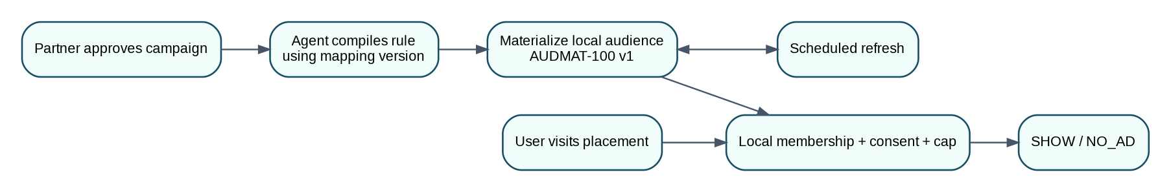
Figure 4. Approved audience rules are materialized locally before serving.
- Agent receives approved signed manifest.
- Resolve standardized attributes through PartnerAttributeMapping.
- Compile local query/API call against Audience Attribute View.
- Materialize matching partner_user_id values into Partner-local audience index.
- Assign local materialization version.
- Refresh on approved schedule.
- Real-time ad decision uses fast membership lookup, not full rule evaluation.
partner_user_id | activation_id | materialization_version | expires_at
U123 | act_500_a | 4 | ...
U982 | act_500_a | 4 | ...
Privacy boundary
Audience materialization and member IDs remain inside the Data Partner. Oolix stores only status/version/freshness/aggregate outcomes.

12. Partner-Owned Web/App Runtime
- User opens Partner placement.
- Partner backend resolves partner_user_id from existing session.
- Partner backend calls local Partner Agent.
- Agent checks local materialized audience membership.
- Agent re-checks consent/purpose eligibility.
- Agent checks dates, frequency, pacing, creative, policy and kill switches.
- Agent returns SHOW or NO_AD.
- Only aggregate delivery and outcomes return centrally.
POST /private/v1/ad-decision
{
"partner_user_id":"U123",
"placement_id":"offers_page",
"context":{"page_type":"offers"}
}
200
{
"decision":"SHOW",
"activation_id":"act_500_a",
"audience_materialization_version":4,
"creative":{...},
"click_token":"<opaque-random-token>"
}

13. Meta/Google External Activation Impact
Audience Group rules
↓
Partner approval
↓
Partner Agent local materialization
↓
approved local member set
├── PARTNER_WEB / PARTNER_APP
├── META (if eligible)
└── GOOGLE (if eligible)
- External matching identifiers may be prepared only after Partner approval and channel eligibility.
- Raw matching payload flows Partner Agent -> external channel, not through Oolix customer storage.
- Oolix stores external resource IDs/status/aggregate metrics only.
- Audience rule version is fixed for the external activation.

14. API Contract Changes
Method | Endpoint | Purpose
POST | /v1/audiences | Create Audience Group
PATCH | /v1/audiences/{id} | Edit draft/new version
GET | /v1/audiences | List Buyer Audience Groups
GET | /v1/audiences/{id} | Read Audience Group
POST | /v1/audiences/{id}/publish | Freeze READY version
GET | /v1/audiences/{id}/partner-matches | Calculate/list matches
POST | /v1/audiences/{id}/reach-estimates | Request estimates
GET | /v1/audiences/{id}/reach-estimates | Read estimate states
PUT | /v1/partner/capabilities | Publish safe Partner capabilities
POST | /v1/campaigns/{id}/audience-link | Link Audience Group version
POST | /v1/campaigns/{id}/partner-requests | Create Partner requests

14.1 Create Audience
POST /v1/audiences
{
"name":"Urban Shoe Shoppers",
"description":"Likely footwear buyers",
"rules":[
{"attribute":"age","operator":"BETWEEN","value":[18,35],"required":true,"weight":5},
{"attribute":"online_shopper","operator":"EQ","value":true,"required":true,"weight":5},
{"attribute":"purchase_category","operator":"IN","value":["FOOTWEAR"],"required":true,"weight":5},
{"attribute":"payment_method","operator":"IN","value":["UPI","CREDIT_CARD"],"required":false,"weight":2}
]
}
201
{"id":"aud_100","version":1,"status":"DRAFT"}

14.2 Partner match response
{
"partner_org_id":"org_partner_a",
"status":"COMPATIBLE",
"match_score":100,
"supported_rules":["age","online_shopper","purchase_category","payment_method"],
"missing_required_rules":[],
"missing_optional_rules":[],
"channels":[
{"channel":"PARTNER_WEB","status":"AVAILABLE"},
{"channel":"META","status":"CONDITIONAL"}
],
"capability_version":4
}

15. Database / Migration Changes
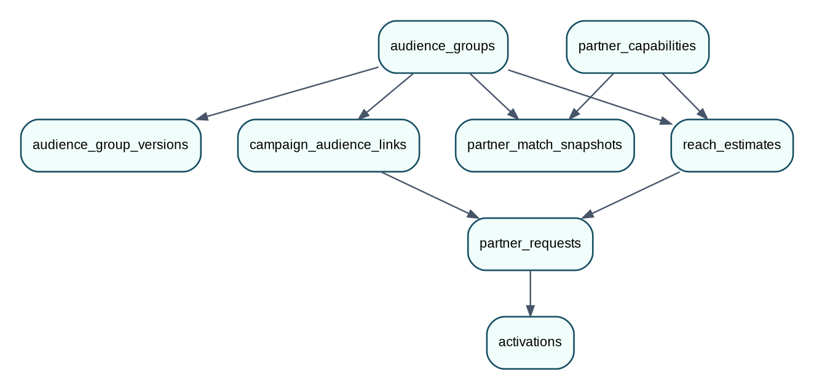
Figure 5. Central model additions for Buyer-defined audiences.
Table | Important fields
attribute_definitions | key, display_name, category, data_type, operators_json, allowed_values_json, policy_class, version
partner_capabilities | partner_org_id, capability_version, attributes_json, geographies_json, channels_json, status
audience_groups | id, buyer_org_id, name, description, status, current_version, created_by
audience_group_versions | audience_group_id, version, rules_json, rule_hash, status
partner_match_snapshots | audience_group_id, version, partner_org_id, capability_version, match_score, supported/missing JSON
reach_estimates | id, audience_group_id/version, partner_org_id, status, reach_bucket, freshness, rule_hash, mapping_version
campaign_audience_links | campaign_id, audience_group_id, audience_version
partner_requests | add audience_group_id, audience_version, audience_rule_hash, reach_estimate_id

15.1 Representative migration
CREATE TABLE audience_groups (
id UUID PRIMARY KEY,
buyer_org_id UUID NOT NULL REFERENCES organizations(id),
name VARCHAR(120) NOT NULL,
description TEXT,
status VARCHAR(24) NOT NULL DEFAULT 'DRAFT',
current_version INTEGER NOT NULL DEFAULT 1,
created_by UUID NOT NULL REFERENCES users(id),
created_at TIMESTAMPTZ NOT NULL DEFAULT NOW(),
updated_at TIMESTAMPTZ NOT NULL DEFAULT NOW()
);
CREATE TABLE audience_group_versions (
audience_group_id UUID NOT NULL REFERENCES audience_groups(id),
version INTEGER NOT NULL,
rules_json JSONB NOT NULL,
rule_hash CHAR(64) NOT NULL,
status VARCHAR(24) NOT NULL,
created_at TIMESTAMPTZ NOT NULL DEFAULT NOW(),
PRIMARY KEY (audience_group_id, version)
);
Keep existing prebuilt segments
Do not delete the current segment model immediately. Treat it as optional PREBUILT_SEGMENT supply for Partners that already have CDP audiences. The v6 Audience Builder becomes the primary Buyer flow.

16. States and Versioning
Object | States
AudienceGroup | DRAFT, READY, ARCHIVED
AudienceVersion | DRAFT, READY, SUPERSEDED
PartnerMatch | COMPATIBLE, INCOMPATIBLE
ReachEstimate | REQUESTED, PROCESSING, READY, BELOW_THRESHOLD, UNAVAILABLE, FAILED, EXPIRED
PartnerRequest | DRAFT, PARTNER_REVIEW, CHANGE_REQUESTED, APPROVED, REJECTED, EXPIRED, REVOKED
AudienceMaterialization local | NOT_STARTED, BUILDING, READY, STALE, FAILED, REMOVED
Activation | PENDING_CHANNEL_CHECK, READY, SYNCING, LIVE, PAUSED, FAILED, ENDING, ENDED

- Editing a READY Audience Group creates a new version; live campaigns stay on their approved version.
- Reach estimate is valid only for audience_version + rule_hash + Partner capability/mapping version.
- Partner approval is invalidated by changes to audience version, creative, channel/placement, budget or purpose.

17. Privacy, Anti-Differencing and Policy Controls
- Oolix stores audience rules and Partner capability metadata, not Partner customer records or Partner local field names.
- Exact audience counts remain local; Buyer sees reach buckets only.
- Minimum cohort size applies before a reach bucket is returned.
- Repeated estimate requests for same audience/Partner/version are cached and rate-limited.
- Do not allow arbitrary SQL, JavaScript or regex rules.
- Allowed fields/operators come from versioned AttributeDefinitions.
- Partner may block attributes, Buyers, categories, purposes or channels.
- Consent/purpose eligibility is re-checked locally during materialization and serving.
- External platform targeting/data-use restrictions still apply even if Partner can evaluate the attribute.

18. Buyer and Partner UI Changes

18.1 Buyer
Current | Change
Audience Discovery route | Replace primary route with Audiences / Audience Groups.
Search Partner segments first | Create audience rules first, then find Partners.
Segment cards | Partner-match cards with supported/missing fields and estimate status.
Campaign Step 3 Audience Discovery | Change to choose/create Audience Group.

- Audience list: name, status, rule summary, compatible Partner count, linked campaigns.
- Audience Builder: attribute/operator/value/required/optional/weight.
- Partner Matches: compatible first, incompatible below, missing optional rules, channels, Request Estimate.
- Audience Detail: versions, rule hash, estimates and linked campaigns.

18.2 Data Partner
- Capabilities page: standardized attributes the Partner can evaluate.
- Local mapping health: mapping version, connector health, freshness - no Buyer access to field names.
- Campaign Request: audience rule, field coverage, safe reach, campaign terms and approval actions.
- Activation page: local materialization freshness/version, delivery, payout and kill switch.

19. Migration From Current Implementation
Do not discard working modules
Current dashboard, campaign basics, creative, lead definition, reporting, billing, RBAC and most approval infrastructure remain valid. The main rewrite is Audience -> Partner Matching -> local materialization.

Current implementation | Developer action
/discover | Replace with /audiences; temporary redirect is fine.
Partner segment catalogue | Keep as optional legacy/prebuilt supply.
Campaign Step 3 | Choose/create Audience Group.
Partner selection | Drive from PartnerMatchSnapshot.
partner_requests.segment_id | Make legacy/nullable; add audience_group_id/version/rule_hash.
Agent segment lookup | Add rule compile/materialization; keep fast runtime membership lookup.
Reach buckets | Reuse existing bucket/minimum-cohort controls.
Signed manifests | Add audience IDs/version/rule hash/capability/mapping version.
Meta/Google | Use locally materialized approved Audience Group.

Migration compatibility:
targeting_source = AUDIENCE_GROUP | PREBUILT_SEGMENT
New Buyer UI defaults to AUDIENCE_GROUP.
PREBUILT_SEGMENT remains optional for existing Partner integrations.

20. MVP Acceptance Criteria
Area | Pass condition
Audience Builder | Buyer creates versioned audience with >=4 rules and REQUIRED/OPTIONAL semantics.
Capability match | Missing required rule => INCOMPATIBLE; missing optional only lowers score.
Privacy | No customer rows, internal Partner field names or exact reach count enter Oolix.
Reach estimate | Selected Partner Agent evaluates locally and returns bucket/BELOW_THRESHOLD.
Campaign link | Campaign binds to one audience version and rule hash.
Partner review | Partner sees complete rule, field coverage, safe reach and campaign terms.
Materialization | Approved rule materializes locally; runtime uses membership lookup.
Owned media | Eligible local user sees ad; ineligible user gets NO_AD.
Multi-Partner | Same Audience Group works across >=2 independent Partners with different capabilities/reach.
External | Meta/Google cannot run before approval, eligibility and local materialization.
Revocation | Partner revoke stops local serving and prevents further audience use.

21. Recommended Developer Sprint Change Plan
Sprint | Build work | Checkpoint
V6-1 | Taxonomy + AudienceGroup/version DB + seed attributes. | Create/read versioned Shoe audience.
V6-2 | Audience Builder UI/API. | Rules validate and publish.
V6-3 | Partner capability API/UI + Agent mapping contract. | Partner A publishes supported fields.
V6-4 | Match engine + match result UI. | 100/partial/incompatible results correct.
V6-5 | Reach estimate service + Agent evaluator + bucket controls. | Partner-local estimate works.
V6-6 | Campaign Audience link + wizard rewrite. | Campaign frozen to aud_100 v3.
V6-7 | Partner review changes. | Approval snapshot includes audience rules.
V6-8 | Agent local materialization + refresh + runtime lookup. | Eligible/ineligible mock users pass.
V6-9 | Regression: attribution/reporting/billing/multi-Partner/channels. | Existing downstream modules still pass.

Execution priority
Do not rewrite reporting or billing first. Replace the audience model end-to-end through Partner approval and local materialization, then run regression on downstream modules.

22. Developer Handoff Summary
The v6 change makes Oolix a Buyer-led audience finding and activation platform. The Buyer defines who they want to reach; Oolix finds which Data Partners can evaluate those conditions; selected Partners calculate safe reach locally; the Audience Group is linked to the campaign; each Partner independently approves; and the Partner Agent materializes/serves the audience locally.
Buyer creates Audience Group
↓
Standard Oolix attribute rules
↓
Oolix capability matching (metadata only)
↓
Compatible Data Partner list
↓
Selected Partner local reach estimate
↓
Audience Group linked to Campaign
↓
Partner-specific campaign request
↓
Partner approval
↓
Local audience materialization
↓
Partner Web/App or eligible Meta/Google
↓
Aggregate results + qualified outcomes
One sentence for the team
Build the audience rule centrally, match capabilities centrally, but evaluate and materialize actual people locally inside each Data Partner.

Appendix A - Suggested MVP Attribute Seed Catalogue
Key | Type | Operators | Example
age | NUMBER | BETWEEN | 18-35
gender | ENUM | IN | MALE, FEMALE
country | ENUM | IN | IN
state_region | ENUM | IN | DL, HR, KA, MH
city | ENUM/ID | IN | standard geo IDs
online_shopper | BOOLEAN | EQ | true
purchase_category | ENUM | IN | FOOTWEAR, FASHION, ELECTRONICS
purchase_recency_days | NUMBER | LTE | 90
purchase_frequency | NUMBER | GTE | 2
payment_method | ENUM | IN | UPI, CREDIT_CARD, DEBIT_CARD, COD
active_user_days | NUMBER | LTE | 30
loyalty_tier | ENUM | IN | GOLD, SILVER

Appendix B - Manifest Additions
{
"activation_id":"act_500_a",
"audience":{
"audience_group_id":"aud_100",
"audience_version":3,
"rule_hash":"sha256:...",
"reach_estimate_id":"re_1",
"capability_version":4,
"mapping_version":8
},
"channel":"PARTNER_APP",
"placement_ids":["offers_page"],
"creative_version_ids":["crv_20"],
"purpose_id":"footwear_offer",
"frequency":{"max_impressions":2,"window":"P1D"},
"start_at":"...",
"end_at":"..."
}

