MINT -Mathematical INTerpreter User Manual

View of MINT Program Editor:

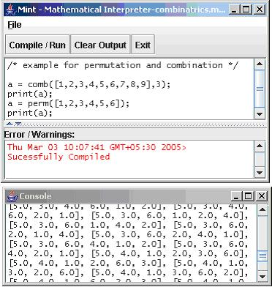
Menu Bar
Clears the output console
Compiles and Runs the program

Exits MINT

Program Editor
Errors and Warnings displayed here
Results displayed in the console window

The above diagram describes clearly about the general structure of MINT software. Basically it contains two separate windows . They are

- MINT Window
- Console Window

(a) MINT Window:
This is the window where the programmer can type the programs. This window also contains the panel for displaying Errors / Warnings. The diagram shows how the errors are displayed in the Error / Warnings panel.

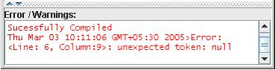

(b) Console Window:
This window is used to display the results of the programs in the program editor.

How to write a program in MINT?
- Open Mint
- By Default it is opened with New file, else to create a new file click File->New File or “Control + N” keys
- After creating new file start writing the program with Mint specified language
- To compile the program to check for errors, click “Compile / Run” button.
- This will displays the status of program. The status may be the following
  - Program compiled successfully and executed
  - Any syntax error in program
- Output is being displayed in the output console.
- The Output Console can be cleared using the “Clear Output” Button
- Next the program can be saved using File->Save or “Control + S” keys
- If you want to save the program in different name, use “File->Save As”
- To Quit the Console, use File->Quit or “Control + W” keys
- Syntax and Semantics of writing a MINT program are explained in detail in the Help Manual available along with the MINT software.

Glimpses of MINT:

MINT Program | Output
/* example for plotting graphs*/  plot3D('Graph1','x^2+2*x'); | 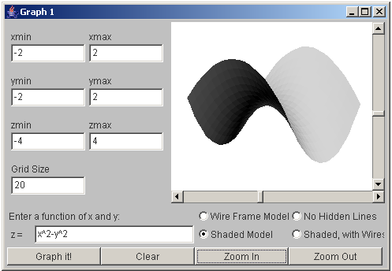
/* Matrix Manipulation */  a = matrix([ 1, 2, 3; 4 , 5 , 6; 7, 8 , 9]);  b = matrix([ 1, 2, 3; 4 , 5 , 6; 7, 8 , 9]);  print(a);  c = a + b;  print('A + B: \n ' + c);  c = a - b;  print('A - B: \n ' + c);  c = a * b;  print('A * B: \n ' + c); | 1.0000000000 2.0000000000 3.0000000000  4.0000000000 5.0000000000 6.0000000000  7.0000000000 8.0000000000 9.0000000000  A + B:  2.0000000000 4.0000000000 6.0000000000  8.0000000000 10.0000000000 12.0000000000  14.0000000000 16.0000000000 18.0000000000  A - B:  0.0000000000 0.0000000000 0.0000000000  0.0000000000 0.0000000000 0.0000000000  0.0000000000 0.0000000000 0.0000000000  A * B:  30.0000000000 36.0000000000 42.0000000000  66.0000000000 81.0000000000 96.0000000000 102.0000000000 126.0000000000 150.0000000000
/*differential calculus */  y='x^2';  wrt='x';  a = dx(y,wrt);  print('Differential:' + a);  /* example for eval function */  b=eval('x=5;c=' + a + ';return c;');  print(b);  /*integral calculus */  z = int(y,wrt);  print('Integral:' + z); | Differential:2 * 1 * x ^ (2 - 1)  10.0  Integral:0.3333333333333333 * x ^ 3

Note: Sample programs are available in the samples directory.

