**BİLKENT UNIVERSITY**

**CS319 GROUP2E**

**USER’S GUIDE**

**İpek Aktaş**

**Raziye Esra Çetin**

**Yunus Nedim Mehel**

**Mustafa İlker Saraç**

Contents

1)Introduction 3

2)Installation 3

2.1) System Requirements 3

2.2) Installation Info 3

3)Inside Game 4

3.1) Game Overview 4

3.2) Game Objects 4

3.3) Scores and Time 5

3.4) Control Settings 5

4)Game ScreenShots 7

4.1) Main Menu 7

4.2) New Game 8

4.3) High Scores 8

4.4) Settings 9

4.5) About 10

4.6) Credits 11

4.7) Quit 11

# **1)Introduction**

Boat Drift is a kind of arcade game. The game is played with single player who controls the boat. Boat must collect all buoys with the boat in order to complete levels. While boat is trying to complete buoys, it should avoid the islands and boxes as well. Also, it can be strengthened with the bonuses. When all buoys collected the next level will be opened.

# 2)Installation

## 2.1) System Requirements

The Standart Java Runtime Environment is required in order to play “Boat Drift”. It can be downloaded from;

<http://www.oracle.com/technetwork/java/javase/downloads/index.html>

minimum system requirements;

Screen resolution: 1024 x 768

64 MB Graphics card

## 2.2) Installation Info

The game does not require any installation. To run the game you need to double-click on the jar file named “BoatDrift.jar”.

# 3)Inside Game

## 3.1) Game Overview

In the BoatDrift player controls the Boat object. There are islands and boxes on the game map. When boat makes collision with islands and boxes it loses a life. Boat has bullets and with them it can destroy boxes if he can shoot box successfully. When box is broken, different bonuses are appeared from inside of it. These bonuses are life bonus, speed bonus and bullet bonuses. These bonuses provide boat with extra advantages. Thanks to life bonus, it has more chance to see next level. Speed bonus supplies to complete level in shorter time and it increases the score. Finally, bullets brakes the boxes and gives extra bonuses. If game is completed successfully or game is over the score is saved and high score list is shown to the player.

## 3.2) Game Objects

These are the objects that shown in the game while playing. They all have different missions and functions.

**Boat:** Boat is the main object of the game. User controls the boat with control buttons. Boat has to collect buoys and it can throw bullets. Also, it can collect the different bonuses which are appeared in the map.

 **Buoy:** Buoys are the objects that are distributed different locations on the map. To complete level, all buoys must be collected.

 **Island:** When boat collides with islands boat loses a life. Boat must avoid islands. User should control boat by considering islands.

 **Box:** Boxes have two features. When boat collides with boxes boat lose a life. However, boat can destroy boxes by throwing bullets. When bullet can shoot a box, box disappears and different kinds of bonuses appear.

 **Bullet:** Boat can shoot the boxes by using bullet.

 **Life Bonus:** When boat collects this object, it wins an extra life.

 **Speed Bonus:** When boat collects this bonus, it makes boat faster than normal.

 **Bullet Bonus:** When boat collects bullet bonus, it has bullets to destroy boxes and gain new bonuses.

**Wind**: When the wind blows, it changes the speed and direction of a boat accordingly.

## 3.3) Scores and Time

Player score is shown at the upper edge of the game screen that is between “remaining lives” and “remaining bullets”. When player gets bonuses, the score increases accordingly. If the taken bonus is buoy bonus, the score increases as 2 points, for bullet bonus 5 points, for life bonus 10 points and for sped bonus 25 points. In order to take life bonus, speed bonus or bullet bonus, the player have to shoot the boxes including these bonuses.

## 

## 3.4) Control Settings

## In our game, the boat can be directed by using arrow keys (right – left) or letter keys (A – D) according to the player’s preference on the setting screen in the game.

According to arrow keys;

 (LEFT) Moves the boat left

 (RIGHT) Moves the boat righ

 (P) Pauses the game

 (SPACE BAR) Shoots the boxes on the screen to get the bonus inside.

According to other keyboard keys;

1. Moves the boat left

 (D) Moves the boat right

 (P) Pauses the game

 (SPACE BAR) Shoots the boxes on the screen to get the bonus inside

# 4)Game ScreenShots

## 4.1) Main Menu

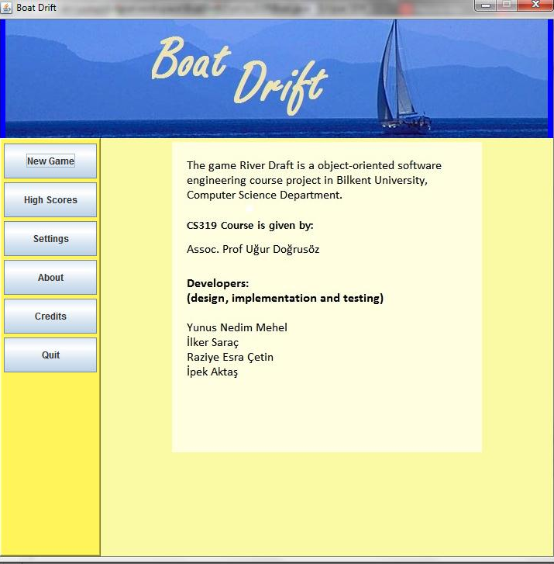

(Figure 1: Screen shot of the main menu)

Boat Drift has a main menu. Actually, this appears after the program executed. Main menu panel includes “New Game”, “About”, “Settings”, “High Scores”, “Credits” and “Quit” buttons. These six buttons takes the player to his/her required places. The functionalities of these buttons are explained in detail below.

## 

## 4.2) New Game

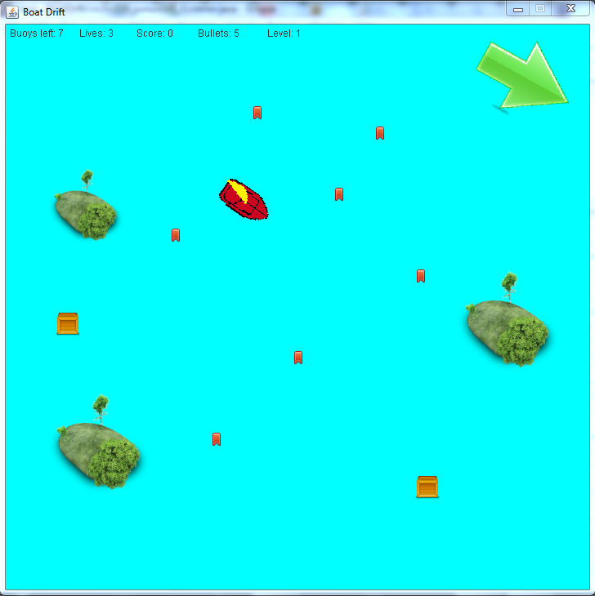

(Figure 2: Screen shot of the new game)

This option gives the players an opportunity to start a new game with a user-defined difficulty level. After the new game button is selected, main menu panel gets invisible and only game map panel becomes visible. Then, the player can start to play Boat Drift.

## 4.3) High Scores

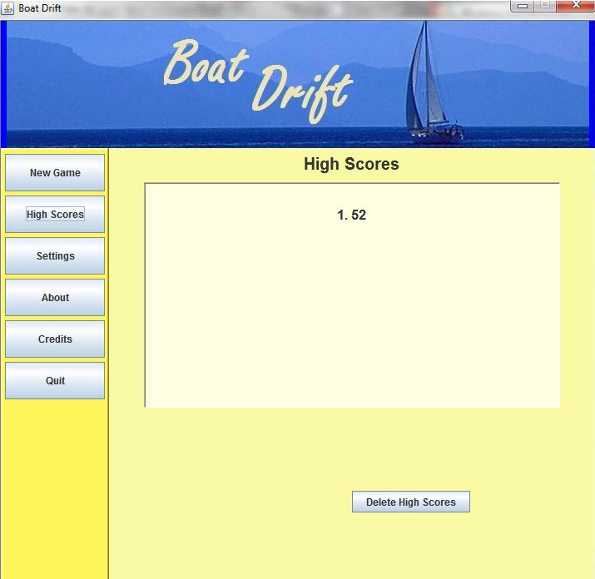

(Figure 3: Screen shot of the High Scores)

In the High Scores screen, the player can see the top ten scores ever had. If his/her score is one of the best scores, obviously, he/she can see his/her own score. Scores are sorted in descending order.

## 4.4) Settings

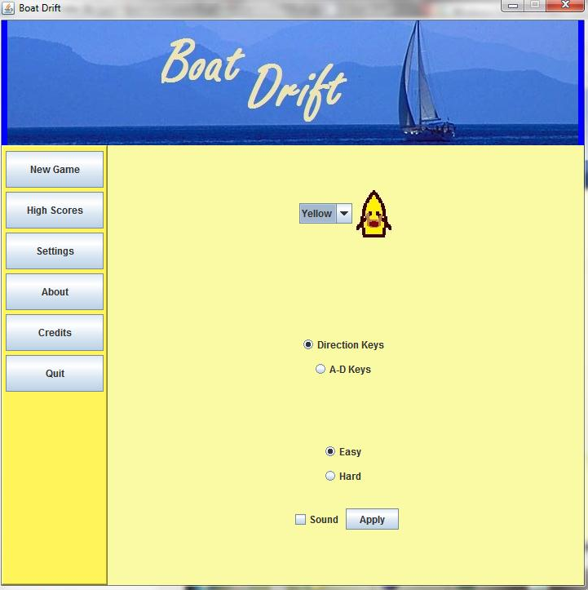

(Figure 4: Screen shot of the Settings)

When the “Settings” button is clicked, the player can make some changes about the features of the game. Boat Drift can be played by using different kind of keys that are W-A-S-D keys or direction (arrow) keys in order to move the boat. This feature offers the player an advantage that he/she can play in different areas on the keyboard. The player can also select the difficulty of the game by selecting “Easy” or “Hard” button in the “Settings” menu.

At the bottom of the settings screen, there is a box called “Sound” which makes the music available during the game period, if it is checked. Otherwise, player can enjoy the game in silent mode. When all the settings are completed, player can click “Apply” button in order to save the settings of the game.

After the settings are done, player can select different button on the left hand side of the screen in order to go to another place of the game.

## 4.5) About

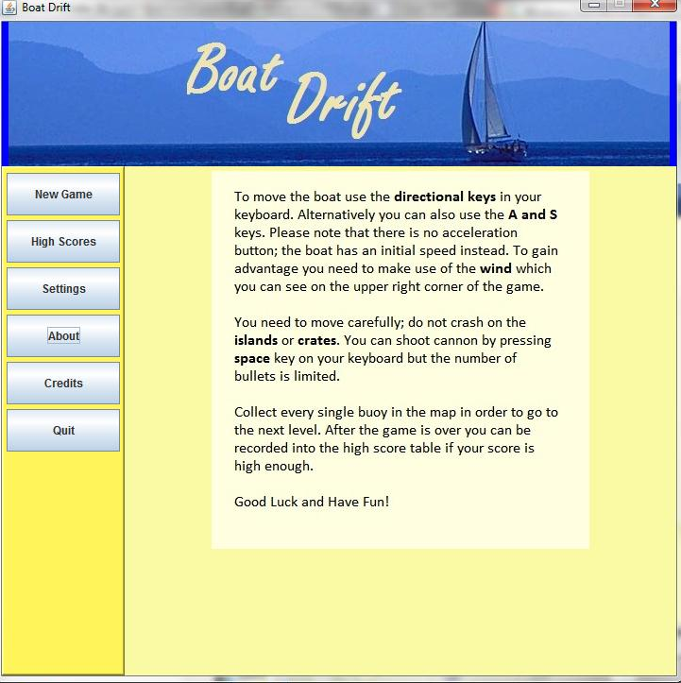

(Figure 5: Screen shot of the About)

When the “About” button is clicked, player can get information about the Boat Drift. This screen instructs the player about how to play this game. The main target about playing the game, how to succeed the main goal of this game and the characters of the game are explained briefly.

The main menu panel which includes six buttons are also exist on the right hand side of “About” screen besides the informative text mentioned above. Thus, player can make a different selection just after the changing setting without using any unnecessary button.

## 

## 4.6) Credits

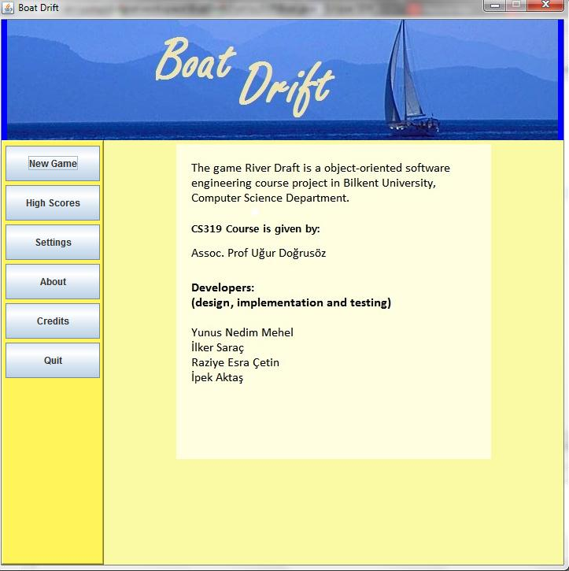

(Figure 6: Screen shot of the Credits)

When the credit button is clicked, there will be an informative text about the developers of the game, their references beyond the duration of the implementation of the game and the game’s overall features on the screen.

## 4.7) Quit

This button can be used to exit the from the game directly.