CODSALL COMMUNITY ARTS FESTIVAL 2012

BOOKING FORM
Please return with a STAMPED ADDRESSED ENVELOPE TO:
Mrs Alison Laight, 62 Oaken Park, Codsall, WV8 2BW. Tel: (01902) 845230

Tickets are available by post: | Event |  | £ | No of  tickets | 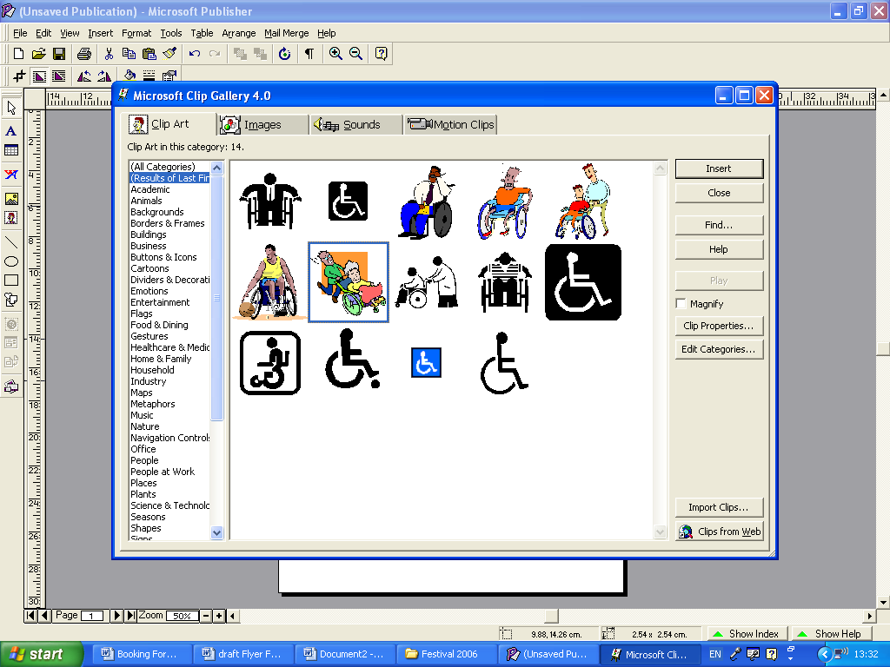 | TOTAL
Postal bookings from 21 February  See below for Box Offices  PLEASE USE BLOCK CAPITALS  Name……………………………………..  Address………………..…………………  …………………………..…………………...  …………………………..…………………..  …………………………..…………………..  Postcode………………………………...  Phone……………………………………..  Enter tickets required for those needing wheelchair space in the auditorium. | We Happy Few | Wed 7 | £ 7
 | by | Thu 8 | £ 7
 | Codsall Dramatic | Fri 9 | £ 7
 | Society | Sat 10 | £ 6
 | The Fairey Brass Band |  | £10
 | Showcase of Dance |  | £ 4
 | The Enigma Codebreakers |  | £ 6
 | The Classic Buskers |  | £ 8
 | Children under 16 |  | £ 4
 | Samuel Adams – Georgian Butler  suitable for age 16+ only |  | £ 7
 | The Grand Union Syncopators |  | £10
 | At the Drop of a Hippopotamus |  | £10
 | Animals Behaving Badly |  | £ 7
 | Freddy Kempf, Piano |  | £10
 | Students under 21 |  | £ 6
 | Simon Weston OBE |  | £ 8
 | Tudor & Stuart Cures |  | £ 6
 | Students (13+, under 21) |  | £ 3
 | Michaela Strachan |  | £10
 | Children under 16 |  | £ 6
 | Gala Evening: |  | £10
 | Musical Memoirs of Ivor Novello
 | Programme (inc. p&p) |  | £ 2
 | GRAND TOTAL £

Cheques should be made payable to: Codsall Community Arts Festival Association  with the amount left open and an upper limit shown in the bottom left hand corner  (e.g. maximum £48.00) | Box 0ffices open from 21 February 2012 for personal applications  Ian Rigby, Jeweller, 84 Wolverhampton Road, Birches Bridge, Codsall  Kaleidoscope, 4 The Square, Codsall  Bradsports (for Showcase of Dance tickets only)  4, Bilbrook Road, Bilbrook

