CODSALL ARTS FESTIVAL 2010
BOOKING FORM
Please return to: Mrs Alison Laight, 62 Oaken Park, Codsall, WV8 2BW. Tel: (01902) 845230.
(Please enclose a stamped, addressed envelope.)

Tickets available by post: | Event |  | £ | No of  tickets | 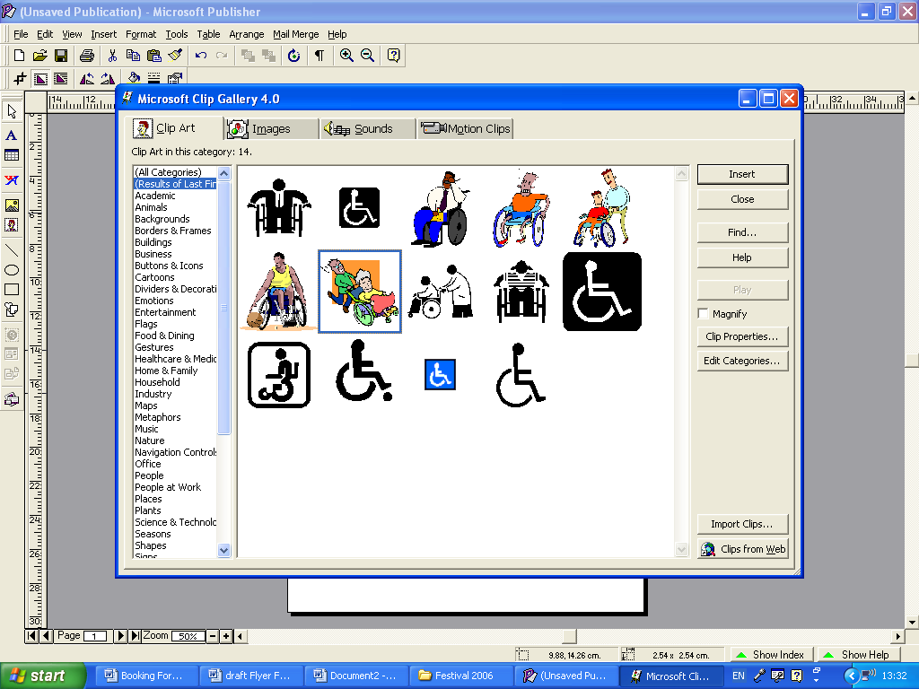 | TOTAL | Event |  | £ | No of  tickets |  | TOTAL
Postal bookings and Box Offices open from 22 February.  PLEASE USE BLOCK CAPITALS  Name……………………………………..  Address………………..…………………  …………………………..………………..  …………………………….……………...  Postcode………………  Telephone…...............................................  Enter tickets required for those  needing wheelchair space in the auditorium.  Cheques should be made payable to  ‘Codsall Community Arts Festival Association’  with the amount left open and an upper limit shown in the bottom left corner  (eg ‘Maximum £48.00’) | Codsall Dramatic  Society | Wed 10 | £ 6.50 |  |  |  | Robert Powell & Friends |  | £10.00
 | Codsall Dramatic  Society | Thu 11 | £ 6.50 |  |  |  | Helen Smith:  Japanese Kimono |  | £ 4.00
 | Codsall Dramatic  Society | Fri 12 | £ 6.50 |  |  |  | Ann Widdecombe |  | £ 8.00
 | Codsall Dramatic  Society | Sat 13 | £ 5.50 |  |  |  | Benjamin Grosvenor |  | £ 6.00
 | Cantorion Colin Jones** |  | £ 8.00 |  |  |  | Free to students under 21 |  | Free
 | Don Billington |  | £ 6.00 |  |  |  | Histons Players | Wed 24 | £ 5.00
 | Studio 61 &  Pattingham  Drama Group | Tue 16 | £ 6.00 |  |  |  | Histons Players | Thu 25 | £ 5.00
 | Studio 61 &  Pattingham  Drama Group | Wed 17 | £ 6.00 |  |  |  | Histons Players | Fri 26 | £ 5.00
 | Studio 61 &  Pattingham  Drama Group | Thu 18 | £ 6.00 |  |  |  | Julian Curry + winetasting** |  | £ 8.00
 | Lesley Smith as  Nell Gwynn |  | £ 5.00 |  |  |  | OR
 | Henry Sandon |  | £ 5.00 |  |  |  | Julian Curry – talk only |  | £ 4.00
 | Football talk |  | £ 8.00 |  |  |  | Gala Evening:  John Miller & His  Orchestra** |  | £10.00
 | Mike Carnie & his  Jazz All Stars |  | £ 8.00
 |  |  |  |  |  |  |  |  | GRAND TOTAL £
**Ticket restrictions apply to postal bookings for Cantorion, wine-tasting and Gala Evenings.
- maximum of 2 tickets per booking form

