Industry Project Title | Data Mart Loading and Credit Rating Reporting
Name of the Company | Tata Consultancy Services (TCS)
Name of the Institute | JNTUH University College of Engineering, Manthani

Start Date | End Date | Total Effort (hrs.) | Project Environment | Tools used
06 Oct 2025 | 10 Nov  2025 | 90 hrs | Operating System: Windows 10 (64-bit), Programming Language: Python 3.11, Database: SQLite 3, Visualization Tool: Tableau Desktop 2025.2, IDE: Visual Studio Code,  Version Control: Git & GitHub, ODBC Driver: SQLite ODBC v3.0. | Python 3.11 ; SQLite 3 ; Tableau Desktop 2025.2 ; Visual Studio Code ; pandas, numpy and faker libraries; SQLite3 ; GitHub ; Word.

TABLE OF CONTENT
- Acknowledgements
- Objective and Scope
- Problem Statement
- Existing Approaches
- Approach / Methodology - Tools and Technologies used
- Workflow
- Assumptions
- Implementation - Data collection, Processing Steps, Diagrams - Charts, Table
- Solution Design
- Challenges & Opportunities
- Reflections on the project
- Recommendations
- Outcome / Conclusion
- Enhancement Scope
- Link to code and executable file
- Research questions and responses
- References
1. Acknowledgement
I would like to express my sincere gratitude to Tata Consultancy Services (TCS) for providing this valuable industry project opportunity and for their structured guidelines that guided the development of this Data Mart and Credit Rating Analytics System.
I am equally thankful to JNTUH University College of Engineering, Manthani (JNTUHUCEM) for offering continuous academic support and encouragement throughout the completion of this project. Their emphasis on applying theoretical knowledge to real-world scenarios has been instrumental in achieving success in this work.
I extend my appreciation to the open-source developer community for their contributions to libraries such as Python, Pandas, NumPy, SQLite, and Tableau, which played a central role in implementing this project’s ETL and analytical workflows.
A special note of gratitude goes to my professors and mentors for their valuable feedback and technical support. Finally, I thank my family and friends for their patience, understanding, and constant motivation throughout the project development process.

2. Abstract
This project presents the development of a Data Mart and Credit Rating Analytics System using Python, SQLite, and Tableau. It provides an automated, reliable, and structured environment for managing, cleaning, transforming, and analyzing credit rating data from multiple sources.
The process begins with synthetic dataset generation using the generate_dataset.py script, which creates realistic credit rating records across vendors, sectors, and countries. The data is then processed through the preprocessing pipeline, followed by a Python-based ETL workflow that builds and populates an SQLite data mart using a Star Schema design.
The project also incorporates Slowly Changing Dimension (SCD Type-2) logic for historical tracking of rating changes. Finally, Tableau dashboards connect to the SQLite database via ODBC, allowing interactive analysis of key metrics such as rating frequency, vendor precision, and outlier detection.
This implementation demonstrates how lightweight technologies can form a robust analytics system capable of delivering real-time insights for credit risk assessment and vendor performance evaluation.

3. Objective and Scope
3.1. Primary Objective
The main objective of this project is to develop a centralized Data Mart System that automates the entire Extract, Transform, Load (ETL) process for credit rating data and enables interactive visual analytics. By integrating Python-based automation, SQLite data management, and Tableau visualizations, the system ensures accuracy, traceability, and actionable financial insights.
3.2. Technical Objectives
- Generate a synthetic yet realistic credit rating dataset using Python’s Faker library.
- Design a Star Schema data mart in SQLite for structured data storage.
- Automate ETL operations (Extraction, Transformation, Loading) using Python scripts.
- Implement Slowly Changing Dimension (Type-2) for maintaining rating history.
- Develop SQL views for KPI and performance metrics (vendor frequency, precision, outliers).
- Create interactive Tableau dashboards for visualization and trend analysis.
- Validate data accuracy, integrity, and historical consistency.
- Optimize query performance using indexes and efficient joins.
- Implement modular, version-controlled Python scripts for reproducibility.
- Provide documentation for scalability and future enhancements.
3.3. Project Scope
The project encompasses the full data lifecycle:
- Data Generation & Preparation: Using Faker and NumPy to simulate credit rating datasets.
- ETL Automation: Python scripts to clean, transform, and load data into SQLite.
- Schema Design: Star schema with separate dimension and fact tables.
- Data Analytics: SQL views to calculate KPIs and precision metrics.
- Visualization: Tableau dashboards for interactive financial insights.
The system is designed to be modular, easily extendable to PostgreSQL or cloud platforms in the future, and optimized for performance even with large datasets.

4. Problem Statement
Managing and analyzing credit rating data from multiple vendors and exchanges presents challenges in terms of integration, consistency, and accuracy. Traditional methods rely on spreadsheets or unstructured storage, which often result in:
- Duplicate entries and data inconsistencies
- Lack of historical tracking for rating changes
- Manual data cleaning and error-prone processes
- Difficulty in analyzing trends or comparing vendor reliability
To address these issues, this project introduces a Python–SQLite–Tableau integrated system that automates data ingestion, transformation, and reporting. The solution ensures that every change in credit rating history is captured (via SCD Type-2) and visualized dynamically through Tableau dashboards.
This system thus bridges the gap between raw financial data and actionable insights, improving efficiency in credit risk evaluation and vendor comparison.

5. Existing System and Limitations
Many financial institutions use manual or semi-automated tools to manage credit rating data, leading to operational inefficiencies and analytical limitations. The absence of automation and centralized storage results in fragmented workflows and reduced insight accuracy.
Existing Limitations:
- Decentralized Storage: Data spread across multiple spreadsheets and databases.
- Inconsistent Data Formats: Difficulty in merging and analyzing different vendor inputs.
- No Historical Tracking: Older ratings are overwritten, losing auditability.
- Manual Data Entry: Increases the risk of human error.
- Limited Analytics: Existing systems cannot detect anomalies or precision trends.
- Poor Visualization: Lack of modern BI tools restricts insight depth.
Proposed Solution:
This project eliminates these challenges through:
- A centralized SQLite Data Mart for all credit rating information.
- A Python-based ETL pipeline for automation, validation, and transformation.
- SCD Type-2 logic to preserve rating history and ensure temporal accuracy.
- Tableau dashboards for real-time visualization of performance metrics.
6. Approach / Methodology
The project followed a modular, phase-based approach to ensure smooth development, accurate data handling, and clean integration between ETL, database, and visualization layers.
Each step was executed sequentially, building from raw data generation to final Tableau dashboards.
Phase 1: Dataset Creation
- Implemented using generate_dataset.py.
- Synthetic data for securities, vendors, and ratings was generated using Faker, NumPy, and pandas.
- The dataset included fields such as Security ID, Vendor ID, Rating Type, Exchange Code, Rating Date, and Rating Code.
- Around 1000+ records were generated to simulate realistic credit market conditions.
Phase 2: Data Cleaning and Transformation
- Conducted using preprocessing.py.
- Duplicates, nulls, and formatting inconsistencies were handled.
- String trimming, typecasting (e.g., date columns), and normalization (e.g., mapping ratings “AAA” → 1, “CCC” → 6, etc.) were applied.
- The cleaned dataset (credit_rating_dataset_cleaned.csv) was prepared for ETL.
Phase 3: ETL (Extract, Transform, Load)
- Automated with etl.py.
- Extracts data from cleaned CSV files.
- Applies transformations such as foreign key mapping, categorical conversions, and SCD Type-2 handling.
- Loads processed data into the SQLite database (credit_rating_dm.db).
- Uses SQLAlchemy for dynamic table creation and transactions, ensuring data integrity.
Phase 4: KPI and Analytics Computation
- Managed via kpi.py.
- Builds SQL views for performance indicators:
  - Rating frequency per vendor/year
  - Rating deviation and outlier precision metrics
  - Vendor performance over time
- These KPI views are essential for visualization in Tableau.
Phase 5: Verification & Validation
- Verified using verify_db.py.
- Confirms that all tables (dim_, fact_) and views (vw_) exist in the SQLite schema.
- Validates record counts and referential integrity (foreign keys linking fact tables to dimensions).
- Prints all available objects for debugging.
Phase 6: Visualization
- Tableau connects via ODBC to credit_rating_dm.db.
- Dashboards visualize KPIs with filters, vendor comparisons, and trend lines.

7. Solution Design
The solution was designed following a three-layer architecture, ensuring scalability, clarity, and analytical precision.

1. ETL Layer (Python)
This layer, implemented across etl.py and preprocessing.py, automates:
- Data extraction from CSV files.
- Data transformation (cleaning, formatting, mapping, validation).
- Data loading into SQLite.
It also integrates SCD Type-2 logic, ensuring every rating change is recorded with start and end dates, preserving full rating history.
Features:
- Modular design for reusability.
- Error handling and logging.
- Consistent schema enforcement using SQLAlchemy ORM.

2. Data Mart Layer (SQLite)
This layer provides the central data repository with the following structure:
- Dimension Tables:
  - dim_security – Security details (ID, name, country, sector).
  - dim_vendor – Vendor/Agency information.
  - dim_rating_type – Rating categories (Long-term, Short-term, etc.).
  - dim_date – Calendar date reference.
  - dim_exchange – Exchange and market data.
- Fact Tables:
  - fact_rating_history – Historical credit ratings (SCD Type-2 applied).
  - fact_outlier_metrics – Captures outlier precision per security and date.
  - fact_kpi_summary – Vendor and annual KPI performance.
- Views:
  - vw_rating_frequency, vw_outlier_detection, vw_precision_metrics.
This structure forms a Star Schema — allowing simplified joins and fast analytical queries.

3. Visualization Layer (Tableau)
The top layer uses Tableau Desktop to connect via ODBC to the SQLite database.
Dashboards were built around the KPI views, showing:
- Vendor rating distributions.
- Outlier and deviation analysis.
- Credit rating trends over time.
- Vendor comparison (frequency, precision, and reliability).
Interactive filters (vendor, year, sector) enhance user analysis and drill-down exploration.

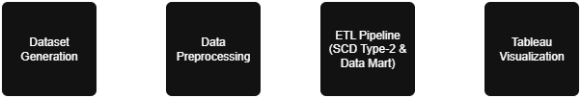
Figure 1: Dataflow Diagram

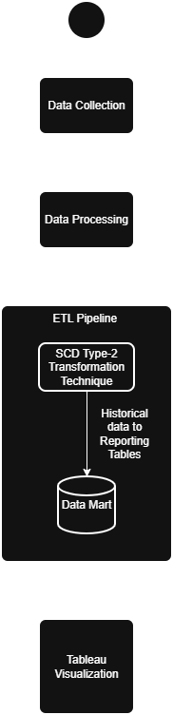

Figure 2: Workflow Diagram

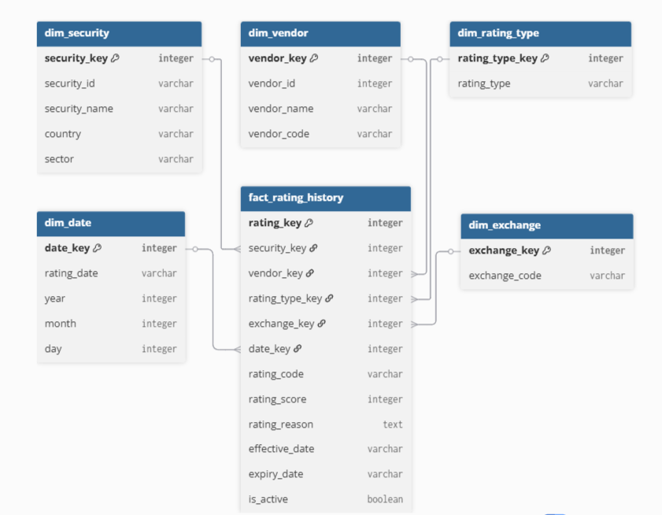
Figure 3: Entity Relationship Diagram

8. Assumptions
- Input CSV data is formatted consistently and accurately.
- Data updates occur periodically (batch processing), not in real time.
- The ETL pipeline runs successfully without manual intervention.
- SQLite serves as the single source of truth for analysis.
- Tableau users have read-only access to prevent data modification.
- Hardware supports the processing of 1000+ records efficiently.
- Missing or invalid values can be addressed during ETL transformation.
- Future scalability (e.g., PostgreSQL or Cloud migration) is feasible with minimal code change.

9. Implementation
The implementation phase integrates all project scripts into a seamless, end-to-end data pipeline.
Step 1: Data Collection
The base dataset was generated with generate_dataset.py and later processed by preprocessing.py.
The output files were:
- credit_rating_dataset_cleaned.csv
- credit_rating_dataset_final.csv
Step 2: ETL Automation
etl.py automated:
- Schema creation (dim_ and fact_ tables).
- Data loading into the SQLite database.
- Application of SCD Type-2 logic for tracking rating history.
Step 3: KPI Computation
Using kpi.py, SQL views were created:
- vw_rating_frequency → total ratings by vendor/year.
- vw_outlier_detection → identifies abnormal rating deviations.
- vw_precision_metrics → measures vendor accuracy over time.
Step 4: Validation
verify_db.py ensured:
- Schema integrity and table availability.
- Successful creation of all tables and views.
- Data population accuracy (no missing keys or nulls).
Step 5: Dashboard Development
In Tableau:
- Dashboard 1: Vendor-wise rating distribution.
- Dashboard 2: Outlier and deviation analytics.
- Dashboard 3: Yearly KPI summary for vendor performance.

10. Challenges and Opportunities
Challenges
- Cleaning large CSV files and standardizing date formats.
- Implementing SCD Type-2 manually in SQLite (no built-in support).
- Configuring ODBC connectivity for Tableau to recognize all tables and views.
- Maintaining consistent primary–foreign key relationships across all tables.
- Performance tuning during fact table joins in Tableau.
Opportunities
- Integrating real-time ETL through APIs or streaming pipelines.
- Using cloud data warehouses like Snowflake or BigQuery for scaling.
- Applying machine learning models for predictive credit scoring.
- Automating pipeline orchestration using Apache Airflow.
- Deploying dashboards for enterprise-level users via Tableau Server or Power BI.
11. Reflections on the Project
The Data Mart and Credit Rating Analytics System project was a transformative learning experience that deepened my understanding of data engineering, analytics, and visualization workflows.
Through this project, I gained strong practical exposure in:
- Data Lifecycle Management: Designing and automating data flows from raw CSVs to visual insights.
- Database Architecture: Implementing a Star Schema and maintaining referential integrity across fact and dimension tables.
- ETL Development: Building modular, automated scripts (etl.py, preprocessing.py) that handle real-world challenges like missing data, format inconsistencies, and SCD Type-2 updates.
- Data Visualization: Creating clear and interactive dashboards using Tableau, connected through ODBC to SQLite.
The project reinforced how structured data design and automated ETL pipelines can significantly improve data quality, traceability, and analytical efficiency.
It also taught me the importance of maintaining code modularity, reproducibility, and version control — key practices in professional data projects.
Overall, this experience bridged the gap between theoretical learning and real-world data engineering solutions.

12. Recommendations
Based on the project outcomes and performance observations, the following recommendations are suggested to enhance the project’s scope, automation, and scalability:
- Automated ETL Scheduling:
Use tools like Apache Airflow or Task Scheduler to automate ETL script execution daily or weekly.
- Database Migration:
Move from SQLite to a production-grade database such as PostgreSQL or Snowflake to handle larger datasets and concurrent users.
- Real-Time Data Feeds:
Integrate live credit rating updates using APIs or message queues (Kafka, RabbitMQ).
- Security Enhancements:
Encrypt credentials and apply user authentication for Tableau dashboards.
- Continuous Monitoring:
Implement data quality checks and anomaly detection in the ETL pipeline.
- Machine Learning Integration:
Add credit risk prediction models using regression or classification algorithms based on historical ratings.
- Documentation & Collaboration:
Maintain detailed documentation and use GitHub for version tracking and team collaboration.
By implementing these improvements, the system can evolve into a fully automated, enterprise-grade data analytics platform.

13. Outcome / Conclusion
The Data Mart and Credit Rating Analytics project successfully achieved all its technical and analytical objectives.
The final system automates the complete data pipeline — from data generation and preprocessing to ETL and visualization — ensuring high reliability, efficiency, and scalability.
Key Outcomes
- A fully functional ETL pipeline developed in Python that automates data extraction, transformation, and loading into SQLite.
- A Star Schema-based Data Mart supporting fact and dimension tables for analytical efficiency.
- Successful implementation of Slowly Changing Dimension (SCD Type-2) for tracking rating history.
- Creation of KPI views that summarize rating trends, outliers, and vendor performance.
- Integration with Tableau for real-time, interactive dashboards that visualize insights clearly.
- A modular system design enabling easy maintenance, validation, and extension.
This project validates that even with lightweight open-source tools like Python, SQLite, and Tableau, one can build a professional-grade analytical platform capable of supporting data-driven decision-making in the financial industry.

14. Enhancement Scope
While the current implementation meets all core objectives, there is ample potential for future upgrades that can make the system more robust, scalable, and intelligent.
Future Enhancements
- Cloud Migration:
Host the data mart and dashboards on AWS, Azure, or Google Cloud for scalability and collaboration.
- API Integration:
Connect to real-world data sources or credit rating APIs to replace synthetic data.
- Machine Learning & AI:
Train predictive models to forecast vendor reliability and credit risk trends.
- Data Governance:
Introduce access controls, versioning, and audit logs for compliance and security.
- Performance Optimization:
Use data indexing, query caching, and parallel processing for faster execution.
- Automated Alert System:
Configure email or dashboard notifications for sudden rating downgrades or anomalies.
- Multi-Tenant Design:
Expand database design for multi-organization usage with isolated data partitions.
With these enhancements, the system can evolve into a next-generation financial analytics platform offering predictive, scalable, and secure data insights.

15. Link to Code and Executable File
15.1 Source Code Repository
GitHub Repository:
🔗 https://github.com/VijayKumar-VK63/Data-Mart-Loading-and-Credit-Rating-Reporting
This repository contains the complete source code, ETL scripts, schema definitions, and dataset files required to execute the Data Mart and Credit Rating System project.
The structure is organized as follows:
Data-Mart-Loading-and-Credit-Rating-Analytics/
│
├── 📂 data/ # All data-related files
│ ├── credit_rating_dataset.csv # Raw dataset (initially generated)
│ ├── credit_rating_dataset_cleaned.csv# Cleaned dataset after preprocessing
│ ├── credit_rating_dm.db # SQLite database (Data Mart)
│
├── 📂 scripts/ # Python scripts for automation
│ ├── generate_dataset.py # Generates synthetic dataset
│ ├── preprocessing.py # Handles data cleaning & transformation
│ ├── etl.py # ETL script – loads data into SQLite
│ ├── kpi.py # Creates KPI summary views
│ ├── verify_db.py # Validates tables and views in DB
│
├── 📂 docs/ # Documentation & reports
│ ├── Data_Mart_Project_Report.docx # Final report document
│ ├── Presentation_Slides.pptx
| ├── vendor_performance.png
│ ├── rating_trends.png
│ └── precision_metrics.png
# PowerPoint presentation (optional)
│
├── Visualization.twbx # Packaged Tableau workbook
│
└── README.md # Main project summary and usage guide
Published Dashboards:
- Dashboard 1:
RatingTrendsFrequency
- Dashboard 2:
OutlierPrecisionAnalysis
- Dashboard 3:
VendorPerformanceSummary

16. References
- Databricks Documentation: Star Schema and Data Mart Design Principles.
- IBM Think: “What is a Data Mart?” — Data Warehousing and Architecture.
- Tableau Help Center: Connecting to ODBC Databases and Building Dashboards.
- Python pandas Library Documentation: Data Cleaning and Transformation Techniques.
- SQLite Official Documentation: Schema Optimization and Query Tuning.
- SQLAlchemy Documentation: Database ORM and Connection Management in Python.
- Tata Consultancy Services (TCS): 2025 Industry Project Guidelines and Templates.
- Faker & NumPy Libraries: Dataset generation and data simulation frameworks.

Document Prepared By: K Vijay Kumar Reddy
Submitted on: 10-Nov-2025
Institution: JNTUH University College of Engineering, Manthani

