RESUME
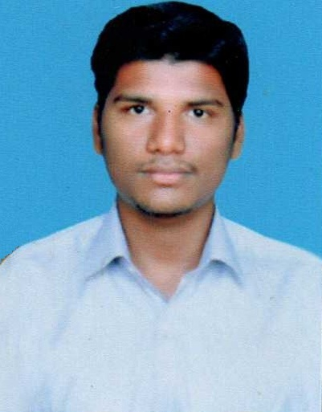
P.PRABHAKARAN
S/o G.Palanichamy
6, Ramar Kovil Street,
T.Kallipatti,
Periyakulam,
Theni (Dt),
Tami nadu .
Phone no : 8220439465
Email ID : prabhakaranpalanisamy@yahoo.com

CAREER OBJECTIVE

To seek a challenging position in a progressive company with my experience and contribution to the growth of the company with my knowledge and position.

COURSE | INSTITUTION | UNIVERSITY | YEAR OF PASSING | PERCENTAGE
BE (Mech) | VPV College of Engineering, Periyakulam | Anna University | 2017 | 6.43
DIPLOMO  (Mech.) | Theni Kammavar Sangam Polytechnic College, Theni | Technical Education | 2013 | 65%
SSLC | St.Anne’s Hr.Sec.School,Periyakulam | State Board | 2010 | 70%
ACADEMIC PERFORMANCE

EXTRA CURRICULAR ACTIVITIES

- Drawing

TECHNICAL SKILLS
- Operating system: Windows XP, 7
Basic Computer Knowledge

PROJECT DONE:
- Composite Material Using a Mechanical Properties of Polyester Resign

AREA OF INTEREST:
- Quality Control
PERSONAL PROFILE

Name : P.PRABHAKARAN
Date of Birth : 21/10/1993
Father’s name : G.Palanichamy
Permanent Address : 6, Ramar Kovil Street,
T.Kallipatti,
Periyakulam,
Theni (Dt),
Tami nadu .
Gender : Male
Marital Status : Unmarried
Languages Known : Tamil & English
Nationality : Indian
Hobbies : Listening melody Music, Reading books
DECLARATION

I hereby declare that the above mentioned information is true to the best of my knowledge.

Place: THENI Yours Sincerely,
Date:

( P.PRABHAKARAN )

