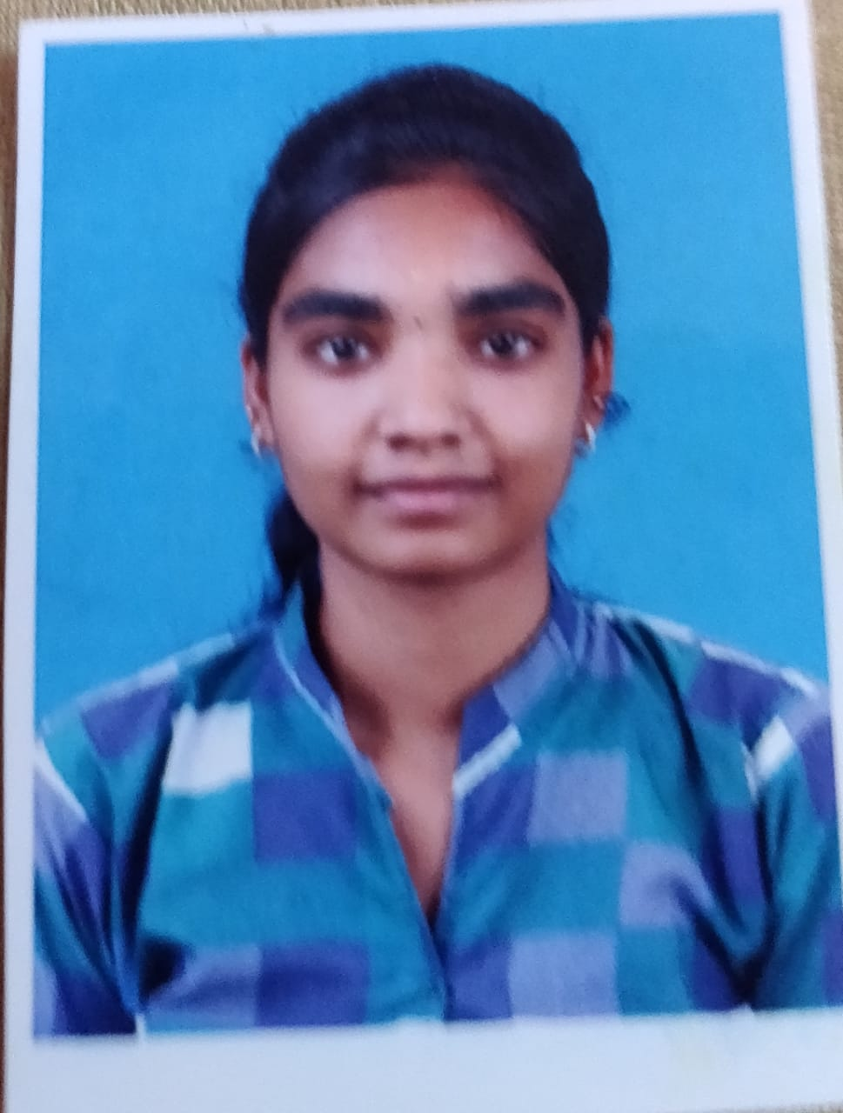
CURRICULUM VITAE
PA. RADHAI
radhaiy2001@gmail.com.
9344257454
CAREER OBJECTIVES
To make a position for myself in the competitive corporate world and contribute to achieving the goal on both professional and personal level .
EDUCATIONAL QUALIFICATION
EXAMINATION | GRADE | PASSING YEAR | SCHOOL/UNIVERSITY
High school | 82.4% | 2018 | Mahatma Montessori School
Intermediate | 81.2% | 2016 | Mahatma Montessori School
Certificate in accounting technique | 131/200 | 2019 | Padmarajam institute of management.

KEY SKILLS
• Able to work under high pressure
•High commitment in team work

LANGUAGES KNOWN
• English
• Tamil
EXTRA CURRICULAR
• Visharadh Uttarardh certificate in Hindi prachar sabha.
PERSONAL PROFILE
NAME : Radhai yadav. PA
DATE OF BIRTH : 06/08/2001
GENDER : Female
MARITAL STATUS : Single
MOBILE NUMBER : 9344257454
EMAIL ID : radhaiy2001@gmail.com
ADDRESS : 5/1316, shanthi nivas , yagappa nagar 1st street,
Yagappa nagar
Madurai (TamilNadu) 625020

DECLARATION
I hereby declare that all information given in this document are true , complete and correct .

