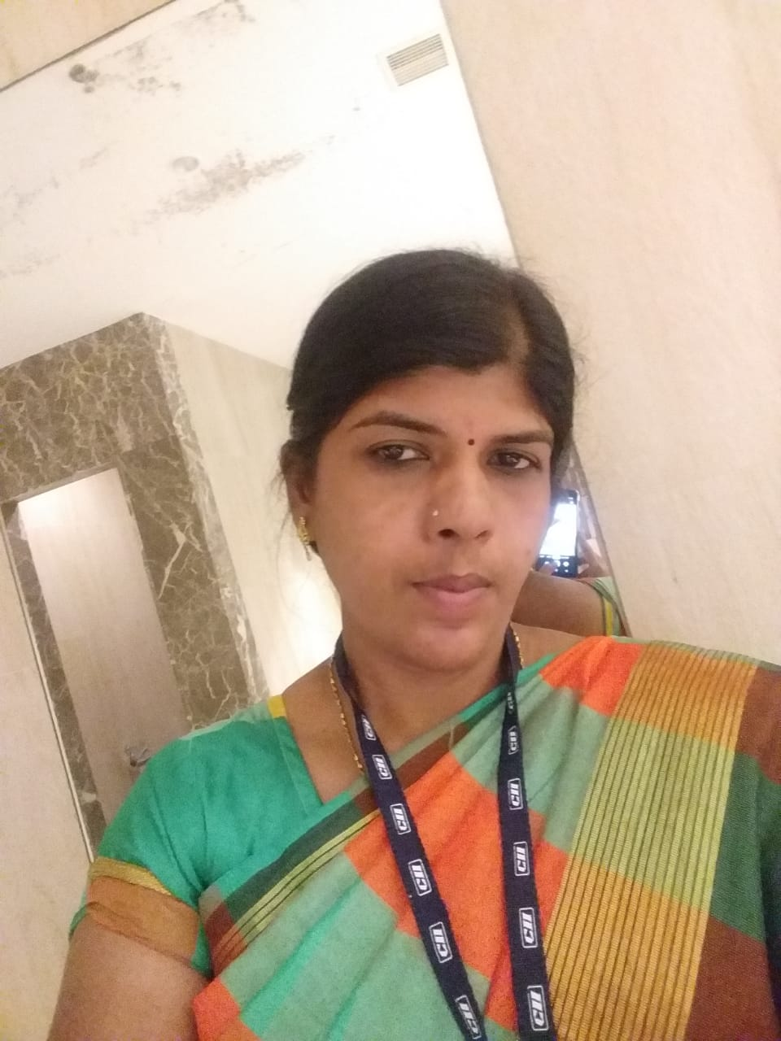
M PADMAVATHY
Mobile No: 8870 227134
Email ID padmavathy0120@gmail.com
Designation: Office Assistant (5yrs) )

CAREER OBJECTIVE:

To be an asset to the company by contributing to the growth of company value and to utilize my skills effectively in the recent developments and technology and at the same time improve myself professionally.

PROFILE SUMMARY:
- An enthusiastic fresher with highly motivated and leadership skills having bachelors of engineering degree in Mechanical Engineering.
- Expert in implementation of each step of project.
- Eager to learn new technologies and methodologies.
- Always willing to innovate the new things which can improve the existing technology.
Personal Qualities

.
- Eager to learn new technologies and methodologies.
- Actively involved in function and coordination of team within the assigned accounts

ACADEMIA:

- Bachelor of Business Administration from Sermathai Vasan college of Women and, Avaniapuram (1999-2002), 50%
- 12th 1998 Batch with 61% from Capron Hall G HSS Madurai
- 10th 1996 Batch with 64% from Capron Hall G HSS Madurai

CO- CURRICULAR ACTIVITIES:

- Drawing, Books reading,

ORGANISATIONAL EXPERIENCE:

Company Details:
- Previous Employer - Confederation of Indian Industry (CII) 
April 2015 – September 2020

Work Exposure

- Administrative:
- Taking phone calls, office maintains
- Doing administrative and clerical tasks (such as scanning or printing)
- Running errands to the courier office or supply store, telephone office, EB, Xerox, etc.…
- Maintaining folders on servers

Accounts
- Income and expenditure;
- Records of all income and expenditure such as copies of orders, invoices and receipts;
- other relevant information such as bank statements, cheque books and paying-in books.
- Accounts receivable.
- Accounts payable.

IT SKILLS:

- Operating systems: MS Office, Internet Applications

PERSONAL DETAILS:

Spouse Name - Mr Muruganandham
Date of Birth - 22.05.1981
Gender - Female
Language known - English and Tamil
Nationality - Indian
Address - B6/16 Housing Board
K K Nagar, Madurai – 625 020

