



## M.S.NITHIYAN

# 137B/117, Grace Cottage, Anthoni Puram, Suramangalam,

## Salem 636 005

TamfiNadu,

India.

Mobile : +91 8098891994.

Email : i hi e i La7 a o

Career Objective

"Seeking a chaLenging career witii a corporate structure which gives me a scope

to apply my knowledge and skills".

Position Applied:

*i• Assistant Manager Educational §Jualifications

B.A., English Litrature, Positive Traits

Quick learner and Hard worker

Can work under stress.

Positive attitude and self - motivated,

Team Motivation.

Clarity, CurioCsity,

Co-Ordination.

onfident, Commitment, Creativity, Communication,

Stren ths:

,y Self- Confident

„• Time management skills

,¿ Hard Worker

,¿ Quick Learner & Ready to do multitask

## ,¿ Honesty

Personal Skills :

# During Comprehensive problems, ability to deal with people Diplomatically,

$'J1ll1R \lt?SS tO

# Solve the issues by way of understandirig the customer needs.

Professsional Experience :

•^ Eureka Forbes Pvt Ltd , Salem.

•^ Kzazana Jewellery Pvt Ltd, Salem.

# Career Summaw

•^ Worked as an Group leader in Eureka Forbes Pvt Ltd , Salem From May 1999 To

## Dec 2005.

Worked as an Assistant Manager in Kzazana Jewellery Pvt Ltd, Salem From Dec 2009 To May 201S.

Job Responsibilities as a Show Ma a er:

I Dea•eloping and Maintaining a good relationship with customers through

personal contact or meeting or via telephone etc.

<* Listening to customer requirements and presenting them to the appropriate

sales counter for making a sale.

›f Mairitaining and developing relationships with existing customers in person and via telephone calls and emails.

# I Responding to incoming email and phone enquiries.

I Gathering market situatioris and customer information.

I Sending the sales images and fwther information to the HO for geHing the new stocks which are needed for effective sales purpose.

<* Merchandising the right products at right place foz effective attraction to choose

the choice of the customers.

<* Managing the available stalls to work in a professional way by giving positive

attitude to make the sales close.

Personal Profile :

## Name M.S.Nithiyan

Father’s Name M.Shanmugasundaram,

Date Of Birth . 22th May 1976. Languages Known to Speak and Write : Tamil and English Address # 137B/170, Grace Cottage,

## Anthoni Puram,

Suramangalam.

Salem - 63fi 005.

## Contact No +91 8098891994.

Declaration:

I declare that all the information mentioned above are true & correct to the best of

my knowledge.

Thanks and Regards,

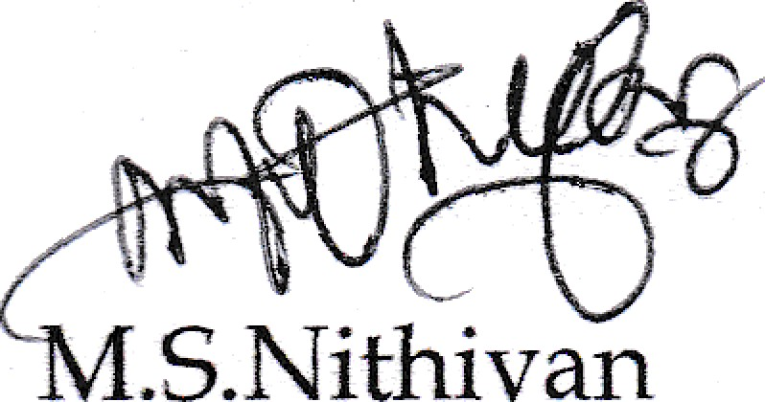

.S.Nithiyan

## Place Date



JIWELLERY

Date: 11*h Nov 20ä9

SERVICE LETTER

TO WHOM SO EVER IT MAY CONCERN

Tiris i» to certify that Mr. Nithiyan M S was employed with us as Assistant Manager - Sales

!rcn! t!^e pericd 23”* üesert:ber 20SS ic ?2'* May 01#.

ForKhazana Jewellery Pvt Ltd



Sathish Xumar D Manager - HR



Regd.off: Khazana Jewellery Pvt. Ltd., Khazana Square, 46, Whites Road, Royapettah, Chennai - 600 ß14, Tel:+91 (44) 42297700 CIN : U36999TN1992PTC022434, E mail: [corporate@khazanajewellery.com,](mailto:corporate@khazanajewellery.com) Website : [www.khazanajewelIery.com](http://www.khazanajewelIery.com/)