**ABINAYA R**

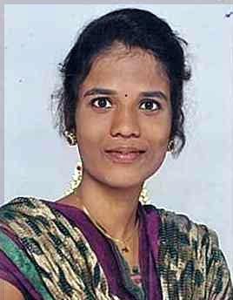

10D, New colony, North Street,

Chinnaudaippu (PTC) post,

Madurai (DT),

Phone: +91 9629850258

Mail id: er.dhivyalingam**@**gmail.com

**CAREER OBJECTIVE**

To work in pragmatic way in an organization where I can show the talent and enhance my skills to meet company goals and objective with full integrity and zest

**ACADEMIC PROFILE**

|  |  |  |  |  |
| --- | --- | --- | --- | --- |
| **Course** | **Institution** | **University/ Board** | **Year of passing** | **AGGREGATE** |
| BE(**Electrical Electronics Engineering)** | Velammal College of Engineering,  Madurai | Anna University, Chennai | 2014-2018 | 7.36% |
| HSC | Velammal Matriculation Hr. Sec. School,  Madurai | Matriculation | 2014 | 76.16% |
| SSLC | Velammal Matriculation Hr. Sec. School,  Madurai | Matriculation | 2012 | 85.80% |

*CGPA up to eight Semester

**FIELD OF INTEREST**

* Transmission and Distribution
* Power Electronics

**COMPUTER PROFICIENCY**

* Languages Known : C and C++

**CO-CURRICULAR ACTIVITIES**

**PAPER PRESENTED**

* Paper presented on the topic of **Solar Energy** in our college
* Paper presented on the topic of **Recent Trends In Power System** at RAMO Institute of Technology

**WORKSHOP UNDERGONE**

* Attended Embedded System at **Coimbatore Government College** in Coimbatore.

**MEMBERSHIP IN PROFESSIONAL ASSOCIATIONS**

* Active member in **Health Club**

**EXTRA CURRICULAR ACTIVITIES**

**SOCIETY CONCERN**

* Attended district rally level **Green Revolution** rally

**PERSONAL PROFILE**

Father’s Name : Mr A RAMALINGAM

Mother’s Name : Mrs R LAKSHMI

Gender : Female

Date of Birth : 14-july-1995

Nationality : Indian

Linguistic Ability : Tamil, English (read, write&speak)

Hobbies : Reading Novels

Place: Madurai

Date: (**R.ABINAYA**)