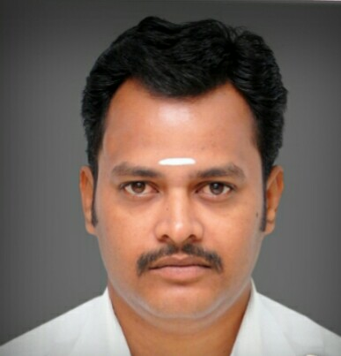

**CURRICULAM VITAE**

**Prembabu MC**

# 18A/5, New Ramnad Road, E-Mail: prembabumc@gmail.com

Madurai -9 Cell No.: 8608552737

## OBJECTIVE:

To enhance and develop my technical skills and continually learn

about the latest paradigm and processes. To fulfill my needs and aspirations along with the organization with loyalty and honesty.

**WORK EXPERIENCE** :

Working as a **Store Manager** in CHENNIS Madurai from

March 2019 to till date.

**JOB PROFILE** :

Taking care of inside sales and customer service. Also following

Showroom purchase order and cash handing. Sending all kind of operation works Report to Head office on daily basis.

**WORK EXPERIENCE** :

Working as a **Asst**.**Store Manager** in RAMRAJ COTTON Madurai from

Oct 2015 to Feb 2018

**JOB PROFILE** :

Taking care of inside sales and customer service. Also following

Showroom purchase order and cash handing. Sending all kind of operation works Report to Head office on daily basis.

**WORK EXPERIENCE:**

* Worked as a **Business Development Executive** in Malabar Gold & Diamonds at Madurai from June 2014 to sep 2015.

**JOB PROFILE**:

## 

## **Doing all kinds of Marketing work as, Door to door Marketing, KP data collection and Marketing, Indoor and outdoor (other cities) Exhibition marketing and VIP Marketing. When there is an any exhibition in show-room that time also coordinating the sales team. Successful sales has been done for the Exhibition of Sivakasi**, **Karaikudi**, **Melur and Theni** , **thirumalagam Indoor Artistry show**.

**WORK EXPERIENCE:**

* Worked as a **Floor cum advertisement Manager** in The Chennai Silks (Chennai) During the year 2004-2010

## JOB PROFILE:

## 

1. Managing the staffs & supervisors and maintaining the floor stock.
2. Comparing the other showroom products in terms of quality.
3. Compare the Advertisement with the Competitors.
4. Instructing the Supervisors to display the new product to the counter as soon as possible.
5. Handling all kind of Indoor and outdoor Advertisement and keep on checking and update for the same. (flex , wall paint add)

**WORK EXPERIENCE:**

* Worked as a **Gold appraiser cum Loan collection in** Land Development Bank (Melur)during 2002-2004.

## JOB PROFILE:

## 

1. Appraise the Jewell and approve the loan if the gold is really worth.
2. Full responsibility for the jewel loan which was approved by me.
3. If the due date is crossed need to inform the customer to do the renewal or pay for interest.
4. Collecting the document for Agriculture loans and other kind of loans.

**WORK EXPERIENCE:**

* Worked as a **Production Supervisor in** Vedal weaving mills during 1999-2002

**JOB PROFILE:**

1. Managing the labor’s and maintaining the production as per the raw material given to us.
2. Handling the labor’s for each shift and taking care of their shift change to not to stop the production. And Controlling the production each shift

**EDUCATIONAL QUALIFICATION:**

* Graduation.

Master Degree : M.A ,

University : Tamil Nadu Open University, Madurai.

Year of passing : 2006

Percentage : 58 %

* Diploma : D.T.T.,

College : K.L.N Polytechnic

Year of passing : 1998

Percentage : 60 %

## COMPUTER SKILLS:

MS-Office, DOS – Windows, HTML, ASP

## PERSONAL INFORMATION:

Name : Prembabu MC

Father’s Name : Chandrasekaran.M.S (Late)

Date of Birth : 08-Mar-1980

Sex : Male

Nationality : Indian

Religion/caste : Hindu / Sourasthra

Marital Status : Married

Languages Known : Sourasthra, English, Hindi, Tamil,

## DECLARATION:

I here by solemnly declare that all the above details provided by me is genuine and accurate to the best of my knowledge.

Date : Signature

Place : (Prembabu MC)