*RESUME*

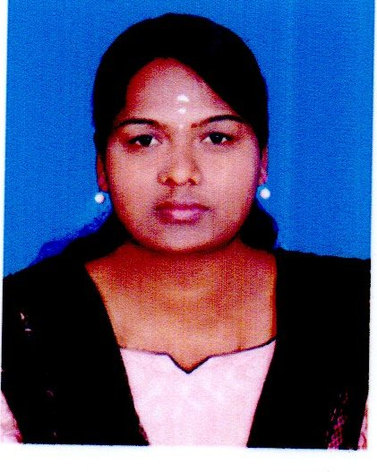

*T.SASIKALA*

Thulasinga Nagar(New Street)

Valparai Post.

Coimbatore Dist, E-mail Id : sasikala8825@gmail.com

Tamil Nadu. - 642127. Mobile no : 91- 9486420248

**CARRIER OBJECTIVE**

To be associated with a progressive organization which can provide me with a dynamic work sphere to extract my inherent skills as a professional , use and develop my aptitude to further the organization’s objectives and also attain my career targets in progress.

**EDUCATIONAL QUALIFICATION**

|  |  |  |  |  |
| --- | --- | --- | --- | --- |
| **COURSE** | **INSTITUTION** | **BOARD/UNIVERSITY** | **YEAR OF COMPLETION** | **% OF MARKS.** |
| **B.Sc., IT** | **Bharathiar University Arts & Science college Valparai.** | **Bharathiar University** | **2013 -2015** | **70%** |
| **H.Sc.** | **Govt. Higher Sec. School, Valparaiso.** | **State Board** | **2011-2012** | **50%** |
| **S.S.L.C.** | **Govt. Girls Hr.Sec. School, Valparai** | **State Board** | **2010** | **71%** |

**EXTRA QUALIFICATION**

* Diploma in Hardware and Networking with ‘A’ Grade –by SSI – IT Education.
* Typewriting Higher English & Tamil
* NSS & SPORTS

**TECHNICAL SKILLS**

* Operating System : Windows 9X/2000/XP/7
* Programming Languages : C, C++., JAVA , VB.NET
* Packages : MS Office
* Web Technology : HTML
* Multimedia Tools : Movie Maker

**AREA OF INTEREST**

* Computer Networks.
* Wireless Network Communication.
* Object Oriented Analysis and Design
* Web Designing.

**PROJECT**

Presently working in a final year project “ TEMPLE MANAGEMENT SYSTEM”.

Attending Seminar “Challenges and Opportunities in Computing Research” by

Sree Saraswathi Thyagaraja College Coimbatore.

**ACHIEMENT**

Talent Oriented Inter Collegiate Meet “TEXCIT 14” IInd place winner in Web

Designing conducted by Sree Saraswathi Thyagaraja College Coimbatore.

No History in Arrears of my Course Periods.

**EXPERIENCE**

2 years working in the Accounts Section in Kosamattam finance at

Valparai

**PERSONAL PROFILE**

**Name : T.SASIKALA**

**Father’s Name : A. Thirupathi**

**Sex : Female**

**Date of Birth : 21.06.1994**

**Marital Status : Unmarried**

**Nationality : Indian, Hindu**

**Languages Known : Tamil & English**

**Permanent Address : D/o A. Thirupathi**

**Thulasinga Nagar(New Street)**

**Valparai -642127**

**Coimbatore Dist.**

**DECLARATION**

**I hereby declare that all the details furnished are true to the best of my knowledge and belief. Thanking you,**

**Date : Your faithfully**

**Place : Valparai.**

**( T.SASIKALA)**