**RESUME**

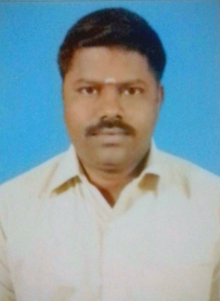

**ARUMUGAM.S**  No:36, Chetty street,

Pandamangalam,

Woraiyur,

Mobile No: +91- 8610214260 Trichy - 620003

E.Mail Id : citraru85@gmail.com Tamil Nadu.

**Objective**

To obtain as any position in a people-oriented organization with a challenging environment, to achieve the corporate goals, and to maximize my secretarial skills and experience.

**■ Personal Attributes**

* Accuracy | Excellent organizational skills | Confidentiality | Planning and Time management
* Initiative | Reliability | Stress tolerance | Customer-service orientation.

**ACADEMIC QUALIFICATIONS:-**

|  |  |  |  |
| --- | --- | --- | --- |
| Academic | Name of the Institution | % of Marks Obtained | Year of Passing |
| B.SC(Maths) | BharathidasanUniversity,Trichirappalli | 67 % | 2004 |

**Work Experience/Background**

**Sales Man in GRT Jewellers - 2012 JAN to 2016 OCT**

**Objectives and Achievements:**

* To inform customers and clients of all benefits on offer
* To inform customers and clients of new versions and variations of products
* To make actual sales through convincing salesmanship
* To inform customers and clients of offers, promotions and schemes
* Worked in Gold ,Silver and Diamond section
* To meet sales targets

**Sales Manager in N Gopaldas Diamond Jewellers - 2017 to 2018 MAY**

**Objectives and Achievements:**

* Supervise and Motivate the juniors
* Plan sale strategy and set the target
* Handle the daily operation and management
* Daily reports send to Management every day
* Assumed responsibility of providing new employees with training and orientation
* Handled Branch activities.
* Promoted sales exe to Manager. ( Manager as 9 months)

**Floor Manager in Lalitha Jewellers - 2018 JUL to 2019 MAR**

**Objectives and Achievements:**

* Supervise and Motivate the juniors
* Plan sale strategy and set the target
* Handle the daily operation and management
* Daily reports send to Management every day
* Assumed responsibility of providing new employees with training and orientation.
* Worked in Diamond and Gold section

**Personal Details:-**

Name : S.ARUMUGAM

Father’s Name ; N.Sivasankaran

Date of Birth : 13.04.1984

Age : 35

Sex : Male

Religion : Hindu- Kammalar

Marital status : Married

Languages Known : Tamil, English and Hindi to speak.

Address for communication : No:36, Chetty street,

Pandamangalam, Woraiyur,

Trichy - 620003

Tamil Nadu,

**Declaration**

I hereby declare that all the above particulars are given by me are true and correct to the best of my knowledge**.**

**Signature**

**S.ARUMUGAM**