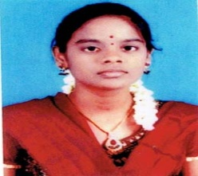

R.SOUNDARYA

Mobile:9894502741

E-mail id:soundarya8969@gmail.com

**Career Objective:**

To work for an organization which provides me the opportunity to improve my skills and knowledge

**Academic Qualification:**

|  |  |  |  |
| --- | --- | --- | --- |
| Degree/course | Institution | University/Board | Percentage |
| M.sc(maths) | Thiagarajar college | Kamaraj university  (Madurai) | 83.3 |
| B.sc(maths) | Fatima college | Kamaraj university  (Madurai) | 91 |
| XII | E. V.R.N.Girls  Hr.Sec.School  (Madurai) | State Board | 79 |

Co-curricular activities:

* Writing short stories
* Computational Mathematics

Software proficiency:

* Visual Basic
* C,C++,PGDCA

Operating system:

* Windows XP, 7, 8

Strengths:

* Self motivated, Honest
* Quick learner, Hardworker

Hobbies:

* Learning new things
* Listening to music

Languages known:

* Tamil, English

**Personal Memoranda**

Father’s Name : T.Rajendran

Age & Date of Birth : 23 & 08-09-1996

Blood Group : $O^{+}$ ve

Address : 55,south marret street, madurai -625002

Experience: : 3 Months as OMT

1 year Billing work in ITC

I hereby declare that the above details are true to my Knowledge

Date:

Place: Madurai Signature of the Applicant