## **RESUME**

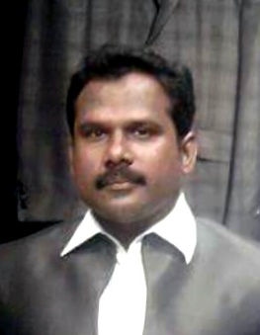**B.GNANA SUNDARAM**

**Cell No - 9894164307**

**Email ID: manispri@gmail.com**

**Objective:**

To be associated with a progressive organization that gives scope to apply my knowledge and skills, and to be a part of a team that dynamically works towards the growth of the organization.

**Educational Profile:**

**ITI DIESEL MECHANICAL SENTHU BASKAR INSTITUTION**

**SSLC (1996) Alagappa Model Hr.Sec school- Karaikudi**

**Strengths:**

* I am a flexible person to learn and work different environment.
* Capable of working hard to complete the work.
* Group co-ordination and punctual at all times.

**Technical Skill:**

* **Operating System** - **Windows, 98/ME/XP/NT.**
* **Packages** - **MS-Office,V.B-6.0,Wed design HTML,Hardware**

**Working Experience:**

Organization name : ICICI Bank (Personal Loan)

Profile : Team In charge

Period of working : April -2001 to Dec -2003

Address : Madurai

Organization name : State Bank of India (Credit Card)

Profile : Team Leader

Period of working : Jan -2004 to Nov -2008

Address : Madurai

Organization name : ZIMSON WATCH

Profile : SERVICE CENTRE INCHARGE

Period of working : Jan -2009 to Dec -2011

Address : Coimbatore

Organization name : UK SILKS – THE FAMILY SHOP

Profile : SHOWROOM MANAGER @ ADMIN

Period of working : Jan -2012 to June -2017

Address : Coimbatore

Organization name : AMAZON LOGISTICS

Profile : TEAM LEADER

Period of working : Jan -2018 To Dec -2019

Address : Coimbatore

**PERSONAL PROFILE**

**Name : B.GnanaSundaram**

**Father Name : S.S.Balasubramanian**

**Date of Birth : 01.08.1980**

**Nationally : Indian**

**Sex : Male**

**Marital Status : Married**

**Language Known : TAMIL & ENGLISH (Read & Writing)**

**Present address : No 89,Meenakshi amman nagar**

**Surya Nagar,K.pudur Madurai 625006**

**Permanent address : 2/2062, 2nd Street,**

**K.K. Nagar,**

**Kalanivasal, Karaikudi,**

**Sivagangai Dist. – 630 002**

**Declaration,**

**I hereby declare that the above stated information is true to the best of my knowledge and**

**Faith.**

***Yours faithfully***

**(*GnanaSundaram.B)***

**Place : Madurai**

**Date : .01.2020**