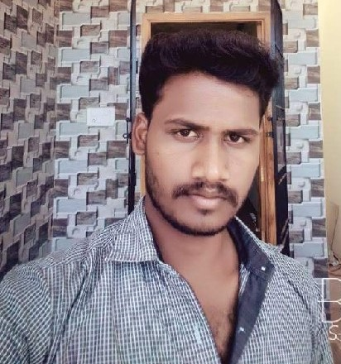 **NAME : K.RAJESH**

**MOBILE : +91-8754247840**

**EMAIL : rrrajeshrevathi.re@gmail.com**

Professional Summary:

I have completed Civil Engineering with totally 2 years 3 months experience as Site Engineer in construction of Industrial and Building projects, I have good knowledge in Auto cad, MS excel, MS word and MS Project.

Professional Experience:

Employer : M/s Vijaya Sarathi Infraa Private Limited

Period : Aug 2019 to Present

Current Position : Site Engineer

Current Project : Grand parant , hosyr

Project Value : 12.5 Crores

Project Duration : Aug 2019 to Present

Previous Site Experience:

Employer : Varatharajan Construction

Project Name : Commercial building & Residential Chennai

Project Duration : Dec 2018 to May 2019

Project Value : 22 Crores

Employer : Sanjana homes

Project Name : Commercial building Chennai

Project Duration : Dec 2017 to Nov 2018

Project Value : 10 Crores

Client : Subam homes

Employer : Eminient foundation

Project Name : Residential Building Chennai

Project Duration : March 2017 to Nov 2017

Project Value : 18 Crores

Client : New Horizon home

Actions / Responsibilities:

* Report to Construction manager and Site manager.
* Coordinate work activities with Sub-contractors and others section engineers and interfacing contractors.
* Ensure compliance with the Specification and relevant Standards for site works.
* Ensure and file all inspection reports/records .

Prepare method statements for the relevant work items.

* Conduct training/briefing to Supervisors on relevant Method Statements, Standard Work Method, Work Instruction Work Quality Plan.
* Prepare daily/weekly quality and progress reports.
* Site work quality of Sub-contractors on site and report for non-conformance

Educational Qualification:

|  |  |  |  |
| --- | --- | --- | --- |
| Course | Institute | University / College | Marks |
| Civil Engineering | Thiruvallur Engineering College & Technology | State Board of Technical Education | 73 % |

**Other Qualification & Skills:**

* Auto Cad
* MS Project
* MS office

Personal Details:

Name : Rajesh K

Fathers Name : Kumar

Sex : Male

Marital Status : Single

Date of Birth : 25/05/1996

Address : No 318 ,Pillayar kovil street,

Vallam Koot road , Kadambai post,

Vandavasi TK,

Tiruvannamalai District.

Tamil Nadu

Languages Known : Tamil, English, Hindi

**Declaration;**

I hereby declare that, the above information furnished by me is correct up to my knowledge and I hear the responsibility for the correctness of the above-mentioned particulars.

Place : SIGNATURE

Date :

(k.Rajesh )