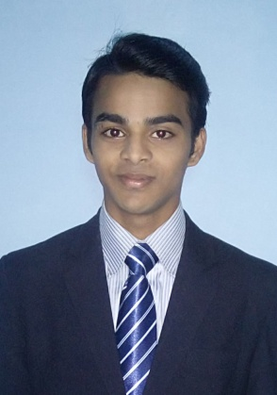**CURRICULUM VITAE**

**NAME : KALAISELVAN. M**

**Email Id :** [**selvankalai791@gmail.com**](mailto:selvankalai791@gmail.com)

**Ph. No. : 8610953250**

**Objective :**

To work with the progressive company that offers challenging work atmosphere with long term growth prospects and gives me an opportunity to prove caliber and improve my intellect in hospitality industry.

**Academic Qualifications :**

|  |  |  |
| --- | --- | --- |
| **Year** | **Institute / University** | **Degree / Examination** |
| 2013-2016 | Bell Institute of Hotel Management, Sivakasi | Diploma, (C & HA) |
| 2012-2013 | M.N.M.S.P.S. High Secondary School, Mallanginar | SSLC |

**Work Experience :**

IET – Six Months training in RADISSON BLU CHENNAI CITY CENTRE

OJT– Six Months job training in FOUR SEASONS HOTEL IN NUMBAI

**Languages Known :**

Tamil (Read, Write, Speak)

English (Read, Write, Speak)

**Personal Details :**

Father Name : S. Muthukrishnan

Age, Date of Birth : 21, 29-07-1998

Marital Status : Unmarried

Nationality : Indian

Address : 1/1086, Malli Kittangi Street

Pandian Nagar

Virudhunagar – 626 001

**Declaration**

I declare that the above information is true to my knowledge and belief.

Date : (Kalaiselvan.M)

Place :