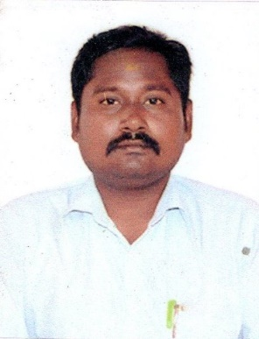**RESUME**

|  |  |
| --- | --- |
| **MANIKANDASEKAR . S**  **Mobile: 7397069217**  **Email: mslsekar88@gmail.com** |  |

­­­­­­­­­­­­­­­­­­­­­

**OBJECTIVES**

I would like to take a challenging position in an esteemed organization where my knowledge and skill would greatly enhance the company’s success and my own personal growth.

**ACADEMIC QUALIFICATION**

|  |  |  |  |
| --- | --- | --- | --- |
| **CLASS** | **NAME OF THE INSTITUTION** | **PERIOD**  **OF STUDY** | **PERCENTAGE** |
| **B.Sc Chemistry** | Alagappa Unviersity | 2010 | 60% |
| **HSS (+2)** | KR Higher Secondary School | 2008 | 50% |
| **SSLC** | KR Higher Secondary School | 2006 | 60% |

**WORKING EXPERIENCE**

1. Ipac - Activa Division working at 2 ½ years worked on Trichy HQ
2. Ranbaxy - Reachout Division working at 1 ½ years worked on Trichy HQ
3. ICICI Bank - Senior officer at Thiruchendur Kayalpattinam Branch Working at 4 years

**PERSONAL PROFILE**

|  |  |  |
| --- | --- | --- |
| Name | : | **MANIKANDASEKAR. S** |
| Father’s Name | : | T. Sundaramahalingam |
| Date of Birth | : | 02.01.1988 |
| Sex | : | Male |
| Religion | : | Hindu |
| Nationality | : | Indian |
| Marital Status | : | Married |
| Contact Number | : | 7397069217 |
| Address | : | 3B, Mookapillai 1 Street, Tallakulam,  Madurai - 625002. |
| Language Known | : | Tamil & English |

**DECLARATION**

I hereby declare that the details furnished above are true and correct to the best of my knowledge.

Place : Madurai Yours Faithfully,

Date :

**(MANIKANDASEKAR . S)**