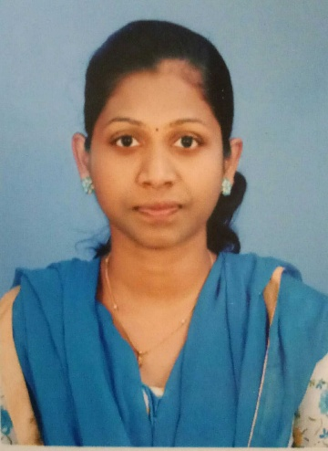**INFANT M RESHMI. M.Sc, B.ed**

Email: infantreshmi05@gmail.com

Mob: +91 9360971869

**OBJECTIVE**

To obtain a position in special education teaching that will allow me to use my strong passion for student development coupled with skills and experience that will enable me to make a difference at School.

**EXPERIENCE**

Working as a **MATHS TEACHER** in Global Public School (CBSE), Karatagi in Karnataka, India from 4 June 2019 to still date

| Worked as **MATHS TEACHER**| ARC PUBLIC SCHOOL, Maharastra, India from 1st April 2017 to 2019 |

Good Computer skills.

Good communication skills, easily understood by students.

**ACHIEVEMENTS**

* Special recognition by Principal for good work.
* 100% result in every class.

**EXTRA DUTIES**

* Every day math tuitions conducted for students ( 1 to 10thstandard)
* Preparing at logical maths questions

**ACADEMIC QUALIFICATIONS**

* B.ED (maths) with 80 % marks at **ANNA VINAYAGAR College of** Education Tamil Nadu, from 2015 to 2017
* Bachelors Degree in Mathematics with 71 % marks, at **ST JEROMES** Arts and Science College

MS UNIVERSITY, Tamil Nadu, from 2012 to 2015

* Masters Degree in Mathematics (Doing.......)
* Higher Secondary with 68 % mark at **LITTLE FLOWER** school, Tamil Nadu from2010 to 2012
* SSLC with 84 % marks at **ST.JOSEPH** school, Tamil Nadu from 2008 to 2010

**COMPUTER LITERACY**

* Working knowledge at computer
* Operating systems: Windows XP, Vista.
* Application packages: MS Office.

**PERSONAL DETAILS**

Date of Birth : 05/04/ 1995

Languages known : English,Tamil,Hindi

Address : H.N:5/408, James nager, Muttom

Kanyakumari dist-629202

Tamil Nadu

Interest : Listening song and read books

DATE : Yours faithfully , Place : ( INFANT M RESHMI )