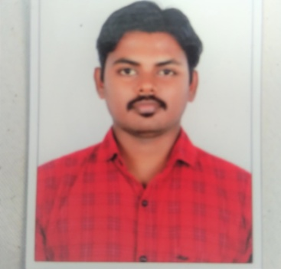**Vignesh R**

2,Raju Street,

West Mambalam

Chennai-600033  
**M:+919488677163**

E-Mail : [Vicky.vdm@rediffmail.com](mailto:Vicky.vdm@rediffmail.com)

**About Myself :**

I am very Practical Person with an amiable disposition and Strong Cultural values.I Believe I have Good Communication Skills that would Provide Transparency and Productivity in the Organization.

**Education Qualification:**

* SSLC From Govt High Sec School in the Year Of 2005.
* 12th From Govt High Sec School in the Year Of 2007.
* B.Sc Computer Science in the Year of 2010 (Bharathidasan University).
* MBA Marketing in the Year of 2012 (Manomanium University).

**Career Experience:**

* Worked at  **EZ Cost Wholesale Pvt Ltd** Joined May 2017 to May 2020
  + - Designation : Senior Sales Executive
* Goals set for centres month on month, maintaining relationship with target customers.
* Maintaining AD stock as per norms, Credit Amounts collection, Provide daily updated data to AD., Promoting the Brands & Encouraging the Sales through various Promotional Activities (No Parking Boards).
* Updating all Customer Credits records and documents (Hard copy as well as Soft copy), maintaining Near By Expiry stocks.
* Proper execution of order and dispatch it on time.
* Follow up for Retailers Payments and Product Related Quires.
* Report sales activity to upper management
* Monthly twice regular visit junior executive retailers for inspection about executive knowledge.
* Worked at **Naricuss Hotel and Residence,Riyadh**(April 2014 To May 2016)
  + - Designation : Floor Supervisor
* Responsible for supervising the work of the on-duty staff
* Assign duties to the employees
* Issue cleaning equipment and supplies to the staff for respective duties
* Confirm with the front office for special guest requests such as flower arrangement in the room, etc.
* Ensure that arrival rooms are made ready on time
* Make sure that the check out rooms are cleaned and handed over to the front office on time
* Update the system with real time status of room occupancy and the cleaning status
* Ensure that the public areas are regularly cleaned, especially during events or functions
* Prepare shift closure report
* Give and take proper handover at the end and beginning of the shift
* Coordinate with the housekeeping manager for conducting the performance appraisal

**Achievements:**

* Achieved Best Employee of the Year of 2018 at Ez CostWholesale Pvt Ltd.
* Received Shares From Ez CostWholesale Pvt Ltd.

**Computer Literacy:**

* MS Office(Excel ,Outlook, Access, Project)
* Windows OS

**Personal Information:**

Date Of Birth: 14th Dec 1989

Fathers Name: Ramesh

Marital Status : Married

Languages known: English ,Hindi ,Tamil,Telugu&kannada

**Declaration :**

I acknowledge that the details shared above are true to the best of my knowledge and belief and can be supported with documented proofs, if required.

**Best Regards,**

**Vignesh R**