**CURRICULUM VITAE**

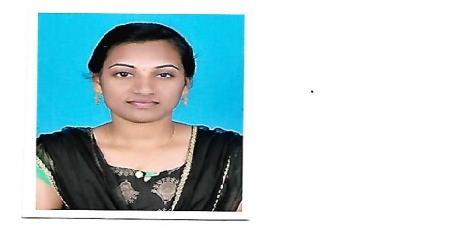

**M.VIJAYALAKSHMI**

Swamiyarmadam,

Kanayakumari.

**OBJECTIVE**

To work in an institution that provides ample opportunities to develop professional qualities and to contribute constructively to the overall betterment of the organization and my family.

**EDUCATIONAL QUALIFICATION**

|  |  |  |  |  |
| --- | --- | --- | --- | --- |
| **Education** | **University / Board** | **Name of the Institution** | **Academic Year** | **Percentage** |
| 10th | State Board | Nadar Higher Secondary School, Kovilpatti | 2008-2009 | 75% |
| HSC | State Board | Nadar Higher Secondary School,Kovilpatti | 2010-2011 | 73% |

**PROFESSIONAL QUALIFICATION**

|  |  |  |  |  |
| --- | --- | --- | --- | --- |
| **Education** | **University / Board** | **Name of the Institution** | **Academic Year** | **Percentage** |
| Bachelor of Nursing | The Tamil Nadu Dr. MGR Medical University, Chennai | V.V.Vanniaperumal Nursing College For Women Virudunager | 2011-2015 | 73% |

**PROFESSIONAL REGISTRATION**

|  |  |  |
| --- | --- | --- |
| **Registration** | **Registration No.** | **Registration data** |
| Nursing & Midwife Registration Council, The Tamil Nurses & Midwives Council | Nurse & Midwife –161858 | 19/01/2016 |

**WORKING EXPERIENCE**

|  |  |  |  |  |
| --- | --- | --- | --- | --- |
| **Designation** | **Name of the Hospital** | **Job Specialization** | **Period** | **Total Experience** |
| Staff Nurse | 200 Bedded Vadamalaiyan Hospital, Madurai | EmergencyIntensive Care Unit | 3years | 3years |

**EQUIPMENT USED, JOB DESCRIPTION AND RESPONSIBILITIES**

|  |  |
| --- | --- |
| **Job Description and Responsibilities** | **Equipment used** |
| Patient care  Management of Emergency, ICU  Hemodynamic monitoring  ABG Analysis  Assisted like, intubation, CPR, ICD, Bronchoscopy, thoracic and abdominal aspirations.  Vitals signs checking  Administration of medication  Airway management  Catheterization (female)  Suctioning and drainage  Checking blood sugar  BLS, ACLS course completed   * Care of patient with IABP | Infusion pump  Cuff pressure monitor  Suction apparatus  ABP Monitor  Infusion pump  Cardiac monitors  Ventilators  Oxygen flow meter  BP apparatus  Defibrillater  Syringe pump |

**PERSONAL PROFILE**

Name : **M.VIJAYALAKSMI**

Father's Name : Mr. S. MURUGAN

Date of Birth : 01.04.1994

Sex : Female

Marital Status : Married

Nationality : Indian

Religion : Hindu

Mother Tongue : Tamil

Languages Known : Tamil, English, and Malayalam

Phone No : 8056981494

Email ID : m.viji141994@gmail.com

**DECLARATION**

Hereby I declare that the above given information are true to my knowledge.

Place: Marthandam,

Date :

**M.VIJAYALAKSMI**