***CURRICULUM VITAE***

NAME : MADHUMITHA.A

ADDRESS : M.274 NEW HOUSING BOARD

NARASSINGAPURAM,

ATTUR(PO),SALEM(DT),

636108

E-MAIL : preanaja2910@gmail.com

CONTACT NO: 7010933846

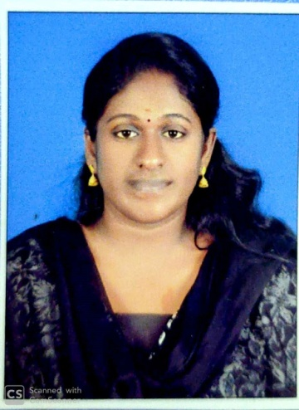

***OBJECTIVES :***

Having a strong desire to pursue a career in Ayurveda Health Care Sector. This can give me a chance to utilize my knowledge, potential and to expand it. I would like to be part of your organization; itsgrowth along with my personal success.

***EDUCATIONAL QUALIFICATION* :**

|  |  |  |  |
| --- | --- | --- | --- |
| Y YEAR | INSTITUTION | | PP PERCENTAGE |
| 2010 | | SARASWATHI MATRIC HIGHER SECONDARY SCHOOL | 81 % |
| **STATEBOARD** |
| 2012 | | SARASWATHI MATRIC HIGHER SECONDARY SCHOOL | 65% |
| **STATEBOARD** |
| 2019 | | Dharma Ayurveda Medical College & Hospital.  Dr. M.G.R. Medical University ,sriperumbudhur(TN) | 60% |
| **BAMS** |

***ACTIVITIES :***

**Seminars:**

* Advance Core Life Support And First Aid Training Program By Indian Istitute Of Medical Service ,2018
* Soft Tissue Rheumatism & Anuktha Vyodhi Chikitsa At Ayargram

Coimbatore.

* State Level Seminar On Therapeutic Yoga,2017
* Seminar On Autism Spectrum Lifestyle Disorder ,2017
* Seminar On Musculo Skeletal Disorder ,2016
* Krishamacharya National Level Yoga Seminar,By Nasya
* Seminar On Autism Spectrum Lifestyle Disorder ,2017

***TECHNICAL SKILLS :***

* I attended many patients with different disease during my internship period .i had done many therapies and cured many vata vyadhis in my college opd and assisted my medical officer in many cases,
* I had prepared medicine and external ointments for certain disease
* I had more experience in external therapies like abhyangam swedanam ,kati basthi, jalaukaavacharanm
* Knowledge about basic life supporting medicines .

**Experience:**

1. Internship At Dharma Ayurveda Medical College &

Hospital (6 Month)

1. Compulsory Rotational Internship

* Dharma Ayurvedic Clinic, Adayar (6 Month)
* Trained Under Senior Physician In Department

Of Surgery, Ophthalmology, Ent, Gynecology

At Esic Hospital, Chennai

***PERSONAL PROFILE :***

|  |  |
| --- | --- |
| Name | MADHUMITHA.A |
| DOB | 29.10.1994 |
| Age | 25 |
| Sex | Female |
| Marital | Single |
| Name of Father | C.AYYADHURAI |
| Name of Mother | SUMATHI |
| Nationality | Indian |

LANGUAGE KNOWN:

English, Tamil

AREA OF INTEREST :

* Consultation And Prescribing Medicine
* Preparing Medicines

DECLARATION :

I do hereby confirm the information furnished above is true to the best of my knowledge .i can contribute substantially to the organization i join

BY

Dr.MADHUMITHA.A