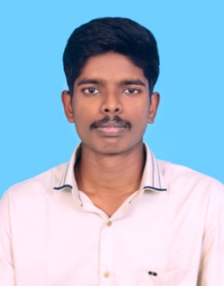**GNANA SUGANTH.V**

Degree: - B.voc (Hospital Instrumentation and Management),

E-mail: - gnanavel224@gmail.com,

Phone No: -9965605817.

**CAREER OBJECTIVE**

“To work in a highly competitive environment with a perfect challenge by contributing the best for the growth of the organization while ensuring growth in personal career”.

**EDUCATIONAL QUALIFICATION**

|  |  |  |  |
| --- | --- | --- | --- |
| **Discipline** | **Name of the institution** | **Year of passing** | **Percentage/grade** |
| B. Voc [HI&M] | Annamalai University,  Chidambaram. | 2020 | 7.OGP |
| HSC | St.paul’s matriculation hr.sec.school,neyveli | 2017 | 140.67% |
| SSLC | St.paul’s matriculation hr.sec.school,neyveli | 2015 | 83.6% |

**CURRICULAR ACTIVITIES**

* Processing of medical images (MAT lab).
* MS–OFFICE.
* Troubleshooting of minor medical equipment.
* Able to handle analyzers and calibration devices.
* Operation theatre equipment handling and servicing.

**AREA OF INTEREST**

* Clinical engineering.
* Radiological technician.
* Servicing and calibration of biomedical equipment.
* Management of hospital minor equipment.
* OT Technician and equipment handling.

**PERSONAL DETAILS**

|  |  |
| --- | --- |
| **Name** | Gnana suganth.V |
| **Father`s Name** | Venkatesan.G |
| **Permanent Address** | Om sakthitemple,fowl lane,block-3,neyveli-607801,cuddalore district. |
| **Date Of Birth** | 17-03-2000 |
| **Marital Status** | Single |
| **Nationality** | Indian |
| **Linguistic Skills** | English, Tamil |

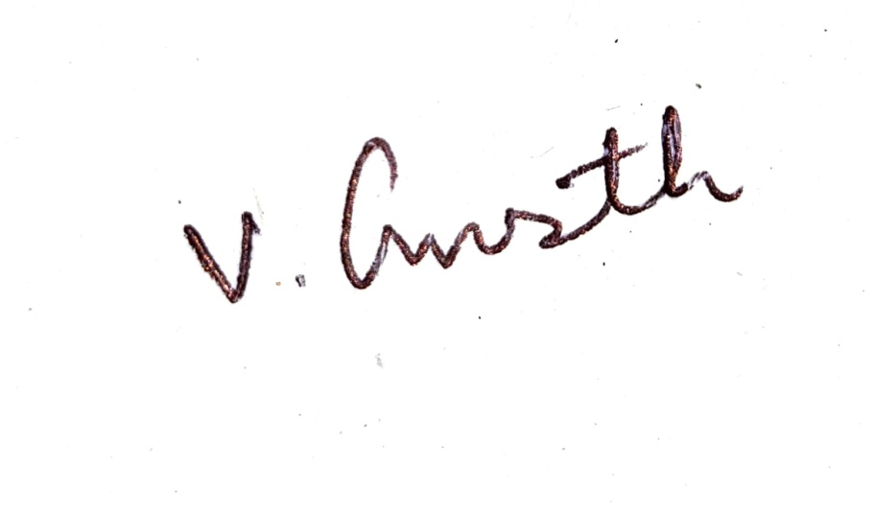**GONE TRAININGS**

* Undergone designing of PCB by using EAGLE software and hands-on workshop training in the SUNSHIV Electronic solutions.
* UndergoneHands-On Training On Medical Electronics and its properties in TMI System.
* Undergone hands-on practical in Raja Muthaiya Medical College& Hospital [RMMCH] on major equipment servicing.
* Undergonethe online examination for Medical Equipment Technician[MET] in National Skill Development Corporation [NSDC].

**DECLARATION**

I do hereby assure you that the above information and the details are true to the best of my knowledge.

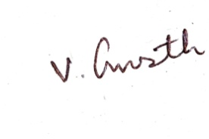

**GNANA SUGANTH.V**