**K . NALIM MILAN**

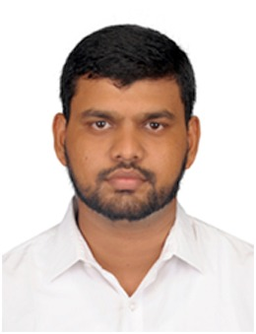

6/A Quthe millathe nager

East vally street

Madurai-625001.

Email ID**:**nalimmilan881@gmail.com

Contact No**:** 7530054361

**-------------------------------------------------------------------------------------------------------------------OBJECTIVE:**

To secure a challenging position in an esteemed organization where I can utilize my skills for the organizational development and constantly learn for my personal development.

**EDUCATIONAL QUALIFICATION:**

|  |  |  |  |
| --- | --- | --- | --- |
| **DEGREE** | **NAME OF THE COLLEGE/**  **SCHOOL** | **YEAR OF PASSING** | **PERCENTAGE OF MARKS** |
| B.Tech in  Civil engineering | Dr.M.G.R. Educational and Research Institute University | 2014-2017 | 61.1% |
| HSC | M.A.M Matriculation Higher Secondary School | 2011-2013 | 55% |
| S.S.L.C | ST.ANNES Higher Secondary School | 2010-2011 | 60.6% |

**TECHNICAL SKILLS:**

**Software knowledge :** AUTO CADD.MEP

**Operating System :** Windows XP, Windows.

**AREAS OF INTEREST:**

* Customer Service
* Production.
* Quality control.
* Industrial Management.

**PERSONAL SKILLS:**

* Willingness to learn
* Team work & Communication Skills
* Adaptive to work
* Hard and smart worker

**ACHIEVEMENTS:**

**PAPER PRESENTATIO**N:

* Won **1st Prize** in **PAPER PRESENTATION ON MECHANICL ENGINEERING IN 2025**

**WORKSHOP:**

* Participated in one day workshop on **“CUTTING TOOLS AND LUBRICATION”** conducted on 15th July 2014.
* Participated in one week workshop on **“ENGINE DISMANTLING”**
* Participated in one day Industrial visit in **ICF**.

**PERSONAL PROFILE:**

Name : K.Nalim milan

Father’s Name : Mr.M.Kaleel rahuman

Mother’s Name :. Mrs.K.Farvin banu

Date of Birth : 08.06.1995

Sex : Male

Age : 22

Marital Status : Single

Nationality : Indian

Hobbies : Listening to music, Playing Cricket

Languages known : English, Tamil.

**DECLARATION:**

I hereby declare that the above mentioned information is correct up to my knowledge and I bear the responsibility for the correctness of the above mentioned particulars .

PLACE: MADURAI (K.NALIM MILAN)

DATE : 23/07/2017