Name: **G.SUGANYA**  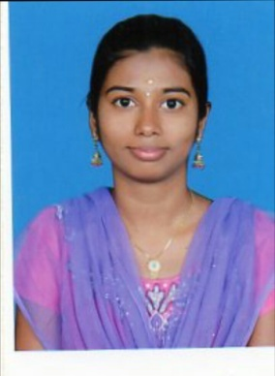

E-mail:suganyasriklu@gmail.com

Phone: +91 994-392-4624

**Career Objective:**

To serve for an organization with moral excellence, diligence and strive to attain great heights.

**Key skills:**

-Programming Languages: C, C++

-Web Technologies: HTML

-Database: MYSQL

**Personality Traits:**

- Good listener, Active team player and a Self-starter.

-Intelligent, Punctual, Hard working, Responsible

-Easily adaptable to new technologies

**Certifications:**

-Successfully completed certification course **CLOUD COMPUTING** in **ICTACT** academy-June 2015

-Successfully Completed **BEC (BUSINESS ENGLISH CERTIFICATION**) course

**Educational Qualifications:**

- 2012-2016 B.Tech (Bachelor of technology) in ComputerScienceEngineering from

KALASALINGAM UNIVERSITY Secured 7.58CGPA

- 2010-2012 12th HSC from C.E.O.A Matriculation Higher Secondary School,

Secured 74.75%

-2009- 2010 10th SSLC from St.Joseph’s Girls Higher Secondary School

Secured 79.6%

**Co-Curricular Activities:**

-Attended two days Workshop in **ENTREPRENEURSHIP DEVELOPMENT PROGRAM**

-Attended one day Seminar in **RECENT TRENDS IN MOBILE APPLICATION DEVELOPMENT**

**-**Undergone IN-PLANT TRAINING **“Fundamentals of Telecom”** in **BSNL, TUTICORIN**

**-**Undergone IN-PLANT TRAINING in **ASP.NET** in **ZEALSOFT SOLUTION, MADURAI**

-Undergone IN-PLANT TRAINING in **“Cloud Computing”** in **PHOENIX SOFTECH, MADURAI**

**-**Attended “NATIONAL CONFERENCE ON RECENT ENHANCEMENT IN ADVANCED COMPUTING TECHNOLOGIES” and presented a paper in **POLLUTION DETECTION AND OBSERVING USING IOT**

**-**Done **INTERNATIONAL JOURNAL OF DIGITAL COMMUNICATION AND NETWORKS (IJDCN) VOLUME 2, ISSUE 12, DECEMBER 15**

**Curricular Activities:**

**-** Member as **NSS** volunteer and undergone for NSS CAMP at **SETHUNARAYANAPURAM.**

**-** Co-Ordinator in Photography Club.

**-**Participated in “State Level Essay Competition” conducted by ANURAGAM during school days

**-**Professional Society: Member in **CSI** (Computer Society of India) association.

Area of Interest:-Data mining, Computer Networks

**Minor project:**

**TITLE: ONLINE COLLEGE MAGAZINE**

**Project Description:** Collecting the articles from both the student and the staff and uploading the information in the website and they can also update their profile details.

**Major project:**

**TITLE: VEHICULAR POLLUTION MONITORING USING IOT**

**Project Description:** The aim of this project is designing a microcontroller based toxic gas detection , and if the gas has detected it automatically alert the owner and also the vehicle door will be automatically opened then it transmits the warning message to the authorized user.

**Hobbies:**

-Reading Novels, News paper   
-Writing Poems, Debate

**Personal Profile:**

-Date of Birth : 23.02.1995

-Languages Known: TAMIL, ENGLISH

-Gender : Female

-Nationality : Indian

**Declaration:**

The above information is true to the best of my knowledge

Place: Madurai (G.Suganya)