UserAPI — DevOps Project
Python · Flask · PostgreSQL · Docker · Kubernetes · Vagrant · Ansible
Author: Eshwar reddy · August 2026

1. Work Performed
A brief summary of all features and components implemented in this project.
1.1 User API — Core Application
RESTful CRUD API built with Python 3 and Flask, storing user records in PostgreSQL via SQLAlchemy ORM.
- Full CRUD: POST /users · GET /users · GET /users/<id> · PUT /users/<id> · DELETE /users/<id>
- Health check: GET /health — actively queries the DB, returns {"status":"ok","database":"healthy"}
- Input validation: required fields, email format, duplicate username/email (409 / 422 responses)
- Web dashboard: index.html — shows live user count, DB status, API status, Add/Delete user UI
- Application Factory pattern: create_app(config) separates test, dev and production configs cleanly
1.2 Test Suite — Four Levels (46 tests)
File | Type | Tests | What it covers
test_unit.py | Unit | 6 | User.validate(), to_dict(), __repr__ — pure logic, no HTTP or DB
test_config.py | Config | 11 | Config class values, env-var overrides, app-level config injection
test_connection.py | Connection | 7 | DB reachability, schema, insert/delete/rollback/unique constraints
test_api.py | API | 22 | Full HTTP cycle for every endpoint — 201/200/404/409/422/400

1.3 Docker & Docker Compose
- Dockerfile: python:3.11-slim, gunicorn WSGI, 2 workers, PYTHONPATH wired correctly
- docker-compose.yaml: three services — postgres:16 (5432), pgadmin4 (5050), Flask app (3000)
- Health checks: Compose waits for pg_isready before starting the app
- Named volumes: postgres_data and pgadmin_data persist across container restarts
- Image published to Docker Hub: kousiksc/userapi:latest and eshwarreddy/userapi:latest
1.4 Infrastructure as Code — Vagrant + Ansible
- Vagrantfile: ubuntu/jammy64, port-forwards 3000→3000 and 5432→5433, syncs userapi/ into VM
- Ansible role python: installs python3, pip3, venv, libpq-dev, build-essential
- Ansible role postgresql: creates userapi_db, sets md5 auth, configures listen_addresses
- Ansible role app: installs deps, creates systemd service (userapi.service), runs /health check
1.5 Kubernetes — Minikube
- deployment.yaml: postgres (1 replica + readinessProbe) · userapi (2 replicas + liveness & readiness on /health)
- service.yaml: postgres-service (ClusterIP:5432) · userapi-service (NodePort:30080)
- persistent-volume.yaml + persistent-volume-claim.yaml: 1 Gi hostPath storage for PostgreSQL
- Deployed using Minikube with Docker driver on Windows 11
1.6 CI/CD — GitHub Actions
- Pipeline file: .github/workflows/ci.yml — triggers on push and pull_request to main only
- Runner: ubuntu-latest (1× billing multiplier); pip cache enabled — avoids re-downloading packages
- Steps: checkout → setup-python 3.12 → install → unit → config → connection → API tests
- Tests use SQLite :memory: via TestConfig — no PostgreSQL container needed in CI

2. Screenshots
2.1 Docker Compose — All Containers Up
Running docker-compose up -d starts all four resources: network, PostgreSQL (Healthy), pgAdmin, and the Flask app.
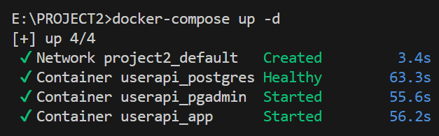
Fig 1 — docker-compose up -d: network + 3 containers all healthy/started
2.2 Docker Desktop — Images
Docker Desktop showing the three pulled images: project2-app (Flask), dpage/pgadmin4, and postgres:16.

Fig 2 — Docker Desktop images: app (263 MB), pgAdmin (778 MB), postgres (642 MB)
2.3 UserAPI Dashboard — Running via Docker Compose
The web dashboard served by gunicorn at http://localhost:3000. Shows 2 users, database Connected, API Running.
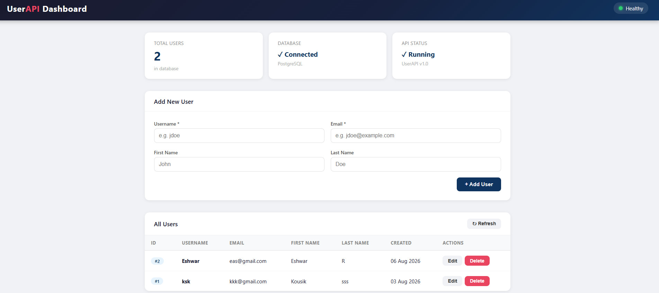
Fig 3 — UserAPI Dashboard at localhost:3000 — 2 users in DB, Healthy badge active
2.4 pgAdmin — userapi_db Database
pgAdmin 4 connected to PostgreSQL, showing the userapi_db database with its public schema.
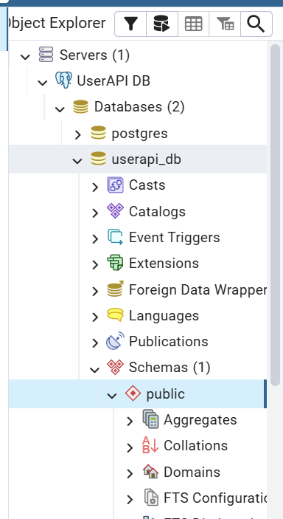
Fig 4 — pgAdmin Object Explorer: UserAPI DB → userapi_db → public schema
2.5 Docker Hub — Published Images
The Docker image was built and pushed to Docker Hub under

eshwarreddy/userapi:latest
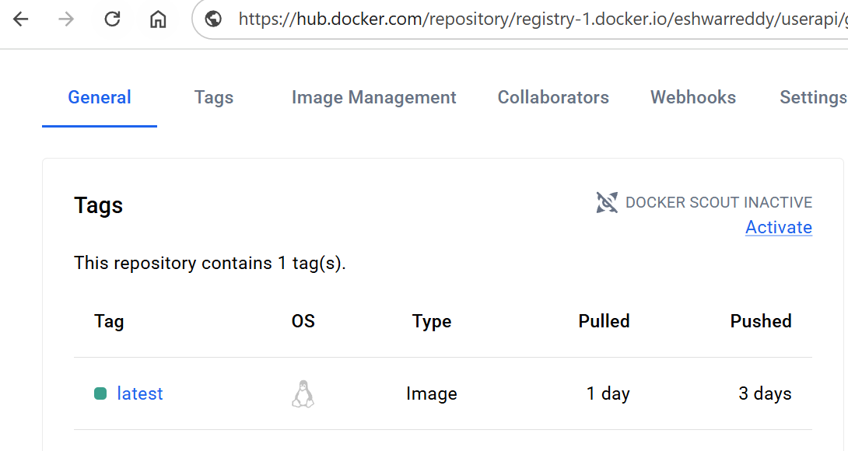
Fig 6 — hub.docker.com/r/eshwarreddy/userapi — latest tag, Linux image, pushed 3 days ago

2.51 CI CD -Github actions
The CI CD pipeline is configured using github actions

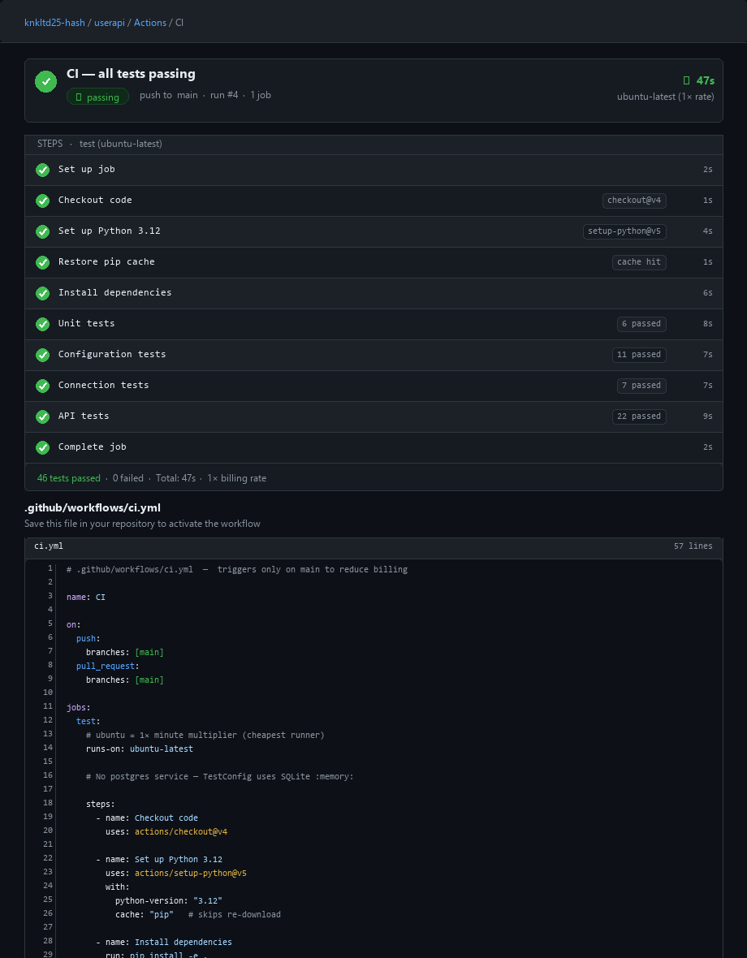

2.6 Vagrant — App Running Inside VM
Inside the provisioned Ubuntu 22.04 VM (vagrant ssh). The app package is installed and the systemd service started.
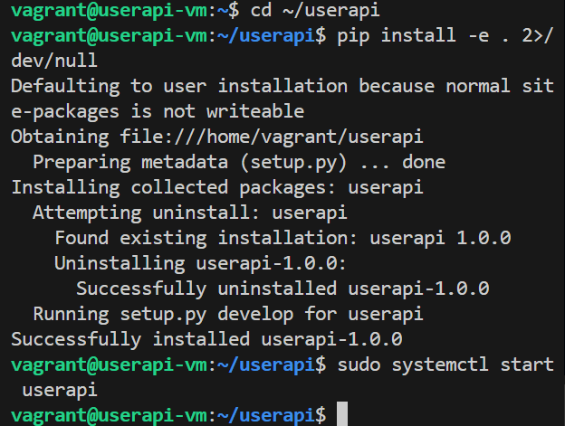
Fig 7 — vagrant@userapi-vm: pip install -e . succeeded, sudo systemctl start userapi

2.7 Kubernetes — Minikube Start
Starting Minikube v1.38.1 on Windows 11 using the Docker driver.
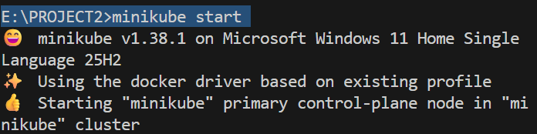
Fig 8 — minikube start: v1.38.1 on Windows 11 Home, docker driver, control-plane booting
2.8 Kubernetes — Exposing the Service
Running minikube service userapi-service --url to get the NodePort URL for the deployed app.
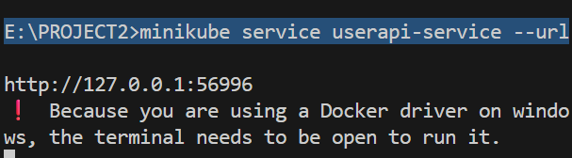
Fig 9 — minikube service userapi-service --url → http://127.0.0.1:56996
2.9 Kubernetes — App in Browser
UserAPI Dashboard accessed via the Minikube NodePort URL (127.0.0.1:56996). DB Connected, API Running.
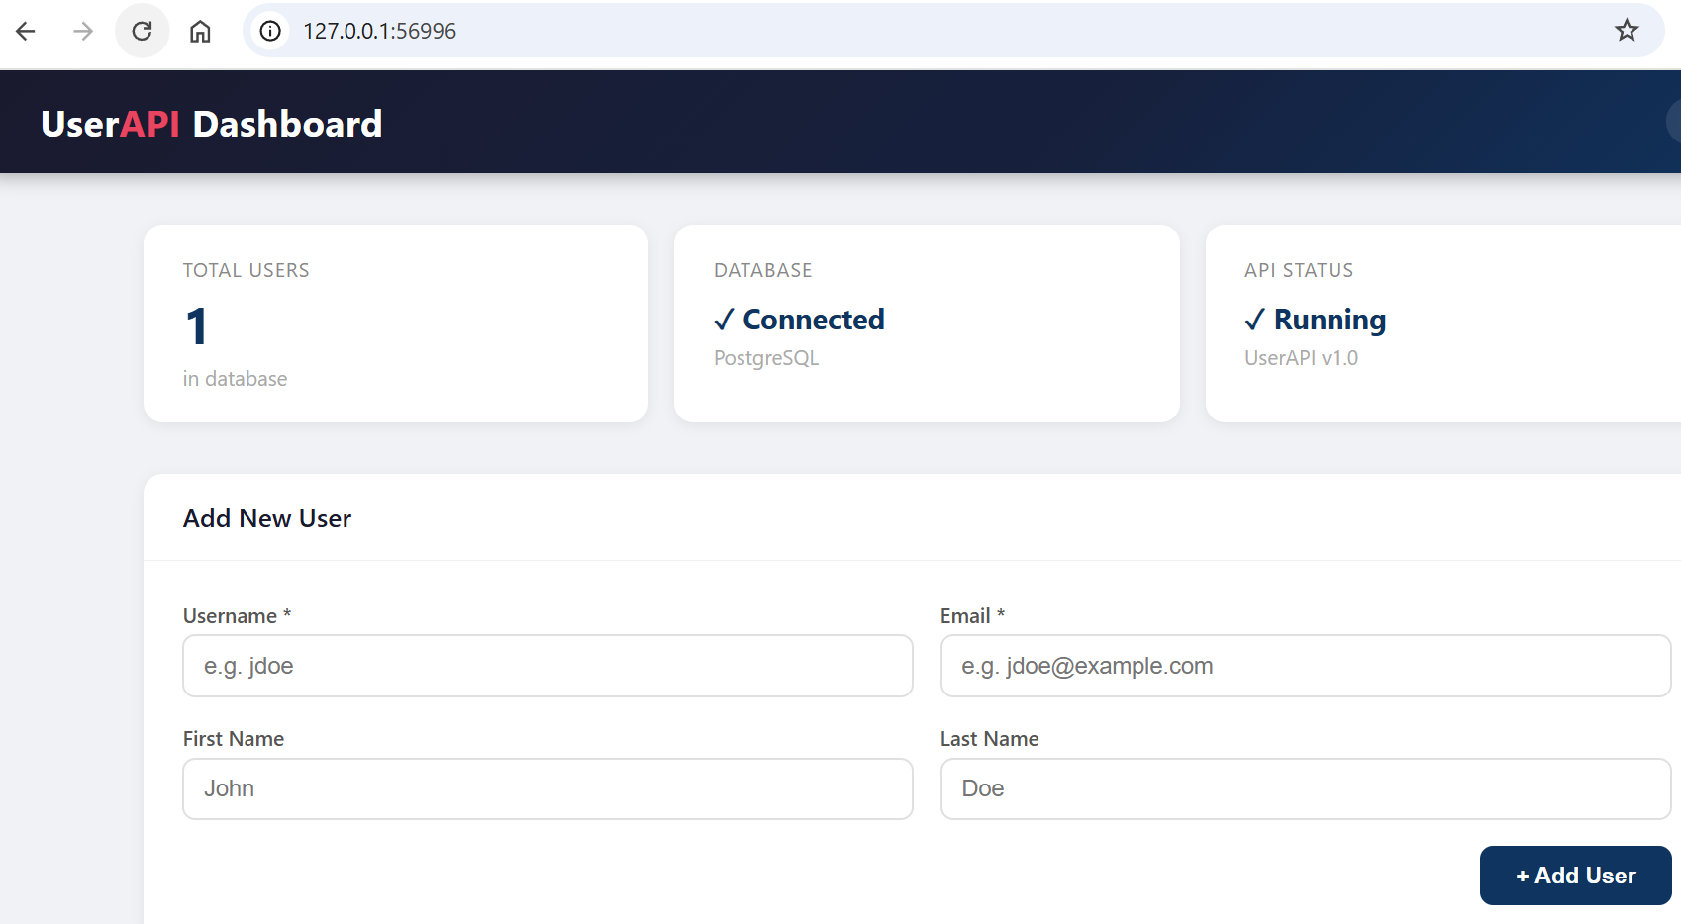
Fig 10 — App running on Minikube at 127.0.0.1:56996 — 1 user, Healthy
3. Instructions
3.1 Prerequisites
Tool | Purpose
Python 3.10+ | Running tests locally, local dev
Docker Desktop | docker-compose up
VirtualBox 7.x | Required by Vagrant
Vagrant 2.x | vagrant up (IaC provisioning)
Minikube | Kubernetes local cluster
kubectl | Applying K8s manifests

3.2 Environment Setup
Create E:\PROJECT2\userapi\.env:
DB_HOST=postgres
DB_PORT=5432
DB_NAME=userapi_db
DB_USER=<user>
DB_PASSWORD=<password>
SECRET_KEY=<secret-key>

Note: Inside Docker Compose, DB_HOST=postgres is set automatically via docker-compose.yaml environment block.
3.3 Run with Docker Compose
cd E:\PROJECT2

# Build and start all 3 services
docker-compose up --build

# Or detached (background):
docker-compose up -d

# Access:
# App → http://localhost:3000
# Health → http://localhost:3000/health
# pgAdmin → http://localhost:5050 (admin@admin.com / admin)

# Stop and remove containers
docker-compose down

3.4 Use the API
# Create a user
curl -X POST http://localhost:3000/users \
-H "Content-Type: application/json" \
-d "{\"username\": \"alice\", \"email\": \"alice@example.com\", \"firstname\": \"Alice\", \"lastname\": \"Smith\"}"

# List all users
curl http://localhost:3000/users

# Get one user by ID
curl http://localhost:3000/users/1

# Update a user
curl -X PUT http://localhost:3000/users/1 \
-H "Content-Type: application/json" \
-d "{\"firstname\": \"Alicia\"}"

# Delete a user
curl -X DELETE http://localhost:3000/users/1

# Health check
curl http://localhost:3000/health

3.5 Run Tests
cd E:\PROJECT2\userapi

# All 46 tests
pytest test/ -v

# By category:
pytest test/test_unit.py -v # 6 unit tests
pytest test/test_config.py -v # 11 config tests
pytest test/test_connection.py -v # 7 connection tests
pytest test/test_api.py -v # 22 API tests

3.6 Vagrant (IaC)
cd E:\PROJECT2\iac

# First boot — provisions the full Ubuntu VM (~5-10 min)
vagrant up

# SSH into the VM
vagrant ssh

# Inside VM: check app service
sudo systemctl status userapi

# App available at http://localhost:3000 (port-forwarded)

# Stop VM (keeps all data)
vagrant halt

# Resume a halted VM
vagrant up

# Destroy VM completely
vagrant destroy

3.7 Kubernetes (Minikube)
# Start Minikube
minikube start

# Apply manifests (from E:\PROJECT2)
kubectl apply -f k8s/persistent-volume.yaml --validate=false
kubectl apply -f k8s/persistent-volume-claim.yaml --validate=false
kubectl apply -f k8s/deployment.yaml --validate=false
kubectl apply -f k8s/service.yaml --validate=false

# Check status
kubectl get pods
kubectl get services
kubectl get pv,pvc

# Open app in browser
minikube service userapi-service --url

# Cleanup
kubectl delete -f k8s/
minikube stop

4. Platforms & Links
Platform | URL / Reference | Notes
Docker Hub (kousiksc) | hub.docker.com/r/eshwarreddy/userapi | eshwarreddy/userapi:latest — used in K8s deployment
Docker Hub (eshwarreddy) | hub.docker.com/r/eshwarreddy/userapi | eshwarreddy/userapi:latest
GitHub Repository | github.com/ eshwarreddy | Source code and commit history
GitHub Actions | github.com/ eshwarreddy → Actions | CI pipeline — all tests on every push to main
App (Docker Compose) | http://localhost:3000 | Flask app served by gunicorn
pgAdmin (Docker) | http://localhost:5050 | admin@admin.com / admin
App (Kubernetes) | minikube service userapi-service --url | NodePort — URL generated by Minikube
App (Vagrant) | http://localhost:3000 | Port-forwarded from VM (vagrant up in iac/)
Vagrant Box | app.vagrantup.com/ubuntu/boxes/jammy64 | ubuntu/jammy64 v20241002.0.0

5. Author
Name
Email
GitHub
Docker Hub | hub.docker.com/u/ eshwarreddy
Project date | August 2026

6. Additional Information
Project Structure
E:\PROJECT2\
├── userapi\ Flask application
│ ├── src\
│ │ ├── __init__.py App factory (create_app)
│ │ ├── app.py Entry point
│ │ ├── config.py Config / TestConfig / ProductionConfig
│ │ ├── models.py User SQLAlchemy model
│ │ ├── routes.py All API blueprints & health check
│ │ └── templates\
│ │ └── index.html Web dashboard
│ ├── test\
│ │ ├── conftest.py Fixtures: app, db, client, clean_db
│ │ ├── test_unit.py Unit tests (6)
│ │ ├── test_api.py API tests (22)
│ │ ├── test_config.py Config tests (11)
│ │ └── test_connection.py Connection tests (7)
│ ├── Dockerfile
│ ├── requirements.txt
│ └── .env
├── iac\ Vagrant + Ansible IaC
│ ├── Vagrantfile
│ └── playbooks\
│ ├── setup.yml
│ └── roles\ (python / postgresql / app)
├── k8s\ Kubernetes manifests
│ ├── deployment.yaml postgres (1) + userapi (2 replicas)
│ ├── service.yaml ClusterIP + NodePort
│ ├── persistent-volume.yaml
│ └── persistent-volume-claim.yaml
├── .github\workflows\
│ └── ci.yml GitHub Actions CI pipeline
└── docker-compose.yaml

Key Design Decisions
- SQLite for tests: TestConfig switches to sqlite:///:memory: — no PostgreSQL dependency in CI
- Application Factory: create_app(config) lets the same code run under test, dev, and prod configs
- Systemd in Vagrant: app runs as a proper service — auto-restarts on crash, survives reboots
- Gunicorn everywhere: consistent production WSGI server in both Docker and Vagrant
- K8s probes: liveness and readiness both hit /health — Kubernetes restarts pods if DB goes down
- 2 replicas in K8s: demonstrates horizontal scaling — traffic load-balanced across both pods
- Billing-aware CI: triggers only on main, uses pip cache, avoids matrix — preserves free tier minutes
UserAPI DevOps Project Eshwar reddy · August 2026

