Chatbot through RASA

1. **Introduction:**

A chatbot is an application that can initiate and continue a conversation using auditory and/or textual methods as a human would do. A chatbot can be either a simple rule-based engine or an intelligent application leveraging Natural Language Understanding. Many organizations today have started using chatbots extensively. Chatbots are becoming famous as they are available 24*7, provide a consistent customer experience, can handle several customers at a time, are cost-effective and hence, results in a better overall customer experience.

* 1. **Uses**
* Customer support
* Frequently Asked Questions
* Addressing Grievances
* Appointment Booking
* Automation of routine tasks
* Address a query

1. **Prerequisites**

The prerequisites for developing and understanding a chatbot using Microsoft Azure are:

* Python installed
* Microsoft Build tools with visual c++ 14.0 installed. Link: <https://visualstudio.microsoft.com/downloads/>

1. **Introduction to RASA**

Rasa is an open source machine learning framework for building [contextual AI assistants and chatbots](http://blog.rasa.com/level-3-contextual-assistants-beyond-answering-simple-questions/).

Rasa has two main modules:

* **NLU** for understanding user messages
* **Core** for holding conversations and deciding what to do next
  1. **RASA Architecture:**

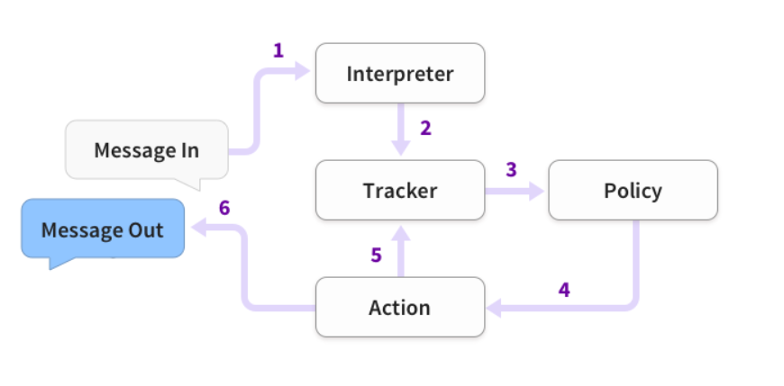

1. **The problem statement**

The goal here is to build a chatbot which can answer queries related to the COVID-19 disease.

* 1. **Technical stack:**
  + Python
  + Rasa X
  1. **The application flow**

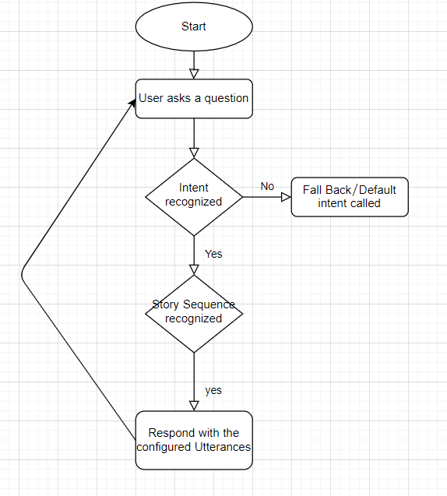

1. **Implementation:**

* Create a new folder for your chatbot project.
* Open that folder using Pycharm
* Create a new environment for your chatbot project from pycharm or from anaconda prompt.
* Run the command **pip install rasa x** for installing all the rasa dependencies
* Run the command **pip install spacy** for installing spacy library.
* Then enter the following commands:
  + - **python -m spacy download en**
    - **python -m spacy download en_core_web_md**
    - **python -m spacy link en_core_web_md en**
* After all this command run successfully, enter the command **rasa init** and for all the subsequent actions choose Y (for training the model etc).
* You’ll then end up with all the predefined structures which RASA would have built, as shown below:

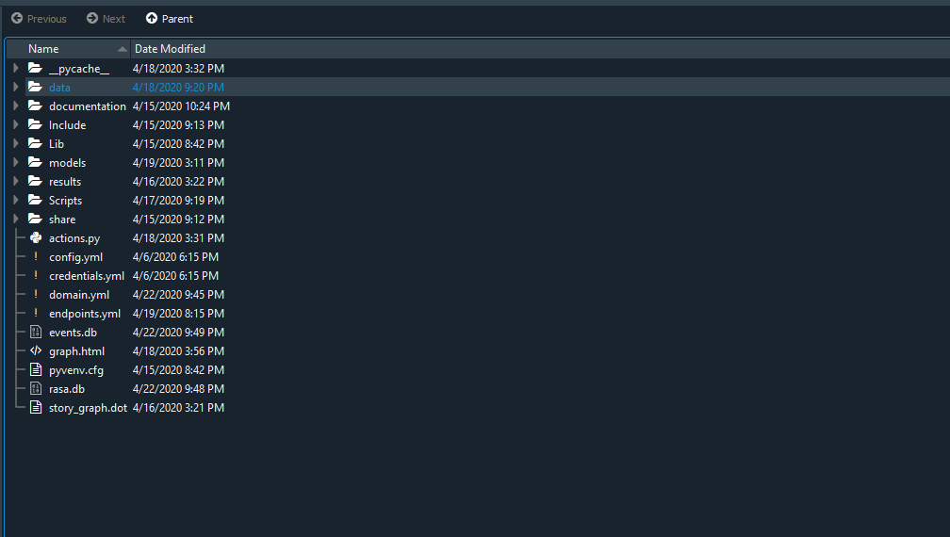

* Open the ‘nlu.md’ file from the data folder and enter the following content:

*## intent:greet*

*- hey*

*- hello*

*- hi*

*- good morning*

*- good evening*

*- hey there*

*## intent:goodbye*

*- bye*

*- goodbye*

*- see you around*

*- see you later*

*## intent:bot_challenge*

*- are you a bot?*

*- are you a human?*

*- am I talking to a bot?*

*- am I talking to a human?*

*## intent:corona_intro*

*- What is corona virus*

*- what is covid*

*- what is a novel corona virus*

*- what is covid-19*

*- tell me about corona*

*- can you tell me about covid*

*- corona*

*## intent:corona_spread*

*- how does corona virus spread*

*- how does the virus spread*

*## intent:corona_food_spread*

*- Does corona spread from food*

*- how will corona spread from food*

*## intent:warm_weather*

*- will warm weather stop the spread*

*- will it stop with warm weather*

*## intent:high_risk*

*- who is at a higher risk of infection*

*## intent:pincode_risk*

*- what is pincode for highly infected*

*- Pincode*

*## intent:corna_state*

*-[india](state)*

*-[karnataka](state)*

*-[Goa](state)*

*-[Punjab](state)*

*-[Gujarat](state)*

*-[delhi](state)*

*-[Andhra Pradesh](state)*

*-[bihar](state)*

*-[punjab](state)*

*-[west bangal](state)*

*-[odhisha](state)*

*-[assam](state)*

This file is used to create all the intents and their sample utterances for conversation.

* Open the ‘domain.yml’ file and put the following content:

session_config:

session_expiration_time: 60

carry_over_slots_to_new_session: true

intents:

- corona_intro

- pincode_risk

- greet

- bot_challenge

- corona_spread

- corona_food_spread

- warm_weather

- high_risk

- corna_state

- goodbye  
- warm_weather  
- high_risk  
entities:

- state

responses:

utter_corona_food_spread:

- text: Coronaviruses are generally thought to be spread from person-to-person through

respiratory droplets. Currently there is no evidence to support transmission

of COVID-19 associated with food. Before preparing or eating food it is important

to always wash your hands with soap and water for 20 seconds for general food

safety. Throughout the day wash your hands after blowing your nose, coughing

or sneezing, or going to the bathroom.

utter_corona_intro:

- text: Coronaviruses are a group of related viruses that cause diseases in mammals

and birds. In humans, coronaviruses cause respiratory tract infections that

can be mild, such as some cases of the common cold (among other possible causes,

predominantly rhinoviruses), and others that can be lethal, such as SARS, MERS,

and COVID-19

utter_corona_spread:

- text: "This virus was first detected in Wuhan City, Hubei Province, China. The\

\ first infections were linked to a live animal market, but the virus is now\

\ spreading from person-to-person. It’s important to note that person-to-person\

\ spread can happen on a continuum. Some viruses are highly contagious (like\

\ measles), while other viruses are less so. The virus that causes COVID-19\

\ is spreading from person-to-person. Someone who is actively sick with COVID-19\

\ can spread the illness to others. That is why we recommend that these patients\

\ be isolated either in the hospital or at home (depending on how sick they\

\ are) until they are better and no longer pose a risk of infecting others.\n\

How long someone is actively sick can vary so the decision on when to release\

\ someone from isolation is made on a case-by-case basis in consultation with\

\ doctors, infection prevention and control experts, and public health officials\

\ and involves considering specifics of each situation including disease severity,\

\ illness signs and symptoms, and results of laboratory testing for that patient.\n\

The virus that causes COVID-19 seems to be spreading easily and sustainably\

\ in the community (“community spread”) in some affected geographic areas. Community\

\ spread means people have been infected with the virus in an area, including\

\ some who are not sure how or where they became infected."

utter_did_that_help:

- text: Did that help you?

utter_greet:

- text: Hey! How are you?

utter_high_risk:

- text: Older adults and people of any age who have serious underlying medical conditions

may be at higher risk for more serious complications from COVID-19. These people

who may be at higher risk of getting very sick from this illness, includes;

Older adults, People who have serious underlying medical conditions like...

Heart disease, Diabetes, Lung disease,

utter_iamabot:

- text: I am a bot, powered by Rasa.

utter_pincode_risk:

- text: 591126,

utter_warm_weather:

- text: It is not yet known whether weather and temperature impact the spread of

COVID-19. Some other viruses, like the common cold and flu, spread more during

cold weather months but that does not mean it is impossible to become sick with

these viruses during other months. At this time, it is not known whether the

spread of COVID-19 will decrease when weather becomes warmer. There is much

more to learn about the transmissibility, severity, and other features associated

with COVID-19 and investigations are ongoing.

actions:

- utter_corona_food_spread

- utter_corona_intro

- utter_corona_spread

- utter_did_that_help

- utter_goodbye

- utter_greet

- utter_high_risk

- utter_iamabot

- utter_pincode_risk

- utter_warm_weather

- action_corona_state

This file is used to configure the bot responses.

* Open the ‘stories.md’ file from the data folder and put the following content:

*## bot challenge*

*\* bot_challenge*

*- utter_iamabot*

*## what is corona*

*\* corona_intro*

*- utter_corona_intro*

*## how does corona spread*

*\* corona_spread*

*- utter_corona_spread*

*## corona food spread*

*\* corona_food_spread*

*- utter_corona_food_spread*

*## corona warm weather*

*\* warm_weather*

*- utter_warm_weather*

*## corona high risk*

*\* high_risk*

*- utter_high_risk*

*## corna pincode*

*\* pincode_risk*

*- utter_pincode_risk*

*# corona tracker*

*\* corna_state*

*- action_corona_state*

This file is used to create the conversation flows.

* After all this, you can just enter the command ‘**rasa train’** to train the model with new conversation elements.
* After the training is completed, enter the command ‘**rasa x**’ to test your chatbot in the web UI. You’ll see :



* Copy this URL in your web browser and you’ll see the web UI for your chatbot:

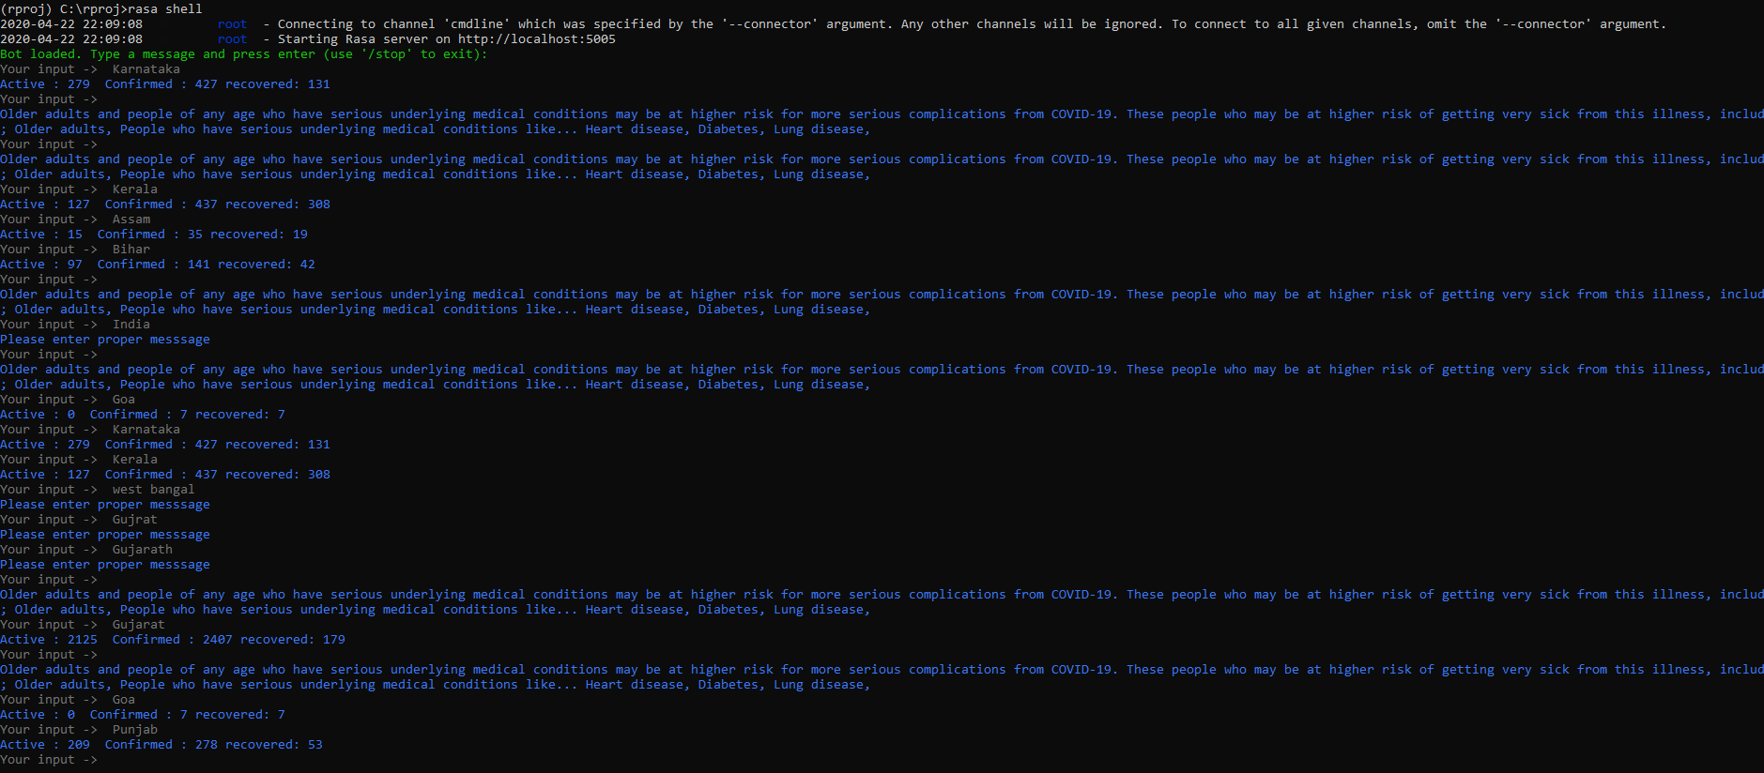

1. **Telegram Integration:**
   * Download ngrok from<https://ngrok.com/download>
   * After extracting the zip file, open the ngrok file and run it.
   * In ngrok, enter the command ‘**ngrok http 5005** ’:

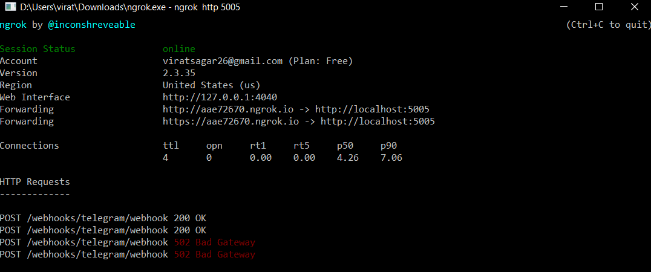

* Then go to telegram and create your own bot using Botfather:

1. Open the telegram app and search for botfather(it is an inbuilt bot used to create other bots)
2. Start a conversation with botfather and enter /newbot to create a newbot.
3. Give a name to your bot
4. Give a username to your bot, which must end in _bot.This generates an access token.

* Open ‘credentials.yml’ and enter:

telegram:

access_token: "obtained from telegram"

verify: "your bot username"

webhook_url: "https://<ngrokurl>/webhooks/telegram/webhook"

* Go to terminal and enter the command ‘rasa run’
* Open one more terminal and run the command ‘rasa run actions’
* Now, you can chat with your bot from Telegram.

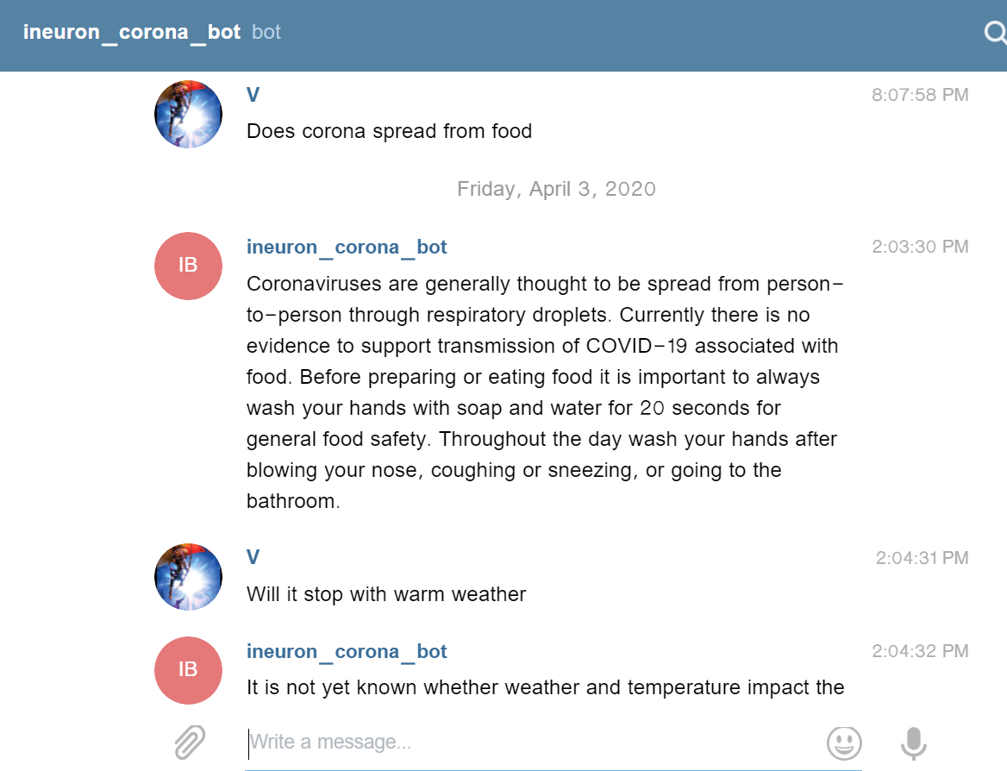

References:

1. Rasa Official documentation <https://rasa.com/docs/rasa/user-guide/installation/>
2. CDC Corona FAQ.