# Homograph Detector

**Intern Name:** Ishan Chowdhury  
**Intern ID: 159**  
**Company:** DigiSuraksha

### 📖 Definition:

A **Homograph Detector** is a cybersecurity tool that detects characters in domain names or strings that look like legitimate Latin letters but come from different Unicode scripts (e.g., Cyrillic or Greek). These are used in phishing attacks to trick users (e.g., gοοgle.com instead of google.com). This tool helps identify and sanitize such suspicious domains.

📌 Objective:

To detect and analyze homoglyph (homograph) attacks in domain names using Python on Kali Linux:

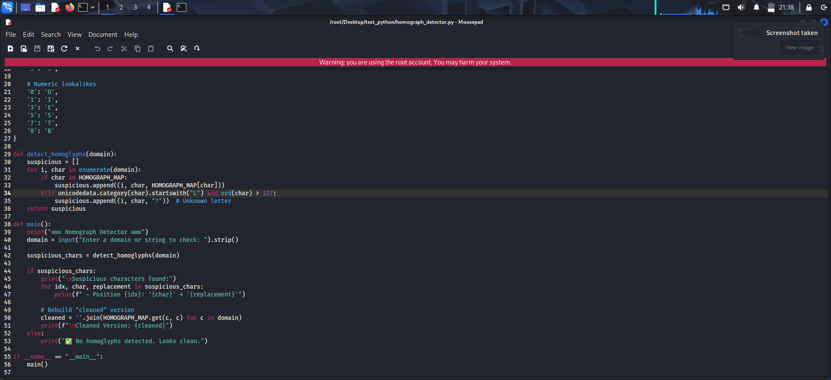

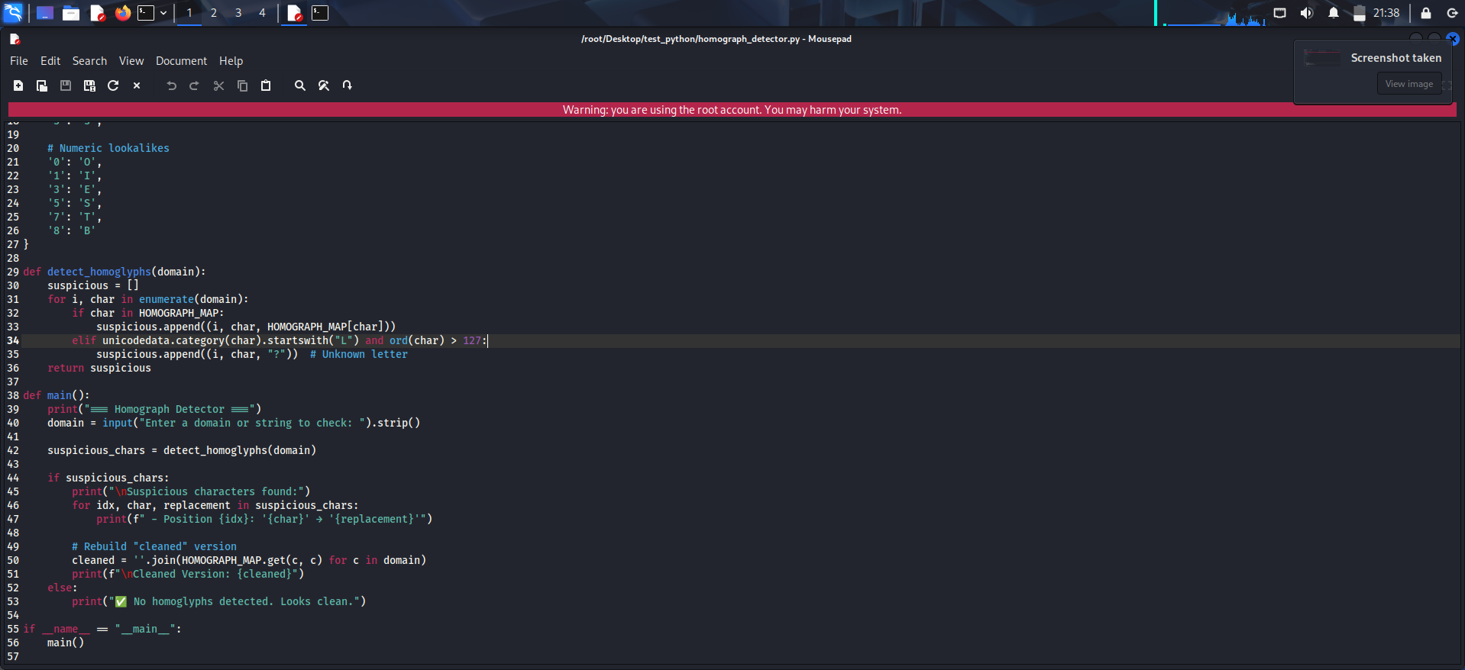

### ✅ Expected Output:

