# Link Shortener

**Intern Name:** Ishan Chowdhury  
**Intern ID:** 159  
**Company:** DigiSuraksha

### 📖 Definition:

A **Link Shortener** is a tool that takes long or complex URLs and maps them to short, easy-to-remember aliases (e.g., /yt for https://youtube.com). It can be used for redirection, brand tracking, or disguising links — and is often useful in phishing investigations, red teaming, and recon tooling.

### 📌 Objective:

To create a custom link shortener and redirector using Flask on Kali Linux.

1. Install Flask: pip3 install flask

2.Create script: mousepad shortener.py

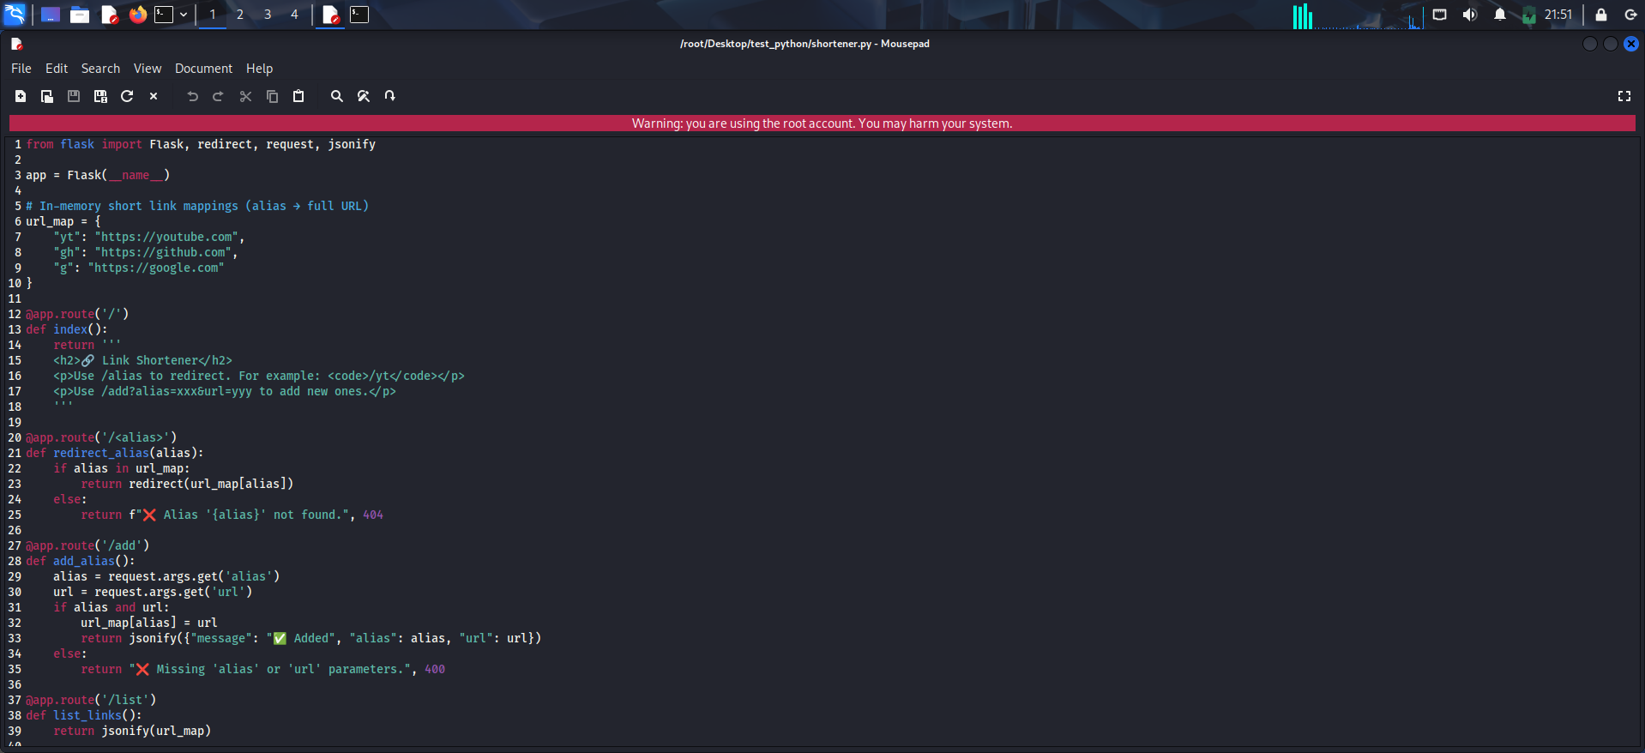

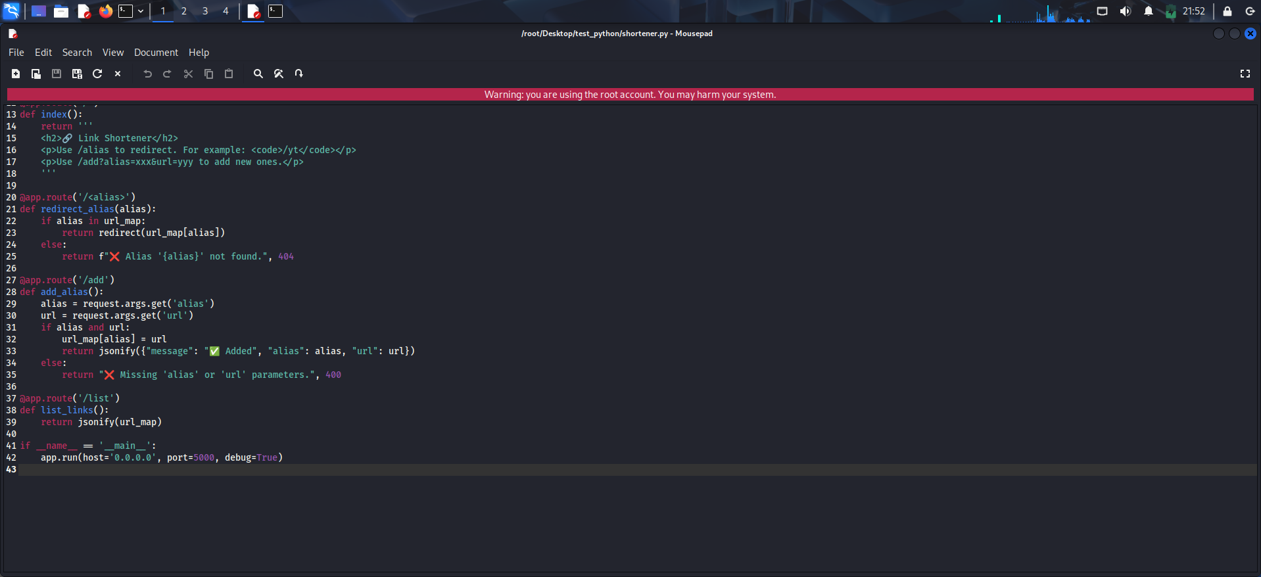

3.Run the script: python3 shortener.py

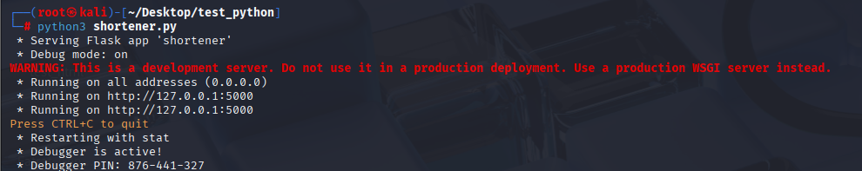

4.Test in browser or curl:http://127.0.0.1:5000/

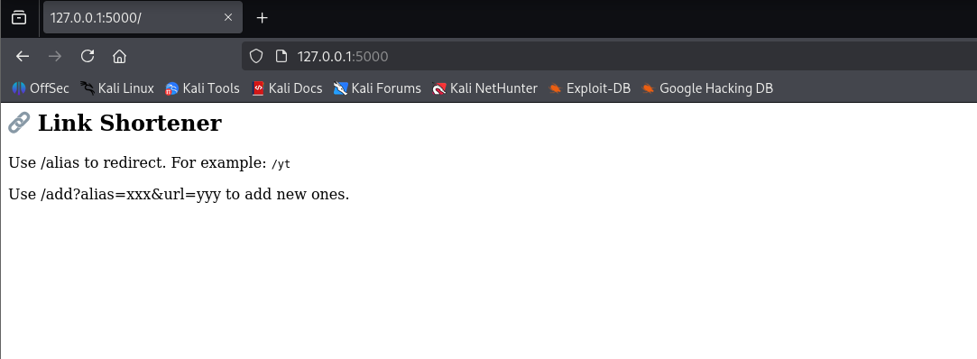

5.Add a new short

link:http://127.0.0.1:5000/add?alias=fb&url=https://facebook.com

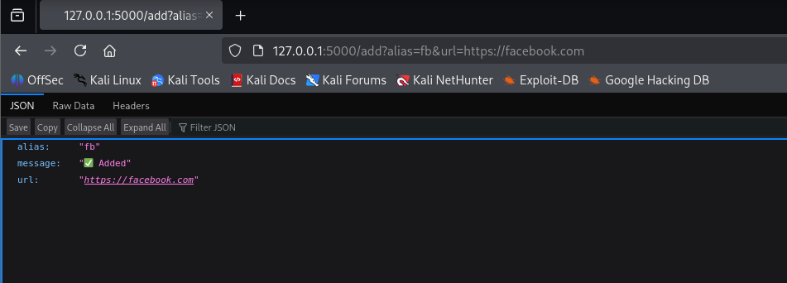

6.Redirect using new alias: http://127.0.0.1:5000/fb

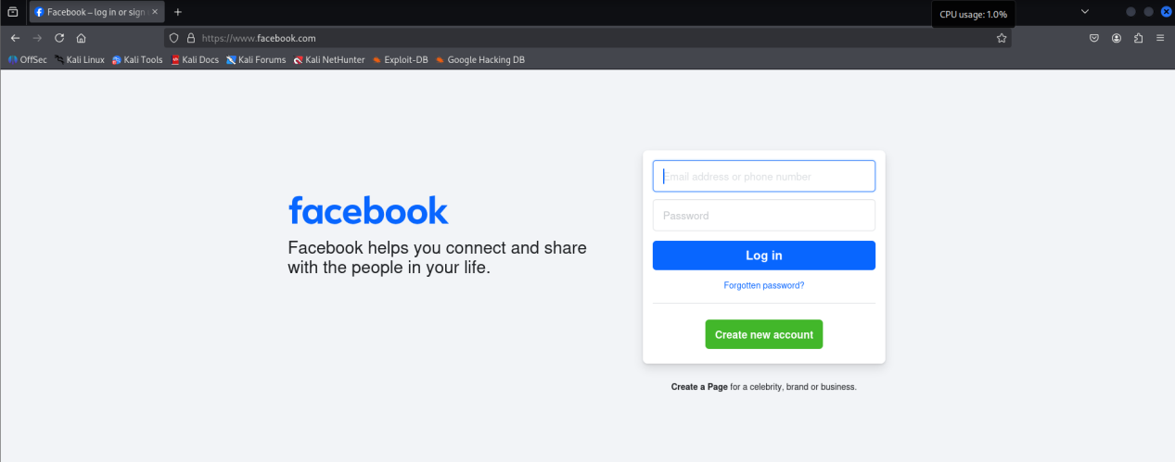

7.View all: http://127.0.0.1:5000/list

