Day 01 — Networking Fundamentals, Nmap Scanning, and Automation Scripting
Author: Ishan Chowdhury
Date: 2025-09-12
Target (authorized for testing): See Target Description below
Document version: 1.0

1. Introduction
This report documents Day 01 tasks: Nmap-based reconnaissance of authorized lab hosts, analysis of scan results, brief research on two identified services, a network diagram placeholder, and inclusion of the automation script output. The purpose is to demonstrate basic networking concepts, Nmap proficiency, and scripting for automated scans.

2. Target description
Target A (scanned with TCP/UDP): 192.168.132.137 — VM on local network (identified via arp-scan).
MAC: 00:0C:29:A6:90:47 (VMware)
Reachability: Host is up (low latency in scans).
Target B (SYN scan returned all filtered): 192.168.56.101 — previously scanned with SYN; reported as filtered (no response for TCP probes).
Authorization: Scans were performed on lab VMs under my control / authorized environment. (Include your explicit authorization statement in final DOCX if required by yourorganization.
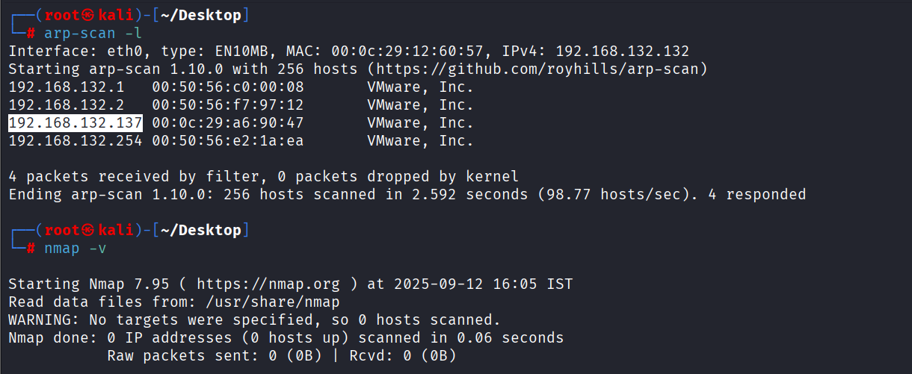

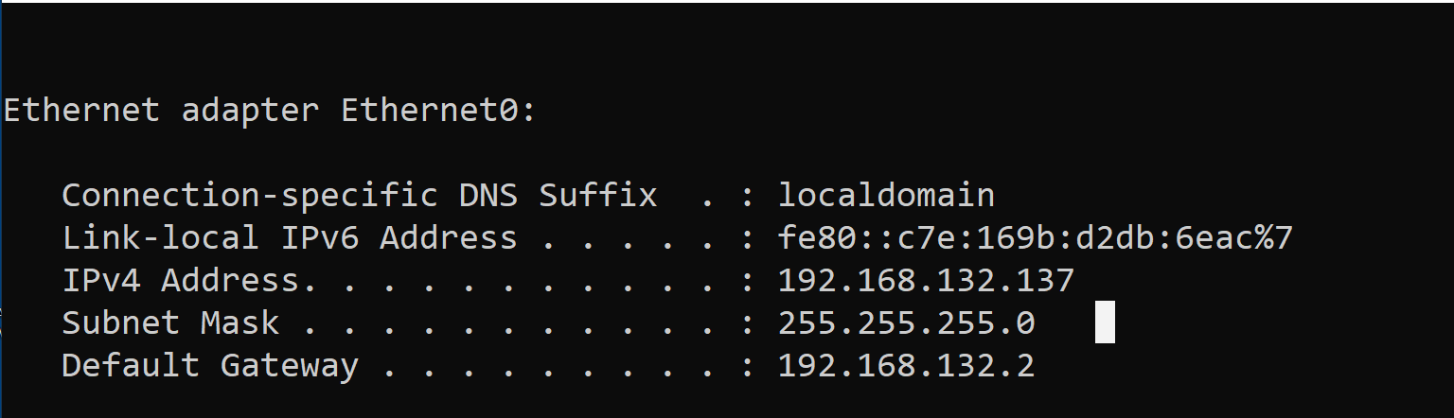

3. Exact Nmap commands used

Verify Nmap: nmap -v
SYN scan: sudo nmap -sS 192.168.56.101 -oN syn_scan.txt
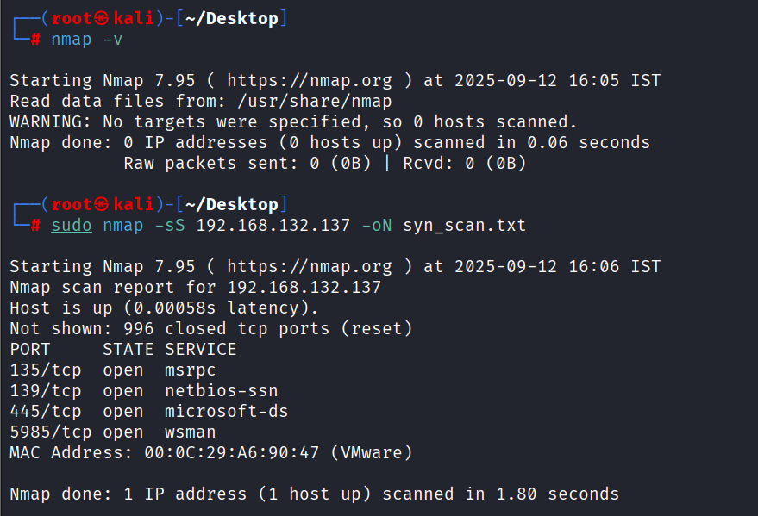

TCP connect scan: nmap -sT 192.168.132.137 -oN tcp_scan.txt
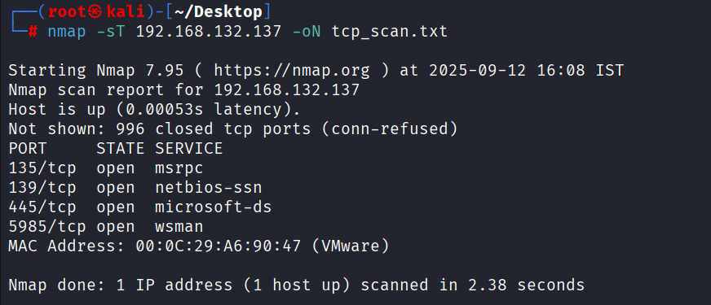
UDP scan: sudo nmap -sU 192.168.132.137 -oN udp_scan.txt
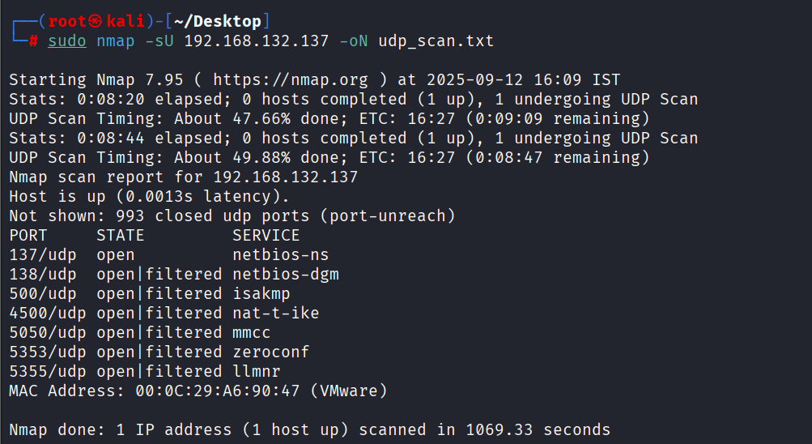

From automation script run — saved syn_scan.txt for 192.168.56.101:
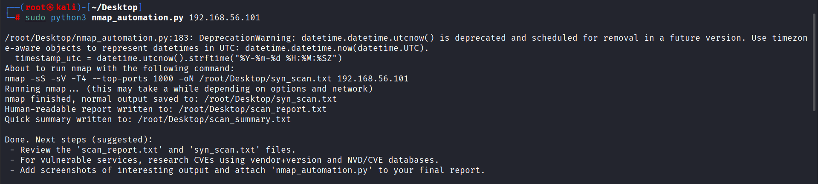

4. Summary of results (high-level)
192.168.132.137 (Target A) — TCP and UDP scans revealed multiple open services commonly associated with Windows-based hosts (NetBIOS/SMB and WS-Man).
192.168.56.101 (Target B) — SYN scan showed All 1000 scanned TCP ports are filtered (no-response). This suggests a firewall/host filtering or the host being intentionally unresponsive to TCP probes.

5. Findings — Open ports and services

5.1 TCP results — 192.168.132.137
Port | Protocol | State | Service | Notes / Product (if available)
135 | tcp | open | msrpc | Microsoft RPC (MSRPC)
139 | tcp | open | netbios-ssn | NetBIOS Session Service (SMB)
445 | tcp | open | microsoft-ds | SMB over TCP (file sharing)
5985 | tcp | open | wsman | WS-Management (WinRM over HTTP)
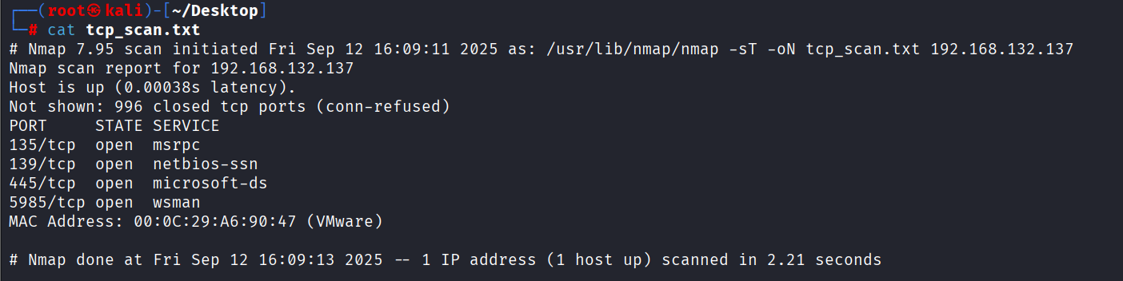

5.2 UDP results — 192.168.132.137
Port | Protocol | State | Service | Notes
137 | udp | open | netbios-ns | NetBIOS Name Service
138 | udp | open | filtered | netbios-dgm
500 | udp | open | filtered | isakmp
4500 | udp | open | filtered | nat-t-ike
5050 | udp | open | filtered | mmcc
5353 | udp | open | filtered | zeroconf/mdns
5355 | udp | open | filtered | llmnr
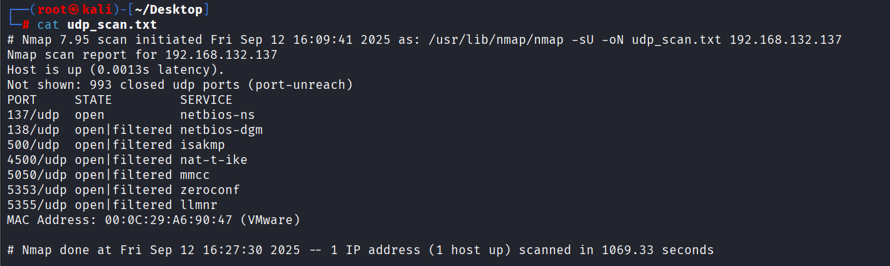

5.3 SYN scan result — 192.168.56.101
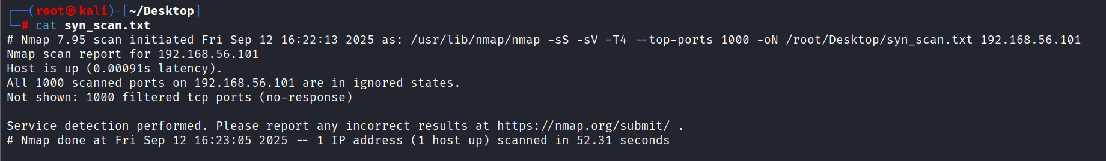

6. Analysis & Potential Security Risks (per-service)
(Short risk descriptions and mitigation suggestions for the services discovered.)

6.1 SMB (Ports 139/tcp and 445/tcp)
Purpose: SMB (Server Message Block) provides file and printer sharing and is commonly used on Windows networks. Ports 139 and 445 are associated with NetBIOS/SMB traffic.
Common vulnerabilities / risks:
Historically exploited for remote code execution (e.g., EternalBlue — CVE-2017-0144) and wormable attacks.
Misconfigured shares can expose sensitive files.
SMBv1 is insecure; should be disabled when possible.
Mitigations:
Ensure OS and SMB implementation are fully patched.
Disable SMBv1 and require SMBv2/SMBv3.
Restrict SMB exposure to internal networks and use firewall rules to block external access.
Enforce strong authentication and limit share permissions.
Monitor for anomalous SMB traffic.
Cited reference sources to include in final DOCX: NVD (nvd.nist.gov), Microsoft Security Advisories, relevant CVE IDs for any discovered product versions.

6.2 WS-Management / WinRM (Port 5985/tcp)
Purpose: WinRM (Windows Remote Management) implements WS-Management for remote management and automation; 5985 is the HTTP endpoint (unencrypted) and 5986 is typically used for HTTPS.
Common vulnerabilities / risks:
If WinRM is exposed and not configured securely, it can allow remote execution, credential dumping, or lateral movement.
Unencrypted WinRM over HTTP (5985) may expose credentials in transit if not using Kerberos or other secure auth.
Misconfigurations or weak credentials increase attack surface.
Mitigations:
Prefer WinRM over HTTPS (5986) and enforce encryption.
Use Kerberos and strong authentication; avoid basic auth over HTTP.
Limit WinRM exposure to management networks; block from untrusted networks.
Apply least privilege and logging/monitoring for remote management sessions.
Reference suggestions: Microsoft Docs on WinRM, NVD entries for any WinRM-related CVEs.

7. Network diagram
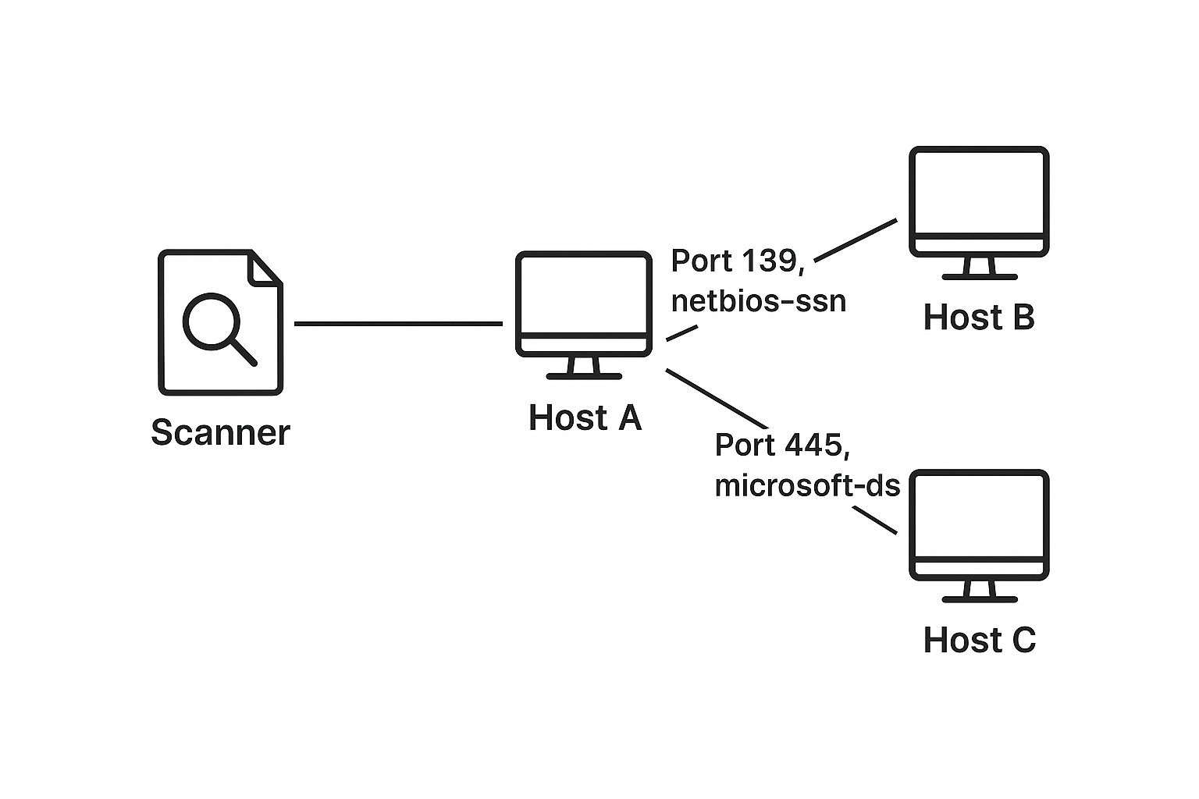

8. Commands & evidence (appendix)
Raw outputs saved:
/root/Desktop/syn_scan.txt — SYN scan output (192.168.56.101)
/root/Desktop/tcp_scan.txt — TCP scan output (192.168.132.137)
/root/Desktop/udp_scan.txt — UDP scan output (192.168.132.137)
/root/Desktop/scan_report.txt & /root/Desktop/scan_summary.txt
Syn scan snippet (192.168.56.101):
All 1000 scanned ports on 192.168.56.101 are in ignored states.
Not shown: 1000 filtered tcp ports (no-response)
TCP scan snippet (192.168.132.137):
PORT STATE SERVICE
135/tcp open msrpc
139/tcp open netbios-ssn
445/tcp open microsoft-ds
5985/tcp open wsman
UDP scan snippet (192.168.132.137):
PORT STATE SERVICE
137/udp open netbios-ns
138/udp open|filtered netbios-dgm
500/udp open|filtered isakmp
4500/udp open|filtered nat-t-ike
5353/udp open|filtered zeroconf
5355/udp open|filtered llmnr

9. Recommendations & next steps
For 192.168.132.137 (Host A):
Patch the host (OS and SMB/WinRM components).
If services are not required, disable them (e.g., turn off file sharing or WinRM if not used).
Restrict SMB/NetBIOS access via firewall to management VLANs only.
Configure WinRM to use HTTPS (5986) and strong auth (Kerberos).
Run authenticated scanning (Nessus/OpenVAS) if you have creds to detect host-specific CVEs.
For 192.168.56.101 (Host B):
Investigate host firewall rules or network segmentation (why all TCP ports are filtered).
Re-run scan with -Pn to skip host discovery if needed:

10. Key learnings
Firewall rules and host discovery behavior can cause a scan to show no open ports even when the host is up. Use -Pn and alternative scan types to bypass host discovery when appropriate (and authorized).
TCP and UDP scans complement each other — many services (NetBIOS, mDNS) use UDP and may not appear in TCP-only scans.

11. Appendix

Python Automation Script
#!/usr/bin/env python3
"""
nmap_automation.py

Automates Nmap scans (SYN -sS + version detection -sV), parses results,
and generates a human-readable scan_report.txt plus the raw nmap output file.

Designed to run on Kali Linux.

Requirements:
- nmap installed and in PATH (verify with `nmap -v`)
- Python 3.8+
- (optional) python-nmap if you prefer more advanced parsing (not mandatory here)

Usage examples:
sudo python3 nmap_automation.py 192.168.56.101
python3 nmap_automation.py example.com --top-ports 200
sudo python3 nmap_automation.py 10.0.2.15 --udp --output-dir ./results

Notes:
- SYN scan (-sS) typically requires root privileges on Linux. If you cannot run
as root, use the --no-syn flag to use TCP connect (-sT) instead.
- UDP scans are much slower and less reliable; use --udp only when needed.
"""

import argparse
import subprocess
import shutil
import sys
import os
from datetime import datetime
import textwrap

# -------------------------
# Helper functions
# -------------------------
def check_dependencies():
"""Ensure nmap is installed."""
if shutil.which("nmap") is None:
print("ERROR: 'nmap' not found in PATH. Install Nmap (apt install nmap) and try again.")
sys.exit(1)

def run_command(cmd, capture_stdout=True):
"""Run command and return (returncode, stdout, stderr). stdout/stderr are strings."""
try:
proc = subprocess.run(cmd, stdout=subprocess.PIPE if capture_stdout else None,
stderr=subprocess.PIPE, text=True, check=False)
return proc.returncode, proc.stdout if proc.stdout is not None else "", proc.stderr if proc.stderr is not None else ""
except FileNotFoundError:
return 127, "", f"Command not found: {cmd[0]}"
except Exception as e:
return 1, "", str(e)

def parse_nmap_normal_output(nmap_text):
"""
Parse nmap normal output to extract host(s) and open ports.
Returns: list of hosts, each host is dict: {'host': ip_or_name, 'state': 'up'/'down', 'ports': [ {port, proto, state, service, extra} ... ]}
This is a lightweight parser sufficient for common outputs.
"""
lines = nmap_text.splitlines()
hosts = []
cur_host = None
in_port_section = False

for i, raw in enumerate(lines):
line = raw.strip()
# Host line examples:
# Nmap scan report for 192.168.56.101
if line.startswith("Nmap scan report for"):
if cur_host:
hosts.append(cur_host)
host_id = line[len("Nmap scan report for"):].strip()
cur_host = {"host": host_id, "state": None, "ports": []}
in_port_section = False
continue

# Host status line: Host is up (0.0010s latency).
if cur_host and line.startswith("Host is"):
cur_host["state"] = line
continue

# Start of ports table
if cur_host and (line.startswith("PORT") and "STATE" in line and "SERVICE" in line):
in_port_section = True
continue

# Empty line ends port section
if in_port_section and line == "":
in_port_section = False
continue

# Lines within port section look like:
# 22/tcp open ssh OpenSSH 7.2 (protocol 2.0)
# 80/tcp open http Apache httpd 2.4.7 ((Ubuntu))
if in_port_section and cur_host:
# split into max 4 parts: port_proto, state, service, rest
parts = line.split(None, 3)
if len(parts) >= 3:
port_proto = parts[0] # e.g., "22/tcp"
state = parts[1] # e.g., "open"
service = parts[2] # e.g., "ssh"
extra = parts[3] if len(parts) == 4 else ""
# Separate port and proto
if '/' in port_proto:
port, proto = port_proto.split('/', 1)
else:
port, proto = port_proto, "tcp"
try:
portnum = int(port)
except ValueError:
portnum = port
cur_host["ports"].append({
"port": portnum,
"proto": proto,
"state": state,
"service": service,
"extra": extra.strip()
})
else:
# Not a standard port line; skip
pass

if cur_host:
hosts.append(cur_host)
return hosts

def generate_report_text(target, hosts, scan_cmd, raw_output_path, timestamp_utc):
"""Construct human readable report text."""
lines = []
lines.append("Scan Report")
lines.append("=" * 72)
lines.append(f"Scan timestamp (UTC): {timestamp_utc}")
lines.append(f"Target provided: {target}")
lines.append(f"Nmap command used: {scan_cmd}")
lines.append(f"Raw nmap output saved to: {raw_output_path}")
lines.append("")
if not hosts:
lines.append("No hosts found or scan returned no data.")
for h in hosts:
lines.append("-" * 72)
lines.append(f"Host: {h.get('host')}")
if h.get('state'):
lines.append(f"Status: {h.get('state')}")
lines.append("")
if not h.get('ports'):
lines.append("No open TCP ports detected (or port section not present in output).")
else:
lines.append(f"{'Port':<7} {'Proto':<6} {'State':<8} {'Service':<15} {'Product/Version (if detected)'}")
lines.append("-" * 72)
for p in sorted(h['ports'], key=lambda x: (str(x['port']), x['proto'])):
lines.append(f"{str(p['port']):<7} {p['proto']:<6} {p['state']:<8} {p['service']:<15} {p['extra']}")
lines.append("")
lines.append("=" * 72)
lines.append("Notes and recommendations:")
lines.append(" - Review open services and ensure only required services are exposed.")
lines.append(" - For Telnet (port 23) use SSH instead; Telnet sends credentials in cleartext.")
lines.append(" - For SMB/NetBIOS (ports 139/445), ensure patches and restrict exposure.")
lines.append(" - Consider running authenticated vulnerability scans for deeper CVE detection.")
lines.append("")
lines.append("Scan completed.")
return "\n".join(lines)

# -------------------------
# Main program
# -------------------------
def main():
check_dependencies()

parser = argparse.ArgumentParser(description="Nmap SYN automation and report generator")
parser.add_argument("target", help="Target IP or hostname to scan (authorized target only!)")
parser.add_argument("--no-syn", action="store_true", help="Do not use SYN (-sS). Use TCP connect (-sT) instead (useful if not root).")
parser.add_argument("--udp", action="store_true", help="Also run a UDP scan (-sU). Warning: slow.")
parser.add_argument("--top-ports", type=int, default=1000, help="Scan top X ports (default 1000). Use 0 for default nmap behavior (recommended leave default).")
parser.add_argument("--output-dir", default=".", help="Directory to save reports and raw output (default: current dir)")
parser.add_argument("--timeout", type=int, default=0, help="Seconds to wait for nmap to finish (0 = no timeout)")

args = parser.parse_args()

target = args.target
outdir = os.path.abspath(args.output_dir)
os.makedirs(outdir, exist_ok=True)

timestamp_utc = datetime.utcnow().strftime("%Y-%m-%d %H:%M:%SZ")
# Decide scan type
syn_flag = "-sS" if not args.no_syn else "-sT"
udp_flag = "-sU" if args.udp else None

# Build nmap command (normal human readable output)
normal_outfile = os.path.join(outdir, "syn_scan.txt")
# Build argument list
nmap_cmd = ["nmap"]
# add sync or tcp connect
nmap_cmd.append(syn_flag)
# include service/version detection
nmap_cmd.append("-sV")
# faster timing template
nmap_cmd.append("-T4")
# top ports tweak
if args.top_ports and args.top_ports > 0:
nmap_cmd.extend(["--top-ports", str(args.top_ports)])
# UDP optional
if udp_flag:
nmap_cmd.append(udp_flag)
# output normal to file
nmap_cmd.extend(["-oN", normal_outfile])
# target
nmap_cmd.append(target)

# Inform user
print("About to run nmap with the following command:")
print(" ".join(nmap_cmd))
if syn_flag == "-sS":
if os.geteuid() != 0:
print("WARNING: SYN scan (-sS) usually requires root privileges. Consider running with sudo.")
print("Running nmap... (this may take a while depending on options and network)")

# Execute nmap and capture stdout/stderr
ret, out, err = run_command(nmap_cmd, capture_stdout=True)
if ret != 0:
print(f"nmap exited with code {ret}. stderr:\n{err}")
# still attempt to read outfile if present
else:
print(f"nmap finished, normal output saved to: {normal_outfile}")

# Read raw nmap normal output (if exists)
raw_text = ""
try:
with open(normal_outfile, "r", encoding="utf-8", errors="replace") as f:
raw_text = f.read()
except FileNotFoundError:
# fallback: use captured stdout
raw_text = out or ""
print("Warning: couldn't find the normal output file; using captured stdout instead.")

# Parse the normal output
hosts = parse_nmap_normal_output(raw_text)

# Build report text and write to scan_report.txt
scan_cmd_repr = " ".join(nmap_cmd)
report_text = generate_report_text(target, hosts, scan_cmd_repr, normal_outfile, timestamp_utc)
report_path = os.path.join(outdir, "scan_report.txt")
with open(report_path, "w", encoding="utf-8") as rf:
rf.write(report_text)

print(f"Human-readable report written to: {report_path}")

# Also save a short JSON-like summary for quick consumption (optional)
summary_path = os.path.join(outdir, "scan_summary.txt")
try:
with open(summary_path, "w", encoding="utf-8") as sf:
sf.write(f"Scan Summary for target {target} at {timestamp_utc}\n\n")
for h in hosts:
sf.write(f"Host: {h.get('host')}\n")
for p in h.get("ports", []):
sf.write(f" - {p['port']}/{p['proto']}: {p['state']} ({p['service']}) {p.get('extra','')}\n")
sf.write("\n")
print(f"Quick summary written to: {summary_path}")
except Exception as e:
print(f"Could not write summary file: {e}")

print("\nDone. Next steps (suggested):")
print(" - Review the 'scan_report.txt' and 'syn_scan.txt' files.")
print(" - For vulnerable services, research CVEs using vendor+version and NVD/CVE databases.")
print(" - Add screenshots of interesting output and attach 'nmap_automation.py' to your final report.")

if __name__ == "__main__":
main()

File: nmap_automation.py
Description: Automates Nmap SYN scan, saves outputs, generates human-readable report.
