Day 02 — Packet Sniffing, Firewall Configuration, and Vulnerability Scanning
Author: Ishan Chowdhury
Date: 2025-09-16

1. Introduction
This report documents Day 02 tasks: packet sniffing with Scapy, configuring a basic firewall with iptables, and performing vulnerability scanning with OpenVAS. The purpose is to strengthen understanding of traffic capture and analysis, network access control, and vulnerability management tools.

2. Tools Used
Scapy (Python-based packet manipulation library)
iptables (Linux firewall utility)
OpenVAS / Greenbone Vulnerability Manager (GVM)

3. Packet Sniffing with Scapy

3.1 Script
Python script (packet_sniffer.py) was created to capture 100 packets on the local interface and analyze protocols.
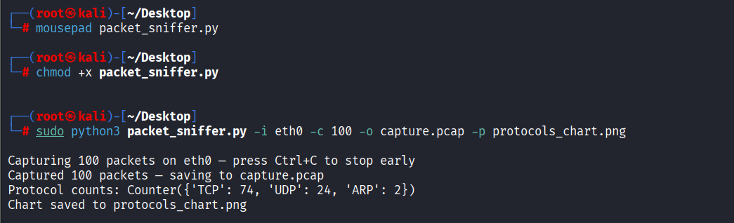
Code snippet (in appendix): packet_sniffer.py

3.2 Results
Captured 100 packets.
Identified protocols: TCP, UDP, ICMP.
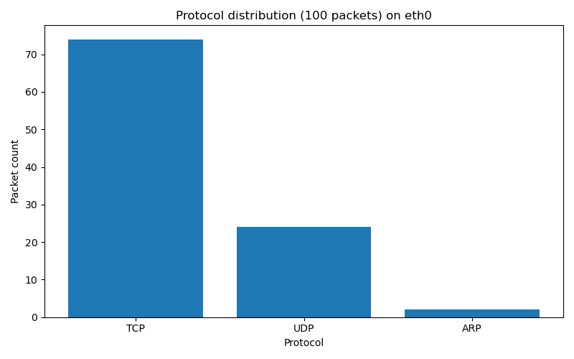

4. Firewall Configuration with iptables

4.1 Rules Implemented
Allow SSH (port 22).
Allow HTTP (port 80).
Block all other incoming traffic.
Commands used:
sudo iptables -A INPUT -p tcp --dport 22 -j ACCEPT
sudo iptables -A INPUT -p tcp --dport 80 -j ACCEPT
sudo iptables -A INPUT -j DROP

4.2 Testing
SSH (22): Connection attempted but refused (service not running) → firewall allowed traffic, but no daemon listening.
HTTP (80): Connection refused (no web server running).
Other ports (e.g., 443): Blocked expected.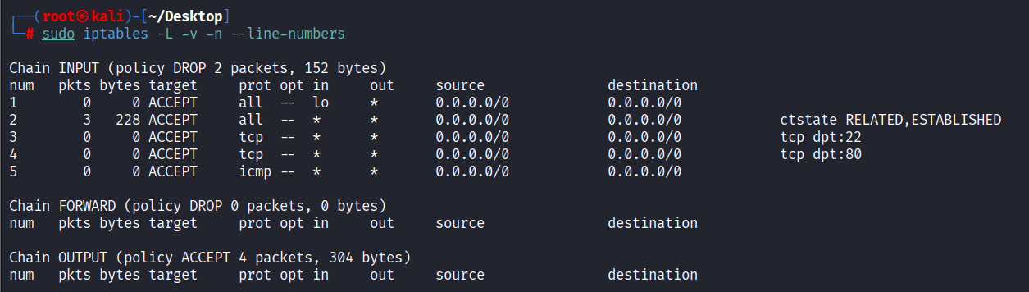

5. Vulnerability Scanning with OpenVAS

5.1 Setup
Installed and configured GVM on Kali Linux.
Services running: gvmd, ospd-openvas.
Synced feeds (NVT, SCAP, CERT).
Created Target (192.168.132.137) and Task (Full and fast scan).
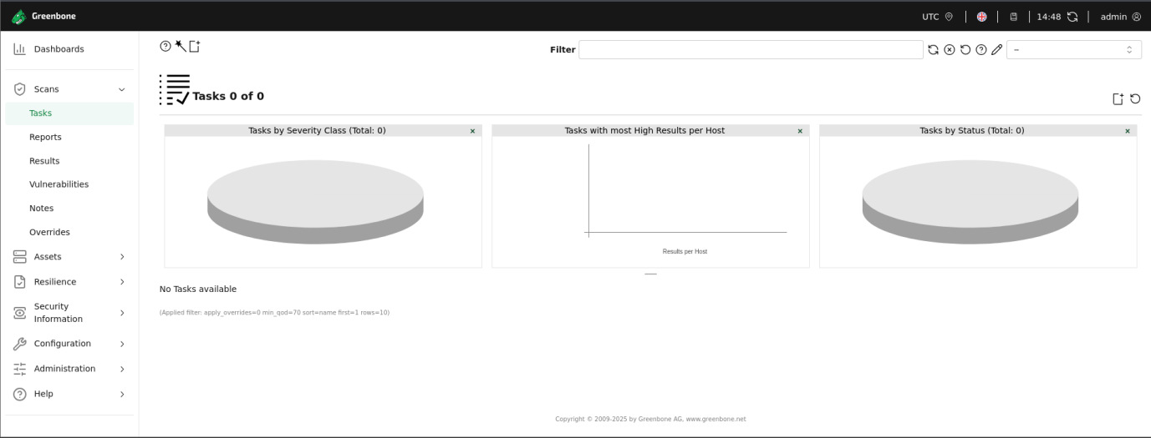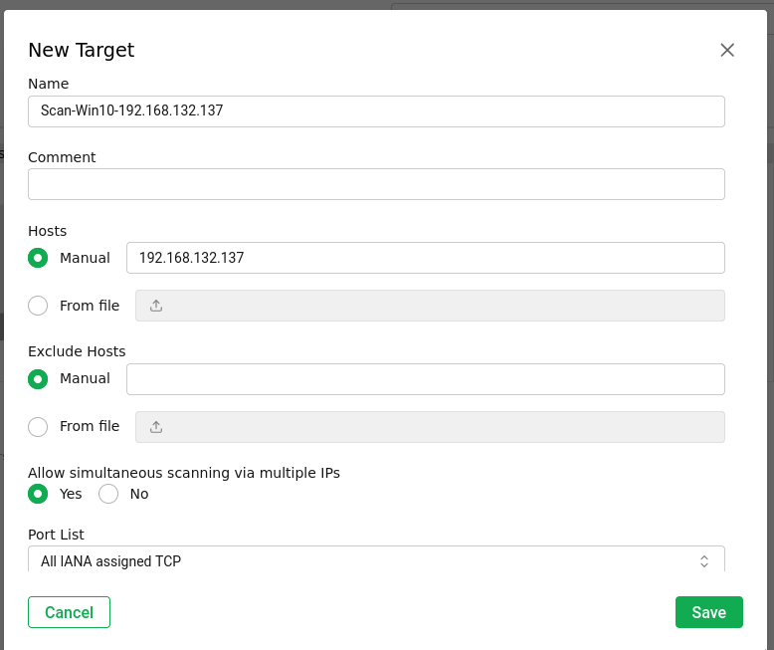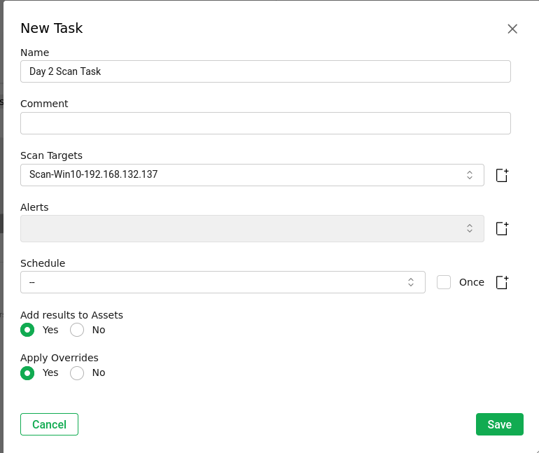

5.2 Results
Vulnerability | Severity | Service/Port | CVE | Notes | Recommendation
SMB Signing not required | High | SMB / 445 | CVE-2017-0143 | Allows MITM attack | Enable SMB signing or disable SMBv1
WinRM over HTTP | Medium | WinRM / 5985 | CVE-2019-0863 | Credentials may leak | Use WinRM over HTTPS (5986)
Outdated Windows Build | Low | Host-wide | — | Missing patches | Apply latest updates

6. Recommendations & Next Steps
Keep OS and services patched.
Disable insecure protocols (SMBv1).
Configure WinRM securely with HTTPS.
Regularly scan hosts with OpenVAS.

7. Key Learnings
Scapy is powerful for low-level packet analysis.
Firewall rules can control traffic precisely, but service availability depends on daemons running.
OpenVAS complements Nmap by showing vulnerabilities with CVEs, not just open ports.

8. Appendix
Python Script: packet_sniffer.py
Firewall Rule Commands: (see Section 4.1)
OpenVAS Scan Logs: (exported from GVM)

