Day 03 Report: Network Security Monitoring and Analysis

Student Details
Name: Ishan Chowdhury
Date: 18/09/2025

1. Introduction
This task focused on network security monitoring using Wireshark, Snort, and Scapy.
The main objectives were:
Capture and analyze network traffic passively using Wireshark.
Configure Snort as an Intrusion Detection System (IDS) with custom rules.
Generate test traffic with Scapy to trigger Snort alerts.
Identify and respond to common network threats such as SYN floods and port scans.

2. Tools Used
Tool | Purpose
Wireshark / TShark | Passive network traffic capture and analysis
Snort | Active intrusion detection system
Scapy (Python) | Generate custom test packets
Kali Linux | Host environment for tools and testing

3. Wireshark Analysis
Captured packets using: tshark -i eth0 -a duration:600 -w capture.pcapng
Applied filters: tcp || udp || icmp
Protocols Identified:
TCP – HTTPS and standard communication.
UDP – DNS and NTP traffic.
ICMP – Network diagnostics.

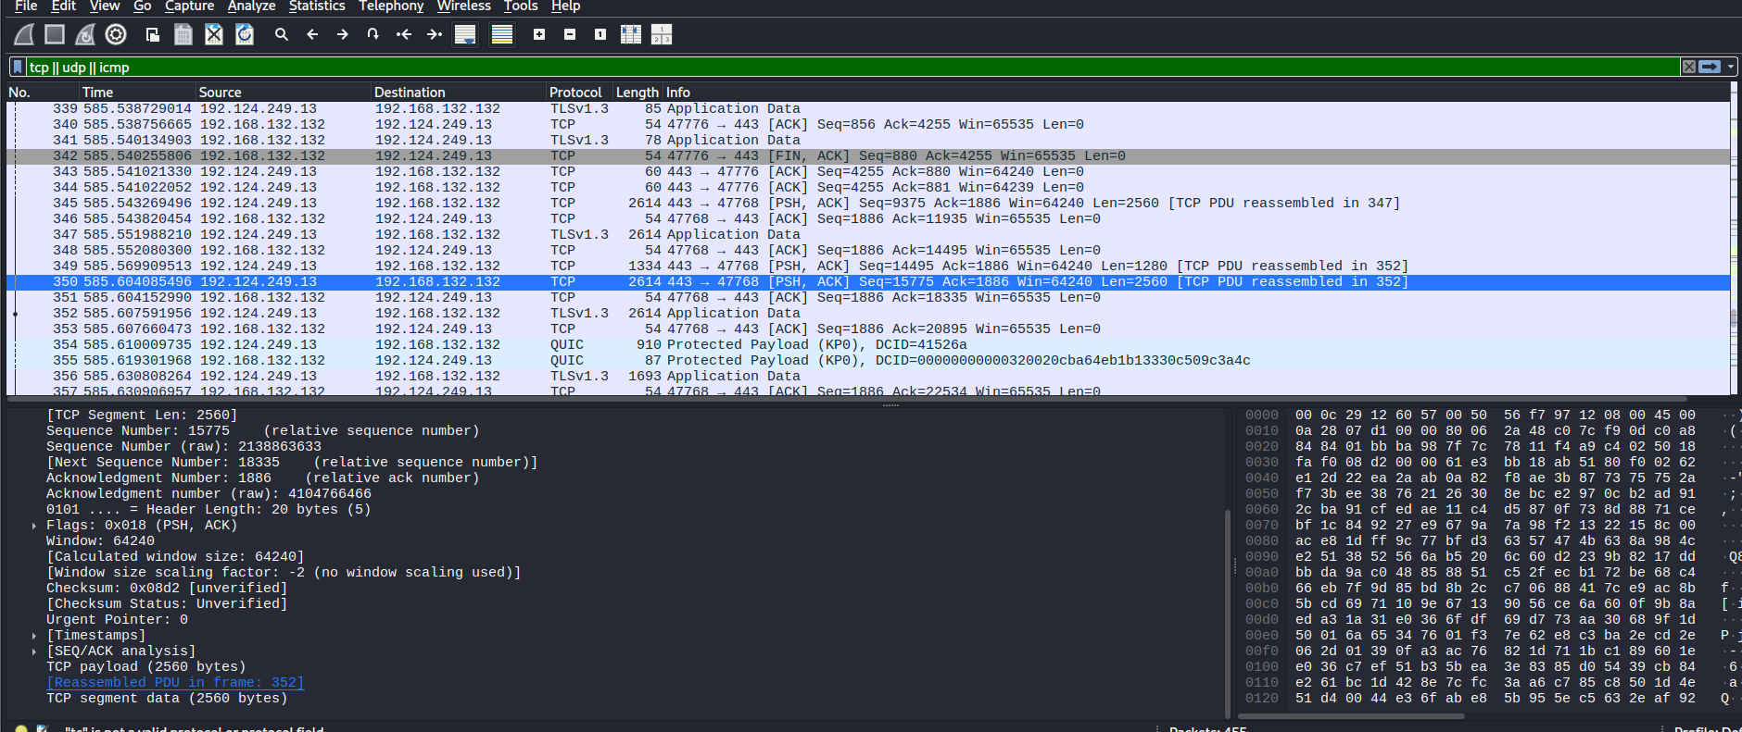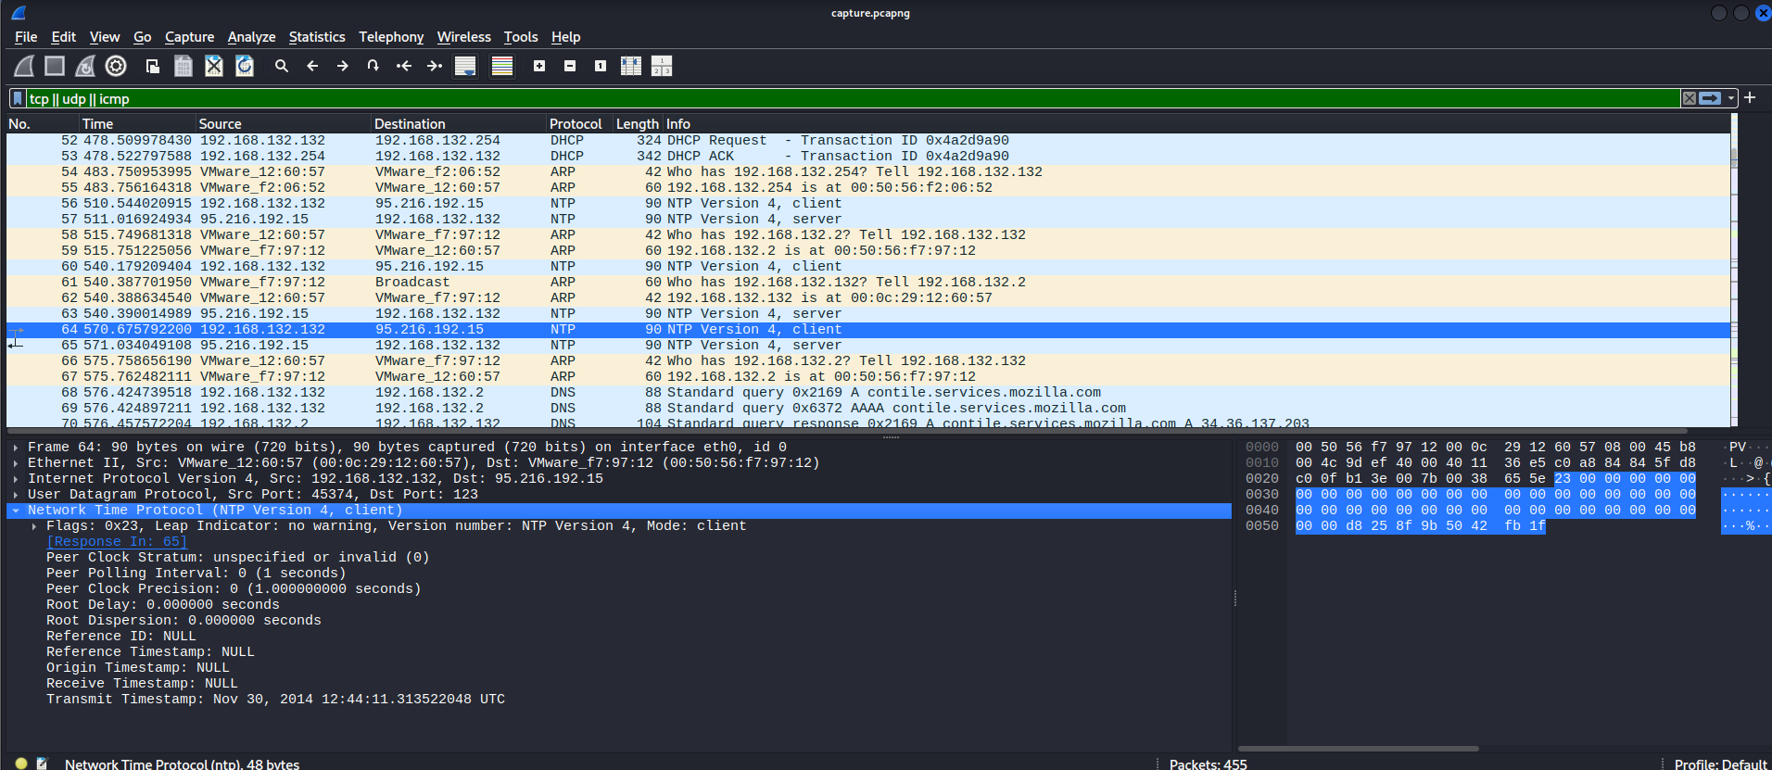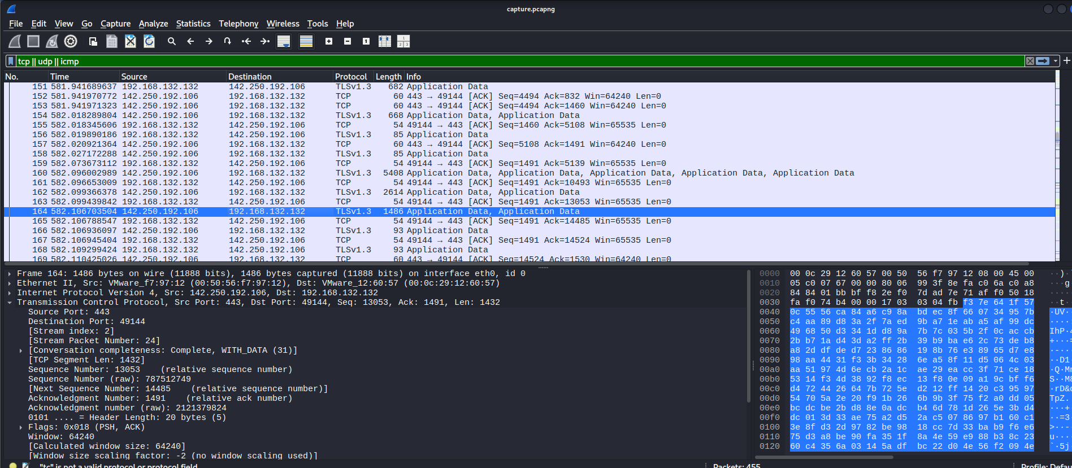4. Snort Configuration
Installed Snort:
sudo apt install snort
Created custom rules in /etc/snort/rules/local.rules:
alert tcp any any -> any any (msg:"SYN Packet Detected"; flags:S; sid:1000001;)
alert tcp any any -> any 1-1024 (msg:"Potential Port Scan"; flags:S; sid:1000002;)
Verified configuration:
sudo snort -c /etc/snort/snort.lua -R /etc/snort/rules/local.rules -T
Result: No errors found, rules successfully loaded.

5. Traffic Simulation with Scapy
Python script (test.py) created to generate SYN packets to trigger Snort alerts.
#!/usr/bin/env python3
"""
test.py

Scapy-based SYN packet generator for lab testing (Task 03).
Sends SYNs to a range of destination ports to simulate a simple port scan.

Usage (run as root):
sudo python3 test.py --target 127.0.0.1 --start 1 --end 200 --delay 0.01
"""

from typing import List
import argparse
import time
from scapy.all import IP, TCP, send # requires python3-scapy

def parse_ports(start: int, end: int) -> List[int]:
"""Return a list of ports from start to end (inclusive)."""
return list(range(start, end + 1))

def send_syn_scan(target: str, ports: List[int], delay: float = 0.01) -> None:
"""
Send TCP SYN packets to target:ports.

Args:
target: destination IP or hostname (lab/Vm only).
ports: list of destination ports to send SYNs to.
delay: seconds to wait between packets to avoid flooding the NIC.
"""
for dport in ports:
pkt = IP(dst=target) / TCP(dport=dport, flags="S")
# send at L3 (will craft L2 automatically). verbose=False to reduce noise.
send(pkt, verbose=False)
time.sleep(delay)

def main() -> None:
p = argparse.ArgumentParser(description="Scapy SYN port-scan generator (lab use only).")
p.add_argument("--target", "-t", required=True, help="Target IP (e.g., 127.0.0.1)")
p.add_argument("--start", type=int, default=1, help="Start port (default 1)")
p.add_argument("--end", type=int, default=1024, help="End port (default 1024)")
p.add_argument("--delay", type=float, default=0.01, help="Delay between packets (seconds)")
args = p.parse_args()

ports = parse_ports(args.start, args.end)
print(f"[+] Sending SYN packets to {args.target} ports {args.start}-{args.end} (delay={args.delay}s)")
send_syn_scan(args.target, ports, args.delay)
print("[+] Done.")

if __name__ == "__main__":
main()

Execution:
sudo python3 test.py

6. Snort Detection Result:
Ran Snort live:
sudo snort -c /etc/snort/snort.lua -R /etc/snort/rules/local.rules -i lo
Alerts logged in /var/log/snort/alert_fast.txt.
Final Packet Statistics Screenshot:
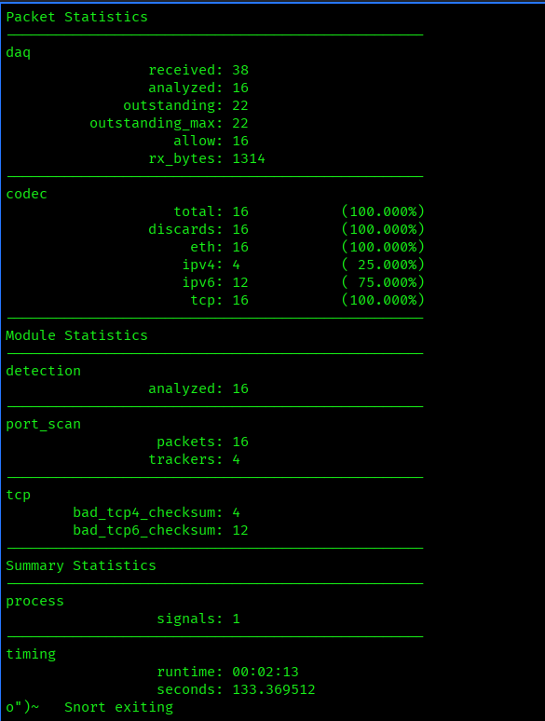
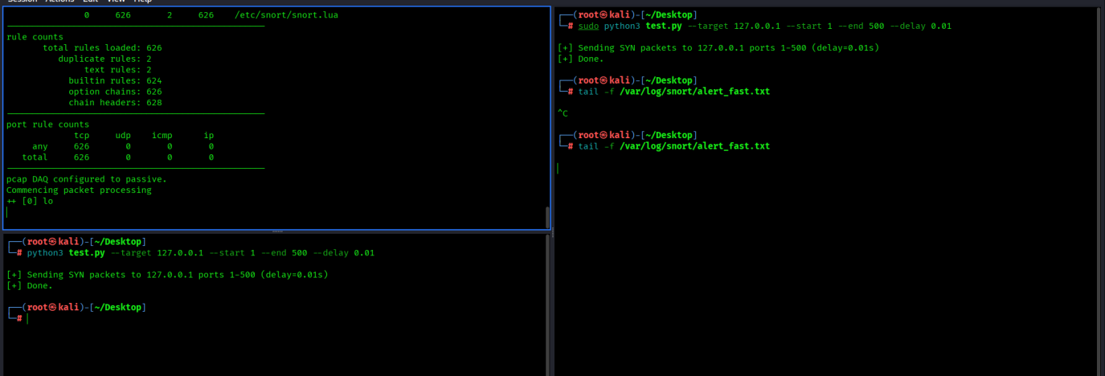

7. Findings
Wireshark successfully captured TCP, UDP, and ICMP traffic.
Snort correctly detected custom test traffic:
SYN packets.
Port scans.
Generated traffic matched rule triggers.

8. Challenges Faced
Challenge | Solution
Snort config file errors | Fixed syntax and ensured full paths were provided.
No TCP packets visible initially | Adjusted capture filters and tested using browsing activity.

9. Conclusion
The task successfully demonstrated:
Passive monitoring using Wireshark.
Active intrusion detection using Snort.
Traffic generation and IDS testing with Scapy.
This setup provides a foundational network defense workflow, enabling early detection of malicious activity.

