Task 05 Report – Networking and Security Operations
Name: Ishan Chowdhury
Date: 25/09/2025

1. Subnet Design

1.1 Subnet Calculations
IP Range: 192.168.1.0/27
Subnet Mask: 255.255.255.224
Total IP Addresses: 32
Usable IPs: 30
Address Type | Address
Network Address | 192.168.1.0
First Usable | 192.168.1.1
Last Usable | 192.168.1.30
Broadcast Address | 192.168.1.31

1.2 Network Diagram
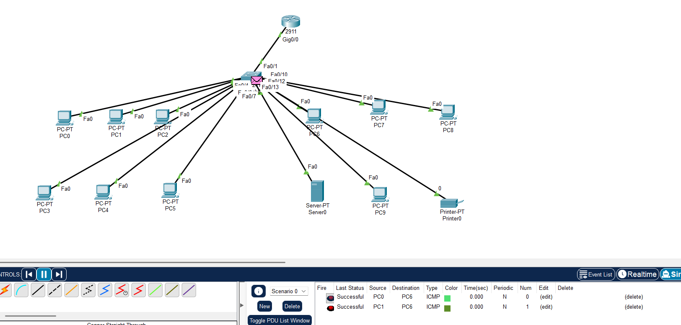

2. Network Traffic Analysis

2.1 Tools Used
Wireshark

2.2 Observations
Protocol | Purpose | Notes
TCP | Reliable communication | Most web traffic used TCP
UDP | Fast, connectionless | DNS queries
DNS | Name resolution | Few suspicious spikes

2.3 Screenshots
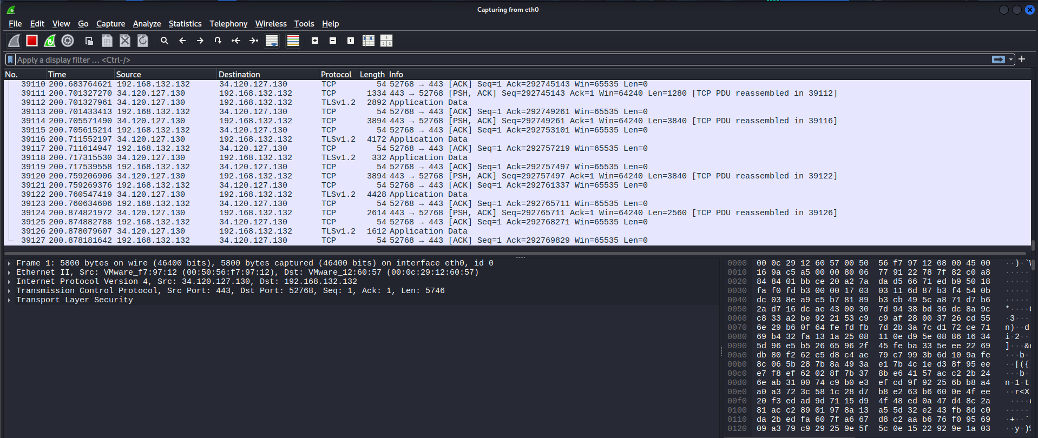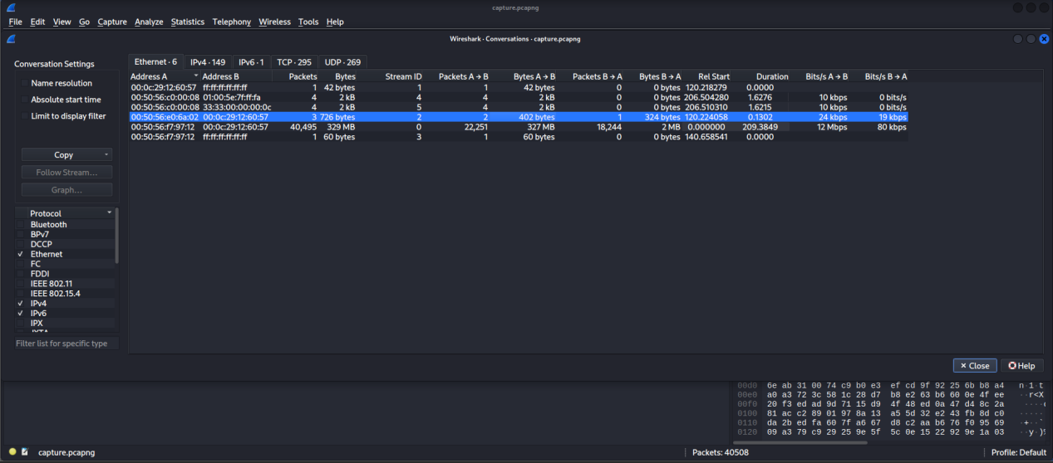

3. Troubleshooting Network Protocol Issues

3.1 Scenario
Issue: DNS misconfiguration prevented hostname resolution.

3.2 Troubleshooting Steps
Checked connectivity using ping.
Verified DNS resolution using nslookup.
Identified incorrect DNS entry and corrected configuration.

3.3 Result
Connectivity restored successfully.
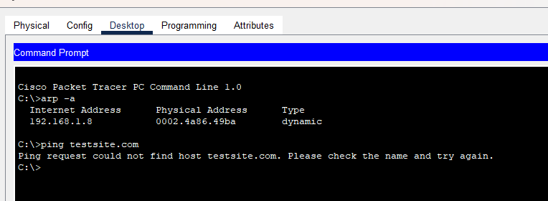
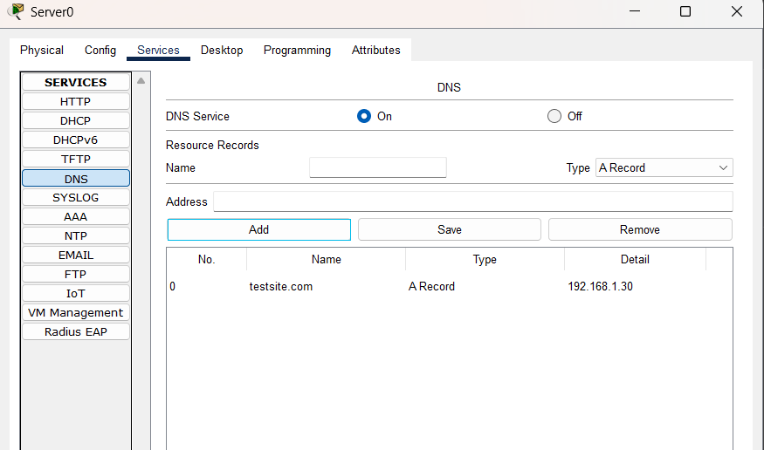
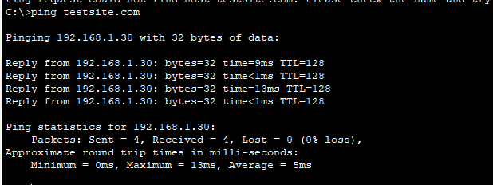

4. SIEM Setup (ELK Stack)

4.1 Installation Steps
Installed Elasticsearch, Logstash, and Kibana on kali VM.
Configured Logstash to collect syslog data.
Accessed Kibana dashboard via browser.

4.2 Screenshot
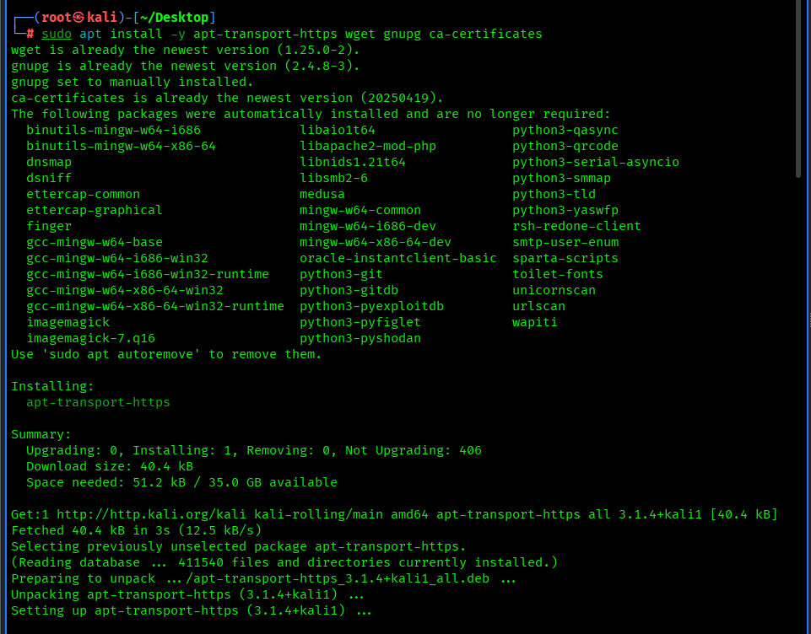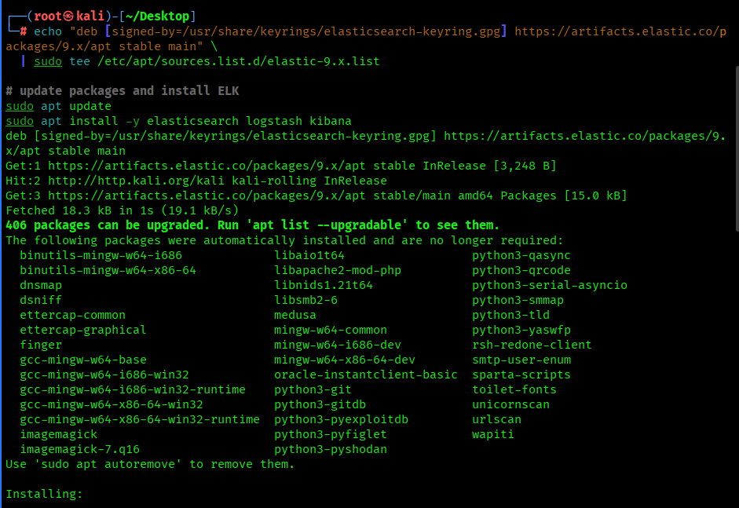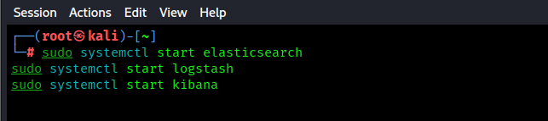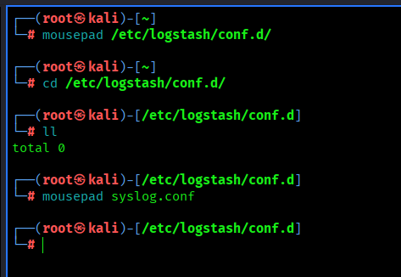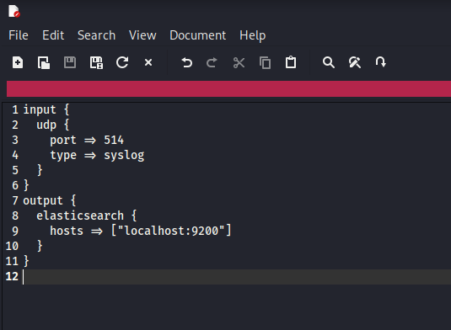
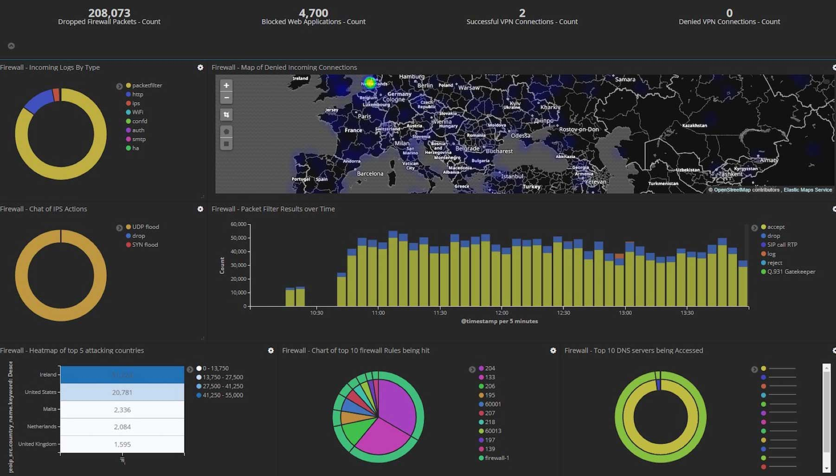

5. Incident Simulation and Network Forensics

5.1 Incident Description
Simulated unauthorized SSH brute-force attack using Hydra.

5.2 Wireshark Findings
Detected repeated SSH login attempts from a suspicious source IP.
Attack targeted port 22.

5.3 Kibana Timeline
Logs confirmed attack attempts and timestamps.

6. Threat Hunting

6.1 Process
Used Kibana search to identify failed logins and abnormal outbound traffic.
Detected multiple suspicious login attempts from a single IP address.

6.2 Screenshot
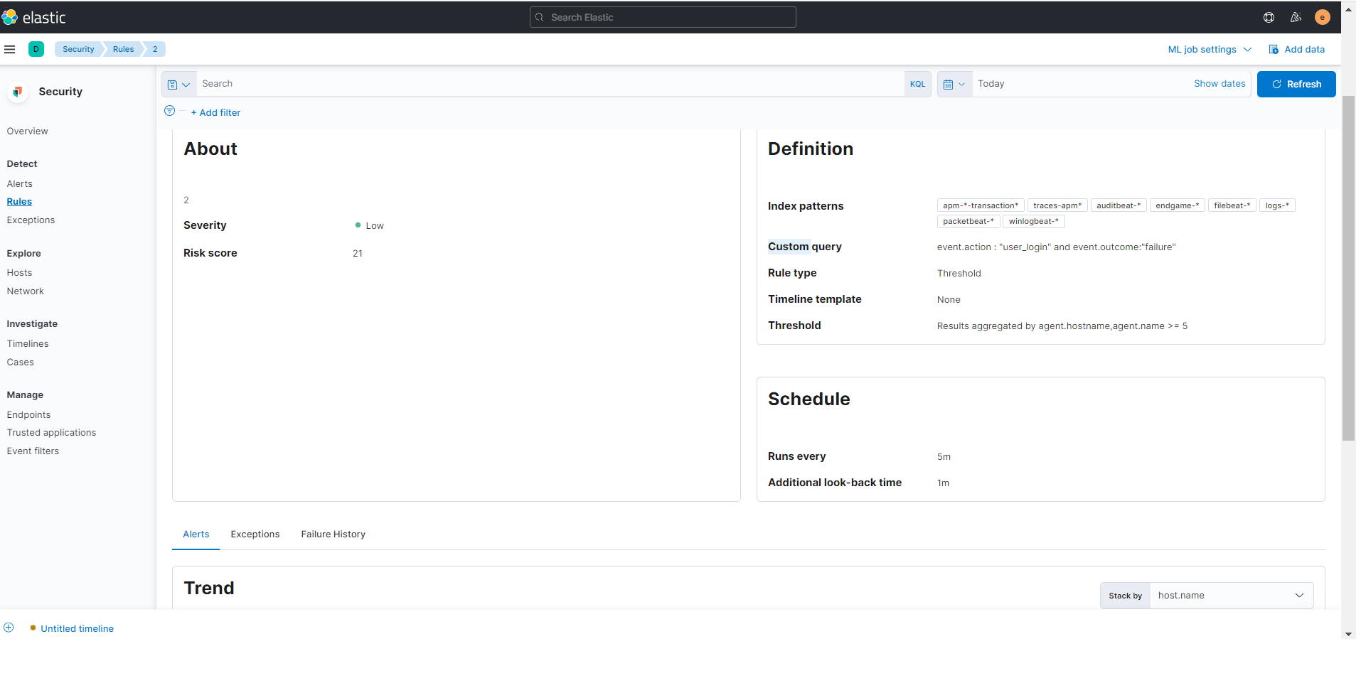

7. Key Learnings
Learned how to design and calculate subnets for efficient IP allocation.
Gained experience in traffic analysis and SIEM dashboard creation.
Understood incident response workflow by correlating logs and network captures.

Conclusion
This task provided practical exposure to networking and security operations, combining subnetting, traffic analysis, SIEM integration, and forensic investigation.
The project demonstrated how network defense and incident response workflows intersect in real-world SOC environments.

