Martin Ponce Ponce 10371381 Date 11/08/2014

Family name Given name Student number

**ENS1161 Computer Fundamentals**

**Test 2**

(a) Let P denote a set of people, and M a set of movies, and suppose that the predicate S(x, y) means that person x has seen movie y.

(i) Write the following statement in symbols:

For each movie there is somebody who has not seen it.

∀y ∈ M, ∃x P, ~S(x, y)

(ii) Write the following statement in symbols:

There is some movie that at least one person has not seen.

∃y ∈ M, ∃x P, ~S(x, y)

(iii) Write the negation of the statement in (i) in **simple** English.

∃y ∈ M, ∀x P, S(x, y)

There is some movie that everybody has seen

(iv) Write the negation of the statement in (ii) in **simple** English.

∀y ∈ M, ∀x P, S(x, y)

Everybody has seen all the movies

1. Consider three subsets A, B and C of a universal set U. Given that n(U) = 50,   
   n(A) = 24, n(B) = 19, n(C) = 27, n(A∩B) = 7, n(A∩C) = 11, n(B∩C) = 8 and n(A'∩B'∩C') = 3, find:

(i) n(A∩B∩C') = 4

(ii) n((A∩B)∪(A∩C)) = 15

(iii) n(A'∩B'∩C = 11

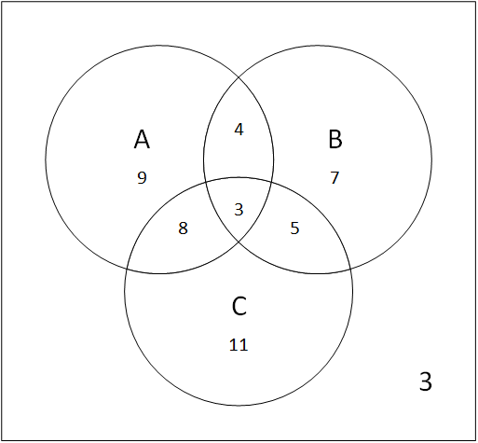 [6 + 4 = 10 marks]