Ponce Martin 10371381 Date 02/09/2014

Family name Given name Student number

**ENS1161 Computer Fundamentals**

**Test 5**

(a) Consider sets A = {a, b, c, d}, B = {e, f, g} and C = {m, p, q}, and relations R between A and B, and S between B and C, defined by:

R = {(a, f), (b, e), (c, e), (c, g), (d, f)} and S = {(f, m), (f, q), (g, p)}

(i) Find matrices M(R) and M(S) that represent R and S,

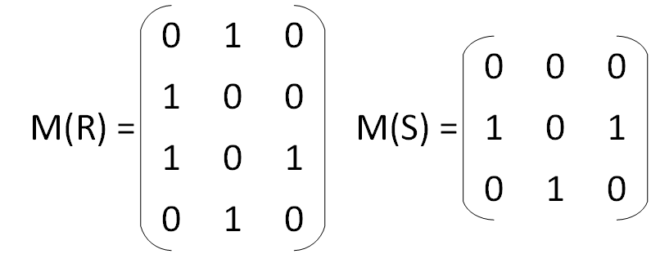

(ii) Find the matrix M(RoS) that represents the composition RoS, and represent the relation RoS with an arrow diagram.

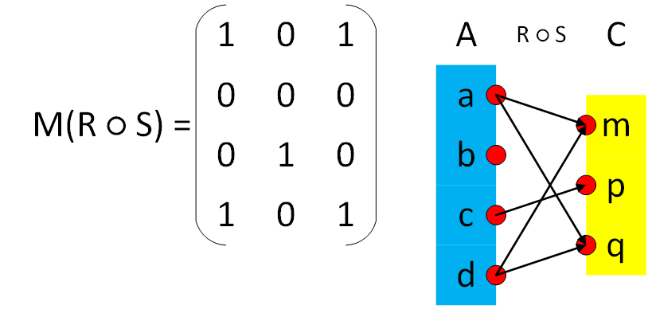

(b) In each of the following, there is a set and a relation defined on that set. For each indicate with "Y" or "N" whether the relation is reflexive, symmetric or transitive, and hence whether it is an equivalence relation.

|  |  |  |  |  |  |  |
| --- | --- | --- | --- | --- | --- | --- |
|  | **Set** | **Relation** | **Reflex?** | **Symm?** | **Trans?** | **Equiv?** |
| **1** | **people** | **lives no more than 1km from** | **Y** | **Y** | **N** | **N** |
| **2** | **people** | **likes to play chess with** | **N** | **N** | **N** | **N** |
| **3** | **students** | **attends the same class as** | **Y** | **Y** | **Y** | **Y** |

(c) A relation P between sets {k, l} and {r, s, t} is represented by the matrix

. Represent the inverse relation P–1 as a set of ordered pairs.

P-1 = {(r, k), (r, l), (t, k)}

[ 5 + 3 + 2 = 10 marks ]