Ponce Martin 10371381 Date 16/10/2014

Family name Given name Student number

**ENS1161 Computer Fundamentals**

**Test 10**

(a) Join the vertices to create a graph that corresponds to the adjacency matrix given:

|  |  |  |  |  |  |
| --- | --- | --- | --- | --- | --- |
|  | A | B | C | D | E |
| A | **0** | **0** | **0** | **1** | **1** |
| B | **0** | **0** | **0** | **0** | **1** |
| C | **0** | **0** | **0** | **0** | **1** |
| D | **1** | **0** | **0** | **0** | **1** |
| E | **1** | **1** | **1** | **1** | **0** |
|  |  |  |  |  |  |

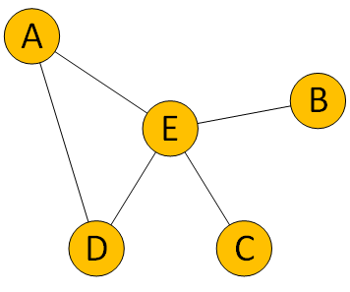

(b) For each of parts (i) and (ii), determine whether the given pair of graphs is isomorphic. If so, find a function f : {A, B, C, D, E} → {P, Q, R, S, T} that shows the isomorphism. If not, explain why not.

A

B

C

D

E

P

Q

R

T

S

(i)

These graphs are not isomorphic. The first graph contains one vertex that is degree 4, while the second graph does not have such a vertex.

(ii)

P

Q

R

T

S

A

B

C

D

E

These graphs are isomorphic. P → A, Q → B, R → C, S → E, T → D.

(c) For each of the following graphs, state whether the graph has:

* no Eulerian path (N)
* an Eulerian path but no Eulerian circuit (P)
* an Eulerian circuit (C)

Indicate your answers by writing N, P or C in the spaces provided.

(i) (ii) (iii)

N: > 2 odd vertices P: 2 odd vertices P: 2 odd vertices

(d) Find an Eulerian path in graph (i), a Hamiltonian circuit in graph (ii), and a Hamiltonian path in graph (iii). Give your answers by listing the vertices in order along the path or circuit, **and also** by sketching clearly the path or circuit.

(i) (ii) (iii)

A

B

C

D

E

F

A

B

C

D

E

F

A

B

C

D

E

F

DEFDACBA ADFEBCA DFEBCA

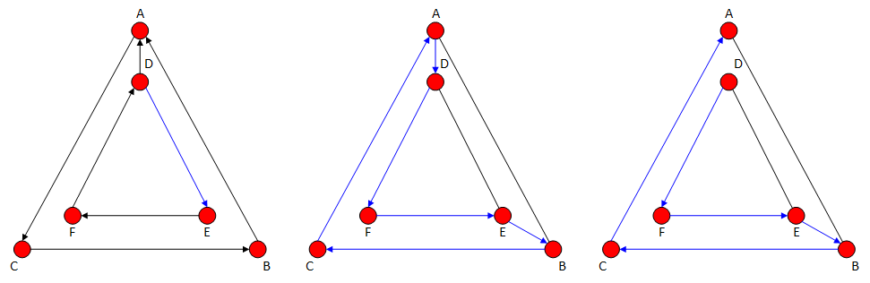

[1 + 3 + 3 + 3 = 10 marks]