Module 05 Tutorial Session

This week’s tutorial simply goes over how to start SQL Server Management Studio (SSMS), connect to the SQL Server, run the script to set up the “company” database, and test it out.

It is recommended that you install SQL Server 2008 R2 (Express Edition) and SSMS on your netbook or home computer/laptop in order to work away from campus. Ask your tutor for assistance if you are having difficulties with this.

**Starting SSMS and Connecting to the SQL Server**

In SCSS computer labs, SSMS can be found by typing into the search box in the Start Menu. Start typing “SQL Server Management Studio” and it will appear.

SSMS will ask you to connect to the server. The default server name should be shown in the server name field, and the authentication field should show “Windows Authentication”.

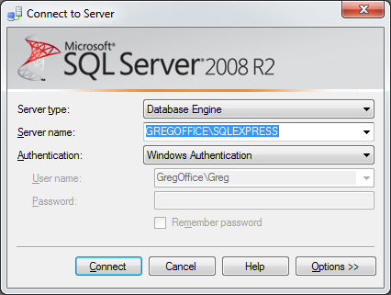

Press connect without changing anything to connect to the server. If the default server name is not shown, select it from the drop-down list or browse for it.

Welcome to SSMS! Refer to the lecture slides for an overview of the application.

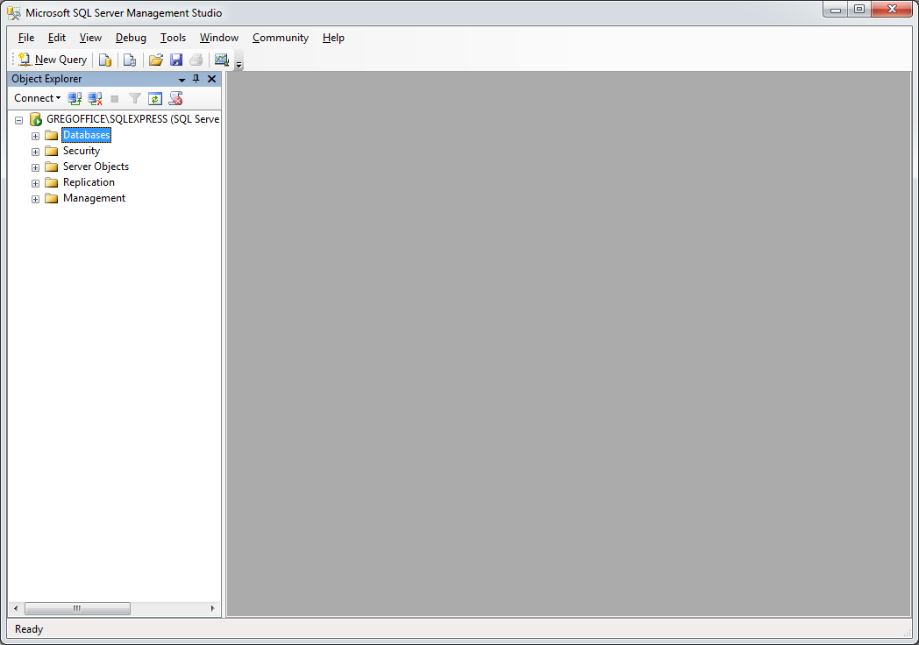

**Creating the “company” Database**

If another student has already created the “company” database on the computer you are using, it may already exist. Regardless, it is a good idea to re-create it to ensure that it has not been modified and to practise the process of running SQL files.

Download “company.sql” from Blackboard and save it to the desktop.

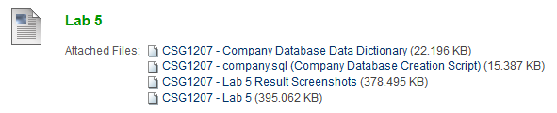

In SSMS, go to File > Open > File or click the “Open File” button on the toolbar () and go to the desktop to open company.sql.

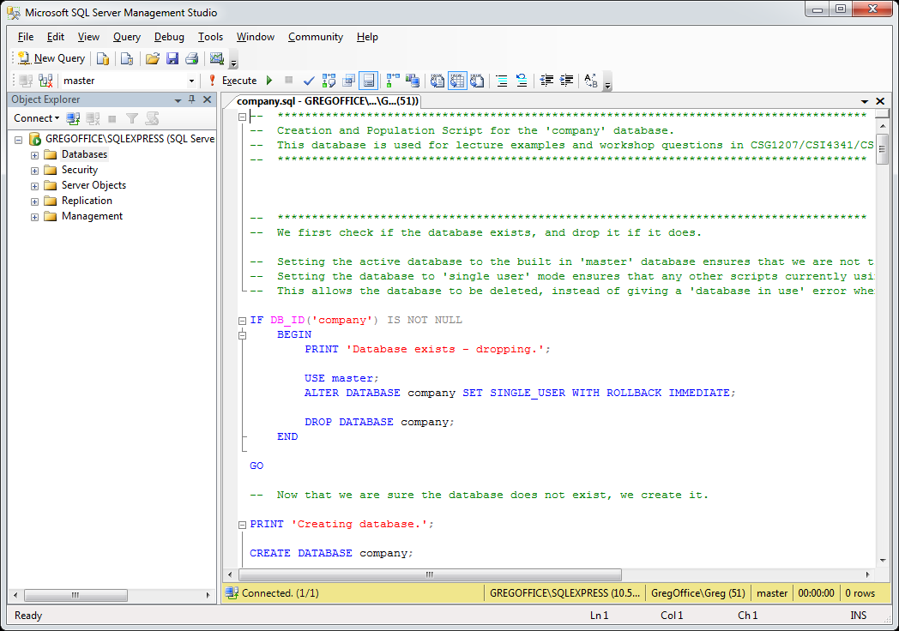

Press the “Execute” button on the toolbar () to run the script on the server. After a few moments, you should see “Query executed successfully” in the status bar, and a list of messages that were produced when the script was run.

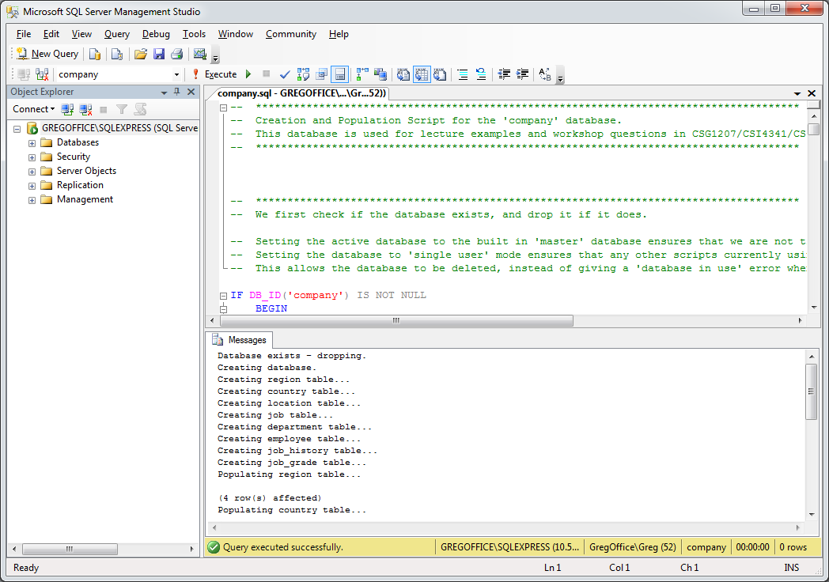

The company database has now been created on the server.

**Viewing Content and Executing Queries on “company”**

First of all, examine some of the content in the “company” database. To do this, expand the Object Explorer until you can see the list of tables in “company”. Right click on a table name to see the options and click “Select Top 1000 Rows” to view the content of the table.

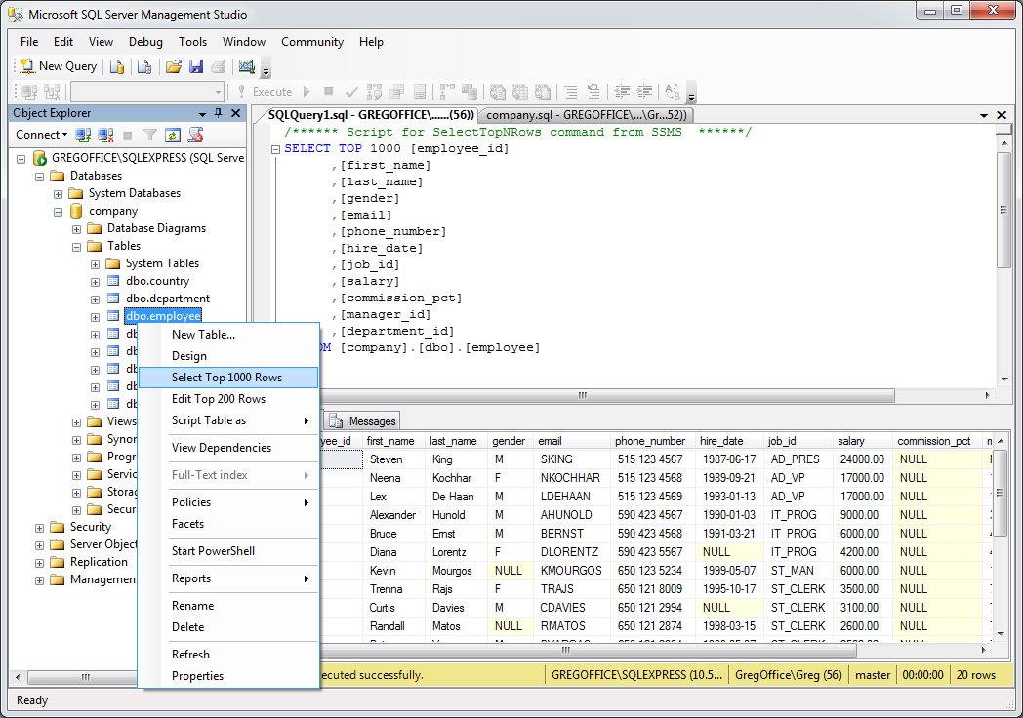

The content of the table will be displayed. If “company” does not appear in the list of databases, right click on the server name at the top of the Object Explorer and click “Refresh”.

You may have noticed an option to edit content (which also allows you to insert new content) in the right click menu. We won’t do it now, but remember where it is for when you need to.

Now, click the “New Query” button at the left of the toolbar () in SSMS. This will open a blank query window in which SQL statements can be typed and executed.

Type a simple query:

SELECT last_name, salary, hire_date

FROM employee;

Then press the Execute button in the toolbar. The result of the query is shown.

If you encounter an error message such as “Invalid object name 'employee'”, it is because your query is being run on the wrong database. Use the drop-down list in the top left of the window to select which database (“company”) to execute the query on.

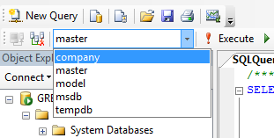

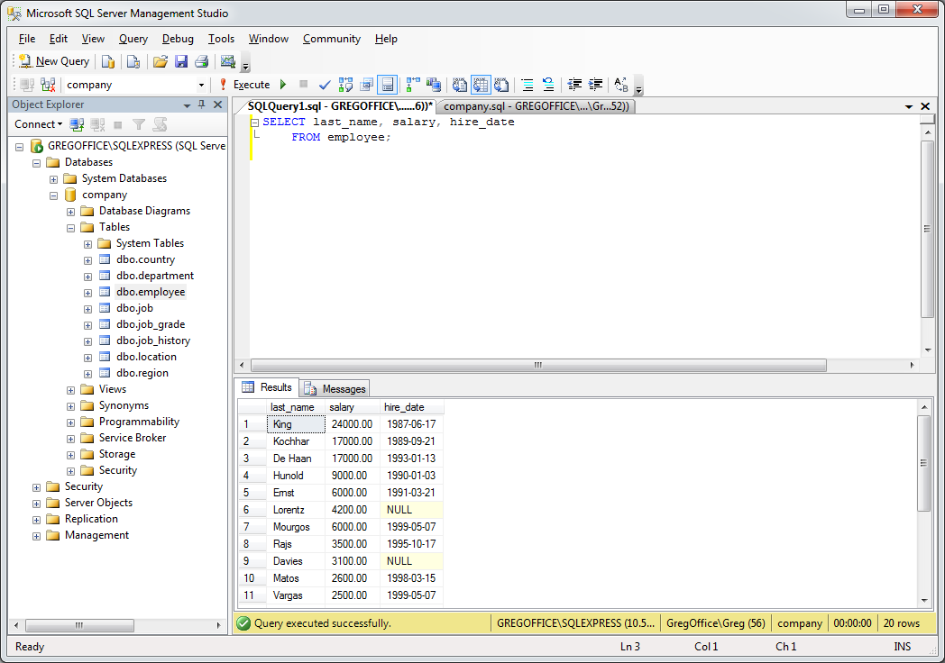

Press the “Results to Text” button on the toolbar (), the press Execute again. You can press the “Results to Grid” button () to change back to the grid layout for query results.

Save the query by going to File > Save or pressing the “Save” button on the toolbar (). This saves the query as a .sql file, which is essentially a text file. Note that you are saving the text of the SQL query itself, not its results or output.

Take a few moments to familiarise yourself further with SSMS before continuing with the lab!