

**Computer Security**

**Tutorial 1:**

*Each tutorial activity in this unit is divided into multiple parts. Throughout the semester it is important that you thoroughly complete each of the parts in the tutorial as these will help you better understand each of the modules, assignments and prepare you for the final exam. In this first module, there are a total of three parts.*

**Part 1: The Basics**

Presumably you can log into Blackboard if you are reading this. If you are currently working with another student because you cannot log into Blackboard yourself, then you must resolve any login issues as quickly as possible.

Take some time to explore the Blackboard site for this unit. In particular, do the following;

1. Locate and read through the assignments
2. Browse the Blackboard forums for this unit
3. Locate the ECU online referencing guide - this is essential to ensure you understand the fundamentals or referencing within this and other units that you undertake
4. Familiarise yourself with where content is located for this unit

**Part 2: Aims of Security**

As part of the assessments and exam for this unit, it is essential that you keep up to date with past and present computer security breaches. Using the Internet, find real world examples of breaches to Confidentiality, Integrity, Availability, Authenticity and Non-repudiation. You should note down these examples as they will become very beneficial throughout this unit. You should also note down where you acquired the information from as you can use this as a reference in your assignments.

The following sites might help you to get started (although you may also has to search further);

http://www.securityfocus.com/

http://www.networkworld.com/topics/security.html

http://www.microsoft.com/security/default.aspx

http://www.zdnet.com.au/topic/security/

**Part 3: EndNote & Referencing**

The third part of this tutorial activity focuses on learning to use EndNote to include in-text and end-text references in your Microsoft Word documents. If you have not already downloaded and installed EndNote to your own machine you may do so by obtaining the software from the link provided under module 1. For those students using a lab machine, EndNote should already be pre-installed on that workstation.

1. EndNote can be used on its own or together with Microsoft word to manage your references. Anytime you locate information that you would like to include into your assignments you need to include an in-text and end-text reference into your assignment. EndNote automates the process, and prevents errors if the process was done manually.
2. Open the EndNote program on your computer and close any pop-ups relating to the program. You should see something similar to the screenshot shown below. We are going to create a *new* library of references. Click on File > New to create the new library.

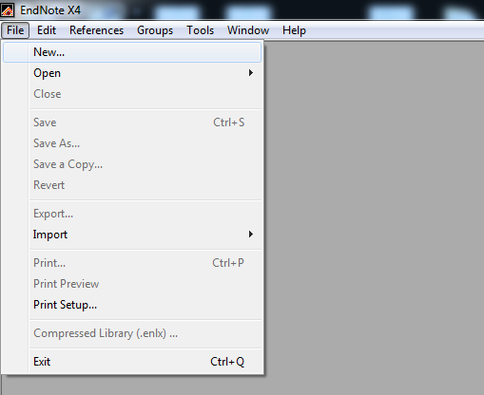

1. The program will then ask you where you would like to create the new library (Reference Library). You may create it on your desktop for the time being. However, if you save the library onto your USB drive for instance, you will be able to open it on another computer, at home etc. This would allow you to create and store all your references and potentially use them for multiple units throughout your studies.
2. You should have a screen similar to what is presented below. This is where all the references will be listed. At ECU we use a particular referencing style (or referencing system). It is important that you know which style is used, and that you follow the correct style throughout your studies.

As per the image below, the current referencing style is set to *Annotated*. This needs to be changed to the referencing style used at ECU. Within this module, you will notice that there is a link to the ECU referencing guide. Within this guide there is plenty of helpful of information regarding how to reference different types of information (books, journals, web pages etc.). Read and locate the correct referencing system used at ECU within the guide and change this appropriately by clicking Annotated > Select Another Style...

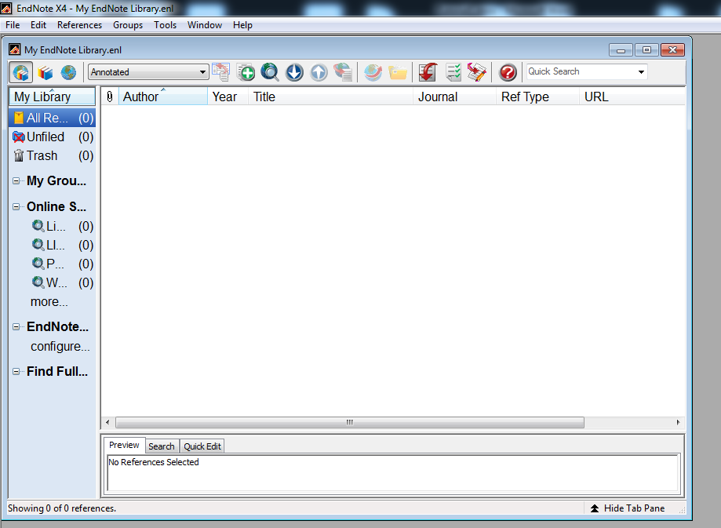

1. Now that the software is setup you are ready to start using the software. Right click within the software then click "New Reference". As per the image below the New Reference option will appear. As an example we are going to include a new book reference into our library. Clicking on the "Reference Type" list will show various forms of references which could be included into the EndNote library.

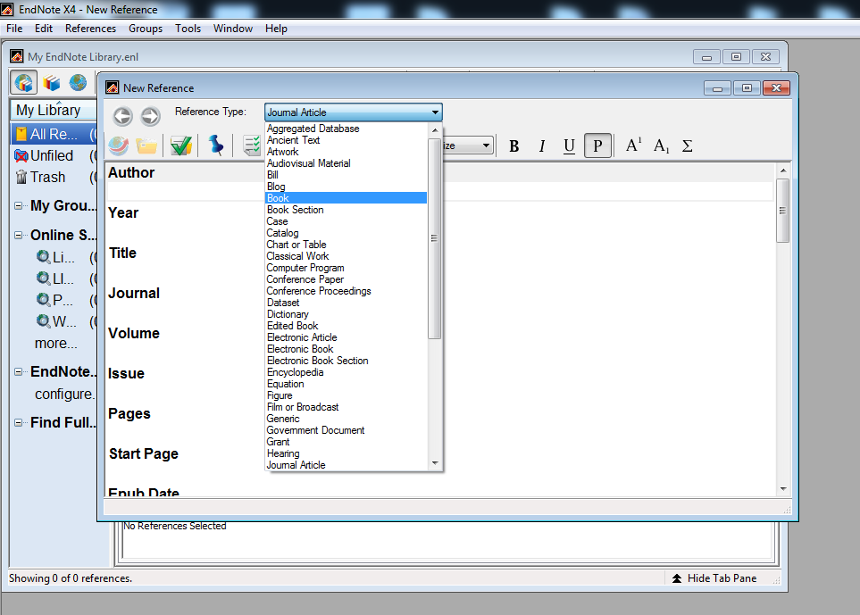

1. You will notice that the New Reference option is asking for plenty of data regarding the new source of information. Fortunately, we do not have to include all of this data. This is where the ECU referencing guide is beneficial as it shows you what information is require to properly reference a particular source. The unit text has two authors. In the ECU referencing guide turn to the section titled "Book with two authors". You will notice that a book with two authors requires the following information; authors, year of publication, book title, place of publication and publisher.
2. As per the image below, you will notice that required fields have been populated all in relation to the text book. It is important to pay special attention to the authors property. Each author should be included on a separate line. If the authors were listed on one line, the program would interpret this as one author with a long list of names. Lastly, for the "City" field, we input the city of the publisher, and the acronym of the state. If the book was published in Perth, we would include Perth, WA.

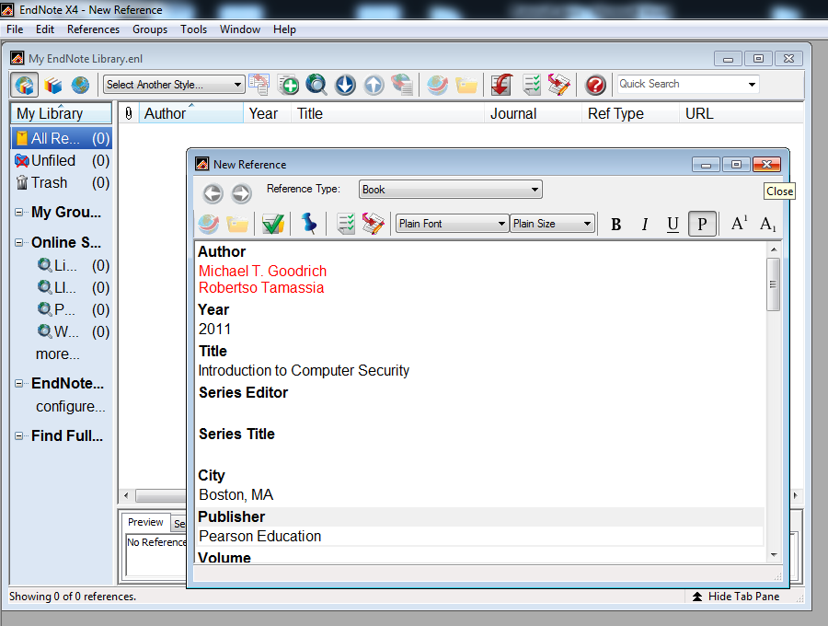

1. Go ahead and close the "New Reference" window. It may ask you if you would like to save the reference, to which you should answer yes. If you have done everything correctly, you now should have one entry in your EndNote library as per the image below.

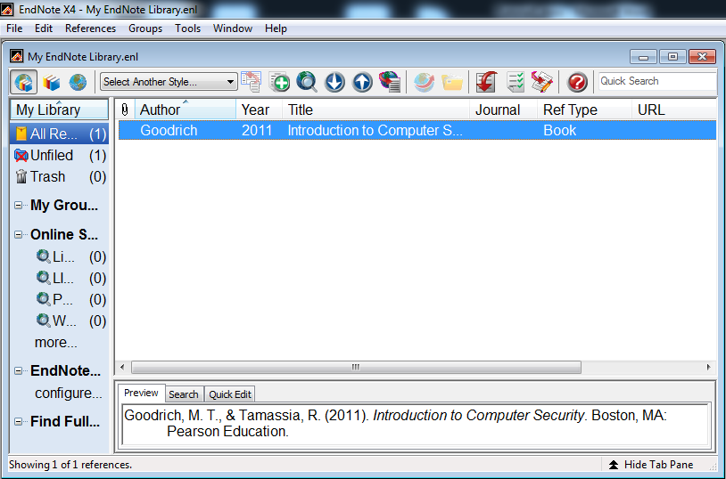

1. When you want to add another reference to your library, simply repeat the previous steps. As per the image above, you will notice that the end-text reference has been displayed in the preview panel at the bottom of the program. Since the correct referencing system used at ECU was selected, the reference is perfectly formatted.
2. Now onto using the reference in the EndNote library in a Microsoft Word document. As per the image below you can see that I have only written one sentence and yet it already lacks credibility. Fortunately, the text book in this unit substantiates my claim. As a result I can use the text book as a reference to backup what I said.

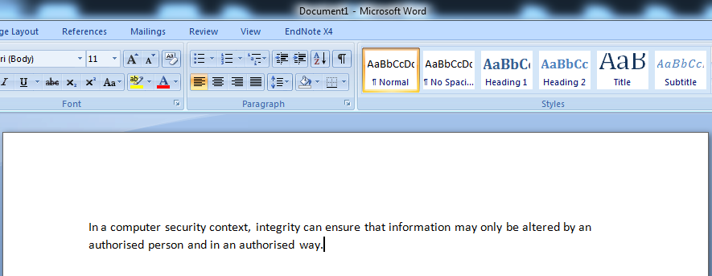

1. Firstly, I need to select which reference from my EndNote library I will use to substantiate my sentence in the Microsoft Word document. I can easily do this by simply clicking (selecting/highlighting) the appropriate reference from the library. Next go back to the Microsoft Word document and click at the end of the sentence (just before the full stop). The reference will be inserted where the cursor is currently located on the document. Click on the EndNote tab at the top. Click on the "Insert Citation" button followed by "Insert Selected Citation(s) as per the image below.

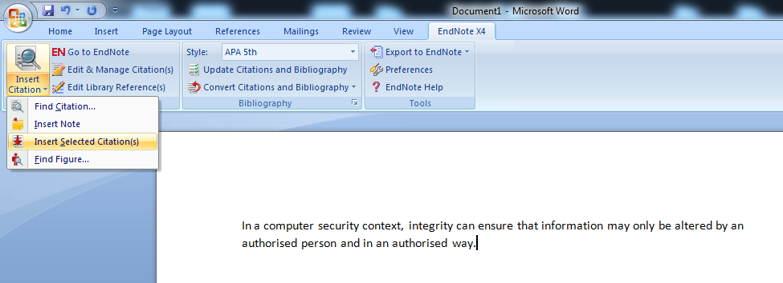

1. Assuming you have done everything correctly, you should now have both an in-text and end-text reference. The in-text reference would be located where the cursor was present. The end-text reference would have appeared at the end of your document and is now called your reference list.

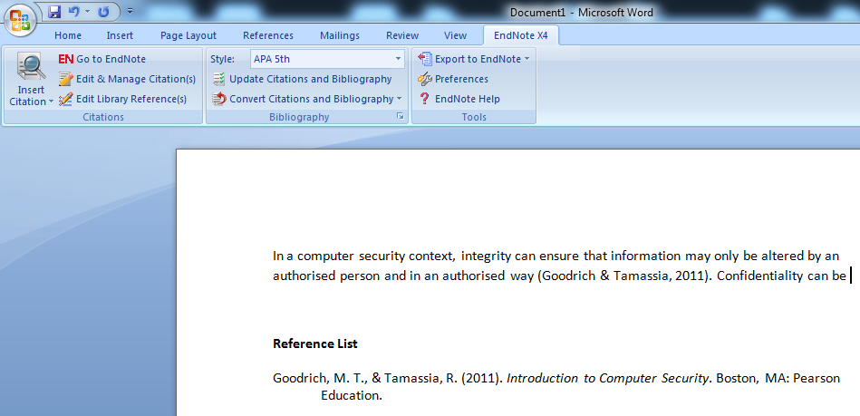

1. You can use multiple references to further substantiate sentences, ideas, statistics etc. This adds additional credibility to your work. When using EndNote your end-text references will automatically be sorted alphabetically as per the ECU referencing guide requirements. It is important that you familiarise yourself with EndNote and the ECU referencing guide as you will be using these for all of your studies.